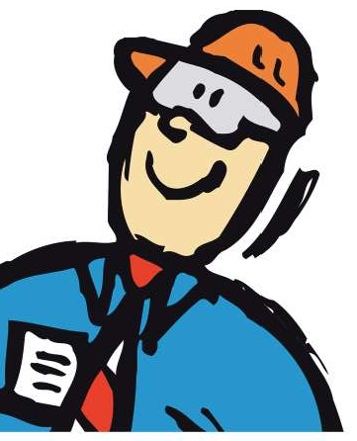



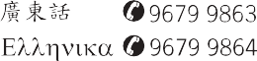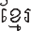

Health and Safety Handbook
004AUG06

A Message from the CEO about Occupational Health and Safety

Occupational Health and Safety (OH&S) is an absolute priority for Greater Dandenong. We care about the wellbeing of all our employees and will not compromise on health and safety standards. Maintaining a safe workplace and operating in accordance with safe work practices are matters of paramount importance to us.
Trying to save time or money by not observing health and safety requirements is false economy. If work procedures require a job to be done in a certain way, then it must be done that way. Taking shortcuts to save time or money may endanger your health and safety, or that of someone you work with.
Managers and business unit leaders must set the example when it comes to health and safety and always ensure total compliance with safe work practices. Under no circumstances should a manager or business unit leader allow staff to ignore safe work practices, even if it might save a few minutes or dollars.
It is not just managers and business unit leaders who must take responsibility for health and safety. It is the responsibility of all staff. If
you think a procedure could be improved, or should be changed to improve health and safety practices, please talk to your manager or business unit leader. Alternatively, contact the councils Health and Safety Consultant (8571 5276) or your designated Health and Safety Representative and discuss your proposal with them. The health and safety consultant can give you advice and assist you to document a case to take to your manager or business unit leader. Do not make changes to work practices and procedures yourself.
Always check with a trained representative first.
Occupational health and safety is everyones responsibility and everyone must take this responsibility seriously.

Chief Executive Officer: Jacqui Weatherill

This form to be completed by the Supervisor and the Employee
Supervisors Name (Print) ....................................................................
Date Position .............................................................
Department / Unit ...............................................................................
I have provided a copy of the Health and Safety Handbook to the staff member named below, and I am fully satisfied he or she understands its contents.
Signed ..................................................................................................

Please forward this page of the Health and Safety Handbook to Organisational Development for audit purposes. This declaration will be filed in the employees personal file.

Employee Name (Print) .........................................................................
Date Position ..................................................................
Department .........................................................................................
Business Unit .......................................................................................
I acknowledge receipt of the Health and Safety Handbook which I undertake to keep readily accessible.
I understand that I am required to read and follow all applicable procedures and instructions.
If there is a procedure or instruction I do not understand, I shall seek explanation or clarification from my manager or supervisor.
Signed .................................................................................................




28



Notes
Contents
Council Commitment 1
Health and Safety Committee 2
Health and Safety Representatives 3
Employee Legal Responsibilities 4
Issue Resolution Procedure 5
Smoke Free Workplace 5
Office Safety 6
Health & Safety Management System 7
Staff Identification & Security 7
Standard Operating Procedures 8
Emergency Procedures 9
Fire Prevention 10
First Aid 11
Hazard Identification and Reporting 12
Accident/Incident Reporting 13
Rehabilitation & Return to Work 14
Infectious Diseases 15
Infectious Waste Collection & Disposal 16
Personal Protective Equipment & Clothing 17
Dress for Safety 18
Dangerous Goods or Hazardous Substances 19
Noise Management 20
Drugs & Alcohol in the Workplace 21
Tips for Manual Handling - Not just for Work 22
Permit to Work 23
Housekeeping 23
Use and Care of Council Vehicles 24
Guarding 25
Skylarking 26
Step Backwards for Safety 26
Declaration Form 28
27


Council Commitment Skylarking

Greater Dandenong City Council (GDCC) is committed to providing and maintaining a working environment that is safe and without risk to health. The personal commitment and involvement of management and all staff is essential to establish and maintain a safe and healthy work environment

Objectives
Management is responsible and accountable for the effective implementation of the OH&S policy. The policy aims:
- To provide an injury free workplace
- To prevent or eliminate hazards, practices and behaviour which could lead to incidents involving staff, contractors, the public or visitors. This is achieved by implementing policies, procedures and safe systems
of work on OH&S issues and conducting risk assessments and implementing controls to identified hazards
- To comply with all relevant statutory and legislative requirements and AS4801 the Australian Standard for Occupational Health and Safety Management Systems
- To review and continually improve OH&S performance through the use of innovative technology, by educating employees and by promoting other best practice management methods
- To provide resources and training necessary to achieve Councils health and safety obligations
- To provide and maintain safe plant, equipment and systems at work
- To provide health and safety training to employees
- To promote a positive OH&S culture that includes consultation and performance reviews, available to all relevant parties
The policy objectives will be achieved through the implementation and management of the City of Greater Dandenongs OH&S Management System Manual and the targets outlined within it.
Certified By

Chief Executive Officer: Jacqui Weatherill

Practical jokes, bullying or horseplay is not acceptable behaviour at work. Staff found to have behaved in this way will be disciplined.
For more details refer to Councils Code of Conduct or Prevention of Bullying and Violence in the Workplace (A7602957). This document can be viewed on the Source.

Step Backwards for Safety
The method suggested for climbing down from an elevated vehicle or position is best described in the slogan Step backwards for Safety. Remember that this message means that support offered by steps and handrails will be maintained until sound footing is made. Many sprains, strains and falls occur when people jump from vehicles and ladders, landing awkwardly or landing on uneven surfaces.

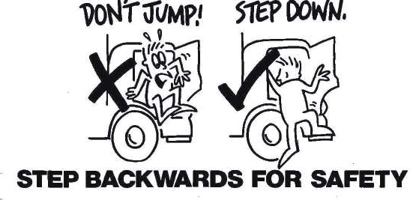



1
26


Guarding
Health and Safety Committee


Guards are designed and fitted to provide a safety barrier between an identified hazard and the equipment operator. Examples where guards are commonly used include:
- Machinery  to protect against moving parts, belts and chains.
- Locked electrical cupboards  to prevent accidental contact with electricity.
- Automatic cut out switches
– to prevent accidental operation of equipment.
- Guards or deflector chutes  to deflect
and reduce the speed of grass and debris from the blades of mowers.

All safety guards are designed to prevent injury. The removal, redesign or modification of guards, unless for the purpose of service or maintenance, is illegal.
Councils Health and Safety Committee meets bi-monthly following a meeting of health and safety representatives.

The Committees role is to:
- Facilitate consultation between Council and its employees regarding health and safety issues and proposed changes which may affect workplace health and safety.
- Provide a forum for the discussion and formulation of relevant policies and procedures.
- Make recommendations to Council regarding health and safety strategies and programs.
- Promote awareness of, and commitment to, Councils health and safety management systems amongst employees; and
- Review accident investigation and hazard reports and corrective actions to ensure adequate measures have been considered to prevent recurrences.
The committee is comprised of management and employees, with at least
half the members being employees. In addition to committee members, guest speakers, other staff and management may be asked to attend and contribute if the need arises.


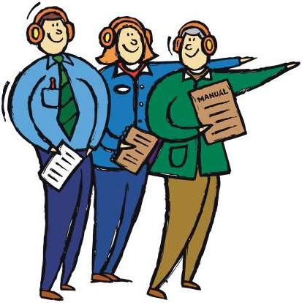

25 2


Health and Safety Representatives
Use and Care of Council Vehicles

Council operations have been grouped into agreed designated work groups:
- Springvale Office
- Dandenong Office
- Operations Centre
- Parks
- Food Services
- Library Services
- Maternal & Child Health
- Heritage Hill & Community Arts
- Planned Activity Groups (PAG)
- Economic Development Unit
- Youth Resources
- Home Care
- HL Williams Court Hostel
- Other decentralised workplaces

The elected staff and management representatives are listed on the health and safety notice boards.
Staff operating or driving council vehicles, and/or operating plant and equipment, are required by law to carry and maintain licenses for any equipment operated. Your supervisor must be notified immediately if your license

has lapsed or been cancelled
or suspended. If you have been granted a provisional license, you are required to display a P plate at all times when driving.
Council expects that all vehicles will be driven safely and maintained in a roadworthy and clean condition. A visual check should be made of any vehicle prior to driving. Simple checks can be made of light fittings, mirrors, tyre pressures and condition of windscreen cleanliness. A pre-
start assessment of mirror and seat adjustment, fuel, oil and water gauge operation and handbrake and foot brake operation will save possibly embarrassing or expensive situations later.
Pool vehicles are available for use through a centralised booking system. Your supervisor will provide relevant information. Vehicle fuel levels should be maintained to at least half tank capacity.
If you are involved in a motor vehicle accident, do not admit liability or fault; liability will be determined by Councils Risk Management
Coordinator. Emergency contact information and steps to take in the event of a motor vehicle accident are contained on a card located in the glovebox of each Council vehicle.




3 24


Permit to Work
Employee Legal Responsibilities

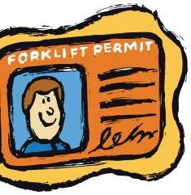
Some hazardous tasks require permits to be completed before work is started. These duties include entry into confined spaces, working from heights, hot work and electrical works requiring power isolation.
If you believe you may be required to perform this type of work, ask your supervisor to explain the
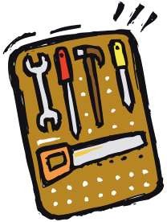
correct procedure before you start.
Housekeeping
Maintaining a clean and tidy workplace will help to reduce the risk of slips, trips, falls and other injuries. Spilt liquids, unwanted rubbish left on the floor or benches, blocked or cluttered passageways and/or exits are often the cause of accidents in the workplace.
Access to fire extinguishers, hose reels and emergency equipment must remain clear at all times.
Remember  a place for everything and everything in its place. Report any unsafe areas to your supervisor.

Occupational Health and Safety Act 2004
Section 25. Duties of Employees
- While at work, an employee must 
  - take reasonable care for his or her own health and safety and for the health and safety of anyone else who may be affected by his or her acts or omissions at the workplace; and
  - co-operate with his or her employer with respect to any action taken by the employer to comply with any requirement imposed by or under this Act.
- An employee shall not 
  - willfully or recklessly interfere with or misuse anything provided in the interests of health and safety or welfare in pursuance of any provision of this Act or the regulations; or
  - willfully place at risk the health or safety of any person at the workplace.





23 4



Issue Resolution Procedure Tips for manual handling -

Health and safety issues will be dealt with as soon as possible after they are reported. Staff, management and health and safety representatives shall work together to resolve health and safety issues as they arise.
See Issue Resolution Operational Procedure (A8166442) for further details. A copy of this procedure is contained in the OH&S systems manual and may also be viewed on the Source.

Smoke-free Workplace

The City of Greater Dandenong Council offices are smoke free. Smoking is not permitted in any council building or under any outdoor shelter or vehicle. See A5808045 for further details.
This document may be viewed on Source.
- Dont bend your back  bend your knees and make them do the lifting.


- If it looks too heavy, it probably is  ask someone to help and work as a team.
- The size or weight of the task wont hurt you, but poor technique will.
- Hand trucks, trolleys and wheelbarrows are made to make light work of heavy loads.
- Use your head to judge the task
– not your back.

5
22


Drugs and Alcohol in the Workplace
Office Safety

Employees must not present themselves for work when their judgement or work performance is impaired by the consumption of alcohol and/or drugs (including prescribed medicines).
Where an employees work performance is impaired due to alcohol or drug use/abuse, assistance will be offered through referral to Councils employee assistance program.
Employees requiring prescription medication must advise their supervisor if they believe this may adversely affect or impair their ability to perform duties safely, or in accordance with legal requirements.
The law requires that any driver of a truck with a gross vehicle mass of over 15 tonnes, or a bus with a seating capacity greater than 12 (including the driver), must have a zero blood alcohol concentration.
All council plant and equipment operators are required to maintain a zero blood alcohol concentration, as are employees working on platforms, ladders or scaffolding.
All employees must operate vehicles and equipment in a safe manner. At all times, operators must remain alert and concerned for their own wellbeing and that of others who may be affected by their actions or inactions.
See COS0025 Drugs and Alcohol in the Workplace for further details. This document may be viewed on the Source.
The office environment is commonly thought to be free from hazards and risks. However, accident statistics show that injuries often occur in offices as a result of simple rules being overlooked.

When reviewing your office environment, attention must be paid to the basics. They include:
- Efficient and effective air conditioning
- Appropriate lighting levels
- Ergonomic workstation layout
- Appropriate furniture
- Electrical, computer and telephone cable management
- Appropriate staffing levels and realistic time frames set for allocated workloads

- Tidiness and housekeeping standards maintained
- Attention to sound manual handling principles are maintained
Your supervisor should be informed of any concerns you have regarding your office environment. For details on how to set up your office furniture, adjust your chair, and position your computer, refer to A6943559 Selection & Layout of Office Furniture and Equipment Procedure which can be accessed on the Source. Ask a health and safety consultant for further assistance regarding this matter.

21
6


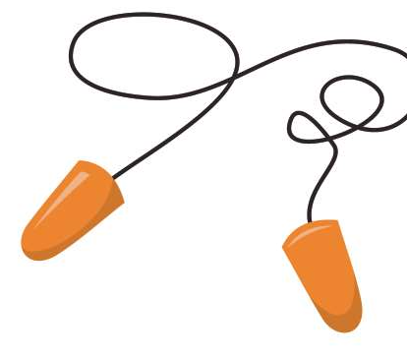

Health & Safety Management System Noise Management

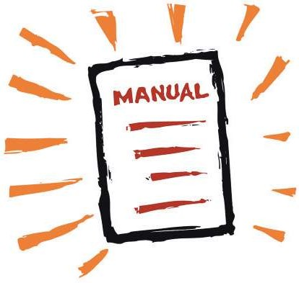
Council has developed an OH&S management system to measure and improve the health and safety of our workplace and procedures.
GDCC’s management system aims to comply with the Australian Standard AS/NZS 45001.
Your supervisor will show you the corporate OH&S
management system through the online induction process on day one.


Staff Identification and Security

Staff will be given identification tags and security access cards as required. The identification
supplied must be worn at all times for identification purposes.
Anyone found in a restricted area without identification or security authority will be referred to their supervisor.
The principle of buy quiet forms part of GDCC’s pre-purchase procedures. This requires the maximum noise levels of machinery, to potentially be bought, to be specified. This forms part of the tender process for all plant and equipment.
Adequate training and audiometric testing will be provided for all staff exposed to
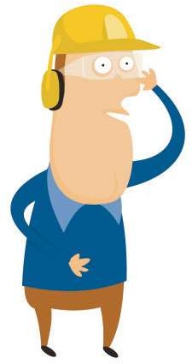
noise levels in accordance with statutory requirements.


7
20


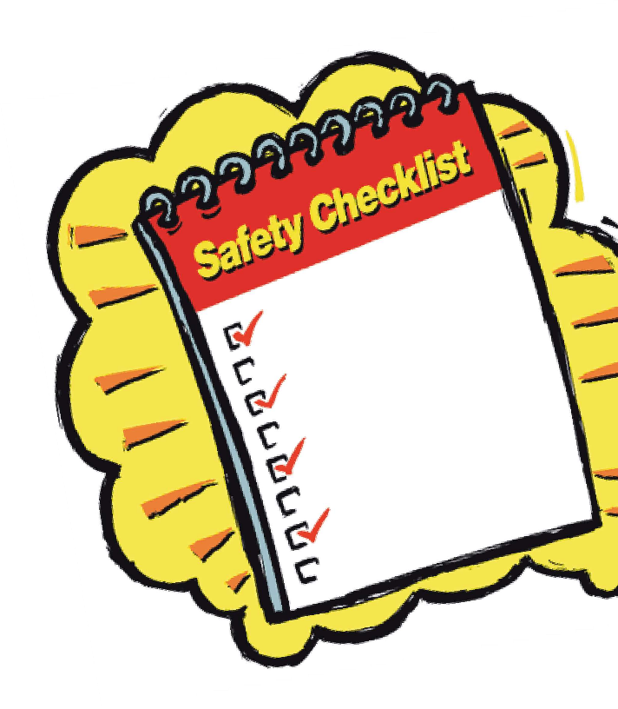

Dangerous Goods or Hazardous Substances Standard Operating Procedures

Purchasing of goods is subject to GDCC Purchasing Goods Procedure (A5808046). Items will not be purchased unless detailed information is supplied in the form of a Material Safety Data Sheet (MSDS).
Supervisors must ensure that staff receive formal training in the safe use of hazardous chemicals they may be required to use in the course of their employment. Supervisors have the responsibility to ensure that
their staff are fully aware of the potential hazards and appropriate control requirements in handling the materials. This information can be obtained from an MSDS on GDCC database InfoSafe 2000, or the departmental chemical register.
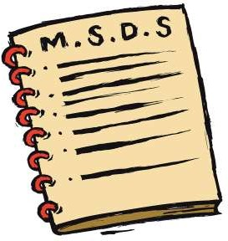
Personal protective equipment and clothing, as required by the nature of the goods or substances, (refer Material Safety Data Sheet) is available through your supervisor and must be worn in accordance with Standard Operating Procedures.
Standard operating procedures have been developed for many tasks performed by GDCC staff. These procedures
identify and explain the safest way to perform tasks. If your job is covered by a Standard Operating Procedure (SOP), Job Safety Analysis (JSA) or similar protocol, you will be trained and tested during the induction process.
Further information regarding
this process will be provided by your supervisor.
A new employee may only operate
plant and equipment under supervision until a nominated mentor is satisfied that the new
employee is proficient in the use of the equipment.

19
8

Emergency Procedures Dress for Safety

Emergency procedures have been established for the safety and protection of people and property.
Building emergency officers and/or emergency wardens will coordinate evacuation procedures at six monthly intervals.
During any emergency drill all staff are to comply with the instructions of the building emergency
officer and/or emergency warden immediately and without question.
Emergency staff will wear a helmet
and carry a torch during this procedure. Where necessary, employees will be directed to leave the building and assemble at a nominated assembly point. It is imperative that everyone remains at this point until further directions are given.
Those people who fail to act in accordance with the directions given by the building emergency officer or delegated officer will be reported to the Chief Executive Officer.
The selection of appropriate clothing for your work is essential to your health and safety.

High visibility clothing (combination day / night condition compliant) must be worn by all staff required to work on the road reserve, in the vicinity of traffic, plant and or equipment. Safety helmets may also form part of essential safety equipment.
Wearing correct protective clothing is identified and detailed by GDCC Standard Operating Procedures.
However, in all circumstances, your health and safety should dictate the type of clothing
worn. Some points for consideration are listed below:
- Ultra violet radiation causes damage to our skin, even when we cant see the sun shining.
- Correct lifting and carrying techniques cannot be adhered to if your clothing is inappropriate for a particular task being carried out.
- Appropriate footwear should be worn in areas of rough terrain or fallen debris.
- Hearing protection is recommended for those working in a noisy environment.
- Jewelry should not be worn if there is a likelihood to cause injury.
- Long hair should be tied back if there is a likelihood it can be caught in machinery or moving parts.

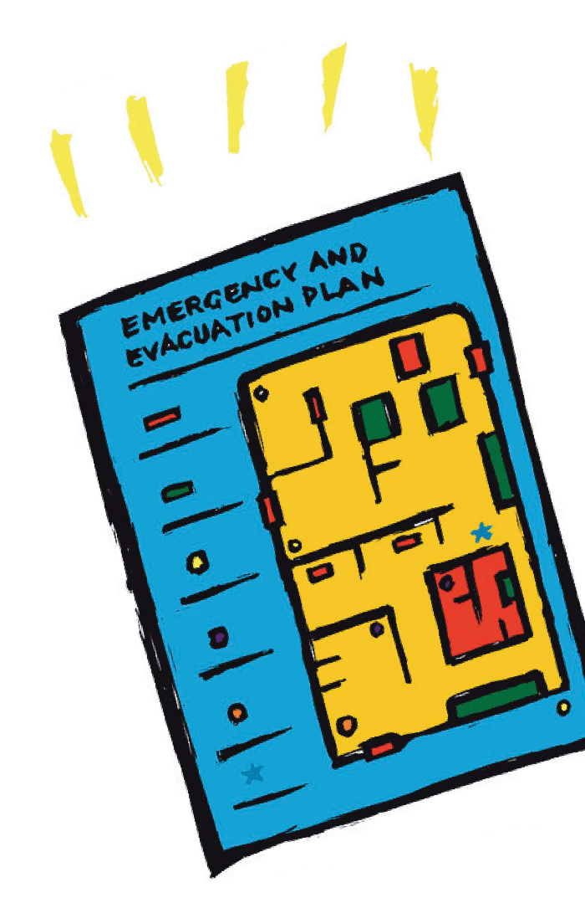



9 18


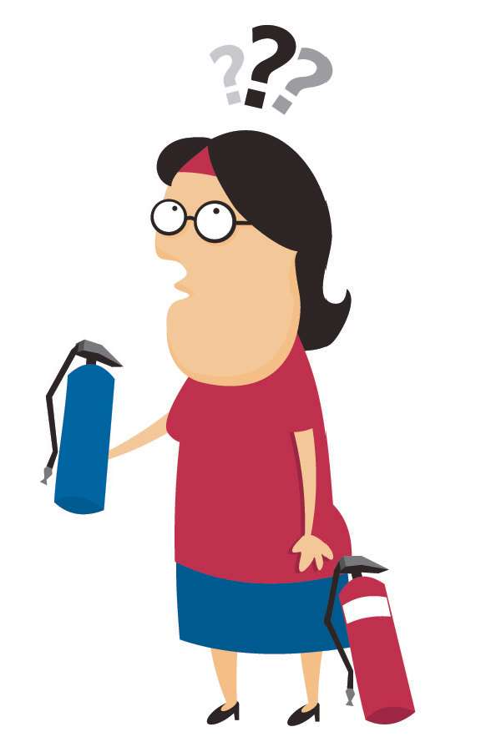

Personal Protective Equipment and Clothing Fire Prevention

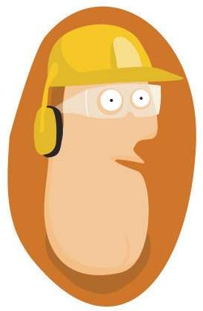

Protective equipment and clothing is provided to employees for protection against their working environment. Employees are expected to wear
the clothing as designed and must not alter the garment in any way.
Sunscreen is available to all employees required to work outdoors for all or part of their day. Employees are advised to apply this cream to unprotected areas of the skin, and
re-apply in accordance with the manufacturers recommendations.

17
Fire authorities advise us that the golden rule in fire control is prevention. While we have emergency wardens trained in evacuation procedures and
fire control, we all share the responsibility for making sure that our actions do not create an environment where fires can start, and consequently threaten our safety.

Common causes of emergencies include:
- Overloading power circuits by the overuse of adaptors and power boards
- Use of faulty power leads or equipment
- Inappropriate use and storage of flammable chemicals
- Accumulation of unnecessary quantities of paper and flammable materials
- Blocking access to emergency equipment, corridors or building exits

- Wedging doors open

If you find any of these practices in your workplace, your supervisor must be advised.

10


First Aid
Infectious Waste Collection and Disposal

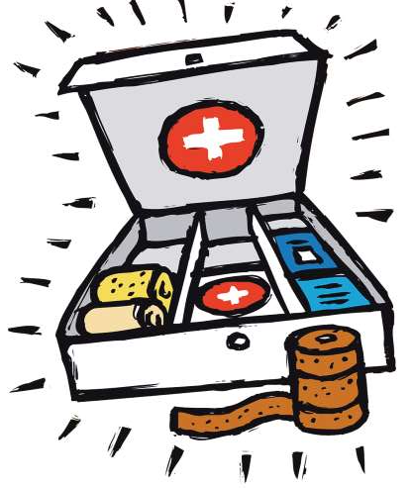
All staff have access to appropriate levels of medical and/or first
aid treatment and facilities. Details of trained first aiders and facilities are displayed on health and safety notice boards.
Staff are encouraged to undertake first aid training which is offered through Councils corporate training program.
All first aid injuries and treatments must be recorded
and reported immediately to your supervisor. An Accident / Near Miss Report must be recorded by the
injured person in Elumina (GDCC’s incident & injury reporting system) which can be accessed on the Source.
All staff are advised that the handling of discarded syringes and potentially infectious waste should not be undertaken unless appropriate training has been completed.
Untrained staff should report any discarded waste they find to their supervisor as soon as possible.

In the event of a needle stick injury staff should follow these procedures:
    - Dont panic  remember, your risk of infection is remote.
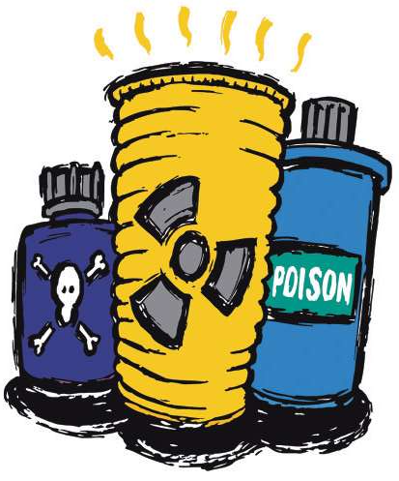
    - Wash the affected area with soap and water as soon as possible or use alcohol swabs.
    - Apply antiseptic and a band aid.
    - Report the injury immediately after the above steps have been completed.
    - Contact the local doctor or hospital emergency department as soon as possible who will advise you on the need for HIV testing and counselling and explain the possible risk of Hepatitis or Tetanus infection.

11
16


Infectious Diseases
Hazard Identification and Reporting

Infectious diseases may include Human Immunodeficiency Virus (HIV), Acquired Immune Deficiency Syndrome (AIDS), Hepatitis A, B, C and D. The importance of personal hygiene, protective clothing and equipment and safe disposal of infectious waste cannot be overstated. Thorough washing is an effective means of reducing the transmission of disease. The sharing of personal items such as toothbrushes, razors, towels and linen should be avoided.
The use of disposable latex gloves is mandatory when providing assistance with personal care and/or cleaning involving bodily fluids and waste products.

Resuscitation masks should be used whenever resuscitation is performed.
Council will provide generalised training and education to all employees and specific training for employees and volunteers placed at
higher risk by the nature of their duties. Council encourages all
at risk employees to participate in its immunisation program.
  - Do not attempt to remove or control a hazard if you are not sure you can do so safely.
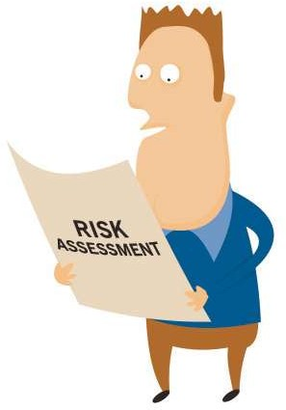
  - If you find a hazard you cannot control, you have the responsibility of reporting it to your supervisor immediately.
  - Hazards posing a serious and immediate threat to your health or safety must be acted on immediately. This may mean stopping others from coming into the area and calling for assistance from others.
  - Minor hazards identified should be reported to
your supervisor and recorded in Elumina which can
be accessed on the Source.

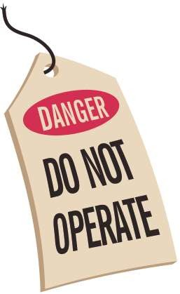

15
12


Accident/Incident Reporting
Rehabilitation & Return to Work

All accidents, incidents or near misses, whether an injury is sustained or not, must be reported to your immediate supervisor and recorded in Elumina (GDCC’s incident & injury reporting system) which can be accessed on the Source.
Where compensation is claimed, an employee should:
Complete all sections of the WorkCover Claim for Compensation form (available from the Injury Management Team).

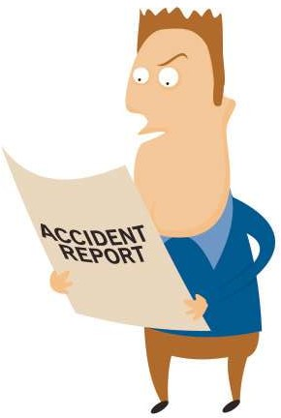
Only the employee or his or her representative is to complete this form.
  - Supply all relevant accounts, receipts and a WorkCover Certificate to the supervisor.
  - Ensure any subsequent
certificates, accounts and other relevant documents, are given to the appropriate supervisor as soon as possible.
  - During the workers recovery he/ she should maintain regular contact with the supervisor, Injury Management and Return to Work Coordinator and/or OH&S consultant.
  - Participate in a return to work rehabilitation program (if applicable).
  - GDCC recognises and accepts its obligations under the Accident Compensation Act 1985 to assist in the rehabilitation and return to work of employees who are injured or become ill as a result of their employment.

  - A rehabilitation program should commence as soon as possible after injury. A return to work plan shall be established for staff unable to work for a period of 20 or more calendar days or more as a result of a work-related injury or illness.
  - All return to work plans must be completed within ten calendar days of the claim reaching 20 days or sooner if circumstances warrant.
  - All staff are expected to cooperate and assist in the implementation of any return to work or rehabilitation program.
  - An employees entitlement under the Accident Compensation Act 1985 may be affected if he/she fails
to actively participate in the rehabilitation program or return to work plan.
  - For full details, see the GDCC Injury Management Occupational Rehabilitation Return to Work Procedure (Document A7911336).

