

Risk Management Procedures

October 2022

Document History

Version No. | Date | Description of Revision
1.0 | Month, Year | Development of risk management procedure by (insert name & title of person who developed procedure), Greater Dandenong City Council)
2.0 | 2 December 2015 | Review of Risk Management Procedure by external consultants, D Daniel, Divisional Manager – Risk, Echelon Australia.
3.0 | 26th February 2015 | Review by Team Leader Risk Management and OHS
4.0 | 17th October 2017 | New risk matrix and risk assessment tool approved by D Daniel, divisional Manager Echelon
5.0 | August 2022 (this DRAFT update) | Various, including improved consistency with ISO 31000:2018 Risk Management, addition of new Risk Appetite Statement, edits to reflect changes to organisational structure and roles, and for consistency (and reduced overlap) with updated policy and framework documents.
5.1 | October 2022 | Incorporating A&RC meeting (august 2022) feedback and (some of) its suggestions

TABLE OF CONTENTS

Table of Contents
1. INTRODUCTION 5
1.1 Enterprise Risk Management 5
1.2 Purpose 5
1.3 Risk Terms and Definitions 6
1.4 Risk Management Objectives 7
1.5 Risk Framework 7
1.6 The benefits of Risk Management 9
2. RISK MANAGEMENT PROCESS 10
2.1 Establishing the Context 10
2.1.1 Defining our Internal Environment 10
2.1.2 Defining our External Environment - Strategic Risks 11
2.1.3 Operational Risks 11
2.1.4 Project or Event Based Risks 12
2.1.5 Compliance Risks 12
2.2 Identify Risks 12
2.3 Analyse & Evaluate Risks 14
RISK MATRIX (including Consequence and Likelihood Tables) 17
2.4 Analyse & Evaluate Risks (continued..) 19
2.5 Treat Risks 19
2.6 Monitor and Review 21
2.5.1 Risk Monitoring 21
2.5.2 Risk Reporting 21
2.5.3 Risk Register 22
2.5.4 Risk Tools 22
2.5.5 Risk Assurance Program 24
3. ROLES AND RESPONSIBILITIES 25
3.1 COUNCIL 25
3.2 Executive Management Team (EMT) 25
3.3 Managers 25
3.4 Audit & Risk Committee 26
3.5 Internal Auditor 26
3.6 Staff Roles and Risk Management Responsibilities 27
3.7 Risk Management Team 27
3.8 All Staff - additional responsibilities 28
4. LINKS TO COUNCIL PLANNING AND BUDGET 28
5. APPENDICES 30

INTRODUCTION

Enterprise Risk Management

Organisational risk management (or enterprise risk management) is a structured, proactive approach to understanding and managing risk. A key focus is to align strategy, processes, people, technology and knowledge with a means to evaluate and manage the uncertainties and opportunities faced by organisations.

The latter process is encapsulated in “risk management” - the activities coordinated to direct and control an organisation regarding risk, to create and protect value.

Context:

Local Government is a complex, multi-sector enterprise. It creates a need for an effective risk management capability, due to several factors:
- Councils are community-focused, with an embedded consultative approach.
- a multiplicity of stakeholders,
- a large and diverse workforce and community, whom may be injured through Council’s activities, decisions and/or assets and infrastructure
- increasing expectations for effective and efficient management of all assets and responsibilities
- a constantly-changing environment, both internally and externally, and a need to enact improvements to best use limited resources.

A structured and robust understanding and management of risk is therefore critical to the organisation’s successful operation. Effectively managing risk enables Council officers to improve outcomes by identifying risks and providing a systematic way to make informed organisational decisions.

Risk Management at Greater Dandenong City Council is therefore the responsibility of everyone at Council. It is not a stand-alone discipline but requires integration with existing business processes to provide the greatest benefits.

This Risk Management Procedure is part of the Greater Dandenong City Council’s commitment and approach to risk management and provides a practical reference source to support our risk management activities. It is an important tool to assist in making decisions in a strategic, operational and project context.

Purpose

The purpose of this risk management procedure is to formalise and communicate Council’s approach to risk management, and to ensure that risk assessments are conducted in a consistent manner and have regard to the stated Risk Appetite.

This includes providing the process of how to identify, assess, manage, monitor and report on key risks which may impact the achievement of CGD’s objectives.

This procedure is also designed for application across all of Council’s business activities and services, so that informed risk assessments and risk management processes can be undertaken to minimize negative outcomes and capitalise on opportunities.

Risk Terms and Definitions

A common understanding of the terms relating to risk management is a starting point for achieving a common approach to managing risk across Greater Dandenong City Council. This procedure and the definitions below are consistent with the International Standard for Risk Management (ISO 31000:2018).

Terms associated with “risk”

Risk is defined as the effect of uncertainty on objectives. Risk is often expressed in terms of combination of the consequences of an event (including changes in circumstances) and the associated likelihood of occurrence.

Risk Appetite - is the level of risk that an organisation is prepared to accept in pursuit of its objectives before action is deemed necessary to reduce the risk. It represents a balance between the potential benefits of innovation and the threats that change inevitably brings

Risk Management - is defined as the coordinated activities to direct and control an organisation with regards to risk

Risk Management Framework - an overview of the various elements that comprise Council’s risk management system, providing the foundations and organisational arrangements for the design, implementation, monitoring, review and continuous improvement of risk management throughout the organisation.

Risk Source - an element which alone or in combination has the potential to give rise to risk

Risk Treatment - an action, procedure, physical device or other measure taken to reduce the likelihood and/or the consequences of an identified event (see also Control)

Other Terms

Audit - is an independent, objective assurance and/or consulting activity designed to add value and improve an organisation’s operations. Audit helps an organisation accomplish its objectives by bringing a systematic, disciplined approach to evaluate and improve the effectiveness of risk management, control and governance processes.

Consequence - outcome of an event, affecting objectives

Control - a measure that maintains and/or modifies risk; controls can include, but are not limited to, any process, policy, device, practice, or other conditions and/or actions which maintain and/or modify risk Controls may not always exert the intended or assumed modifying effect.

Event is an occurrence or a particular set of circumstances. It can have one or more occurrences. An event can have several consequences. An event can be an unexpected outcome, or an expected outcome that does not occur. An event can be a source of risk.

Likelihood - the chance of an event happening; can be expressed relatively or probabilistically

Objectives - can have different aspects, (such as financial, health and safety, technology and environmental goals) and can apply at different levels (such as organisation-wide, operational-, project-, product- and process-level)

Stakeholder (or “interested party”) - a person, or group of people, or organisation that can affect, be affected by, or have the perception that they are affected or can affect a decision or activity

Risk Management Objectives

Risk is not just about downside or adverse events; it is also about missing out on the upside or added value that opportunities bring.

We must recognise opportunities in time and capitalise on them. High risk, high reward is often a phrase utilised and highlights the opportunities aspect of risk.

The key objectives of Council’s risk management program are to:

  - Protect our stakeholders and employees from loss or harm due to adverse risk events
  - Provide a systematic approach to the early identification and management of risks and provide consistent risk assessment criteria, that supports the goals of the Council Plan and Annual Plans
  - Help decision makers make informed choices, prioritise actions and distinguish among alternative courses of action using accurate and current risk information
  - Adopt a risk management framework and strategies that are cost-effective and efficient in reducing risk to an acceptable level
  - Monitor and review risk levels to ensure that risk exposure remains within an acceptable level, and promotes and supports a “risk-aware” culture
  - Encourages the exploration of opportunities within Council’s risk appetite.

Risk Framework

To achieve our risk management objectives, the Greater Dandenong City Council has adopted a risk management framework as depicted here. (Diagram 1).

The framework is based on the concepts and principles identified in AS/NZS/ISO 31000:2009 and ISO 31000:2018. It is supported by CGD’s Risk Management Policy, Framework and Strategy.

Diagram 1 - overview of the Risk Management Framework.

Diagram 2, below, illustrates how this Risk Management procedure links with other key Council risk management documents and activities, including the Council Plan and Risk Management Strategy (four year rolling plan). The Risk Management Framework also explains and discusses these elements



Implementation:

As summarised in in the Risk Management Policy, various officers and levels in the organisation have responsibilities and authorities with respect to the implementation of the Risk Management Framework, and its implementation. These are also summarised in Diagram 3, below.
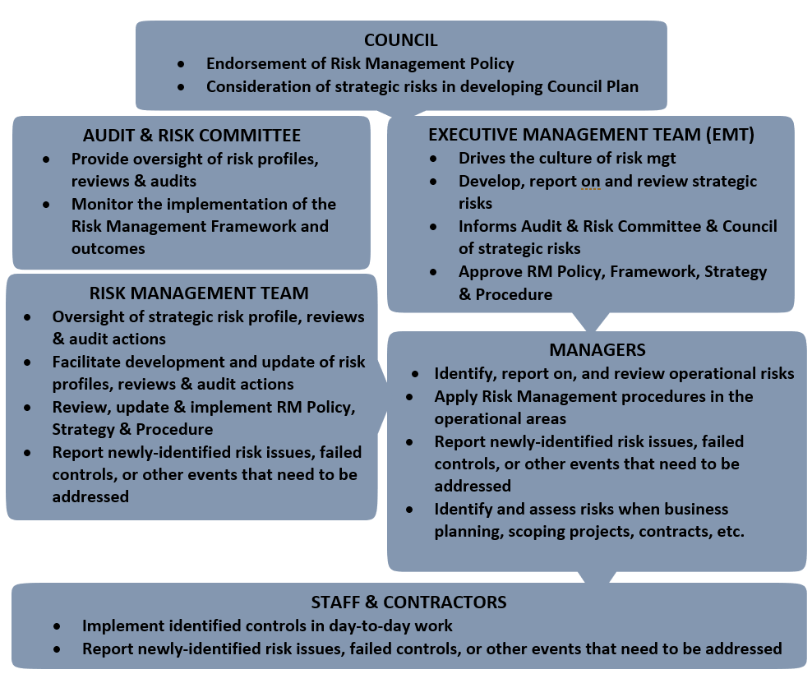
Diagram 3 - Responsibilities and delegations for the implementation of the Risk Management Framework.

The benefits of Risk Management

Applying effective risk management supports Council to maintain our values and deliver our objectives.
The application of a consistent and comprehensive risk management process will:
  - Increase the likelihood of achieving our strategic and business objectives
  - Encourage a high standard of accountability at all levels of the organisation
  - Support more effective decision making through better understanding of risk exposures.
  - Create an environment that enables us to deliver proficient and timely services and meet performance objectives in an efficient and cost-effective manner.
  - Assist in identifying opportunities for innovation, efficiency and improvements to better serve our community.

RISK MANAGEMENT PROCESS

Risk Management is an ongoing and iterative process. It involves the systematic application of management policies, procedures and practices in the elements of communicating, consulting, establishing context, and identifying, analysing, evaluating, treating, monitoring and reviewing risk (as per ISO 31000:2018).

The key steps outlined in the risk management process adopted by Council are depicted in Diagram 4, and described further in this section. It should apply to all Greater Dandenong City Council’s key decision-making processes.
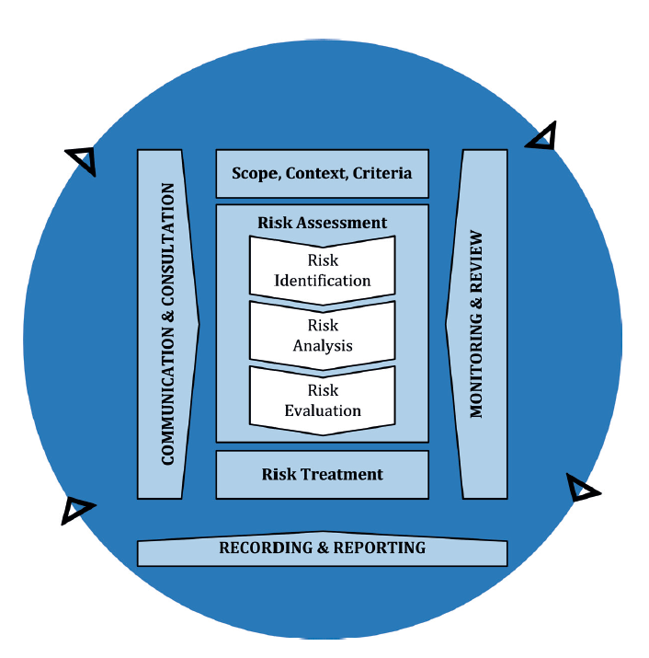

Diagram 4 – Risk Management Process (from ISO 31000:2018)

Establishing the Context

Risk management does not occur in a vacuum. It is applied in the context of CGD’s wider environment - the internal and external factors that determine Council’s role, goals and objectives, responsibilities, resources and capabilities, etc.

The objective of this step in CGD’s risk management process is therefore to establish an understanding of the business environment in which the risks will be identified and assessed. As defined, risks are the events or actions that will influence the achievement of business objectives, it is essential that these objectives are clear before the risk identification process commences.

Defining our Internal Environment

To understand the internal environment, we need to consider the organisational structure, core processes, resources available, resource capacity and their relationships and interdependencies.

As Council manages activities that are community based, risks also need to be addressed with potential non-economic outcomes. Internal factors which may affect Council’s management of risk include strategic plans, policies, organisational processes and procedures, systems and technology, the management of corporate records and availability of information and evidence, budget allocations, staff culture and internal relationships.

These internal and external factors will affect the organisation’s risk appetite; that is, the level of risk the organisation is willing to retain or pursue, and the setting of the risk criteria and policy. Understanding risk appetite helps to determine the level of risk.

Defining our External Environment - Strategic Risks

External factors include community expectations, state and federal policy and legislation, and environmental factors that influence the capacity of the organisation to meet its strategic objectives which are outlined in the Council plan. Good examples are prevailing economic conditions, Sate or Federal budget priorities, or significant societal changes or events.

The key strategic risks for Council are those that:
- Are significant risks that affect the longer-term interests of Council and the community
- Have an impact on the organisation at a higher level, possibly affecting the future service delivery
- May have a municipality-wide focus or impact.

A failure to address strategic risks can result in financial losses or penalties, and a loss of reputation and possibly major political impact. Such risks often align with higher-level corporate strategies (e.g., Council Plan), emerging risks in the local (and/or State) government sector or the broader community.

Operational Risks

Operational risks arise directly from activities undertaken by Council on a day-to-day basis and include but are not limited to the following:
- Community engagement
- Corporate governance
- Employee education, training and competencies
- Managing and maintaining physical assets
- Managing community services
- Managing human resources
- Information management and technology
- Contracting and procurement practices
- Financial management and accountability
- Contingency and emergency management planning.

Note that, due to many of these functions being widespread across the organisation, or critical to achieving Council or Annual Plan goals, they may also be Strategic Risks.

Project or Event Based Risks

Most business units undertake a project or coordinate an event, at some stage of their service delivery. It is important to apply risk management processes for these projects or events in the same manner that we do operationally.

Risks can be identified according to the project goals and objectives, an asset’s life cycle, key milestones or funding injection stages, or the various elements of event planning and execution.

Compliance Risks

Such risks that relate to meeting the requirements of relevant legislation and regulations. Council is subject to a significant range of State and Commonwealth legislation and regulations, ranging from the Occupational Health and Safety Act 2004, the Equal Opportunity Act 2010, the Privacy and Data Protection Act 2014, the Local Government Act 2020 to specific technical requirements in Planning, construction, waste management, etc.

Other examples include, but are not limited to, the following:
- Emergency Management Act 2013
- Accident Compensation Act 1985
- Road Management Act 2004
- Disability Act 2006
- Building Act 1993
- Fair Work Act 2010
- Migration Act 1958 (e.g., in matters of employment)

Identify Risks

Identifying risks is the first step in the risk assessment process.

This step identifies the risks arising from an identified matter, which may need to be managed. Comprehensive identification using a well-structured, systematic process is important, because a potential event not identified at this stage is excluded from further analysis.

In identifying risk, this process illustrates what Council officers should consider potential sources of external and internal risks (Diagram 5, below.)

These can then be allocated to key risk categories (see Table 1) to facilitate reporting of risk categories across Council.

Diagram 5 - Potential Sources of Risk

Council has identified the following key risk categories.

No | Category | Sub-category
1 | Reputation | Professionalism, Customer Satisfaction, Perceptions of Safety, Public Complaints, Fraud Corruption/Criminality, Internal Investigations, Whistle-blower, Public Interest Disclosures and related matters
2 | Regulatory Compliance | Regulatory Control over services, Internal and External Audit, Complaints and investigations
3 | Financial impact | Budget allocation (including recurrent), accounts payable, contingent liability, fixed assets, capital programs, inventory, payroll, procurement, trust accounts, interest rates, rate capping, economic factors.
4 | Assets, Security and Infrastructure | Physical assets, security of assets and infrastructure. Condition of infrastructure. Strategic asset management
5 | People, Safety (including public safety) | HR Management, Education/Training, Equity and Diversity, Industrial Relations, HR Management, Education and Training Equity and Diversity, Industrial Relations, Conflict Resolution, Leave Management, Occupational Health and Safety, Organisational Wellbeing, Recruitment, Retention, Transfer and Promotion, Performance management, discipline, delegations, relationships/teams, public health events  Fire prevention, fire suppression, Fire Investigation, Community capacity, wildfire management.
6 | Environment | Pollution, Carbon Trading, Land Management, and water availability, Impact of Operations on the Environment
7 | Business Continuity/ Interruption | Business continuity, contract management including (tendering), outsourcing, project management, intellectual property, sponsorship, internal controls, technical, public health events.
Table 1- Key risk categories

Risks associated with new services or projects, or changes from our routine operations, require risk categories specific to the project.

Generally, projects have more risk with greater likelihoods of adverse outcomes; therefore, there is an increased reliance on good risk identification and analysis at a project level.

Analyse & Evaluate Risks

The second step of the risk assessment process involves analysing and evaluating the identified risks. The objective is to differentiate minor, acceptable risks from the risks that may require further, active management.

Risk analysis and evaluation includes the following steps:
- Determine the assessed risk rating for all identified risks.
- Assessed risk
The assessed risk considers the potential consequence of the risk and the likelihood of the risk, given any identified existing controls to manage or mitigate a particular risk, and after assessing the effectiveness of those controls.
The assessed risk determines the risk profile of Greater Dandenong City Council after considering the strategies, policies, processes and procedures implemented to manage its business.
The assessed risk determines whether the risk will be accepted (i.e., falls within Greater Dandenong City Council’s risk appetite) or whether further action is required.

- Consequence and likelihood
As defined above, consequence is the outcome of an event, affecting objectives, and likelihood is the chance of an event happening.
Qualitative criteria have been developed by CGD to assist in the evaluation of the potential consequence and likelihood of identified risks and to ensure consistency in rating of the risks across Council. The consequence and likelihood tables are provided on page 18 (below).
Consequence Table
Identified risks matters may lead to multiple consequences, across categories (e.g., possible Financial and Political consequences). Therefore, there may be different assessments of the impact of each consequence (i.e., low for the former, moderate for the latter.).
The consequence rating of highest impact should be used for the final risk rating calculation (see below).
The consequence table will be reviewed with this procedure (or more periodically, as required) by the Risk Management Team, and approved by Executive/Senior Management Team.
Financial amounts in the table are not absolute. Departmental- or Directorate-level risks may be assessed, for example, with reference to a possible financial loss as a budget percentage (project budget, area’s budget, activity budget, etc).
Likelihood Table
The likelihood table is a guide to assist with determining how likely a risk event may occur. That is, how likely is it that the business will be exposed to this specific risk, considering such factors as the:
- anticipated frequency of the event
- specific external environment for the event
- existing procedures, tools, or skills that relate to manging such an event
- commitment, morale, attitude of staff involved with or exposed to such an even
- the history of any similar past events (both directly experienced by CGD, by other Councils, public entities or other parties).

- Effectiveness of mitigating controls
In determining a risk rating, an assessment of the effectiveness of existing the controls (physical, administrative, etc) in managing the risk event, should be made, based on the following matrix.

Control Effectiveness Rating
Control Effectiveness Rating | Effective: | Nothing more to do done except review and monitor existing controls.  Controls are well designed for the risk, address the root causes and Management believes that they are effective and reliable at all times. | 100%
Control Effectiveness Rating | Adequate: | Most controls are designed correctly and are in place and effective.  Additional work is required to improve the operating effectiveness or Management has doubts about operational effectiveness and reliability | 75%
Control Effectiveness Rating | Improvement Required: | While the design of the controls may be largely correct in that they treat most of the root causes of the risk, they are not currently operational or reliable.  and/or  Some of the controls have design flaws in that they do not treat the root cause of the risk and therefore may be ineffective or unreliable | 50%
Control Effectiveness Rating | Weak: | Virtually no credible controls.  Management has no confidence that any degree of control is being achieved due to:  - poor control design and/or  - very limited operational effectiveness | 25%

- Risk rating evaluation
The risk rating is calculated from combining the consequence and likelihood ratings.

The resulting rating (Extreme, High, etc.) is used to evaluate and prioritise risks, leading to a risk profile for Greater Dandenong City Council or individual departments.

The risk matrix is applied during the risk evaluation step. The risk matrix including is provided on page 18 (below).

RISK MATRIX (including Consequence and Likelihood Tables)
 |  | CONSEQUENCE
 |  | Insignificant  1 | Minor  2 | Moderate  3 | Major  4 | Catastrophic  5
LIKELIHOOD | Almost Certain  5 | M | H | E | E | E
LIKELIHOOD | Likely  4 | M | H | H | E | E
LIKELIHOOD | Possible  3 | L | M | M | H | E
LIKELIHOOD | Unlikely  2 | L | L | M | M | H
LIKELIHOOD | Rare  1 | L | L | L | M | H

Extreme | Critical risk  Immediate action required.  Requires timely reporting and oversight by Executive Management Team and Senior Management | Moderate | Medium risk  Management responsibility must be specified.  Managed within Department (or Directorate, for Strategic Risk)
High | Significant risk  Senior management attention needed.  Managed within Directorate. | Low | Low risk  Manage by routine procedures.

Consequence
Severity | Insignificant | Minor | Moderate | Major | Catastrophic
Reputation à | Letters to suppliers, clients or local/state press | Series of articles in local/state press | Extended negative local / state media coverage | Short term negative nation-wide media coverage | Extended negative nation -wide media coverage
Regulatory Compliance à | Minor breaches by individual staff members | No fine – no disruption to service delivery.  Formal discussion & correspondence requiring formal response | Minor or single regulatory breach.  Fine but no disruption to service delivery | Regulatory breach.  Fine and short-term disruption to service delivery | Significant or several regulatory breaches resulting in legal action or ministerial inquiry.  Significant disruption to service delivery over an extended period
Financial Impact à | Less than $25,000 (Department)  Less than $50,000 (Directorate) | Between $25K and $50K (Department)  Between $50k and $150K- (Directorate) | Between $50K and $150K (Department)  Between $150K and $400K | Between $150K and $400K (Department)  Between $400K and $1m (Directorate) | Greater than $400K (Department)  Greater than $1m (Directorate)
Assets, Security & Infrastructure à | Infrastructure or asset is subject fails causing minor delays and is subject to routine maintenance | Failure of infrastructure and asset creates slight inconvenience to users | Part of infrastructure creates a danger to employees or public in immediate vicinity. | Partial destruction/collapse and denial of access to asset or infrastructure | Complete destruction/collapse and denial of access to asset or infrastructure
People, Safety (incl. public safety) & Environment à | Injuries or ailment not requiring medical treatment i.e., First Aid  Minor environmental impact.  Contamination – on-site release contained within short time frame. | Medical treatment Injury.  (MTI)  Transient environmental impact with minimal cost  To restore. | Injury causing hospitalisation and or Lost time Injury (LTI).  Transient environmental impact requiring clean-up work.  Contamination – on-site release contained with outside assistance | Serious or life-threatening injury or multiple serious injuries causing hospitalisation.  Significant harm requiring restorative work.  Contamination – off-site release with no detrimental effects. | Single or multiple deaths.  Long term harm with  major irreversible damage.  Toxic release off-site with detrimental effect or loss of ecosystem functions across species and landscapes.
Business Continuity à | Brief loss of service. Minor errors in systems or processes requiring corrective action, or minor delay without impact. | Localised loss of service for up to one day. Inconvenient, but does not impact service delivery. | Critical service loss for more than one week. Key accountability requirements not met. Services do not fully meet needs. | Critical service loss for up to one month. | Critical system failure. Business severely affected with interruption exceeding 1 month in duration.

LIKELIHOOD
Almost Certain
Has a 90% chance of occurring each year (or occurs annually or more frequently)
Likely
Has a 50% chance of occurring each year (or occurs once every 2 years)
Possible
About a 25% chance of occurring each year (or occurs once every 4 years)
Unlikely
About a 10% chance of occurring each year (or occurs once every 10 years)
RARE
May occur in exceptional circumstances

Analyse & Evaluate Risks (continued..)

- Assess risks against Risk Appetite
Council’s Risk Appetite Statement establishes the context of which risks and to what level of risk we accept or must act to address.
A risk rating arrived at by following the steps in 2.3 should be compared with the relevant category in the Risk Appetite (Appendix C). Risks with a rating outside this tolerance must have treatments identified to reduce the risk.
- Determine a target risk rating for assessed risks.
The target risk rating assists in defining the risk profile within which Greater Dandenong City Council or individual departments plan to operate.
Target risk is calculated by reference to the assessed risk and provides a projected risk rating based on the anticipated impact of any further mitigating strategies, once these have been fully implemented.
Risk reporting can include an assessment of the progress made in implementing mitigation strategies such further controls, and whether these result in achieving the target risk rating.

Treat Risks

The next step, following the risk assessment, involves treating the risks or identifying risk treatment strategies.

Strategic Risks assessed as High or Extreme (or Operational risks assessed as Extreme) are reported to the Executive Management Team and Audit & Risk Committee.

Departmental (operational) risks assessed as Assessed risks rated as High or Extreme are reported to the attention of the Department’s Manager with recommended actions to monitor and manage the risk.

Assessed risks rated as Moderate or Low will be generally managed through defined routine procedures, with oversight provided by an officer of appropriate seniority in the line of reporting.

Council’s risk treatment options are outlined in Table 2 and the process defining risk treatment strategies is set out in Diagram 6.

Table 2: Risk Treatment Options

Rating | Definition | Indicators
1 | Avoid | Decide not to proceed with the policy, program or activity or choose an alternate means of action
2 | Sustain- Monitor | Where risk cannot be avoided, reduced or transferred, may choose to accept the risk. In such cases usually the likelihood and consequences are low. Risks should be monitored and determine how losses, if they occur, will be funded
3 | Treat the risk | Decide to invest in controls aimed at reducing the likelihood and minimising the consequences
4 | Transfer / Share | Share the responsibility with another party such as an Insurer/Contractor who shares the loss if the risk event were to occur
5 | Increase | Decide to increase the risk based on assumptions of new project control

Diagram 6 – Risk Treatment Strategies (from AS/NSZ ISO 31000:2009)

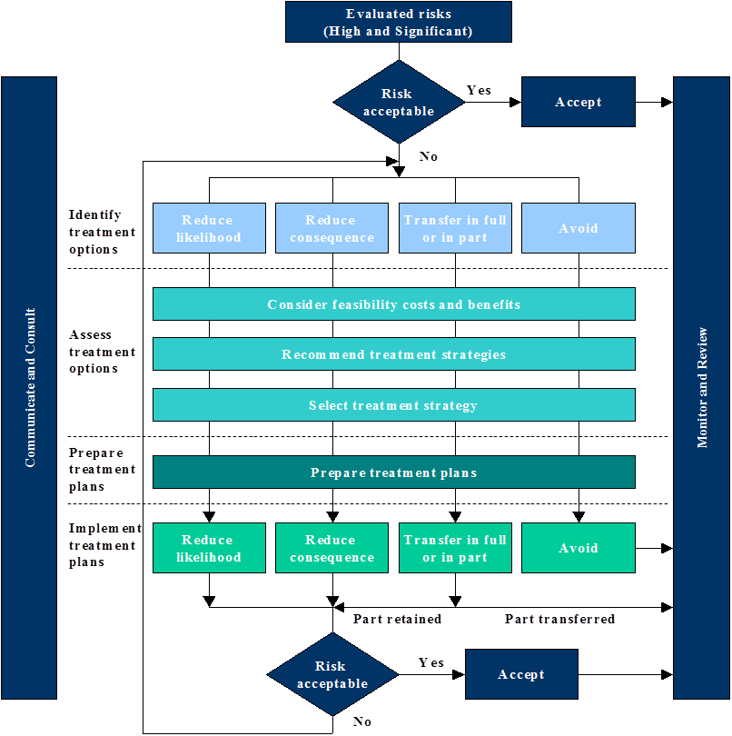

Monitor and Review

Risk Monitoring

Re-current and ongoing review is an essential part of ensuring that identified risk treatments are effective. This also allows emerging risks and opportunities to be incorporated into the risk profile, arising from any changes in the external and/or internal environments.

Additionally, regular monitoring helps to:
- provide assurance that risks are being managed as expected
- assess whether the risk treatment strategy remains relevant
- ensure that CGD’s risk profile anticipates and reflects changed circumstances and new exposures
- identify any lessons from applying the risk management process, or by reviewing events, effective (or non-effective) solutions, and identifying any unanticipated consequences (or unintended outcomes from the implementation of risk treatments).

Factors that affect the consequence and/or likelihood of a risk may change over time, as may any factor affecting the suitability or cost of identified (or unchosen) treatment options. It is therefore necessary to regularly review and repeat the risk assessment cycle.

Risk management performance will be monitored through the following:
- Day-to-day operational risks - departments will monitor day-to-day operational risks on an ongoing basis.
- Strategic Risks against risks to Business Plan objectives - the strategic risk register, and significant departmental risks will be reported to EMT and the Audit & Risk Committee, following annual review. Additionally, the Internal Audit programme is based on Council’s risk profile, and internal audit reports are a standing agenda item for Audit & Risk Committee meetings.
- Risk Appetite – Council’s Risk Appetite Statement will be reviewed as part of the regular review and update of the Risk Management framework and its components. EMT and the Audit & Risk Committee will review and approve any changes.
- Risk treatment strategies - Risk systems, controls and treatments will be reviewed by the risk owners, to assess the effectiveness in reducing risk within acceptable levels. Where these are ineffective, appropriate changes should be identified and made.

Monitoring will be performed by Management in conjunction with the Risk Management team.

Risk Reporting

The following risk categories will be reviewed on the following basis, in conjunction with the Risk Management Team:
- Strategic risk profile - annual review and update (EMT, Senior Management, Audit & Risk Committee)
- Departmental risk profiles - biennial review and update (EMT, Senior Management)
- Major Projects risk profiles - As required during the project (Project officers, with relevant matters reported to EMT/Senior Management as necessary).

Significant risks, issues arising from risk treatments, or control breakdowns identified through day-to-day operations should be escalated to a department’s Manager, Director or EMT (as appropriate), and the Risk Management Team advised. Such situations may be reported to the Audit & Risk Committee. If identified through Internal or other audit or investigation, the Audit & Risk Committee is notified as a matter of course.

Risk Register

Council records risks identified across several categories in its risk management database, Pulse (provided by LGSS), with a range of system reports are available or specialised reports can be developed. At the time of this update of the Risk Management Procedures, these categories are:
- Strategic Risks
- Operational Risks (by Directorate and Department)
- Fraud Risks
- Child Safe Risks
- OHS Risks
- Environmental Risk Register
- Public Outdoor Events and Mass Gatherings
- Project Risks

Reports prepared for the Audit & Risk Committee have been revised throughout 2021-2022, and a final format is still being developed, in collaboration with the Committee.

The Pulse Risk Management module has been designed by the vendor, LGSS, to satisfy the risk assessment steps outlined in ISO 31000:2018 Risk Management, and above.

Risk Tools

Greater Dandenong City Council’s processes for managing risk relies on several mechanisms:
    - the Risk Assessment steps and reference tables, above
    - the Risk Assessment template (Appendices A and B)
    - the Pulse Risk Management Module, as discussed
    - Business Continuity and Emergency Management Planning, including the ITC Disaster Recovery Plan (and associated sub-plans, documentation, contingency arrangements, and emergency management procedures, etc) - CGD’s anticipation and responses to and recovery from a disaster, significant business interruption, or a disruptive emergency or other circumstances o
    - Occupational Health and Safety Strategy - Council has developed and implemented an OHS and injury management system
    - Compliance - Advent software is used to record audit findings and recommendations, and to track officers’ responses to such
    - Financial management systems and processes – including strategic budgeting, capital works and asset management planning, financial auditing and assurance systems and activities
    - An environmental sustainability strategy and commitment to minimising Council’s carbon emissions and the impact of climate change on the organisation and the municipality

Risk Assurance Program

Assurance | Undertaken by | Focus Overview | Reports to
External Audit | Auditor General | Focus: Reports on the organisation’s performance and position in accordance with the standing directions for the Minister of Finance under the Financial Management Act 1994 on annual basis together with any relevant audits identified by the Victorian Auditor General | Parliament
Internal Audit |  | Focus: Independent monitoring of CGD’s performance  Application of internal and external policies in the management of its business risks.  The Internal program is developed on annual basis and its structure is determined by the outcomes of CGD’s Corporate Risk Profile.  The Internal Audit Program also assists Council to monitor its compliance with its obligations to the Victorian Auditor General’s Office in accordance with the “Standing Directions of the Minister for Finance under the Financial Management Act 1994. | Audit & Risk  Committee
Management Audit | CGD-appointed internal auditor (external party, currently Crowe | Focus: An internal process undertaken to monitor compliance with corporate policies, standards and procedures and legislation as well as probity checks undertaken through internal projects, and health checks undertaken by Managers, where deemed appropriate | Audit & Risk  Committee
Mandatory Compliance Audit | Auditors appointed by State Government Agency | Reports on CGD’s performance and compliance with various mandatory legal obligations applicable to both State and Commonwealth Government initiatives and programs e.g., WorkSafe | Internal Management
Review and audit services | MAV – LMI Insurance and underwriters | Through the MAV public liability insurance scheme (LMI), various review and assurance services are offered in each policy year. Additionally, some of Council’s underwriters may offer specialist reviews in various insurance classes. (See below) | Management
Site Risk Survey | Property Insurer | The Site Risk survey involves engineering risk assessments being carried out to analyse property and public liability risks to identify risks and propose risk treatment solutions. | Management

ROLES AND RESPONSIBILITIES

Roles and responsibilities for risk management at CGD are outlined here, and Diagram 3, above.

COUNCIL

The Council (and/or relevant sub-Committees) endorses the Risk Management Policy. Councillors review and consider identified Strategic Risks when developing and/or updating the Council Plan, key strategies and plans.

Executive Management Team (EMT)

The Executive Management Team has overall responsibility for the Risk Management system and Strategic Risk:
      - Implementing the Risk Management Strategy and monitoring its effectiveness
      - Providing leadership to ensure a risk aware workforce.

EMT drives the culture of risk management, through:
      - reviewing and approving the Risk Management Policy, Framework, Strategy, Procedures and other elements of the risk management system
      - considering risk in decision-making, and policy and strategy development
      - ensuring that risk management processes are implemented across all risk categories
      - the dentification of strategic risks and controls, and advising the Risk & Audit Committee and Council of the following
          - reviewing the progress of identified risk treatments and actions
          - informing the Audit & Risk Committee of emerging or changed Strategic Risks
          - developing the risk-based Internal Audit programme

Managers

Risk Management an integral component of all daily business activities and each Manager is responsible for reviewing and updating the risk register for their operations, on at least an annual basis, including identifying, implementing and monitoring risk controls.

Notwithstanding, any time an operational risk is newly identified, the operational risk register should be updated within and if necessary, a mitigating risk treatment plan enacted.

Managers should ensure that
      - staff apply risk management procedures in operational areas, and to relevant Strategic matters, as required
      - they report newly-identified risk issues, failed controls, or other events that need to be addressed (a useful forum to discuss emerging risks is the regular Managers’ meeting)
      - they identify and assess risks when business planning, scoping projects, contracts, etc.

Audit & Risk Committee

Council has established an independent Audit and Risk Committee (the Committee) pursuant to section 53 of the Local Government Act 2020 (the Act).

The primary purpose of the Committee is to support Council in discharging its oversight responsibilities related to:
financial reporting
risk management
maintenance of sound systems of internal control
assurance activities including internal and external audit and
Council’s performance regarding legislative and regulatory compliance including its Codes of Conduct and governing principles.

The Audit Committee is therefore responsible for:
      - monitoring risk management performance, including receiving reports on the risk management implementation at Council, emerging issues, and data and analysis;
      - monitoring extreme and high exposure risks;
      - provide advice to Council and the CEO as required; and
      - provide feedback for updating risk management documentation, such as this policy, the risk framework, and risk procedures
The Audit Committee Charter establishes the levels of monitoring required. The Committee receives periodic reports on the status of the Risk Management Strategy and Policy from the Risk Management Team.

The Committee also receives periodic reports on the status of the risk management system, and its components – the Framework, Policy, Strategy and Procedures.

Internal Auditor

Internal Audit provides an independent review function to Council. As an integral part of each Internal Audit review, the Internal Audit will:
- Review the risk management practices within the area under review and report issues arising from these reviews to EMT, the Audit and Risk Committee, and Council as necessary.
- Evaluate, test and report on the design and effectiveness of internal controls that are in place to manage Council’s key risks of. This includes the adequacy of internal controls, the segregation of duties and accountability.

Staff Roles and Risk Management Responsibilities

Risk Management is the responsibility of everyone at Council.

Councillors, staff (including agency staff), contractors and volunteers are responsible for:
- implementing risk treatments as per their authority and responsibilities, in day-to-day work and tasks
- reporting any risk concerns, control failures, or other events that need to be addressed to the Risk Management Team and/or line management appropriate

Responsibility for Strategic or Operational risk treatments will generally be held by a range of Officers; however, the nature of an individual risk and/or treatment may inherently identify who is best-placed as the lead person for that matter. For example,

      - Chief Executive and Manager – the Executive Manager Communications and Customer Service will principally be responsible for risk in terms of corporate reputation and political exposure (assisted by Directors, Manager, Governance and others)
      - The Manager, Governance will be principally responsible for matters related to governance and compliance, and the Executive Manager Finance and Information Technology is responsible for matters relating to financial or cyber exposures (which can overlap).
<The Manager, Governance facilities the Audit & Risk Committee meetings, and the reporting system for that Committee; this role therefore also supports the process of periodic reporting to the Audit and Risk Committee and tracking of recommendations and actions arising from the Committee’s deliberations and decisions.>

Risk Management Team

Administrative responsibility is devolved to the Risk Management Team to:
- review, update and implement the Risk Management Policy, Framework, Strategy and Procedures, and other risk management tools as required
- monitor compliance with the Risk Management Policy and Risk Management Procedures, including the Risk Appetite Statement
- make recommendations to EMT and Council and/or provide direction and advice to Management on risk matters, such as, but not limited to those arising out of:
  - risk management performance or audit reports
  - notable changes to the internal or external environment
  - newly-identified risk issues, failed controls, or other events that need to be addressed
  - on risk exposure trends, risk management practices and related developments in local government, broader sectors, nationally or world-wide, as appropriate
- facilitate the development and update of risk profiles, reviews and audit actions
- provide oversight to the EMT/Audit and Risk Committee for these such risk profiles, reviews and audit actions
- seek agreement from EMT and/or the Audit & Risk Committee regarding the strategic direction the Council will follow to manage its risk exposures
- providing advice to staff at all levels of Council on risk matters, and support Council officers to identify, implement and review the effectiveness of risk controls
- maintain and monitor Pulse risk registers and assessments, ensuring there is:
  - regular reporting of risks, and
  - regular, proactive risk management being undertaken by Departments
- liaising with peak bodies in the risk and related sectors
- recommending and implementing required training programs.

All Staff - additional responsibilities

Notwithstanding 3.6, above, every staff member is responsible for ensuring that his or her work environment and practices reflect good risk management (including OH&S) practices to protect their health and safety, as well as the health and safety of others.

The risk management responsibilities of staff members include:
      - observing and informing Managers or Team Leaders of any specific public risk (e.g., a hazard arising from damaged or deteriorating infrastructure)
      - maintaining an awareness of risks (current and potential) that relate to their areas of responsibility
      - support and contribute to the management of risk, tasks and actions arising from the risk management strategy (e.g., training), and disseminating relevant information received through their role at Council
      - use this risk management process to eliminate or minimise OH&S risks where appropriate, and complying with OH&S instructions, policies and procedures, including using and maintaining safety devices and personal protective equipment correctly
      - becoming familiar with emergency and evacuation procedures, and complying with the instructions given by emergency response officers (e.g., fire wardens and first aiders)
      - reporting all accidents, incidents and near misses

LINKS TO COUNCIL PLANNING AND BUDGET

The process of risk management identifies issues from the highest, strategic level down to the detailed issues of service delivery and the stewardship of community assets.

Council’s risk management system provides an effective and transparent prioritisation tool for decision-making that can inform planning processes and resource allocation.

Those officers involved in Council and Annual Business planning, budget review and preparation, assert management planning, and other key elements of CGD’s services, responsibilities and activities are therefore encouraged to use all available risk information as part of these processes.

The Risk Management Team can provide reports and analysis, not only regarding identified risks, but for emerging or changed risk environments (internal and external), and claims and incident data and similar, to help inform these activities, project planning, grant applications and other steps in our municipal management.

Similarly, the Risk Management Team seeks input and information from relevant strategies, plans, policies, and internal and external stakeholders when reviewing and updating elements of Council’s risk management system.

APPENDICES
    - Risk Assessment example

Risk/s Description | Cause/s  (Potential Risk Events/Factors) (1) | Impact/s  (Potential Effects) (2) | Inherent Risk Rating |  |  | WITHIN RISK APPETITE? | Controls | Residual Risk Rating |  |  | Risk Treatment  (Future Strategies) (3) | Responsible Person
Risk/s Description | Cause/s  (Potential Risk Events/Factors) (1) | Impact/s  (Potential Effects) (2) | C | L | Risk  Rating | WITHIN RISK APPETITE? | Controls | C | L | Risk  Rating | Risk Treatment  (Future Strategies) (3) | Due Date
Scenario 1 – Setting up a room for a presentation for a community meeting.
Failure to provide appropriate OHS training to relevant staff. | Staff without appropriate OHS training/awareness.  No emergency management policy/procedure. | Liability claim  Personal injury  Reputation damage
Scenario 2 – Council is organising regular volleyball matches for staff during work hours (lunchtime).
Inability to provide a suitable location for volleyball matches. | Adverse weather condition (i.e., extreme heat/heavy rain) | Liability claim  Personal injury  Reputation damage
Scenario 3 – Council is approach by a local artist to install a sculpture in a prominent public place.
Inadequate community / stakeholder consultation. | No project design risk assessment conducted / documented. | Damage to vehicles / pedestrians  Liability claim  Reputation damage
Scenario 4 – Council’s Social Club proposes to hold a Shopping event for staff.
Lack of Staff Conduct Policy/Training/Procedures. | - Staff unaware of what is expected of them as council employees. | - Damage to vendor / private property.  - Alcohol consumption.  - Claim  - Reputation damage

- Set of events / factors that exist and which give rise to uncertainty / risk(s).
- The potential effect/s on the objective, should the risk(s) arise.
- The further options that may be available for responding to the risk/s.

    - Risk Assessment Template

Risk/s Description | Cause/s  (Potential Risk Events/Factors) (1) | Impact/s  (Potential Effects) (2) | Inherent Risk Rating |  |  | WITHIN RISK APPETITE? | Controls | Residual Risk Rating |  |  | Risk Treatment  (Future Strategies)  (3) | Responsible Person
Risk/s Description | Cause/s  (Potential Risk Events/Factors) (1) | Impact/s  (Potential Effects) (2) | C | L | Risk Rating | WITHIN RISK APPETITE? | Controls | C | L | Risk Rating | Risk Treatment  (Future Strategies)  (3) | Due Date
- Set of events / factors that exist and which give rise to uncertainty / risk(s).
- The potential effect/s on the objective, should the risk(s) arise.
- The further options that may be available for responding to the risk/s.

NOTE: Any risk assessment undertaken should be saved with all other documentation relevant to the activity, programme, strategy or project. If a risk register specific to the activity is desired, the Risk Team can assist in creating one in the PULSE Risk Management module. Contact the Risk Management Consultant in People, Culture & Innovation. EXT. 5115.
    - Risk Appetite Statement

The following table provides guidance about the tolerance of risk with respect to the categories used in the consequences table.

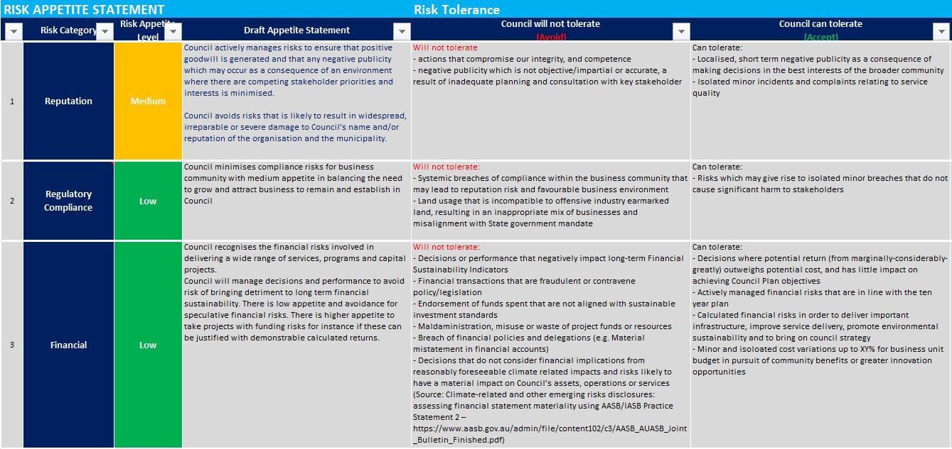
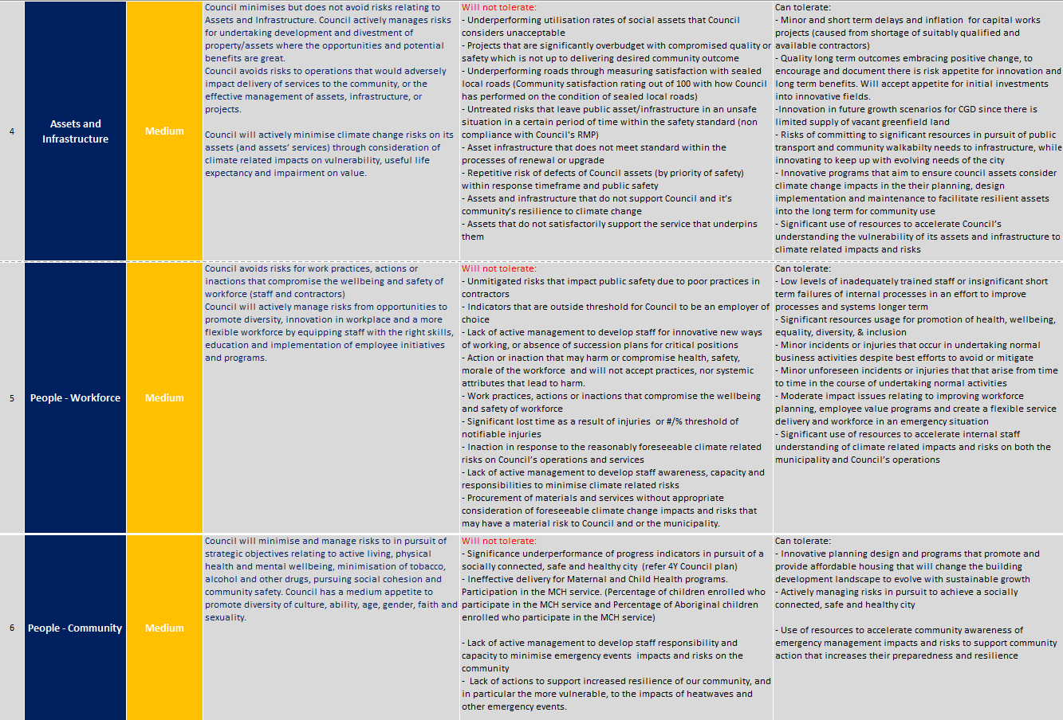

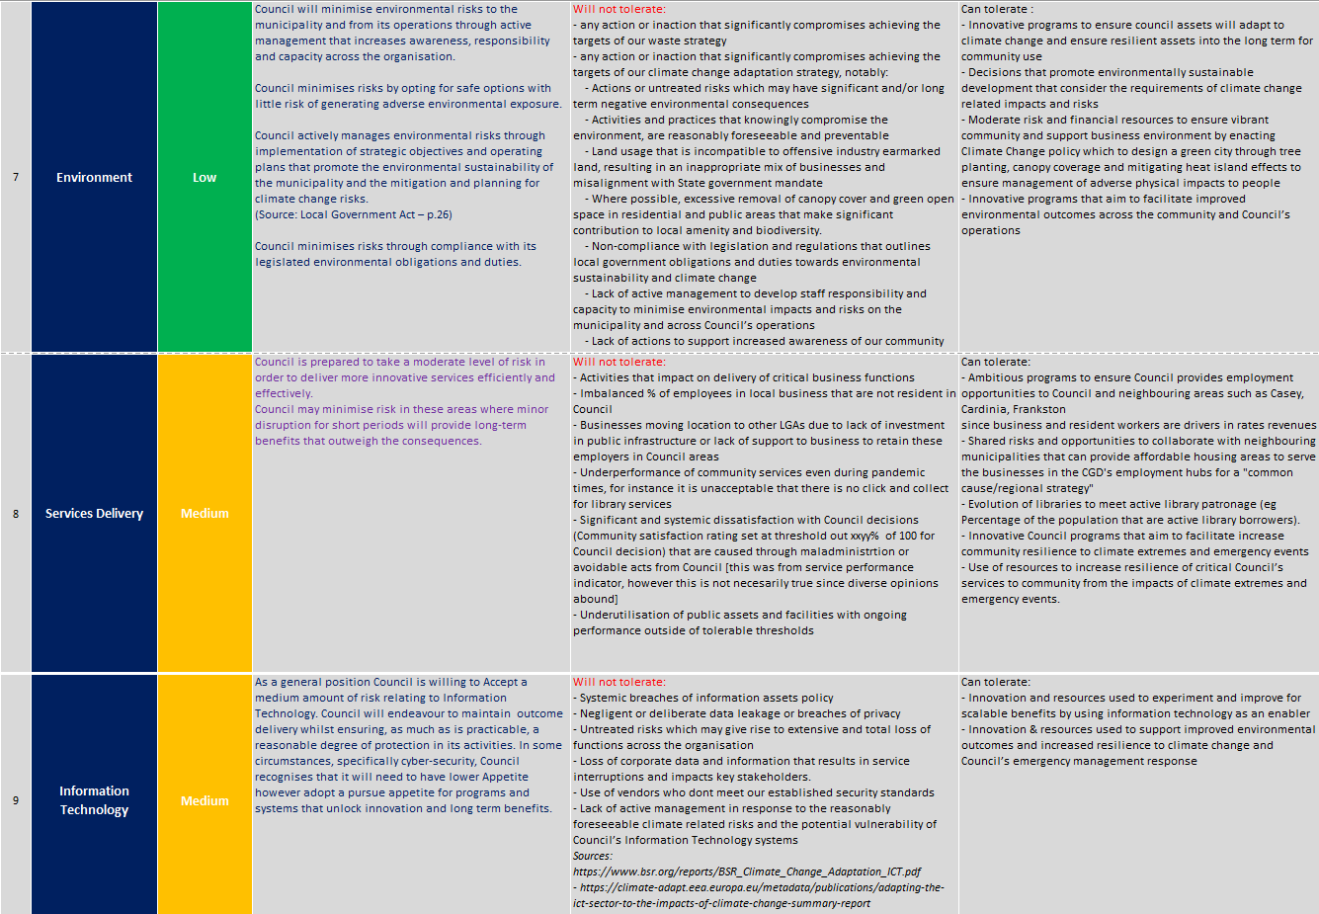
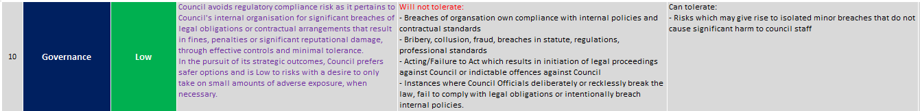

Where it is unclear whether an assessed risk rating is tolerable, or this Statement does not suit an issue being assessed, the Risk Team can assist. Contact the Risk Management Consultant in People, Culture & Innovation. EXT. 5115.

individual events undergo a specific risk assessment, which is retained with all other documentation related to the event
some Project Risk Assessments have been recorded in Pulse; most are retained with the project documentation
Based on the Audit & Risk Committee Charter
Refer to Council’s Occupational Health & Safety Policy

