
Organisational Development
PERSONAL DEVELOPMENT PLANS (PDP)
FREQUENTLY ASKED QUESTIONS

Why do we have to do PDPs?
You, and all that you bring to Council is important, regardless of your position. What’s also important is that your work is recognised, and there is an ongoing focus on your development. That’s why we have Personal Development Plans (PDPs) and why they are embedded into our working arrangements.
PDPs are also a good opportunity to strengthen and build good relationships between you and your supervisor by sharing openly and honestly how things are going. This relationship is key to a culture of mutual respect and trust within the workplace.
Finally, there are three factors that make it mandatory for PDPs to be done.
- PDPs support the Workforce Plan which Council must have under the Local Government Act. The Plan is designed to build staff capabilities to ensure we have people with the skills needed to deliver Council services to our community now and in the future.
- Our Enterprise Agreement (Agreement) requires an annual development plan be completed and sets out the minimum requirements to be included as follows:
- new or enhanced skills required by Council, including the required competency level
- any training (development) to be undertaken
- performance standards
- time frames for completion
- all full-time and part-time staff must have a PDP annually regardless of their role (casuals optional but recommended)
- a current position description
- PDP’s support Council’s Gender Equality Action Plan (GEAP) which Council must have under the Gender Equality Act 2020. The PDP process provides a structured framework for discussions between supervisors and staff that support female, male and gender diverse employees to share equally in the opportunity to:
- learn and advance their careers.
- attain financial self-sufficiency
- choose an occupation of interest and value to them
- both men, as well as women, may be able to seek adjustments in their working arrangements, to enjoy the fulfillment of their child-rearing and other caring responsibilities

What’s in the PDP form?
The form is a little hard to follow online the first time you look at it. A hard copy version of the form is available on the Source > PDPs or in Objective > Document ID A10169534. You can also use the hard copy to make notes in preparation for your PDP meeting.

When do PDPs have to be done?
All PDPs must be started and finished between 1 July to 30 September each year. This means that PDPs align to the financial year and Council’s corporate and business planning cycle.

What’s in it for me?
Having a PDP can help you do the best you can by creating opportunities for you and your supervisor to -
- build your working relationship
- help you understand what your key work-related KPIs are for the coming 12 months
- explore what support you need for your current and future roles, including building your skills and capability
- share feedback on what’s working well and improvement opportunities
- celebrate your successes and achievements
- reflect on the past 12 months and planning for the next 12 months
- explore future training and development needs to build your capability
- ensure any mandatory licences, certificates or qualifications remain valid
- make sure your position description is current

KPIs and Goal Setting
For best practice, your KPIs and goals should be SMART goals. This diagram may help you better understand what a SMART goal comprises of and some questions to assist with writing them.
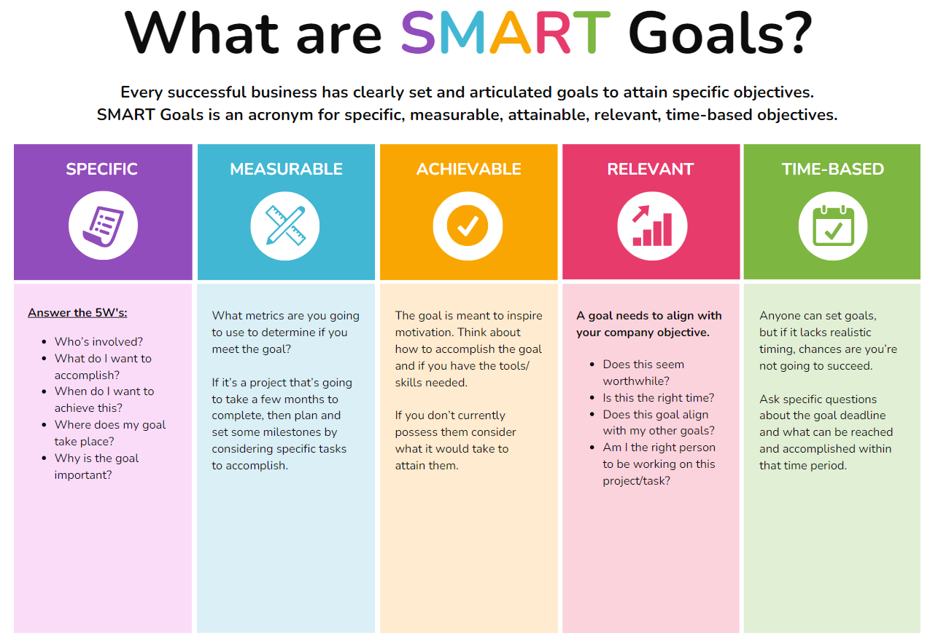

How are PDPs done?
Using an online form developed in partnership between the IT and OD teams.

Who else sees my PDP?
Just you and your supervisor. Currently, OD or higher-level management do not review individual PDPs as a matter of course, although if there is a valid reason for doing so, they can.

My job never changes so I just give the same responses every year. So why do I need a PDP?
With this new PDP format, the focus his now on personal and individual development. Every one of us, regardless of the job we do, has areas that can be developed. Even if you personally don’t have things you would like to develop, there are skills and capabilities that the organisation needs you to develop in order to provide the best possible service to our community. The focus now is on what skills, knowledge and abilities you need to do your job and less on what you have to do or achieve each year.
So it’s unlikely under the new PDP format that you will be able to, or feel the need to, give the same response each PDP.
Also, the fact remains that under Council’s Enterprise Agreement, everyone is required to have an annual PDP each year under Council’s Agreement.

How do I organise training or development activities?
Any training being organised corporately by Council is advertised in PULSE > Learning. This can be applied for using PULSE.
Also in PULSE > Learning, there are a number of eLearning courses that anybody can do at any time. There is a course directory that you can view and select any course that interests you.
Did you also know that through Council’s Library service, you can access over 16,000 free online courses in English, French, German, Japanese, Spanish, Mandarin and Portuguese. You need to be a Library member. To find your next free online course visit, https://www.linkedin.com/learning-login/go/cgdl
Any external training or development activity is to be approved by your supervisor. External training can be requested using Council’s online training request form. Anytime you are requesting external training, events, workshops, seminars, conferences, you must complete the online training history form to ensure this training is captured on your training history and in your personnel file.

Link to online form
Link to instructions
Development isn’t only about training courses though. On The Source, we have a document called A-Z of professional development ideas. Have a read of this for more ideas.
Council’s employee assistance program helps with employee career development and planning. Please visit The Source for further information.

The PDP makes me anxious. Do I have to have one?
We know some people get nervous about having a PDP for fear it will focus on the negatives or tasks that weren’t completed during the year. Others are happy in their current job and worry about being asked about their future career plans.
Everyone is different. Some people are hungry for career progression and development and others are happy just doing what they are. That’s OK. No judgement will be made if you don’t have career plans.
The focus of the PDP is about how you can be the best you can be. Even though you might be happy doing what you do currently, all of us regardless of our jobs, can learn new things to make the jobs easier or done in a way that helps Council meet its goals. For example, rather than focusing on the specific duties of your role or your workplan, you might discuss opportunities to consider Council’s REACH Values or Capability Framework.
If the PDP makes you anxious, share these feelings with your supervisor. Explain your concerns so your supervisor is aware of what is going on for you and try to work together to make the PDP a more positive experience for you both.

Does my supervisor/manager do a PDP?
Yes. The requirement for a PDP applies to all staff covered by the Agreement.
Staff outside of the Agreement also have an annual review although the process is different. They still have to consider their development needs including Council’s Core Capabilities and REACH values.

What happens if my supervisor doesn’t do PDPs with their staff?
If you feel comfortable, we encourage you to chat directly with your supervisor and request they complete a PDP with you. You can also contact a member of the OD team on zzorgdevadmin@cgd.vic.gov.au

Why do I have to do it every year when other people in the department don’t?
While it can be frustrating to think that other people may not be completing PDP’s, it may be helpful to consider what you can control in this scenario and focus your energy on what (if anything) you can influence. Talking to your supervisor or EAP and sharing your frustrations may also be a helpful option.

Who is responsible?
The business unit manager has ultimate responsibility to ensure each team member has an annual PDP.
Each quarter, the number of PDPs in place is reported to the Executive Team.
Your direct supervisor is usually the person who will complete the PDP process with you. It is suggested that both you and your supervisor be involved in the preparation phase of the PDP.
You have an important role to play too. Prepare and be ready for the PDP discussion. Be open during the meeting to sharing your thoughts.
In preparation for the meeting, we recommend you:
- read through your existing position description. Does it reflect what you currently do? If the PD was signed before November 2022, it needs to be transferred across to Council’s new PD template (link to position description templates)
- check the expiry date of accreditations to ensure these can be included in next year’s PDP so they remain current. Accreditations are stored in PULSE > Learning > My Accreditations.
- Think about you’re your work requirements and tasks, personal and professional goals, aspirations for the coming year and beyond. Remember, it’s OK if you don’t have any specific in mind. You should also think about what possible development opportunities you see in terms of your position description, Council’s Capability Framework and REACH principles.
- Think about what could help you in your current role and/or future roles (if this is something you aspire to)
- Jot down any questions you might have about what might happen in the next 12 months that might affect your job
- Any training and development opportunities you would like to explore
- Gather any documents that you would like to highlight, i.e. achievements, recognition, etc.
- Review Council’s Code of Conduct to refresh your memory. Remember, every staff member is obliged to follow the Code of Conduct at all times and this includes compliance matters like gender equality and diversity, child safety and climate change and sustainability.

How long will it take?
That depends on a number of factors. As a guide, you should probably allow at least 30 minutes to prepare and up to an hour for the PDP discussion.

Is the PDP looked at again once it is in place?
Yes, it should be. Progress towards the development goals and actions in the PDP should be monitored, reviewed and adjusted as necessary. The PDP form allows for progress updates to be recorded throughout the year. As a reminder to both staff and supervisors, an automatic reminder email is sent each quarter. This email includes a link to enable either person to return to the online form and comment / include progress updates.
You and your supervisor are both responsible for monitoring and updating progress. The responsibility doesn’t solely rest with your supervisor.

What happens if I think of something I wanted to say in my PDP after it is done?
Once the PDP goals have been set and submitted for the year, they cannot be changed. You can make comments throughout the year through your individual dashboard. Click into your PDP Workflow Inbox
Reminder emails are sent to the staff member and supervisor to check in and review progress.

What is Council’s Capability Framework all about?
Council’s Core Capability Framework is a tool to support staff in their development.
- It helps Council talk about skills and abilities in a consistent way regardless of your job.
- It makes sure staff have the right behaviours, skills, and knowledge to do their jobs well.
- It also helps us have flexible and responsive people able to do their work effectively.
- There are different levels in this framework that explain what is needed continually improve and grow to get better at their jobs.
- This helps staff feel valued and to know what's expected of them.
- The Capability Framework is used for important people issues like hiring people, training them, checking how well they're doing, and planning for the future.

Where can I find a copy of my existing position description?
Position descriptions are saved again a person’s entry on the organisation chart on the Source.
I want to… > Org Chart
Click into your position. On the right-hand side under “Position Title” you should find a link to your existing position description. If the position description is not linked in the org chart, please ask your supervisor to give you a copy.

