

People & Change
Purpose: As we move into 2023 this Handbook sets out some key Organisational Development processes and timeframes, so that we can best support you as a People Leader at Council. The Handbook will change over time as our systems and processes change, and we are always grateful for your feedback!
Handbook for People Leaders
Table of Contents
WHO ARE WE? WHO TO CONTACT? 4
Employee Assistance Program (EAP) 5
Manager Assist 5
RECRUITMENT 6
Preparing for recruitment 6
Position Description 6
Approval process 6
Preparing for selection process / Shortlisting applicants 7
Preferred Candidate – checks 7
Offer of Employment 8
Unsuccessful candidates 8
WELCOMING YOUR PEOPLE 8
Minimum Employment Period (Probation Period) – incl reminders 8
Induction Process 9
DEVELOPING YOUR PEOPLE 9
Learning & Development 9
COUNCIL’S VALUES (REACH) & CAPABILITY FRAMEWORK 10
Performance development & planning (PDP) 11
SHINE 12
PAYROLL 12
Deadlines & Pay Dates 12
Employee is taking leave 13
You are taking leave 13
Overtime & Time in Lieu 13
Higher Duties and Secondments 14
EMPLOYMENT VARIATIONS 14
EMPLOYEE RELATIONS 15
Restructures 15
Policies & Guidelines 15
KEEPING YOUR PEOPLE SAFE 15
Workcover 15
OHS 15
NON-WORK-RELATED INJURIES 15
EXITING YOUR PEOPLE 16
Resignation Process 16
Exit Interviews & Surveys 16
Termination Pays 16
Transfer of Prior Service 16
Long Term Leave 16
Retirements 17
SYSTEMS 17
REPORTING 17
PERSONNEL FILES 18
Hybrid Work Model 18
Flexible Work Options 19
Safety, Health and Wellbeing 19

WHO ARE WE? WHO TO CONTACT?
Welcome to the People, Culture and Innovation team!
Manager People and Change: Anthony Camillo, ably supported by Van Huynh
Team Leader Organisational Development: Nicole Josef (Acting: Susanna Moore)
Organisational Development Consultant – Payroll and Projects: Renee Peake
Contact us for questions on:
Topic | Friendly team member | Contact
Contracts of employment – non senior Officer  Contracts of employment – Senior Officer | Emily Dawson  Anthony Camillo  Van Huynh | zzorgdevadmin@cgd.vic.gov.au
Child Safety | Chelsea Hayes, Susanna Moore
Employee Assistance Program | Susanna Moore
Employee Relations | Jane Grierson, Susanna Moore, Pierre Rosenkotter, Bernie Wallace, Chelsea Hayes
Family Violence | Genene Brownbill, Jane Grierson, Susanna Moore
Gender equity | Chelsea Hayes, Genene Brownbill, Jane Grierson, Susanna Moore
Learning and Development | Genene Brownbill, Dani Gerresheim | zzelearning@cgd.vic.gov.au
Occupational Health and Safety | Caroline Creedon, Robert Feillafe, Anthony Jurkov
Organisational Development | Jane Grierson, Susanna Moore, Pierre Rosenkotter, Bernie Wallace, Genene Brownbill, Chelsea Hayes
Onboarding | Dani Gerresheim, Emily Dawson
Payroll | Nicole Billington, Renee Peake, Megan Arnold | Payroll.inbox@cgd.vic.gov.au
PDPs | Genene Brownbill, Jane Grierson, Susanna Moore, Pierre Rosenkotter, Bernie Wallace, Chelsea Hayes
Position Descriptions | Pierre Rosenkotter
Pulse | Emily Dawson, Dani Gerresheim
Recruitment | Emily Dawson | zzorgdevadmin@cgd.vic.gov.au
Workforce Plan | Genene Brownbill
WorkCover / Return to Work | Bronwyn Duffus, Laura Kilgower | workcover@cgd.vic.gov.au

Employee Assistance Program (EAP)
Provided by Converge International Offers free and confidential support to staff, their immediate family members and people leaders.
There are multiple streams available:
- Money Assist*
- Career Assist
- Conflict Assist
- Employee Assist
- Family Assist
- Manager Assist
- Nutrition and Lifestyle Assist
Appointments during working hours are paid. Converge offer both in-person and online appointments. A counsellor is also available on-site (bookings essential) on Thursdays. The onsite Consultant roster can be found by searching the term “Employee Assistance” in the Source (Home>Safety, Health and Wellbeing>Employee Assistance Program).
OD authorisation or approval to attend sessions is not required. There is a general limit of 3 sessions per issue per employee/people leader. Further appointments can be approved subject to formal request to Converge (facilitated by OD).
Employees generally self-refer, although on occasions, it can be appropriate for a people leader to refer the employee and contact Converge on the employee’s behalf. Employee confirmation however is required. Speak with OD if considering this.
Also available to immediate family members of Council employee free of charge.
People leaders are to recommend EAP at earliest opportunity and definitely whenever a performance, disciplinary, welfare matter is raised by the staff member.
- *For information for staff experiencing financial difficulties, further information about what Council can offer is available by searching the term “Financial Assistance” in the Source. (Home > Safety, Health and Wellbeing > Employee Support >Financial Assistance)

Manager Assist
Available for any people leaders to talk through any people or leadership matters and to obtain independent guidance. OD approval or authorisation is not required. This has been especially helpful for seeking assistance in managing people with a mental illness.
Converge International – 1300 687 327

RECRUITMENT

Preparing for recruitment
TIP: The Enterprise Agreement requires Council to maintain resourcing requirements. Therefore, please start the preparation process as soon as an employee resigns or applies to go on extended leave.

TIP: The Recruitment Policy requires all jobs to be advertised as flexible

TIP: The Enterprise Agreement only permits a role to be temporary if it is for a specified period of time and/or for a specific project, task or tasks.

Position Description
Please refer to the detailed OD Factsheet on Position Description Guidelines on The Source here:
Position Descriptions and Bandings | The Source (greaterdandenong.vic.gov.au)
Or search ‘Position Description Guidelines’. Feel free to call OD for assistance during this process.
Reporting levels and position titles
We are striving for consistency in position titles so that our internal and external reporting is more accurate. Please use the following title conventions:
- Staff member
- Supervisor (generally reports to a Team Leader)
- Team Leader (generally reports to a Coordinator)
- Coordinator (generally reports to a Manager)
- Manager (reports to a Director)
- Director (reports to CEO)
- CEO
Position Description MUST be updated before submitting position requisitions in PULSE or to the EMT (Noting that PDs should be reasonably up-to-date due to the annual review/PDP process).
Draft job advertisement (refer to templates on the Source)

Approval process
Positions to be recruited must be approved via a position requisition in Pulse eRecruitment.
This will be considered by the Executive Management Team (EMT), and the submitter will be notified of the outcome through Pulse.
Please see timeframes below:
Step | Timeframes
1.0 Position Requisition entered into Pulse and approved by relevant parties | COB Thursday
2.0 Position is considered at EMT Meeting | Following Tuesday (if absolutely urgent can be considered via email to EMT)
3.0 Position is advertised for 10 business days (unless EOI – please see the Source) | Following Monday (unless advised otherwise)

Preparing for selection process / Shortlisting applicants
- Search the term “recruitment process” in the Source for a full outline of recruitment processes, including selection options, sample interview question and timeframes (Home>Working Here>Recruitment>Recruitment Process).
- The chair of all selection panels and ideally all other panel members must have attended Council’s corporate training called “Recruitment, Including Unconscious Bias”. This training was rolled out from October 2022.
- Prepare Interview questions – they must be behavioural and consider Council’s Core Capability Framework, Child Safe Standards, REACH values and position specific skills.
- Recruiters to think laterally about how to test suitability of applicant e.g. Interview, practical tests, referees, psychological assessments etc).
- Remember to communicate to candidates how the panel will assess suitability of applicants (ie the entire process may be taken into account including referee comments).
- Review applications via Pulse recruitment. See the Source for user guide.
- There is no requirement to have an OD representative on every selection panel.
- Best practice recruitment processes are timely and responsive, so communicating with applicants as soon as possible increases the likelihood of securing the best candidate for your role.
You can advertise internally only or both internally and externally at the same time. For positions classified Physical Services Band 4 and below, internal expressions of interest must be sought prior to any external advertising.

Preferred Candidate – checks
The recruiting manager is responsible for confirming all details of the offer of employment with the preferred candidate BEFORE submitting the new employee request form. This will eliminate the need to re-issue letters.
- This includes: Salary/banding, start date, vehicle (if applicable), days/hours per week, preferred name (for IT access), and Vaccination status
- Allow 2 weeks for Council’s pre-employment processes to be completed prior to commencement.
- The following checks and documentation must be completed and provided to zzorgdevadmin@cgd.vic.gov.au prior to offer of employment.
- Completed signed copy of the New Employee form
- Recruitment checklist
- Completed selection grid
- A minimum of 2 reference checks using the Reference Check template
- Qualifications and mandatory registrations, ie Nurse, Engineer, etc
- Interview notes from all panel members for all interviewed candidates
- Working with Children Check (if applicable)
- Police Check (if applicable). Please note Police Checks can take up to 1 month to be returned, delaying commencement of new starter.
- Copy of Drivers Licence (if applicable)
- Evidence of COVID vaccination status
If new starter requires IT access, Hiring Manager to complete new IT user request form (see the Source for more details). Use preferred name in IT new user request.

Offer of Employment
OD will prepare Letter of Offer based on details provided in new employee request form, which is then approved by Manager/Director. Hiring manager will be cc’d into the email sending the proposed letter to the Manager for approval.
Once approved, the Offer is emailed by OD via Pulse to preferred candidate. Hiring manager notified via Pulse when offer emailed.
OD emails onboarding link to preferred candidate (allowing the preferred candidate to accept offer of employment via the new employee payroll form in onboarding portal.)
Please note: At this stage, we have no system in place for the hiring manager to know when the prospective employee has accepted the offer. We are working on this process…

Unsuccessful candidates
Hiring manager to telephone unsuccessful applicants that were interviewed to notify of outcome, noting this on Pulse recruitment discussion/notes area.
OD to email all unsuccessful applicants (including those who were not interviewed) of outcome following telephone contact by hiring manager.

WELCOMING YOUR PEOPLE
- Please be present in the office on the employee’s first day.
- Prepare an outline of the employees first fortnight, which may include:
  - Council buildings
  - Carparking maps etc
  - Walk through of office
  - Org chart of team/department with photos
  - Buddy system
  - Key people to introduce around Council – please include payroll and OD
  - IT equipment & log in
  - Swipe card/access
  - System demonstrations (Objective/PULSE)
  - How to use UConnect
  - Pay dates
  - Local food and amenity shops

Minimum Employment Period (Probation Period) – incl reminders
- There is a statutory minimum employment period of 6 months. If a person's employment is terminated during this first 6 months they cannot make an unfair dismissal claim.
- It is your responsibility to monitor performance and conduct and contact OD as soon as problems are emerging (however minor) and ensure this is done before the 3 month mark.
- Make notes of any discussions with employees
  - Issues
  - Expectations
  - Timeframes
  - Outcome/consequence
  - Support provided (I.e. training, mentoring, coaching)
The new employee should have a clear idea of how well they are performing during the first 6 months.
TIP: The minimum employment period cannot be extended so it’s important to use this time to thoroughly assess the person’s suitability for the job. The employee’s job will be automatically confirmed after 6 months.

Induction Process
- New employees receive an onboarding portal link at the start of their employment. This includes all online eLearning induction courses.
- There are three components of induction:

DEVELOPING YOUR PEOPLE

Learning & Development
Corporate compliance training
- OD manage the corporate training budget and training calendar, primarily compliance training
- IT are responsible for the online IT training modules – contact Claude Curulea
- Compliance training is advertised on The Source Events Calendar, and the Pulse Training Calendar.
Study Assistance – search “Study Assistance” in the Source
- To apply, complete the Study Assistance online form
- Only eligible after 12 months
- For reimbursement, contact Finance. Not processed by Payroll or OD – you will need to provide payment receipt and confirmation of their successful completion
- Managers are responsible for monitoring the amount of study leave that is applied for and approved
Departmental training
- If sending a member of your team to any training, seminar or workshop, the staff member is to submit a request via the online Applying for External Training form. The inbuilt workflow ensures the training is saved in Objective and recorded in training records.
- Search “Apply for Training” in the Source for training application process.
Accreditations
- Compliance related certificates, licences and accreditations are recorded and monitored in PULSE
- Onboarding process captures initial compliance certificates
- Local monitoring and updating in PULSE during PDP process and on expiry
- It is the supervisor's responsibility to maintain accreditations beyond initial recruitment and then throughout employment

COUNCIL’S VALUES (REACH) & CAPABILITY FRAMEWORK
- The three building blocks of organisational capability are
  - values (REACH)
  - core organisational capabilities
  - position specific skills (position description)
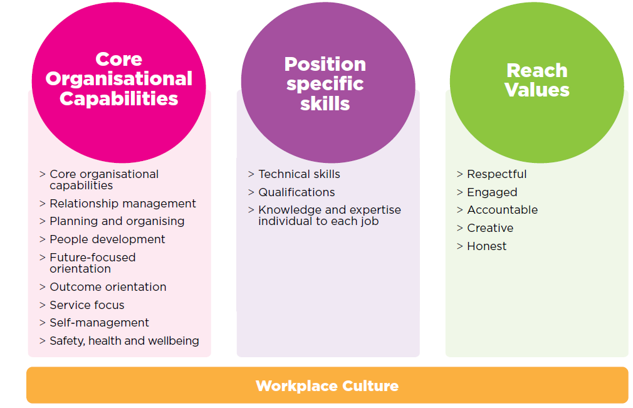

- REACH defines who we are and how we interact with others. It is an extension of our corporate values and provides details about how each of us should aim to operate in the workplace regardless of role
- REACH defines what we strive for collectively, how we want to be treated as individuals and what customers expect from us.
- The REACH values are
  - Respectful
  - Engaged
  - Accountable
  - Creative
  - Honest
- The core organisational capabilities are
  - behaviours, skills, knowledge our organisation and our people need to succeed
  - personal qualities, professional abilities needed to effectively do our jobs
  - the ‘how’ job tasks are performed

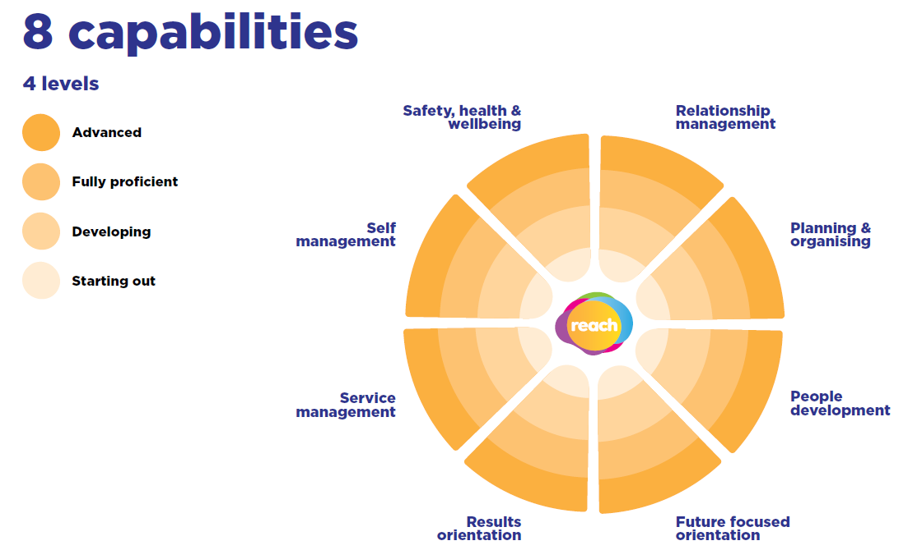
- Capabilities are a common language for effective, consistent communication about capability
- The levels help staff understand what is expected of them now and what is needed to progress. They contribute to staff empowerment and retention.
- They underpin and inform OD activities
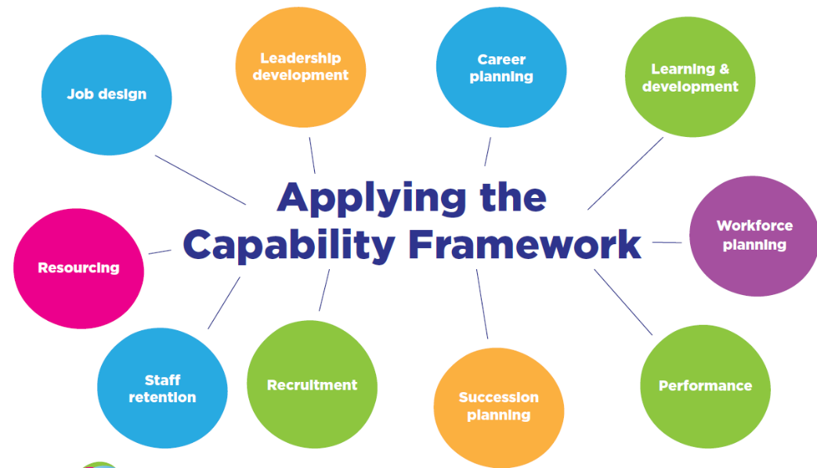
- REACH and the Capability Framework should be incorporated into all we do

Performance development & planning (PDP)
- Council’s PDP process is an annual process for all staff and is a mandatory under Council’s Enterprise Agreement
- Every full-time and part-time employee must have (at least) an annual PDP meeting and plan
- Casual employees can request a PDP, but it is not mandatory
- PDPs align to Council’s corporate planning cycle, i.e. financial year not calendar year
- PDPs support the development of organisational capability as well as ensuring each person has completed any compulsory training or registrations for their position
- The PDP process is a formal process of professional support and learning which:
  - Aims to be supportive, engaging and empowering as well as building trust and rapport
  - Encompasses critical reflection – an opportunity to pause, reflect and celebrate a person’s achievements during the previous year including how they align with the expected Core Competencies of their role, and how they bring the REACH values to life in their work
  - Supports individual personal and professional development for the coming year, including the development/training opportunities available to support a person to improve on or excel in a particular area. Click here for more corporate training options or search ‘Corporate Training’ on The Source
  - Allows a staff member to communicate supports and expectations from their leader/supervisor for the coming year
  - Provides a forum for discussion of any challenges/obstacles a person may be experiencing (or have experienced), including some strategies to help overcome them moving forward (but should never be used for performance management)
- PDPs are conducted using PULSE. For assistance contact the OD team.

SHINE
- Shine is Councils online reward and recognition program to acknowledge:
  - Achievements
  - Informal recognition (i.e. thank you, great work)
  - Semi formal - REACH award $50 – manager discretion
  - Formal awards - Rise Above Awards $250 & $500 – authorised by a reward and recognition committee
- On The Source click ‘I want to … Shine!’ or search ‘Rewards and Recognition’.

PAYROLL

Deadlines & Pay Dates
- Council runs a fortnightly pay cycle from Monday to Sunday week.
- Pay variations/timesheets and UConnect applications must be submitted to Payroll by 12pm on the Friday prior to pay day. If you have previously arranged with your manager to work overtime on the weekend, the deadline for receipt is extended to 10am on the Monday prior to pay day.
- If forms are received at Payroll after these cut-off times, payment will be held over until the next payrun.
- Click here for more payroll related information.

Employee is taking leave
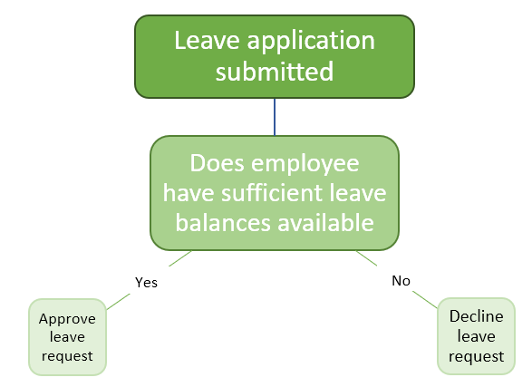
- When you are approving leave applications, employee leave balances must be checked before approval is granted. If insufficient balances, please ‘decline’ the request and have the employee apply for a different leave type. If you are unsure what leave types apply, please refer to the Leave Guidelines.
- Before taking leave without pay, employees must use all other available leave accruals and entitlements, or they must use this leave in conjunction with their leave without pay. Employees are not required to use sick leave accruals or entitlements.
- Leave without pay cannot be applied for via Uconnect. Please complete a leave application form.
- If an employee is taking long term leave, please notify payroll.

You are taking leave
- If you are taking leave, you need to set up relevant delegations in the following systems:
  - UConnect
  - PULSE
  - Outlook
  - Objective
  - Computron G2
  - Comensura (if applicable)
  - Please click here to access the ‘Preparing for Leave Checklist’
- Please complete a higher duties form before you go on leave to ensure the acting employee is paid the appropriate pay rate.

Overtime & Time in Lieu
- Fact sheets – currently in review – will be updated on The Source and leaders notified
- UConnect instructions – currently in review – will be updated on The Source and leaders notified

Higher Duties and Secondments
- Higher Duties is an allowance which should be used for short periods of up to approximately 3 to 4 months, for example to cover a short period of leave.
- If a longer period or the duration of the absence is more certain, we suggest a secondment. This will ensure all systems are adjusted to show the person is acting in the role, for example the Organisational Chart, UConnect (including being able to see and approve staff members’ leave), Shine! and Pulse.If the person acting up is already at the top level of their band, or they have performed the higher level role on a number of occasions, it may be suitable to offer the higher duties or secondment at higher level than level A.
- Click here for the Higher Duties Guidelines and link to the form. Another useful reference is the Recruitment Policy.
- Please also see the Higher Duties Policy for details about forms and processes to record this.
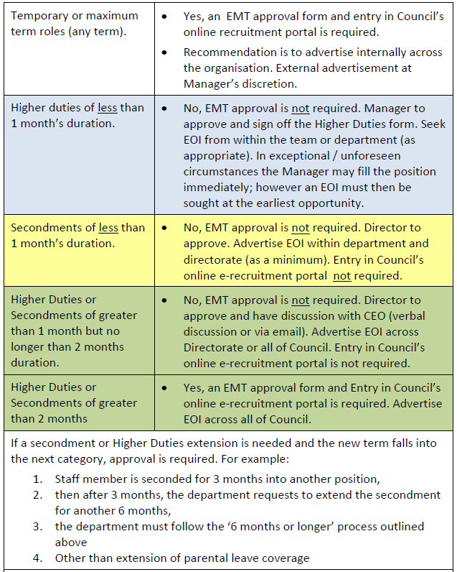

EMPLOYMENT VARIATIONS
- Variation to employment form - to make various employment changes, eg. to increase/decrease hours, extend temporary working arrangements, or 48/52 and secondments. An online form is currently in development and coming soon…
Please note – any variations to employment should commence on a payrun Monday and Organisational Development require a minimum of 10 days notice for processing.
- Variation to Roster online form – for staff who want to vary their roster (with no change to your overall weekly hours)

EMPLOYEE RELATIONS

Restructures
- Council’s Enterprise Agreement has a mandatory process about introduction of change and communication/consultation of change with staff. It is likely you will have a duty to notify affected staff (and their representatives) about changes and an obligation to discuss the proposed changes.
- This applies to proposed changes to structure, work location, individual jobs, reporting arrangements, position duties.
- It is important to speak to the Team Leader, OD or an OD Consultant BEFORE making any decisions about the changes or communicating to staff. They can advise if you have mandatory obligations.
- This also extends to proposed changes to regular rosters or ordinary hours of work
- Learn more about your change obligations in Council’s Enterprise Agreement by searching “enterprise agreement” in the Source (Home>Working Here>Enterprise Bargaining Agreement)
- The relevant clause number is 54 - Introduction of Change

Policies & Guidelines
- Please familiarise yourself with the below:
  - Leave Guidelines
  - Recruitment
  - Flexible and Hybrid Work Policy
  - Performance and Behavioural Issues Policy
- All OD policies are on the Source. Search for the term “OD policies” or (Home>Working Here>OD Policies and Guidelines)

KEEPING YOUR PEOPLE SAFE

Workcover
- Work-related injuries are managed by the Return to Work & Injury Management Consultant and/or Injury Management Officer (Bronwyn Duffus and Laura Kilgower)
- Email workcover@cgd.vic.gov.au
- Incidents to be reported through the online form - Report an Incident, in the Source

OHS
Contact Anthony Jurkov, Caroline Creedon or Robert Feillafe
- Incidents to be reported through the online form - Report an Incident, in the Source

NON-WORK-RELATED INJURIES
- Contact a member of the OD team

EXITING YOUR PEOPLE

Resignation Process
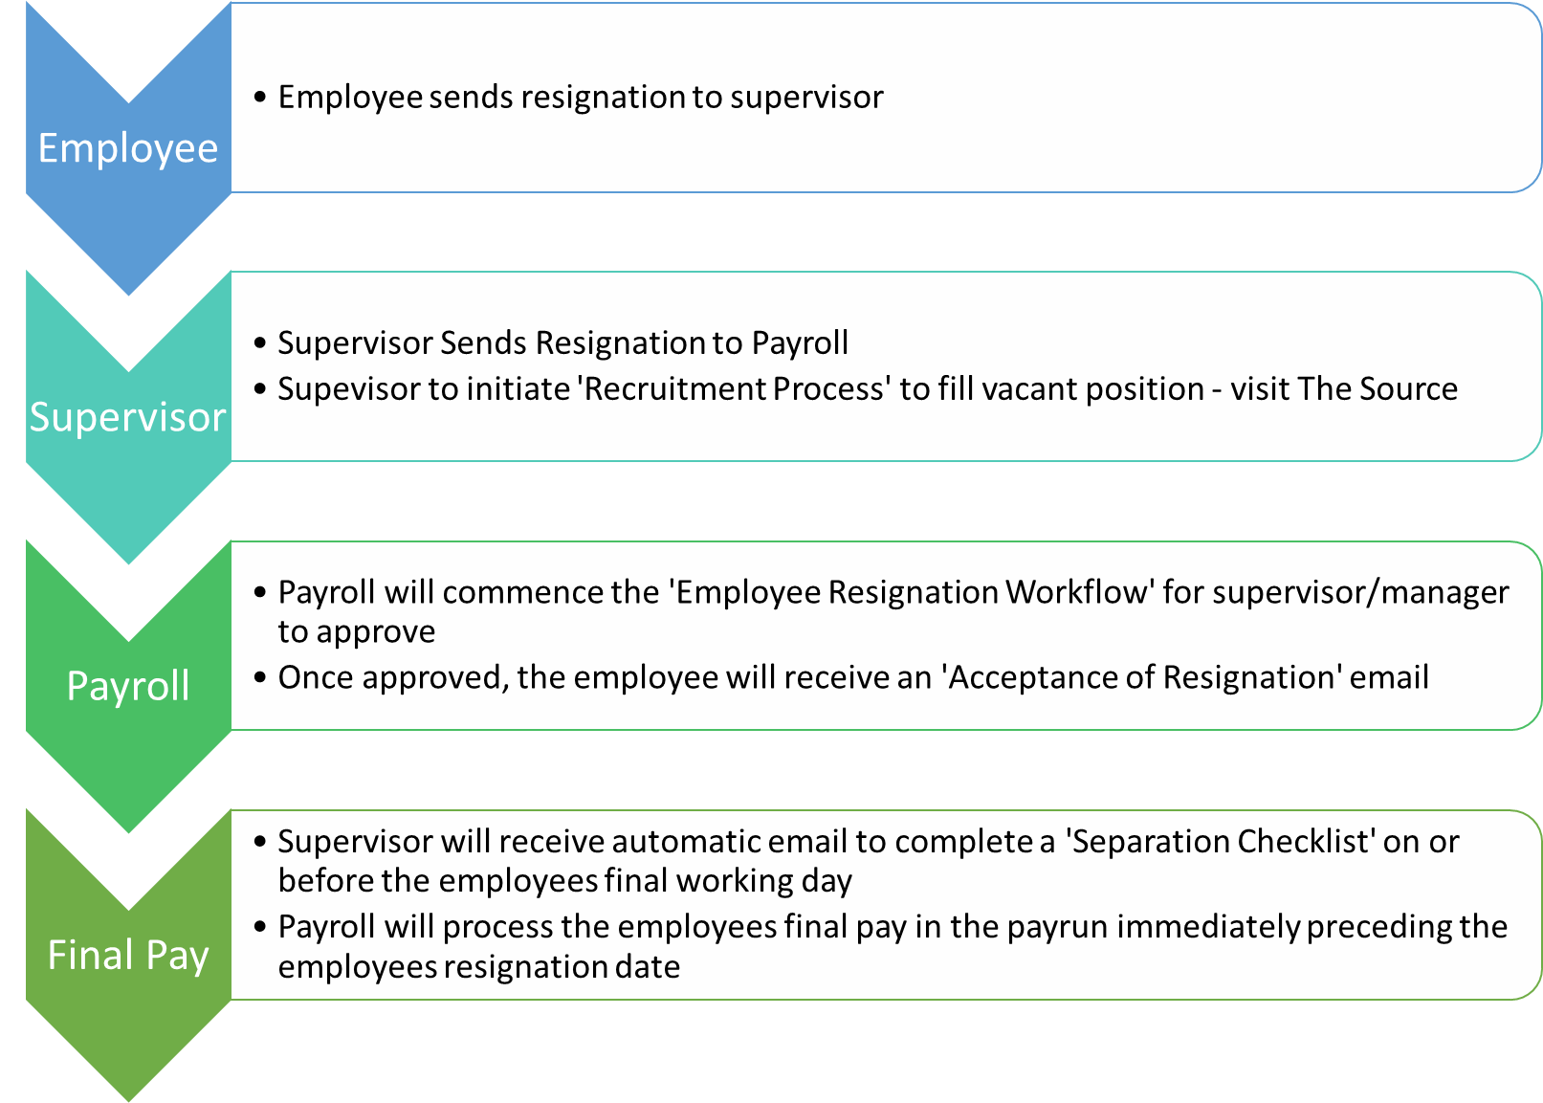

Exit Interviews & Surveys
- We are currently reviewing this process

Termination Pays
- Payroll will process the employee’s final pay in the payrun immediately preceding the employee’s resignation date
- Termination pays will include any accrued annual leave, RDOs, TIL and LSL if applicable.

Transfer of Prior Service
- If an employee is commencing with another Local Government or Authority (please check with Payroll), the employee is required to notify payroll to transfer LSL and some sick leave entitlements.

Long Term Leave
- If a staff member requests to take long term leave, you should advertise the vacancy and fill the position with sufficient time to allow for a handover period.
- Search ‘Recruitment’ in The Source or click here.

Retirements
- If an employee has notified you of their impending retirement and wants to take leave prior to their retirement date, the maximum allowable leave period is 6 months, or less depending on the operational requirements of the business unit.
- If an employee wishes to transition to retirement, this is covered by the Enterprise Agreement. OD can assist you to prepare a Retirement & Transition Arrangement. Ideally you and the employee concerned will decide on an indicative retirement date, which may be reviewed in the future given the circumstances at the time.

SYSTEMS
- PULSE
  - Learning & Development
  - PDPs
  - Recruitment
  - Onboarding
  - Corporate Management Reporting Module – Contact Media & Communications
  - Incidents & Claims Management (Including Child Safety Reports)
- UView
  - Management reporting
- Uconnect
  - Employee and Manager tool. Online applications for leave, overtime, time in lieu. Online payslips
- Elumina
  - Online OHS incident reporting
  - Hazards
- Shine
  - Online reward and recognition
- CHRIS21
  - Council’s payroll system. Only Payroll and limited OD staff have access. Uconnect links directly to CHRIS

REPORTING
You will receive the following reports from OD as a people leader:
Report Name | Description | Link/Reference
Service recognition report  (Quarterly) | A list of staff in the business unit with upcoming service anniversaries and entitled to recognition awards | Sent to managers and business support officers  Search “service recognition” in The Source for policy and procedure
Excess leave report  (Monthly) | List of staff in the unit with excess leave (annual, RDOs, TIL). People leaders are required to work with listed staff to reduce leave accruals | Scheduled report sent to managers and business support officers. Email comes from Uview@cgd.vic.gov.au
Unapproved leave and timesheets  (Each Monday pay week) | A reminder to go to Uconnect and action outstanding leave or timesheet entries in Uconnect that day so that pay is correct | Reminder sent by Payroll and is only sent to supervisors with outstanding leave approvals.
Accreditation’s report  (monthly) | Consolidated list of the status of employee mandatory registrations, accreditations of accreditations or certificates. Data comes from PULSE. People leaders to take appropriate action to ensure accreditations remain current | Scheduled report sent to managers and BSOs. Email is from Uview@cgd.vic.gov.au

- For more information, contact the OD Team or Payroll.

PERSONNEL FILES
- Team leaders have access to their staff personnel files in Objective – search names here
- If you cannot see your staff’s p-files, contact zzOrgDevAdmin@cgd.vic.gov.au
- If you have documents to save on an employee’s personnel file, send through to zzRecords@cgd.vic.gov.au to action. You are also able save documents into file.

TIP: Staff can view their own P files. Be mindful of what you are saving. If in doubt, contact Governance about information privacy.
FLEXIBILITY IN THE WORKPLACE

Hybrid Work Model
- It is up to employees and managers to discuss and agree to individual working arrangements, based on the principle that we start from a position of flexibility, balancing the needs of the team and the organisation with the needs of the individual.
- In relation to remote working arrangements, Council’s starting position is that a hybrid model will be implemented. This currently means three days a week are to be worked in the workplace (for full-time office-based employees) and proportionate days at the workplace for part-time employees: (This does not apply to people who work in roles that are required to be on site such as Customer Service, Libraries and outdoor staff)
- These arrangements may be varied on a case-by-case basis. For example, reasonable adjustments due to a temporary disability or other exemptions.
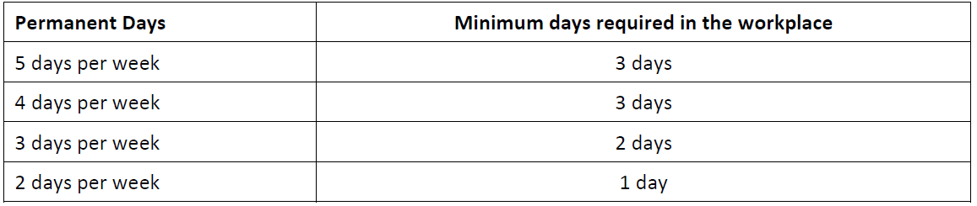

Flexible Work Options
- To implement a flexible work arrangement for an employee you will need to complete a variation to employment form at least 1 month before you would like the arrangement to commence
- If the proposed variation to employment is complex or unusual, please contact zzorgdevadmin@cgd.vic.gov.au to discuss before completing the form
For more information, search ‘Flexible and Hybrid Work Policy’ in The Source or click here.

Safety, Health and Wellbeing
The following OH&S Procedures can be accessed in The Source through the Safety, Health and Wellbeing page:
- OHS Responsibilities Operational Procedure
  - This procedure will advise you the key responsibilities at each level of Management and Supervision
  - It includes Council’s requirements to meet OHS Compliance and other Victorian Laws and Regulations.
- OHS Hazard and Incident Reporting and Investigation Procedure
  - This procedure will advise you on your responsibilities/accountabilities of reporting incidents
  - It includes the requirements of reporting to the Regulator, WorkSafe Victoria, any ‘notifiable’ incidents that MUST be reported within a strict timeframe.
  - It includes Council’s requirements to meet OHS Compliance and other Victorian Laws and Regulations.
- OHS Risk & Change Management Procedure
  - This procedure will advise you on the system Council uses for all high risk tasks undertaken by Council staff, including the risk assessment process.
- OHS Training Procedure
  - This procedure will advise you on all Training processes applicable to Council Staff
  - It includes Council’s requirements to meet OHS Compliance and other Victorian Laws and Regulations.
- OHS Consultation and Communication Operational Procedure
  - It includes Council’s requirements to meet OHS Compliance and other Victorian Laws and Regulations.

Further assistance can also be obtained by visiting WorkSafe Victoria’s website for any other OH&S related matters: https://www.worksafe.vic.gov.au/

