Who we are


OCCUPATIONAL HEALTH & SAFETY REPRESENTATIVES (Page 1 of 3)
Latifa Rahimi (Elected November 2024)
Library Services – Dandenong
8571 5267

Chris Lemiere (Re-elected February 2024)
Drum Theatre – Back of House
8571 1607

Felicity Rolls (Elected March 2023)
Maternal & Child Health
8571 1855

Jason Cordi (Re-Elected November 2024)
Library Services – Dandenong
8571 1408

Jack Winters (Elected November 2024)
Library Services - Dandenong
8571 1535

David Strahan (Re-elected October 2024)
Civic Attendants
0481 917 988

Breanna Rhys-Jones (Elected October 2024)
Civic Facilities – Dandenong
8571 1594

Yas Murray-Naylor (Elected March 2025)
Parking Officer
0478 489 040

Gus Martin (Re-elected November 2011)
Customer Service - Dandenong
8571 1498

Sally King (Re-elected Nov 2024)
Immunisation Services
0466 949 343


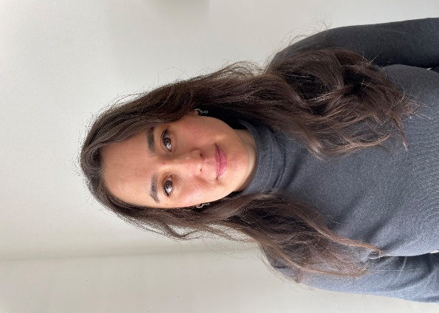



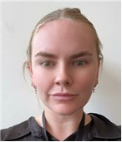
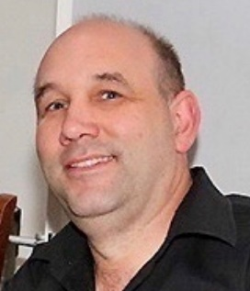
.




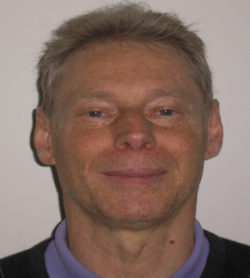
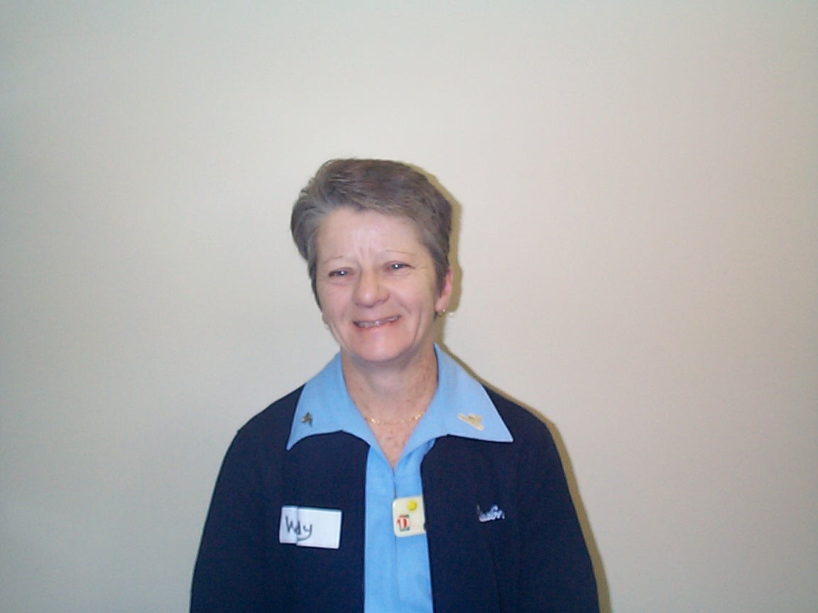
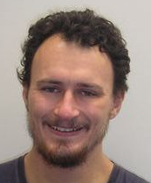
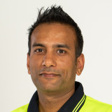
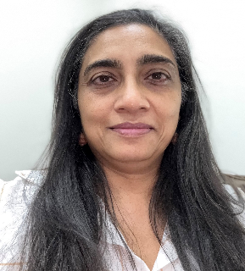
.OCCUPATIONAL HEALTH & SAFETY REPRESENTATIVES (Page 2 of 3)
Tasneem Ally (Elected January 2025)
Children’s Services - Playgroup
8571 1845

Varun Bhalla (Elected April 2025)
Operations Centre - Fleet
0466 521 040

Laith Graham (Re-elected August 2024)
Integrated Community Support Services Protea (& Blue Gum)
0409 899 983

Melda Rasool (Re-elected August 2024)
Family Day Care
8571 1825

Ray Tully (Elected May 2019)
Operations Centre - Fleet
0412 714 933
Erik Van Doorn (Re-elected May 2013)
Operations Centre - Parks
0432 460 879

David Don (Re-elected August 2024)
Integrated Community Support Services Waratah (& Blue Gum)
0417 397 189

Wendy Phillips (Re-elected August 2024)
Integrated Community Support Services Acacia (& Blue Gum)
0414 274 878

Walter Walmaggia (Re-elected Nov 2024
Integrated Community Support Services Home Maintenance
8571 5533
Sam Maliku (Elected January 2025)
Integrated Community Support Services Office
8571 5546

Taryn Hong (Elected January 2025)
Immunisation Services
0403 289 105
Janice Pagliuca Elected January 2025)
Maternal & Child Health
8571 1857

OCCUPATIONAL HEALTH & SAFETY REPRESENTATIVES (Page 3 of 3)


Erik Van Doorn (Re-Elected June 2022)
Operations Centre - Parks
0432 460 879

Erland Cazeneuve (Re-elected September 2024)
Operations Centre - Office & Waste Services
0434 655 803

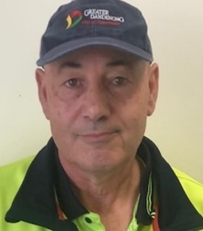
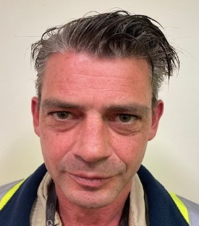

Jordan Turner (Elected December 2024)
Operations Centre – Works Team
0435 210 294

Ida Talback (Elected August 2024)
Festival and Events
8571 5459
Brian Bentley (Elected June 2022)
Operations Centre - Parks
0478 363 755

Vinnie Zammit (Elected June 2022)
Operations Centre - Street Cleansing
0466 936 528

