Automatically Adding Emails from Objective ECM for Browser

The Automatic Email Capture (AEC) module enables automated storage of emails into Objective by means of Exchange Links. Use this procedure to setup each instance of automated email capture from Objective ECM for Browser. If you are using Objective Navigator, then please refer to “Automatically Adding Emails to Objective” (A3736591).
Note: AEC is not to be used for filing emails that need to be stored as a “PR Document” object type as they will not be integrated into the Property & Rating system.

- Start Objective ECM for browser from The Source by hovering the mouse over “I want to..” and then select the Objective ECM  button.

- Browse to the destination where the emails will be stored in Objective.
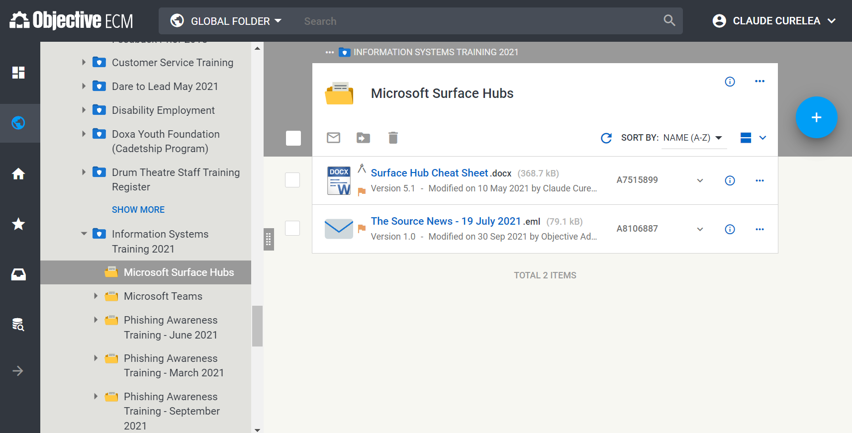
- Select the Ellipsis button next to the destination and click Link to Exchange.
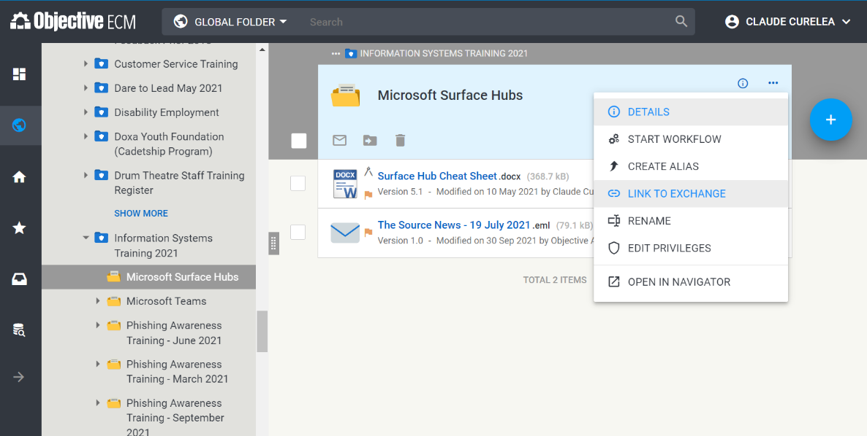

- Click the Create button to create the Exchange link.
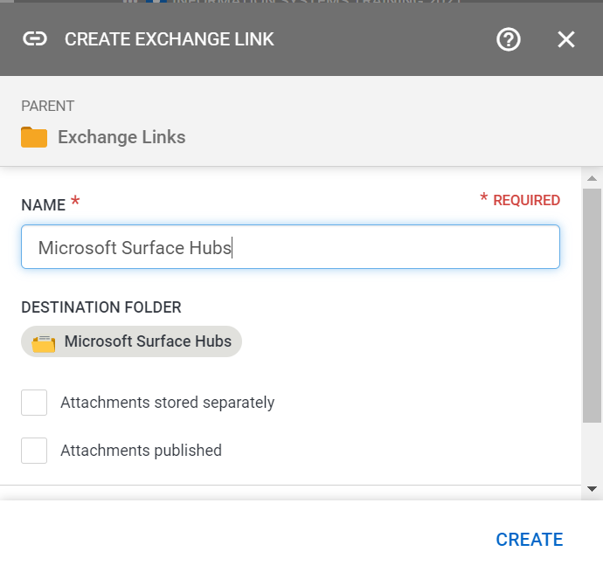
- Wait a few minutes for the folder with the exact name to be created as a subfolder under the Outlook Inbox. Ensure there are no existing folders in Outlook with the same name. If the folder does not appear in 15 minutes, contact the IT Service Desk on 8571-5102 as there could be an issue with the overall AEC service.
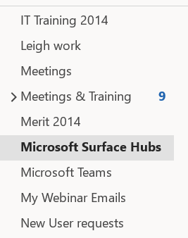
- Once the folder has been automatically created in Outlook select the folder, right-click on the From or Subject columns and select Field Chooser.
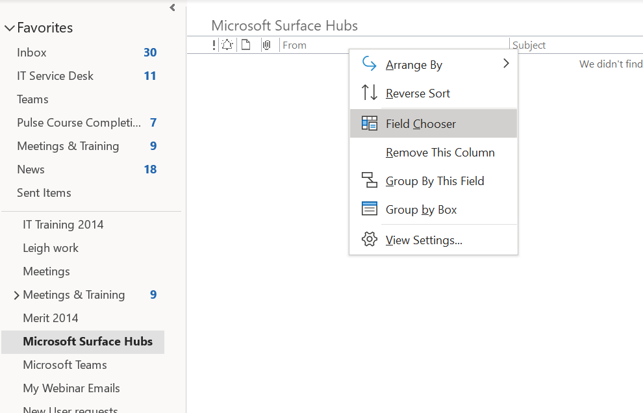
- Select User defined fields in folder from the drop-down menu.
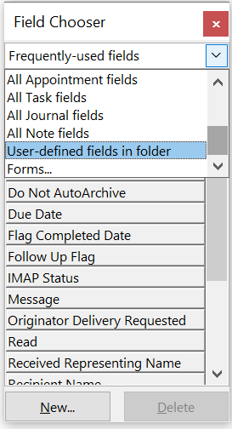

- Press the New… button and create a new field called Objective with the options below and press Ok.
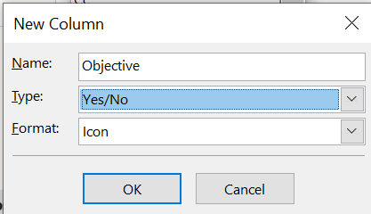
- Drag the field into the columns area and enlarge the column so you can see it properly.
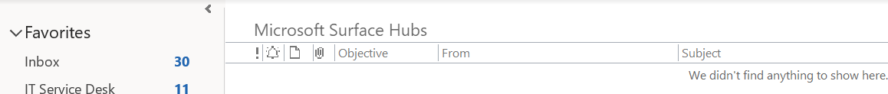
- Any emails you move into this Outlook folder will automatically appear in the Objective destination specified in step 2 of this procedure. Once an email has been automatically copied to Objective it will have either a tick or a “Yes” next to it in the folder in Outlook.
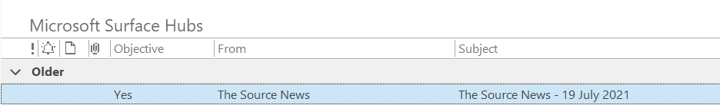

Please contact the IT Service Desk on 8571-5102 or email for assistance with this procedure.

