Deleting Sync Issues in Outlook®

To see how much of your mailbox size is taken up by sync issues

In Outlook, click on the File Tab, select the Cleanup Tools button and select Mailbox Cleanup. In the Mailbox Cleanup menu, select the View Mailbox Size button and find the Sync Issues entry. For example, if your Sync Issues size is 50000 KB, it means that your sync issues are taking up 50 Megabytes.

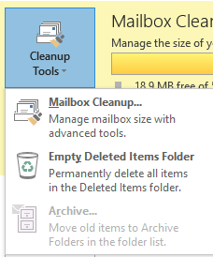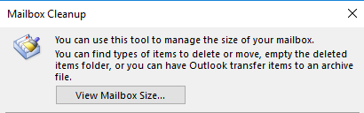
1
22
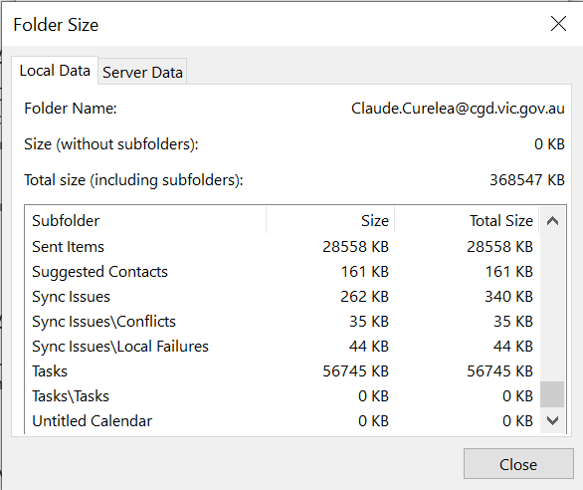
3

Deleting Sync Issues
To delete sync issues in Outlook® click on the More  button and select Folders.
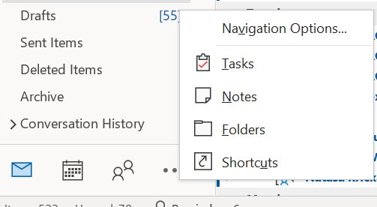
1
22
Right-click on the Sync Issues folder and select Empty Folder.
3

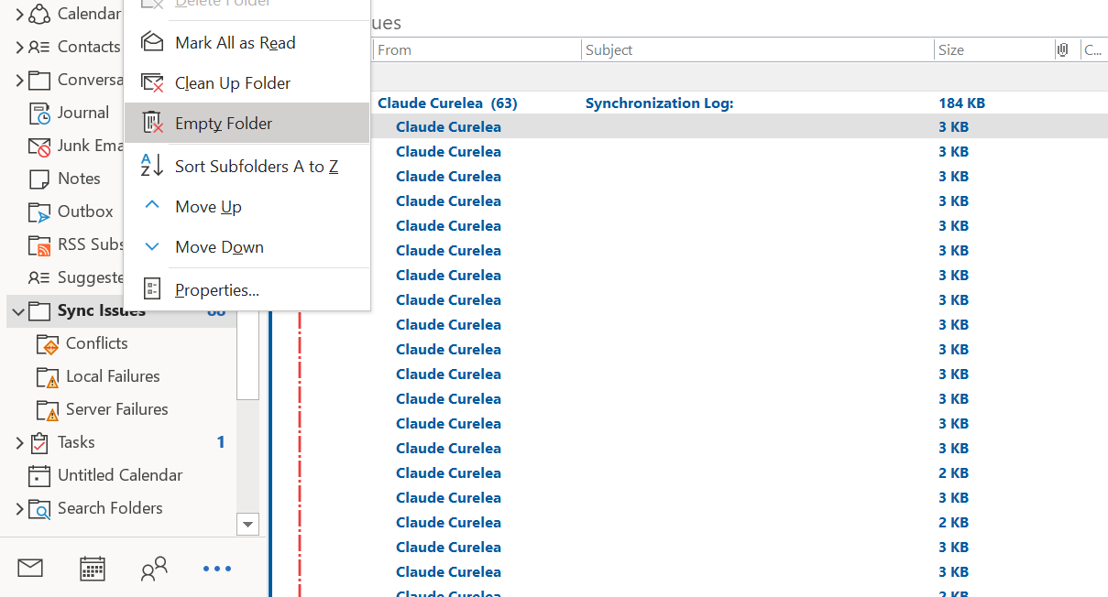

Select “Yes” at the prompt to delete all the contents of the folder.

For assistance with this function please contact the IT Service Desk on 8571-5102.

