Deleting Calendar History in Outlook®

To see how much of your mailbox size is taken up by Calendar

In Outlook, click on the File Tab, select the Cleanup Tools button and select Mailbox Cleanup. In the Mailbox Cleanup menu, select the View Mailbox Size button and find the Calendar entry. For example, if your Calendar size is 50000 KB, it means that your calendar data is taking up 50 Megabytes.

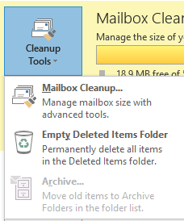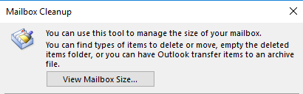
1
22
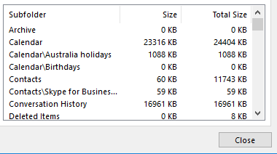
3

Deleting Calendar History

To delete old calendar items in Outlook: From the Calendar, click on the View Tab, select the Change View icon and then the List icon. Click on the Start column to sort your appointments by their start date. Scroll to an appointment that you would like to make the cut-off point and select it. Then scroll to the oldest appointment in your list and hold the Shift key as you click on that appointment. With all the appointments in between those dates selected, press the Delete key to delete these older appointments.

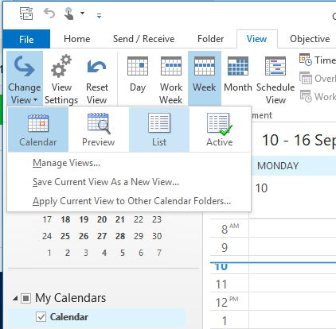
1
2
3
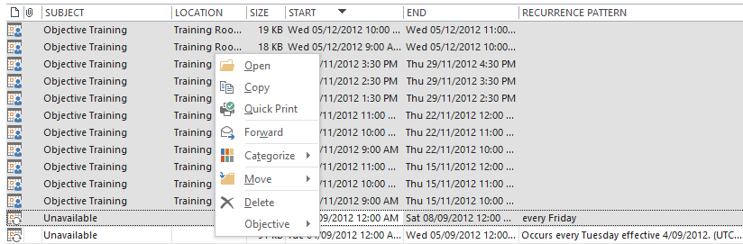

If you need further assistance with this function, please contact the IT Service Desk on 8571-5102.

