Please note
- Please only save aliases into Connect Share Folders. This ensures that documents are kept in their original location.
- If internal (CGD Staff) require access to the share folder, please send an Objective reference of the folder to itservicedesk@cgd.vic.gov.au and permissions will be adjusted.

Creating an Objective Connect Share in Objective ECM Navigator
- Log into Objective and open your Function Folder (Red)
- Inside your function folder, there should be a Connect Workspaces folder.
  - If there is not, please advise IT.
- Right click on > New > New Folder
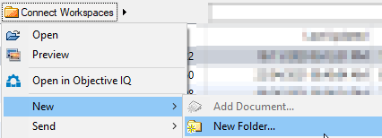
- This will open the “Create New Folder” window
  - Name your folder and click OK
  - Your folder will now be created.
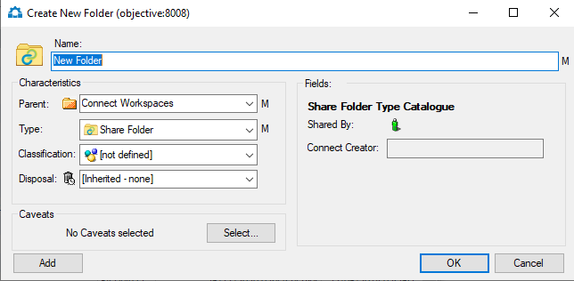

- Right click on your newly created Share Folder and select “Collaboration Share”
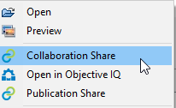

- If you are presented with a “Sign in” pop up, please enter your CGD username and password
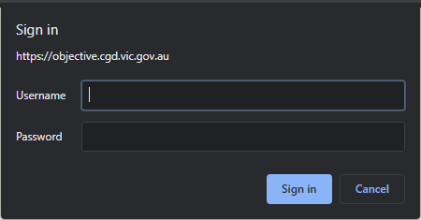

- Once you are logged into Objective Connect, you can invite your external (Non-CGD) participants and provide the relevant access.
  - Highlight the access you wish to allow. Anything that is Blue, is allowed by the participant.
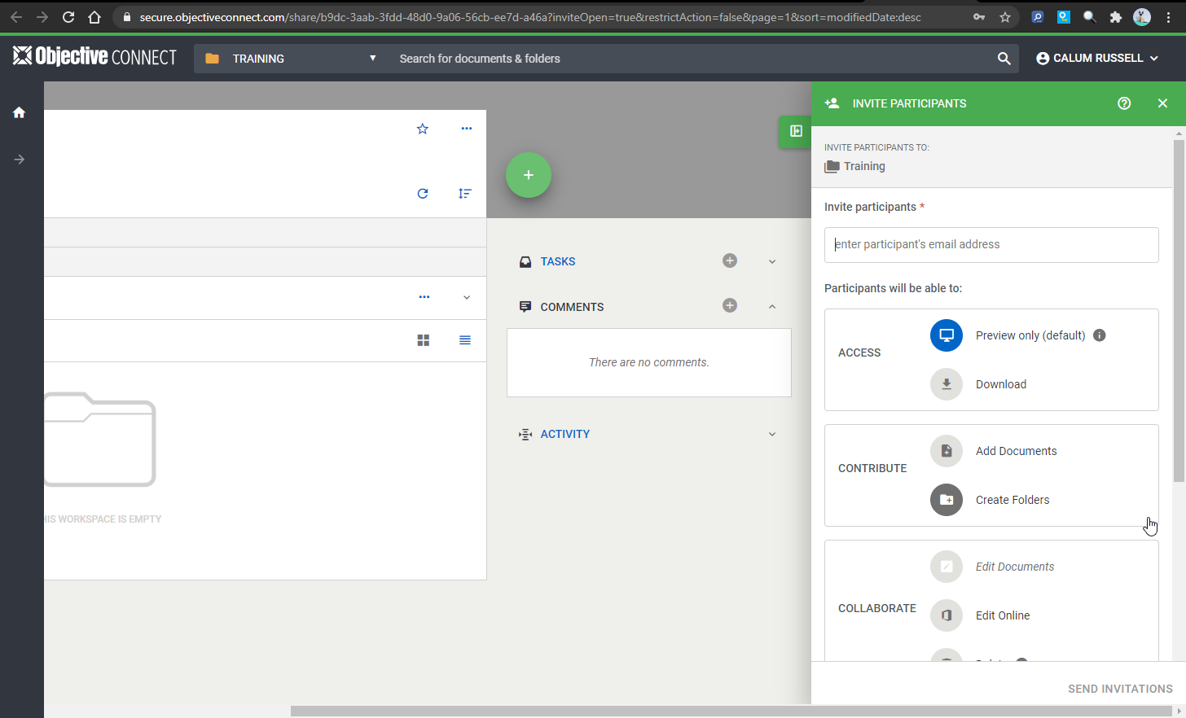
- Once you have added all the emails and selected the access, click “Send Invitations”.

Creating an Objective Connect Share in Objective ECM for Browser
- Log into Objective ECM for browser: https://objective.cgd.vic.gov.au/
- Open your Function Folder (Red) 
- Inside your function folder, there should be a Connect Workspaces folder.
  - If there is not, please advise IT.


- Open the “Connect Workspaces” folder and click on add new 
  - Select “Create Object”
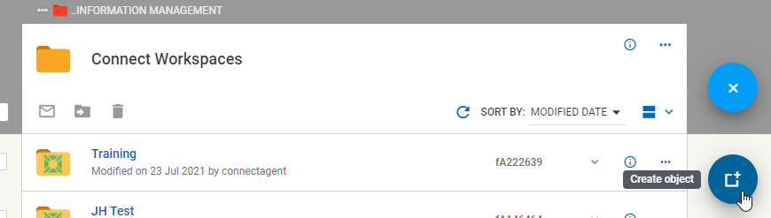
  - Select “Folder”
  - Name the folder and click “Create”
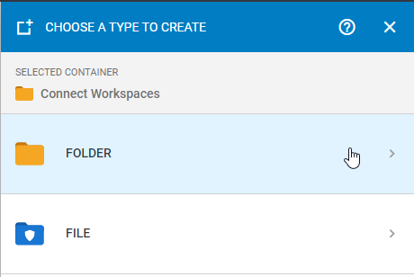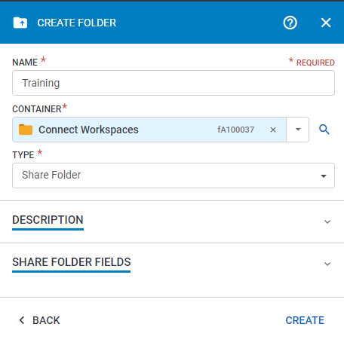

- For the Share folder you just created, open the menu (3 dots) and select “Create Collaboration Share”
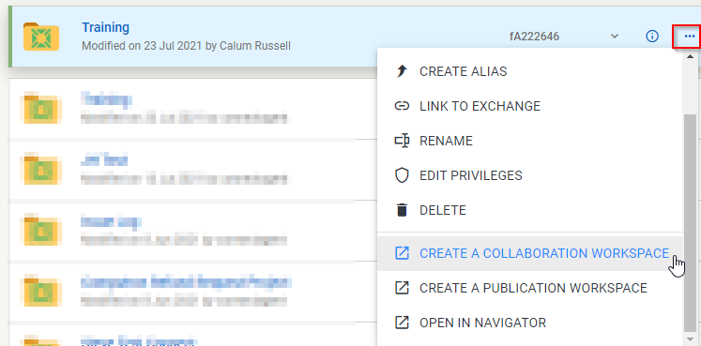

- If you are presented with a “Sign in” pop up, please enter your CGD username and password

- Once you are logged into Objective Connect, you can invite your external (Non-CGD) participants and provide the relevant access.
  - Highlight the access you wish to allow. Anything that is Blue, is allowed by the participant.
- Once you have added all the emails and selected the access, click “Send Invitations”.

Adding documents into your Connect Share
- In Objective ECM Navigator
  - Drag and drop documents into your share, while holding the “ALT” key on your keyboard. Holding the ALT key will create an alias.
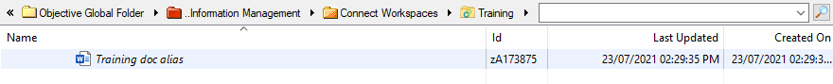
- In Objective ECM for Browser
  - Drag and drop documents into your share, next to the share name. The area should turn a shade of blue
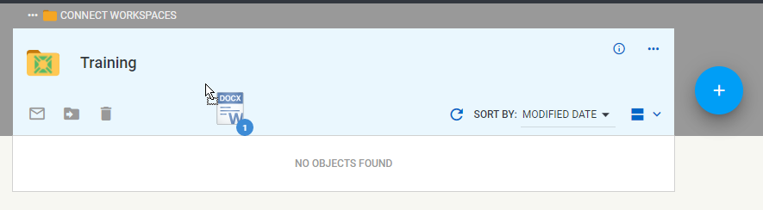
  - Select “Alias” in the Move Objects pop up
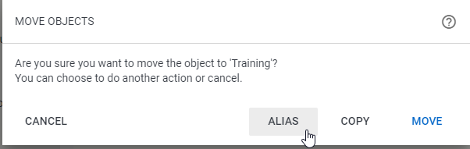
  - The alias will now appear in the share and a success banner message will display.
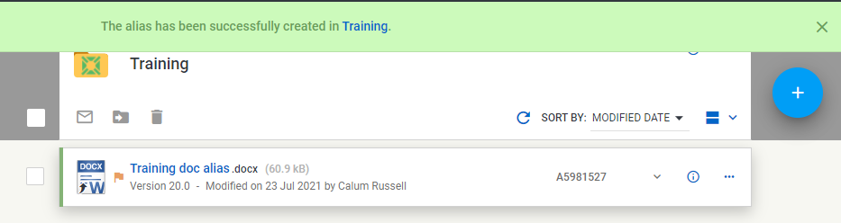

Managing your Connect Share
Only the share owner can manage the connect share participants. If you perform these steps, but cannot see or edit the share, you must not be the share owner.

- Log into Objective Connect: https://secure.objectiveconnect.com/
  - Enter your email address and click “next”
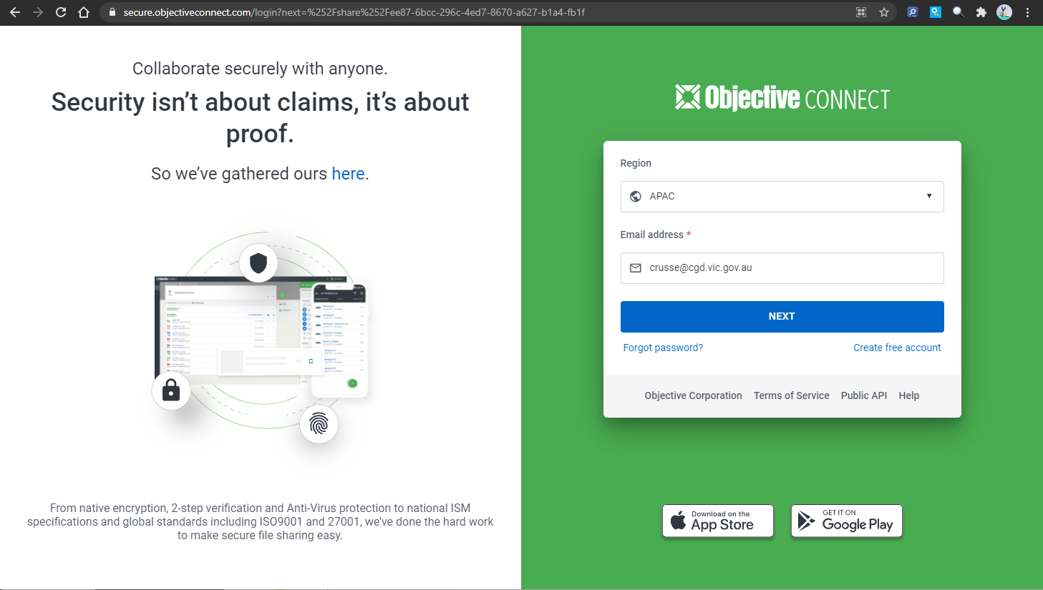
  - If you are on our network, you will be automatically signed in – Continue to step 2.
  - If you are not on our network, you will be asked to authenticate via Microsoft
  - Enter your email, click next and enter your password.
  - You will then need to approve your login via your Authenticator app on your mobile device.
  - You will be logged in once you have Approved the authentication request.
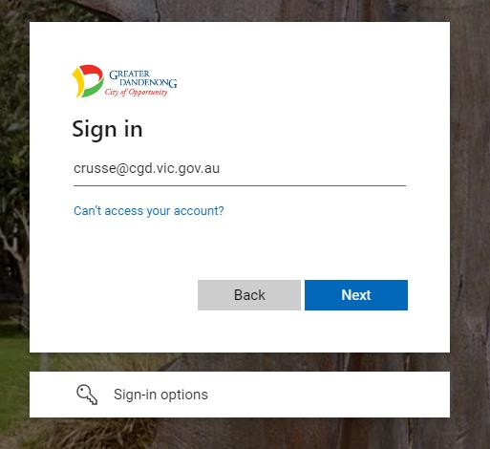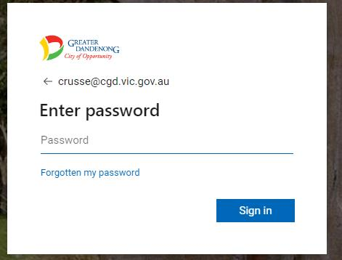

- After logging in, you will be presented with your Connect Dashboard
  - You will see a list of workspaces you are a part of.
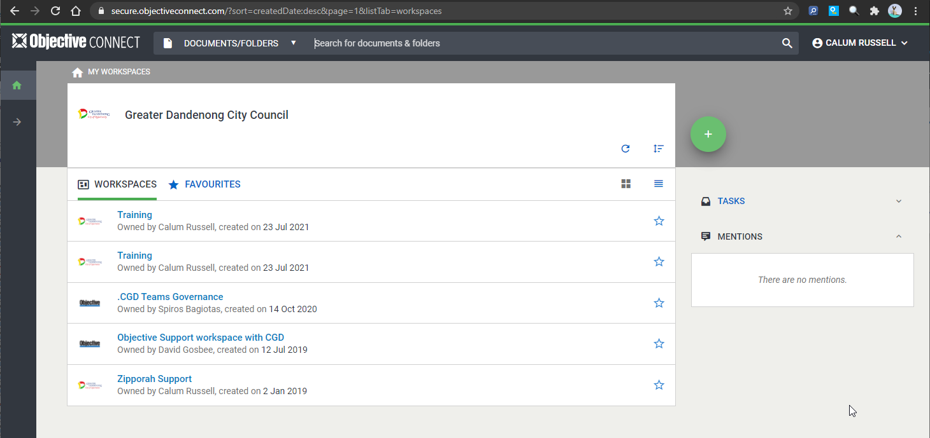
- Click into the workspace you wish to maintain.
- You will now see the Connect workspace.
  - Expanding the “Participants”, “Tasks” and “Activity” sections will provide you with more information.
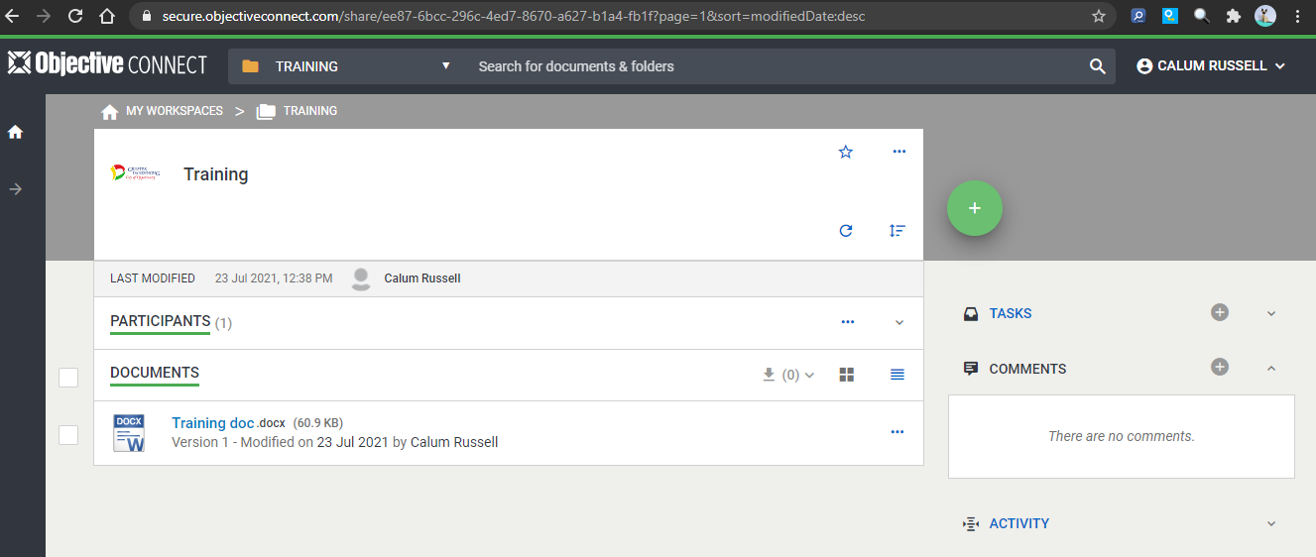

Managing your Connect Share Participants
Adding Participants
- Click on the Green and White “Plus Icon”, then select add participants.
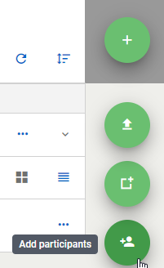
- The Participants blade will open. From here, you can invite your external (Non-CGD) participants and provide the relevant access.
  - Highlight the access you wish to allow. Anything that is Blue, is allowed by the participant.
- Once you have added all the emails and selected the access, click “Send Invitations”.

Removing Participants
- Expand the “Participants” section
- Select the 3 dots next to the participant’s name
- Select “Remove Participant”
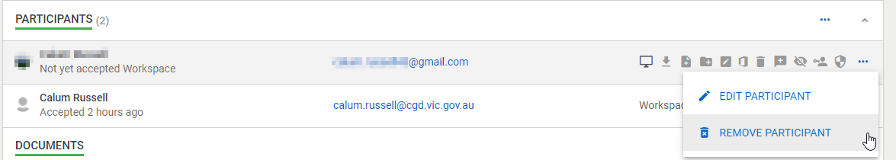

Managing your Connect Share Workspace
We request that all workspaces not longer in use are closed.
- Click on the 3 dots in the upper area of the Workspace page
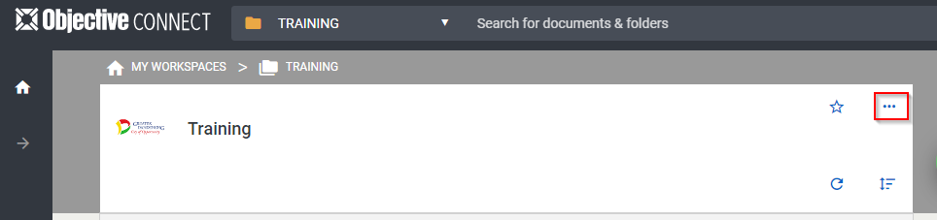
- Select “Close Workspace”
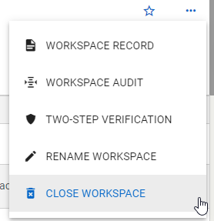
- You can choose to close the Workspace now or schedule the closing date.
  - Choose your selection and click Proceed
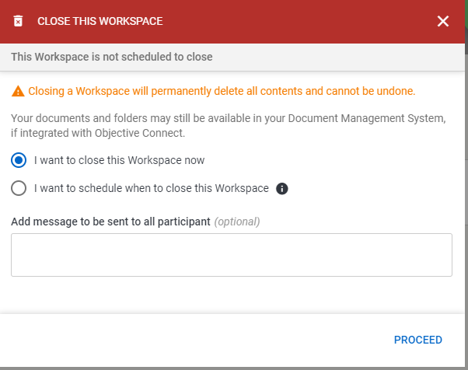

- You can choose to produce reports on Workspace activity.
  - Choose your selection and click Close Workspace
  - If you selected either or both reports, they will be downloaded to your computer.
