Using the Surface Hub in a Meeting

Schedule a Meeting
- Create the meeting in Microsoft Outlook® and press the Teams Meeting  button to make sure It is a Microsoft Teams meeting.
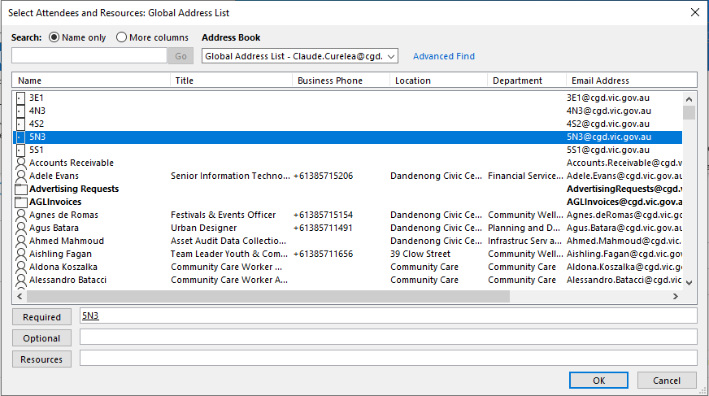
- Invite participants in the usual way and be sure to invite the Surface Hub by pressing the Required button selecting the room where it is stored.
(Tap the Surface Hub screen and the room it is associated with will appear in the bottom-left corner).
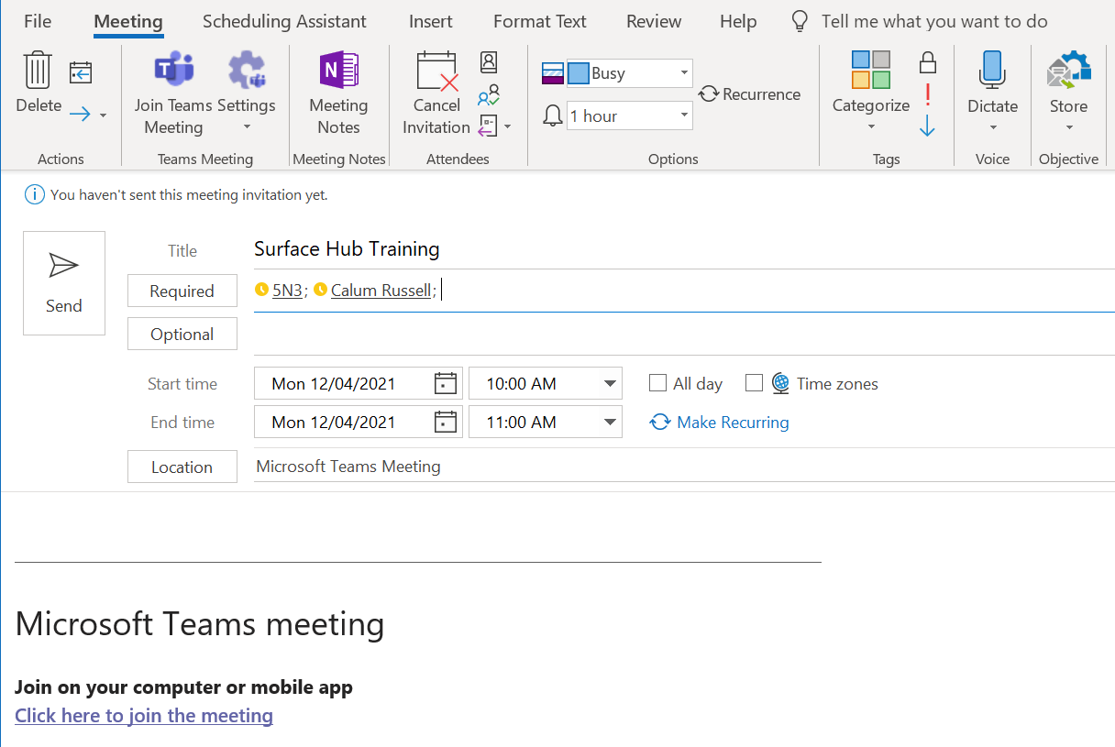
- Send your meeting invitation out in the usual way.

Starting a Scheduled Meeting

Joining a Meeting from a Surface Hub
- Tap on the Surface Hub screen.
- Click the Join button next to your meeting to join the meeting.
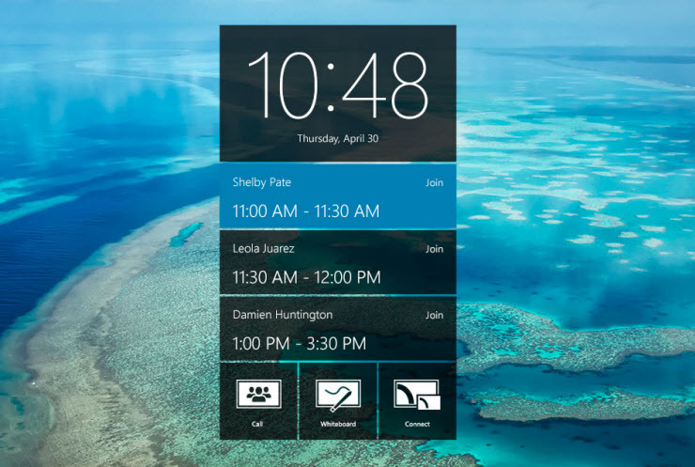
- If you meeting is not listed, press the Start (Windows logo) button on the bottom-centre of the Surface Hub and press the Microsoft Teams button to start the Teams app. The meeting should now be listed.

NOTE: On portable Surface Hubs the meeting will appear as tentative, but you can still press the "Join" button to start the meeting. If you do not see the Join button, you will need to open the meeting from Outlook on your PC and click the "Teams Meeting" button and then the "Send Update" button.

- You will now be in the meeting and can press the End session button to end the meeting when it is finished.

Share the Surface Hub screen during a meeting
- From the Surface Hub Microsoft Teams app Select Share. You’ll see a yellow outline around the content you’re presenting on the screen.
- To stop sharing without hanging up, select Stop Sharing.

Add someone to a call or meeting on Surface Hub
- Select Show participants from the Microsoft Teams app on the Surface Hub.
- Enter the name or email address of the person you want to add in the box that says Invite someone field or alternatively dial the phone number of the person you want to add.

Wirelessly connecting to a Surface Hub from a laptop
- On your Windows 10 device, press the Windows Key + K.
- In the list of devices, select the one that matches the name of the Surface Hub in the room. (Tap the Surface Hub screen and the room it is associated with will appear in the bottom-left corner).
