RISK MATRIX (including Consequence and Likelihood Tables)

 |  | CONSEQUENCE
 |  | Insignificant  1 | Minor  2 | Moderate  3 | Major  4 | Catastrophic  5
LIKELIHOOD | Almost Certain  5 | M | H | E | E | E
LIKELIHOOD | Likely  4 | M | H | H | E | E
LIKELIHOOD | Possible  3 | L | M | M | H | E
LIKELIHOOD | Unlikely  2 | L | L | M | M | H
LIKELIHOOD | Rare  1 | L | L | L | M | H

Extreme | Critical risk  Immediate action required.  Requires timely reporting and oversight by Executive Management Team and Senior Management
High | Significant risk  Senior management attention needed.  Managed within existing Directorate.
Moderate | Medium risk  Management responsibility must be specified.  Managed within Department.
Low | Low risk  Manage by routine procedures.

Consequence | Insignificant | Minor | Moderate | Major | Catastrophic
Reputation | Letters to suppliers, clients or local/state press | Series of articles in local/state press | Extended negative local / state media coverage | Short term negative nation-wide media coverage | Extended negative nation -wide media coverage
Regulatory Compliance | Minor breaches by individual staff members | No fine – no disruption to service delivery.  Formal discussion & correspondence requiring formal response | Minor or single regulatory breach.  Fine but no disruption to service delivery | Regulatory breach.  Fine and short term disruption to service delivery | Significant or several regulatory breaches resulting in legal action or ministerial inquiry.  Significant disruption to service delivery over an extended period
Financial Impact | Less than $5,000 | Between $5,001 - $19,999 | Between A$20,000 – A$249,999 | Between $250K - $500,000 | Between $501K -  $20 Million
Assets, Security & Infrastructure | Infrastructure or asset is subject fails causing minor delays and is subject to routine maintenance | Failure of infrastructure and asset creates slight inconvenience to users | Part of infrastructure creates a danger to employees or public in immediate vicinity. | Partial destruction/collapse and denial of access to asset or infrastructure | Complete destruction/collapse and denial of access to asset or infrastructure
People, Safety (incl. public safety) & Environment | Injuries or ailment not requiring medical treatment i.e. FAI  Minor environmental impact.  Contamination – on-site release contained within short time frame. | Medical treatment Injury.  (MTI)  Transient environmental impact with minimal cost  To restore. | Injury causing hospitalisation and or Lost time Injury (LTI).  Transient environmental impact requiring clean-up work.  Contamination – on-site release contained with outside assistance | Serious or life threatening injury or multiple serious injuries causing hospitalisation.  Significant harm requiring restorative work.  Contamination – off-site release with no detrimental effects. | Single or multiple deaths.  Long term harm with major irreversible damage.  Toxic release off-site with detrimental effect or loss of ecosystem functions across species and landscapes.
Business Continuity | Brief loss of service. Minor errors in systems or processes requiring corrective action, or minor delay without impact. | Localised loss of service for up to one day. Inconvenient, but does not impact service delivery. | Critical service loss for more than one week. Key accountability requirements not met. Services do not fully meet needs. | Critical service loss for up to one month. | Critical system failure. Business severely affected with interruption exceeding 1 month in duration.
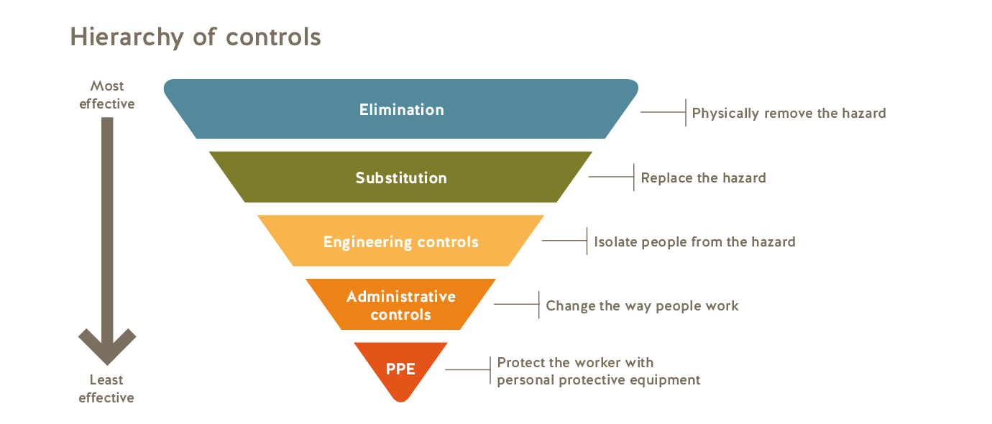

LIKELIHOOD

Almost Certain
Has a 90% chance of occurring in a given year
Likely
Has a 50% chance of occurring in a given year
Possible
About a 25% chance of occurring in a given year
Unlikely
About a 10% chance of occurring in a given year
Rare
May occur in exceptional circumstances

