Website: www.jetcouriers.com.au

Logon: cgda
Password: cgd3175

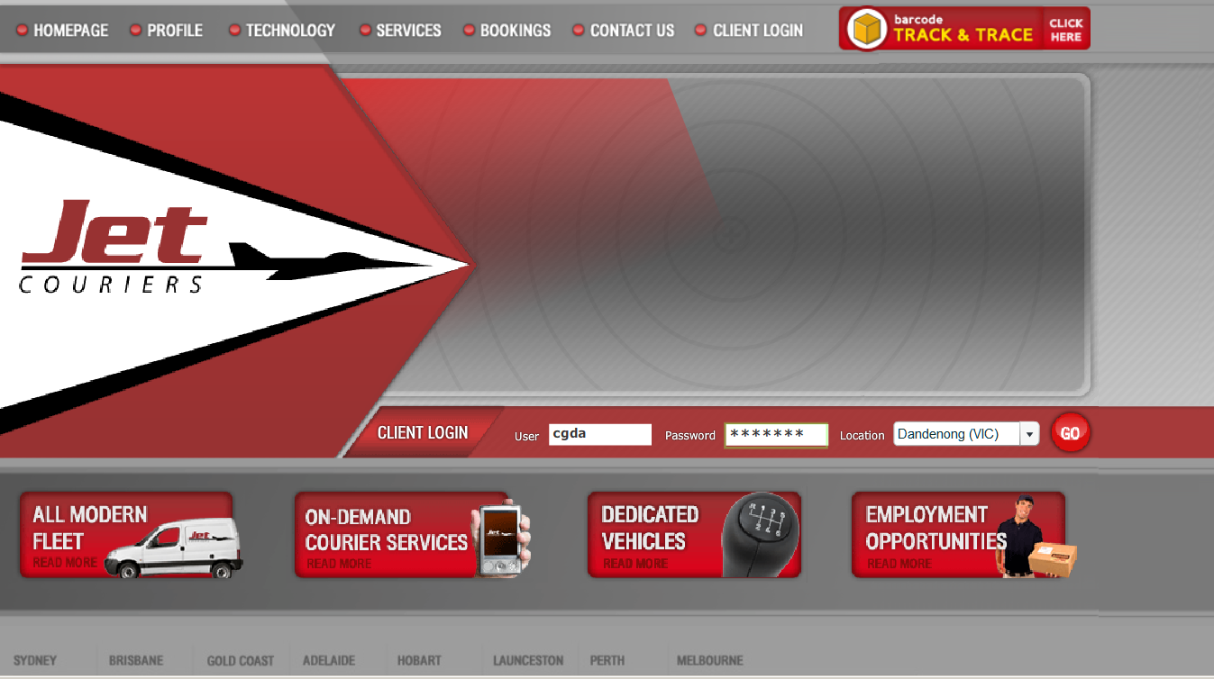
Location: click on drop down box to select Dandenong then click on GO
Client Login: cgda
Password:
cgd3175
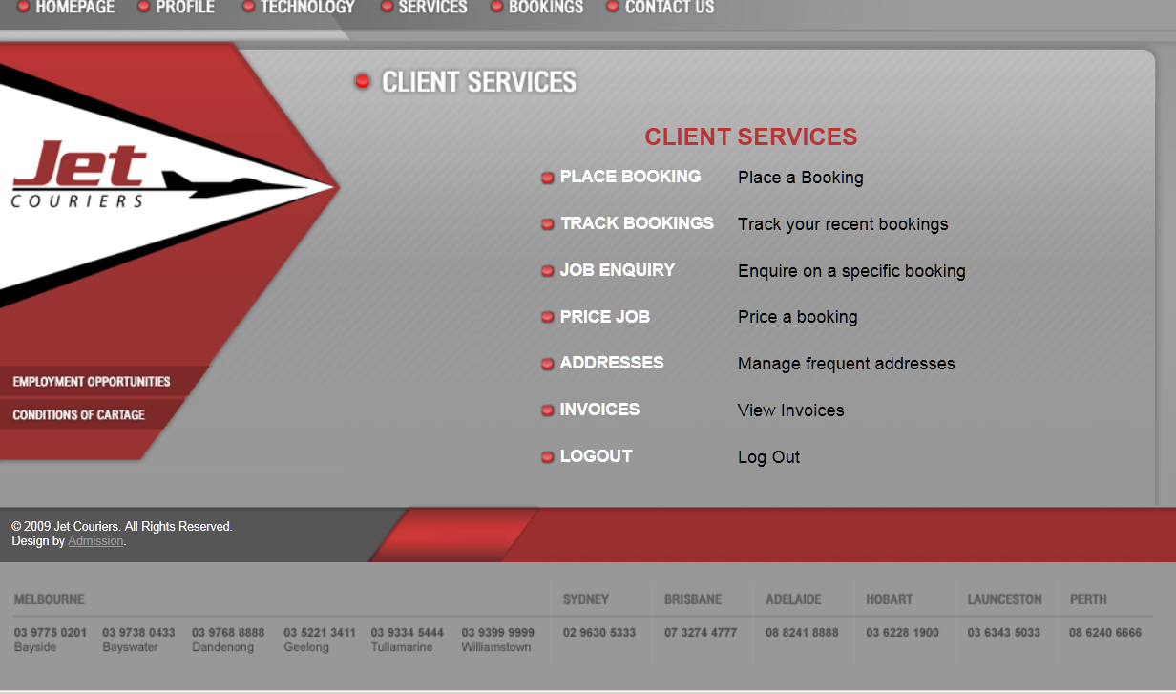
Click on PLACE BOOKING to book a courier

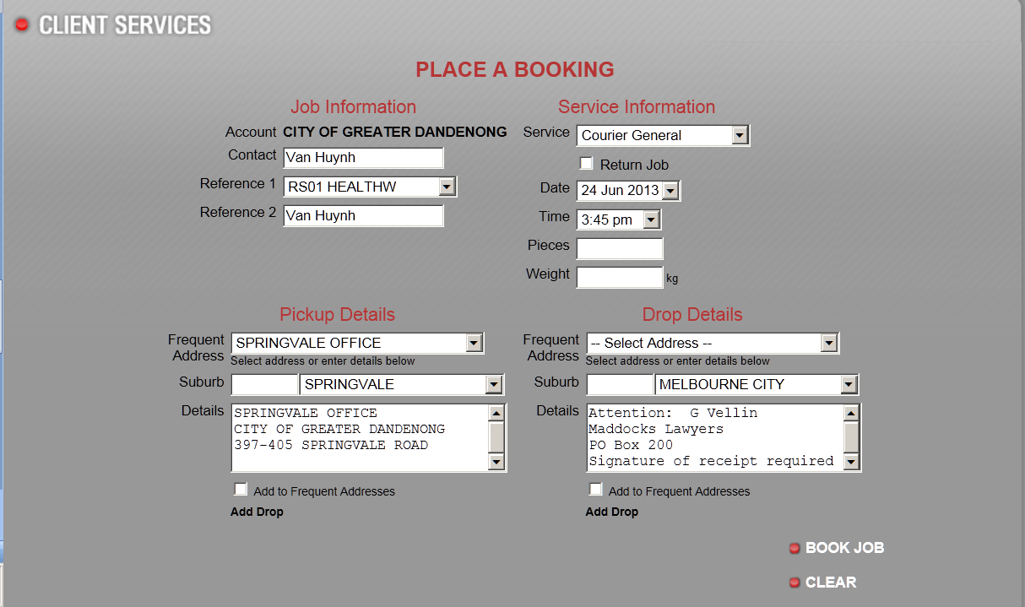
Click on drop down box and find your department code (Computron code) then select it.
Choose which location to be picked up by clicking on the drop down Frequent Address
Enter the Addressee and Company Details (and if you required signature note)
Click on the drop down and choose the Suburb
Once you enter all detail, select BOOK JOB to book a courier
Please enter your name in Contact & Reference 2
Click on the drop down box and select the Service you want to book:
General: Delivery within 4 hours
Express: Delivery within 2 hours
Direct: Direct delivery picked up within 30 minutes and delivered without delay

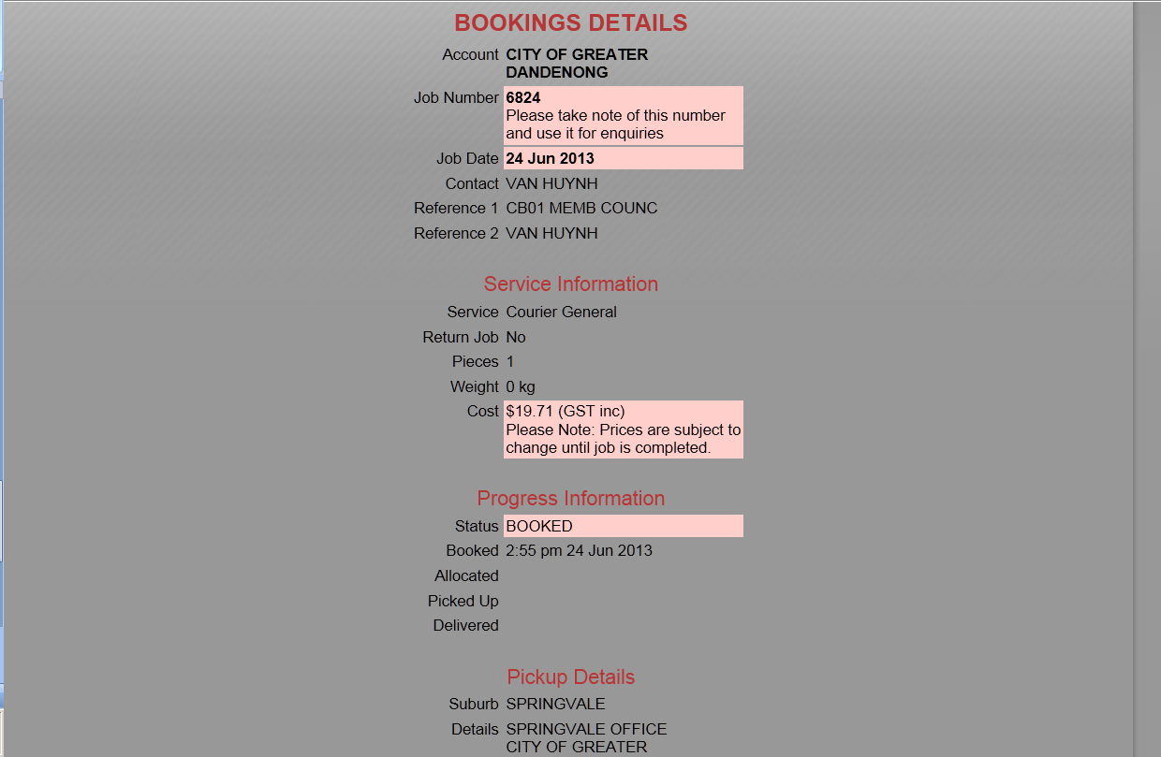
Write the Job Number on the Bottom Right hand corner of the envelope or parcel

