How do you set your speaker/ringer within MS Teams?
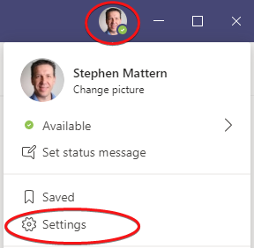
- Click on your image at the top right-hand side of the MS Teams window, then select Settings

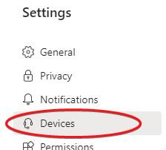
- Then click Devices.

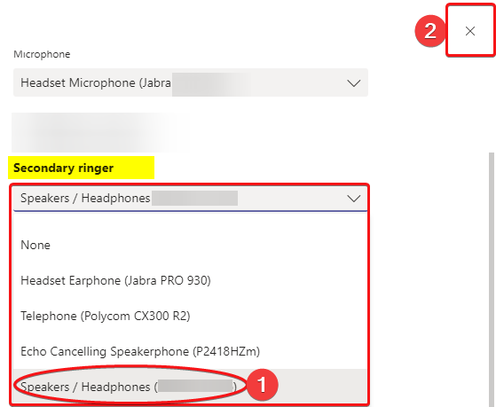
- Scroll down to “Secondary Ringer” and (1) Select the device used as your computer speaker
(this is typically listed as Speakers/Headphones) *Please make a test call to confirm this is working*
(2) Close this window to complete the change.

