How do you manage your incoming calls within MS Teams?
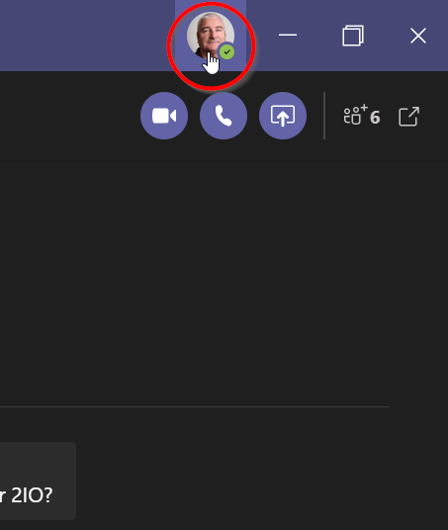
- Click on your image at the top right-hand side of the MS Teams window.
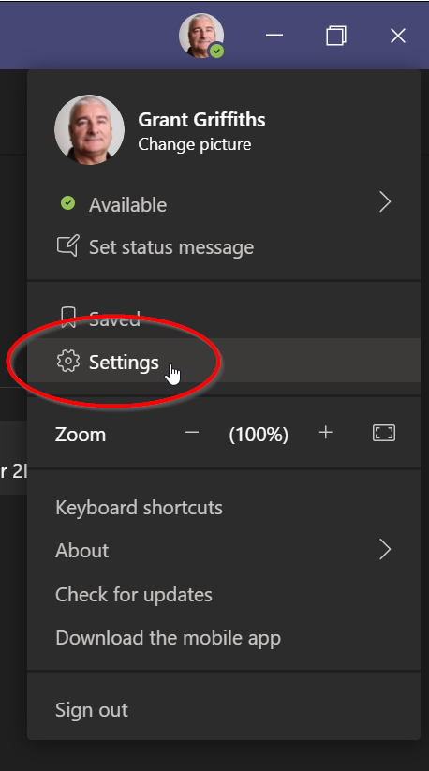
- Then click on Settings.
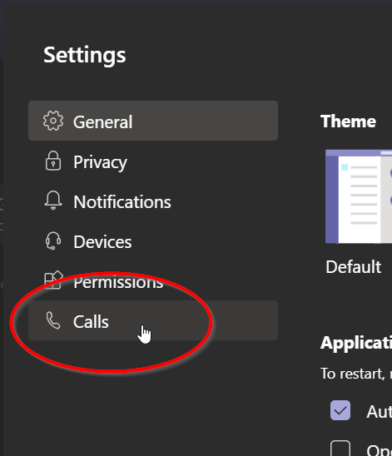
- Then click on Calls.
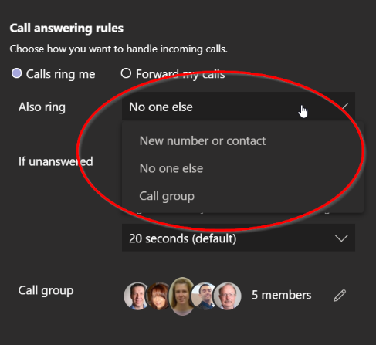
- Here you can decide to have a call also ring another number/contact, no one else or a Call group. Be aware that the incoming call will ring at the same time as ringing you e.g. there is no delay. If you decide on a Call group, you will need to create it first.
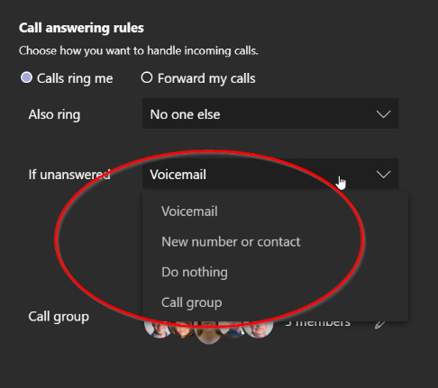
- Here you can decide what happens to the incoming call if it doesn’t get answered. You can forward the caller to voicemail (if you have it), to another number/contact, do nothing or to a Call group.
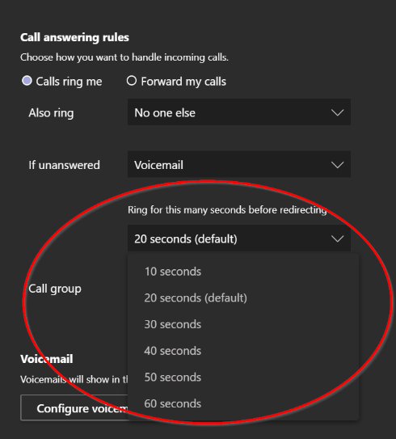
- You can also decide how many seconds before the caller is redirected.
- Please note if you wish to forward your unanswered calls to Customer Service the number is 85711557.

