How to Send faxes with Gofax

The new fax system is entirely email-based, using an external Cloud Fax provider called Gofax.

There are two options to send a fax:
- Create a new email in Outlook and attach a document you want faxed, or…
- Simply type the information into the body of a new Outlook email

Faxing an attached document
- In Outlook, create a new email.
- In the TO: field, enter the recipient’s fax number followed by @send.gofax.com.au eg:
- Enter a Subject line
- In the email body, type the recipient name, company name and any message or other details you want. This will effectively be your “Cover Page”
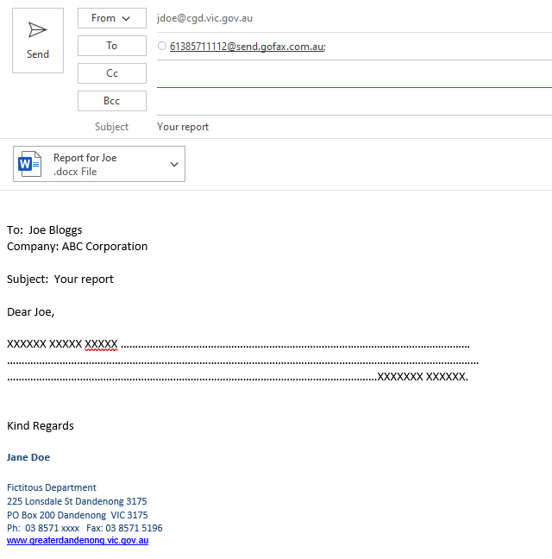
- Attach the document and send the email

Faxing without an attachment:

- In Outlook, create a new email.
- In the TO: field, enter the recipients fax number followed by @send.gofax.com.au eg:
- Enter a Subject line
- In the email body, type the recipient name, company name and any message or other details you want. This will effectively be your “Cover Page”

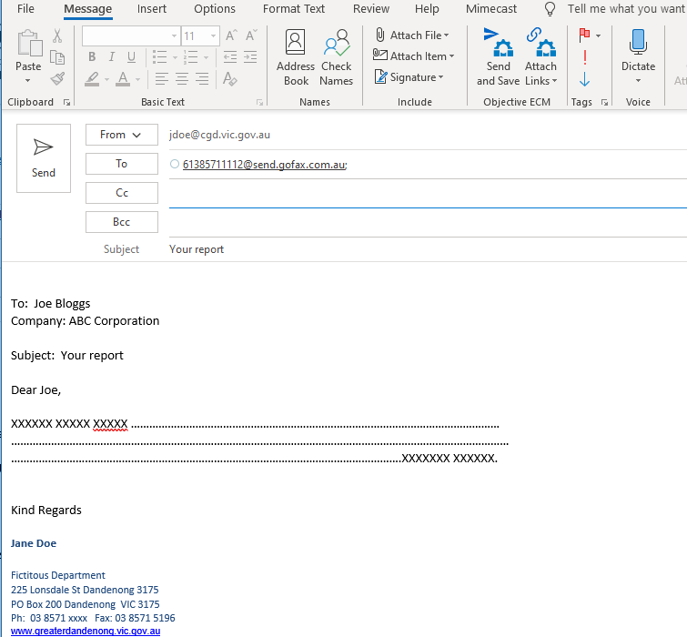

FAQ’s

Q. How do I know the fax was successful?

When the fax has been sent, you will receive an email informing you of the success or failure to send the fax.

Q. Can I find faxes I have previously sent?

You will have these in your Outlook Sent Items. It is your responsibility to save any faxes which are of Corporate Value in Objective.

Q. How do I receive a fax?

Incoming faxes via our CGD fax number (8571 5196) are routed via email to Records, who distribute them via email. This process

