39a Clow Street Dandenong

Reviewed: January 2016
Next Reviewed: January 2017
Emergency Response Procedures
Emergency Response Procedure 2
Building Emergency Officer: 2
Deputy Building Emergency Officer: 2
Building Emergency Officer (BEO) or Deputy 3
If an Emergency is declared 3
In the Event of a Bomb Threat, Receiving Suspect Mail or following an Armed Holdup or Siege 4
Handling Suspect Mail 5
Advice to Media 6
Customer Service Desk 7
Evacuation 7
Customer Service Check List 8
Ground Floor 9
Staff Checklist 10
First Floor 11
Staff Checklist 12
What are my responsibilities in an emergency? What should I do? 13
Do’s and Don’ts 14
Fire Prevention Principles 15
Fire Fighting Equipment 17
Armed Hold-Up or Siege 19
Precautions 19
For Your Protection 19
Observations 20
EMERGENCY TELEPHONE NUMBERS 21
Isolate The Scene 21
Detailed Statement: 21
Physical Description 22
Bomb Threat 23
Telephone Threat 23
Handling Suspect Mail 25
Advice to Media 26
Telephone Bomb Threat 27
Displayed Procedure 30
Ground Floor Plan 31
First Floor Plan 31

Emergency Response Procedure
In the event of an emergency arising during normal office hours, all staff are requested to notify the Building Emergency Officer or Emergency Services immediately (Extension 1619 or Telephone 000 ).
Details required will include:
- Type of emergency (ie. Fire, bomb threat, etc.).
- Exact location and extent of the problem.
- Number of people injured.

DO NOT HANG UP BEFORE STAFF OR EMERGENCY SERVICES have acknowledged that sufficient information has been supplied and understood.
The Building Emergency Officer (B.E.O.) or Floor Warden on location may co-ordinate the response.

Emergency wardens will wear their warden’s hat, carry a torch and megaphones as supplied.
Practice Evacuations will be conducted at six monthly intervals to maintain staff awareness of these procedures.

Building Emergency Officer:
Katharina Verscharen
03 9793 2155
(Internal Extension) 1619

Deputy Building Emergency Officer:
Jessica McKenna
03 9793 2155
(Internal Extension) 1643
Emergency Services Telephone 000

Building Emergency Officer (BEO) or Deputy

ALL PERSONAL ARE ADVISED
DO NOT attempt to combat a fire, or other emergency unless this can be achieved without placing yourself or others at further risk.
It is essential that Emergency wardens wear their warden’s hat, carry a torch and megaphone as supplied.
Where a partial or total evacuation of the building is indicated, the following steps are recommended.

If an Emergency is declared
- The Building Emergency officer and/or Deputy will endeavour to discover the reason for the emergency and determine the necessary response.
- Ensure | Emergency Services | have been notified, as necessary.
(Identify location of emergency and suggest nearest building entrance.)
- Advise Wardens and Staff of required actions, using the siren / megaphone.
- If practicable, station a warden or staff member outside the building to prevent unauthorised access.
- Meet with Emergency Services personnel and assist where possible.
- At the conclusion of the emergency, assemble emergency staff to review procedures, de-brief staff and if necessary, arrange counselling to affected staff or the public. Each organisation within the building are responsible for arranging counselling of their staff.

In the Event of a Bomb Threat, Receiving Suspect Mail or following an Armed Holdup or Siege
- Notify the Emergency services 000
- Close the premises to the public.
- To avoid unnecessary concern or panic, only Emergency wardens and senior management should be made aware of the potential problem.
- Isolate the area from all personnel until the Police arrive.
- If applicable, ask witnesses to remain for the Police to interview.
- Do not make any statements to the Media.
- Mobile phones must not be used as a means of communication during a search procedure.

Where time permits
- The information gathered from the “Bomb threat” caller will be discussed between the person who received the threat, the Building Emergency Officer and Emergency Services and a decision made regarding evacuation.
- It is usual for a search of the building to be conducted by the Emergency Services personnel and selected staff before an evacuation is ordered.
Statement of Events
- As soon as possible after the event, complete a detailed statement of the events leading up to, during and following the incident. Refer to Council’s electronic form on WebStar > Health, Safety and Risk > Building Emergency Procedures and Guidelines > Post Incident Debrief.
- Witnesses should complete independent statements without comparing their observations with others.

Statement of Events
- As soon as possible after the event, complete a detailed statement of the events leading up to, during and following the incident. Refer to Council’s electronic form on WebStar > Health, Safety and Risk > Building Emergency Procedures and Guidelines > Post Incident Debrief.
- Witnesses should complete independent statements without comparing their observations with others.

Handling Suspect Mail
It is important that no attempt should be made to move or open a suspect package.
- Telephone or contact the person to whom the item is addressed and ask if they are expecting such a package.
- Contact the sender if a name and address is on the outer wrapper, and ask for details of the contents, or order number for any materials it may contain, etc.
- Should any package emit noise, eg. Ticking, sizzling, hissing, etc., it must be left alone, the area evacuated and the authorities informed.
- where possible, doors and windows should be left open to reduce the effect of an explosion.
- Under no circumstances should it be immersed in water, hosed or placed where it may become wet. Other points to be observed are:
- There must be no attempt to move, open or tamper with it.
- The suspect item should be clearly visible to the authorities on arrival.
- The package must not be exposed to high temperatures, vibration, flammable materials, power, gas or fuel lines.
- All electrical appliances must be switched off in the immediate vicinity and mobile telephones and radio equipment must not be operated within 100 metres. This measure is to avoid accidental activation of electronic timing devices used with explosives.
- Measures must be taken to ensure that staff cannot approach to within 30 metres of the suspect item.

Advice to Media
Information concerning Bomb Threats or suspect packages, Armed Holdup or Siege should not be given to the media. Apart from causing unnecessary worry to relatives and staff, it could easily lead to an increase in similar emergencies or hoaxes. Under no circumstances should Security Instructions or Procedures be reported or detection equipment photographed.
At the conclusion of the emergency, assemble emergency staff to review procedures, debrief staff and if necessary, arrange to provide counselling, through Organisational Development, to affected staff or the public.

Emergency Services Telephone 000

Customer Service Desk
ALL PERSONNEL ARE ADVISED
DO NOT attempt to combat a fire, or other emergency unless this can be achieved without placing yourself or others at further risk.
- All wardens’ instructions are to be followed precisely.

Evacuation
1. Notify | Emergency Services | as necessary.
(Advise of Location of emergency and building entrance services should use)
2. | Advise First Floor occupants of the emergency using the siren / megaphone
3. | Notify all staff and occupants using the siren / megaphone
4. | Save Computer work, secure cash and documents
5. | Evacuate * Ground Floor Area
6. | * Toilets
7. | * Meeting Rooms
8. | Exit via the nearest safe exit
9. | Limit access by stationing a warden within view of the door to prevent unauthorised entry through Front entrance
10. | Unless otherwise directed or indicated by the nature of the emergency evacuate staff and members of the public to the “Assembly Point B” in Pioneer Memorial Gardens, East of Market Carpark  or “Assembly Point C” whichever is the safer alternative
11. | Ensure that all evacuees remain at the assembly point and are accounted for. Organisations within the building to account for their own staff
12. | Report any missing personnel to the Officer in Charge of the Emergency Services.

Customer Service Check List

NATURE OF EMERGENCY

FIRE ARMED HOLD UP BOMB THREAT CHEMICAL SPILL
GAS LEAK BUILDING COLLAPSE FLOOD/STORM DAMAGE
OTHER

TIME .................................................................

LOCATION AND EXTENT OF EMERGENCY
EMERGENCY TELEPHONE NUMBERS
Fire Brigade }
Police } | 000
Ambulance }
Sam Criticos | 8571 5126 / 0428 399 219
Damian Karaitiana | 8571 5344 / 0419 100 542
Bobby Liew | 8571 5368 / 0417 308 821
Dandenong Municipal Office | 8571 1000
Dandenong Library | 1300 630 920
United Energy | 132 099
Gas Emergencies | 132 691
State Emergency Services VIC | 132 500
South East Water | 132 812
Poisons Information Centre | 131 126
Telephone Interpreter Service | 9280 1941
City of Kingston | 1300 653 356
City of Casey | 9705 5200

Emergency Services Telephone 000

Ground Floor

ALL PERSONNEL ARE ADVISED
DO NOT attempt to combat a fire or other emergency unless this can be achieved without placing yourself or others at further risk.
- It is essential that Emergency wardens wear their warden’s hat, carry a torch and megaphone as supplied.
- Wardens may deputise other willing members of staff to assist.
SUGGESTED EMERGENCY EVACUATION PROCEDURE
- Evacuate personnel from the immediate vicinity.
- Call for assistance
- Notify Building Emergency Officer (during office hours Ext 1619) otherwise point 4 below, giving details of the emergency.

4. Notify | Emergency Services | Fire, Police, Ambulance. Telephone 000

- Evacuate areas surrounding the emergency.
- Areas to be evacuated by the Area Warden.
* | Offices
* | Store room
* | Kitchenette
* | Meeting Rooms
* | Toilets

- Limit all access to buildings until Emergency Services have cleared the building for occupancy.
Unless otherwise directed or indicated by the nature of the emergency evacuate staff and members of the public to the “Assembly Point B” in Pioneer Memorial Gardens, East of Market Carpark or “Assembly Point C” west of the Municipal Offices (or safe alternative)
- Account for all personnel and report to Building Emergency Officer or Emergency Services, any person not accounted for.

Staff Checklist
Ground Floor
NAME | MON | TUES | WED | THUR | FRI | Accounted for
Youth Services
Reception | 9-2 | 9-2 | 9-2 | 9-2 | 9-2
Katharina Verscharen | Y | Y | Y | Y | Y
Jessica McKenna | Y | Y | Y | Y | Y
Sylvia Marov | Y | Y | Y | Y | Y
Simone Perkin | X | Y | X | Y | Y
Mark Carter | Y (fortnightly) | Y | Y | Y | Y
Jess Spargo | Y | Y | Y | Y | Y
David Mackin | Y | Y | Y | Y | Y
Nick Karlas | Y | Y | Y | Y | Y
Rosemary Nelson | Y | Y | X | Y | X
Angie Sanchez | Y | Y | Y | Y | Y
Aishling Fagan | Y | Y | Y | Y | X
Edem Edusei | Y | Y | Y | Y | Y
Yohana Jury | Y | Y | Y | Y | Y
Kylie Wilmot | Y | Y | Y | Y | Y
Family Services
Andrew Chisholm | Y | Y | Y | Y | Y
Thuong Thu Nguyen | Y | Y | Y | Y | Y
Paula Glover | Y | Y | Y | Y | Y
Jane Corb | Y | Y | Y | Y | Y
Vicky Petinarias | Y | Y | Y | X | X
Angie Modeley | Y | Y | Y | X | X
Anna Adaman | Y | Y | Y | Y | Y

Updated July 2016

Emergency Services Telephone 000

First Floor
ALL PERSONNEL ARE ADVISED
DO NOT attempt to combat a fire or other emergency unless this can be achieved without placing yourself or others at further risk.
Follow the Building Emergency Officer instructions if so directed
SUGGESTED EMERGENCY EVACUATION PROCEDURE
1. Evacuate occupants from the immediate vicinity.
2. Call for assistance.
3. Notify Building Emergency Officer (during office hours Ext 6620 - Reception) otherwise point 4 below, giving details of the emergency.
4. Notify | Emergency Services | Fire, Police, Ambulance. Telephone 000

5. Evacuate areas surrounding the emergency.
6. Areas to be evacuated by all occupants. The Building Emergency Officer will announce the nature of the emergency and where to assemble.
* | Offices
* | Storeroom
* | Kitchenette
* | Meeting Rooms
* | Toilets

- Limit all access to buildings until Emergency Services have cleared the building for occupancy.

Unless otherwise directed or indicated by the nature of the emergency evacuate staff and members of the public to the “Assembly Point B’ Pioneer Memorial Gardens, East of Market Carpark, or “Assembly Point C” west of the Municipal Offices (or safe alternative)
- Account for all occupants and report to Ground Floor Warden or Emergency Services, any person not accounted for.

Staff Checklist

First Floor

NAME | MON | TUES | WED | THUR | FRI | Accounted for:
CMY
Heather Stewart | Occasionally at Dandenong
Placid Jayasuriya | Y | Y | Y | Y | Y (fortnightly)
Ruth Thomas | Y | Y | Y | Y | Y
Veronica Stanley | X | Y | Y | X | Y
Sarah Williams | X | Y | Y | Y | Y
Moses Mawira | Y | Y | Y | Y | Y
Zamera Shariffie | X | Y | Y | Y | X
Mandana Azadi | Y | Y | Y | Y | Y
Maneka Dayaratne | Y | X | Y | X | Y
Melanie Cutler | Y | Y | Y
Susan Hillman Stolz | X | Y | X | X | X
Lisa Burke | Y | Y | X | X | X

Updated July 2016

What are my responsibilities in an emergency? What should I do?

Practice Evacuations will be conducted at six monthly intervals to maintain staff awareness of these procedures.
In the event of an emergency arising in your area during normal hours of operation, all staff are requested to notify the Building Emergency Officer immediately (Katharina Ext 1619 or Jess McKenna Ext 1643)
- DO NOT leave the building unless directed to do so OR you are in immediate danger.
- If you are directed to leave the room, department or building by a particular path or exit, the instructions are to be followed immediately and without question.
- Where an emergency arises during the course of a meeting, all attendees, including visitors and members of the public, are requested to evacuate and assemble as a group to facilitate checks.
- Wardens may deputise others willing to assist.
- It is imperative that everyone remains at the nominated outdoor assembly point until directed otherwise.
- Following any emergency or evacuation exercise, you are encouraged to offer all constructive comments about the procedure to the Building Emergency Officer.

Do’s and Don’ts

Do’s

- Report unsafe electrical equipment, wiring, etc.
- Store flammable goods/chemicals in appropriate areas.
- Keep exit doors, passageways and stairs clear at all times.
- Supervise trade or service personnel and ensure awareness of safe work practices, fire extinguishers and appliance locations.
- Make yourself acquainted with the location of the nearest fire fighting appliances and how to operate this equipment.
- Report any faulty or discharged extinguishers.

Do Not’s

- Do not obscure or block access to fire services.
- Do not accumulate unnecessary quantities of paper or combustible materials.
- Fire Hoses are not to be used for cleaning or maintenance purposes
- Do not wedge doors open.

Fire Prevention Principles
“Prevention is better than cure.”
Fire requires 3 elements.
1. Combustible Material (Fuel)
2. Oxygen
3. Source of ignition (Heat)
To extinguish fire, remove 1 element.
Fuel, oxygen or ignition/heat by means of fire extinguisher, hose or blanket.
REACT - RESPOND - RAISE THE ALARM
ASSESS THE SITUATION:
- Extent of problem
- Rubbish bin, electrical appliance, part of room, building
RAISE THE ALARM:
- Alert other personnel
- Notify Emergency Services
- Fire Brigade (MFB) 000
CFA Dandenong 9792 0444
- Police 000
- Ambulance 000
DETAILS:
- Name - location of premises
- Location, type and extent of fire/emergency
- Approximate number of people present

Then turn off all unnecessary equipment and isolate the fire area by closing all doors and windows.
Consider combating the fire/emergency ONLY when this can be done without placing yourself or others at risk.

ASSEMBLE:
- Assemble in groups in Assembly Point “B” or “C”
- Checklist of staff/occupants of the building
- Always leave someone in charge of evacuees
REPORT:
Report to Officer in Charge of Emergency Services (eg Fire Brigade, Ambulance, Police):
- Any missing personnel
- Extent location of the emergency
- Action taken to date
- Facilities available that may assist Emergency Services
- First Aid
- Wardens
- Vehicles/Equipment
- Location of electrical switchboard, gas meter, water supply
- Location of any chemicals of particular hazards in the building or immediate vicinity

Fire Fighting Equipment
PORTABLE APPLIANCES ( location indicated on Floor Plan)
(Photos are examples of equipment stored within the building)
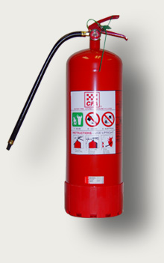
Type: Water Extinguisher (Stored Pressure)
Colour: Red
Capacity: Usually 9 litres
Effective Range: 6 Metres
Discharge Time: 60 seconds (minimum) up to 120 seconds
Not to be used on electrical or fat/oil fires
Effect: Reduces heat of combustible materials

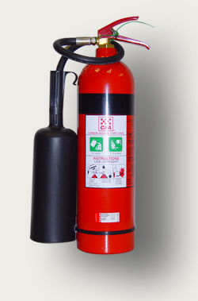

Type: Carbon Dioxide (C O ₂)
Colour: Red with black band

Used for: Recommended for electrical fires.
May damage computer electronics.
Avoid use in confined space. Ventilate area after use.
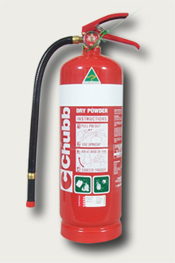

Type: Dry Chemical
Colour: Red with white band

Used for: For use on all fires including electrical

PORTABLE APPLIANCES (continued)
Type: Fire blanket
Material: Fibreglass
Used for: Smother small fires (personnel, property)
Ideal for fat fires etc., in kitchen situation.
Used as a barrier or shield from heat or flames and to smother small fires.

25mm HOSE REEL:
Used for: General purpose, except for electrical and flammable liquid fires
To operate: Turn water on at valve, run out required length of hose and open nozzle. Approach fire with water nozzle open, spray base of fire.

60mm CANVAS HOSE REEL AND HYDRANT
DO NOT attempt to operate this equipment unless fully trained or qualified.
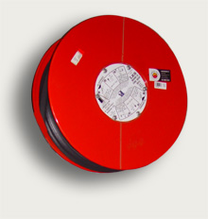

Armed Hold-Up or Siege

The main aim of this section is to reduce the risk of injury to members of staff and the public when involved in an armed hold-up or siege situation.
This suggested procedure should be followed ONLY when this can be done WITHOUT PLACING YOURSELF OR OTHERS AT FURTHER RISK.
When properly implemented, this should also result in a reduction of property stolen or at risk and assist authorities to apprehend the offenders.

Precautions
- Staff should not discuss the amounts of cash handled or banking procedures in public.
- Amounts of cash kept on the premises should be kept to a minimum.
- Security arrangements/precautions should be made known on a “need to know” basis.
- Banking times, personnel, means of transport and even carry bags should be varied.
- Vigilance should be encouraged. Suspicious vehicles or behaviour should be reported to management immediately.

For Your Protection
Witnesses to an armed robbery should endeavour to:
- Remain calm.
- Comply with the demands of the bandit without being overly co-operative.
- Avoid sudden movements. Advise the bandit of any movements you have to make.

Observations
Your personal observations will assist the authorities in their investigations.
- Physical description.
- Build, height and weight.
- Colour of eyes, hair and skin.
- Scars, tattoos.
- Clothing.
- Direction of escape.
- Nationality.
- Accent/speech impediments.
- Names used.
- Weapons used.
- Means of transport.
- Number of offenders.

EMERGENCY TELEPHONE NUMBERS
POLICE 000
AMBULANCE 000
METRO. FIRE BRIGADE 000
COUNTRY FIRE AUTHORITY 9792 0444
OR
000

Isolate The Scene
- Close the premises to the public.
- Isolate the scene of the hold-up from personnel until Police arrive.
- Ask witnesses to remain for Police to interview.
- Do not make a statement to the Media.

Detailed Statement:

As soon as possible after the event, complete a detailed statement of the events leading up to, during and following the incident. Refer to Council’s electronic form on WebStar > Health, Safety and Emergencies > Emergency Evacuation Debrief link
Witnesses should complete independent statements without comparing their observations with others.

Physical Description

SEX : M / F

ESTIMATE: AGE HEIGHT WEIGHT

COLOUR: EYES HAIR SKIN

SCARS/TATTOOS

CLOTHING: (COLOURS)

HEADWEAR: SPECTACLES:

MOUSTACHE/BEARD:

ACCENT/SPEECH IMPEDIMENT:

UNUSUAL WORDS OR ACTIONS:

VEHICLE USED IN ESCAPE:

DESCRIPTION:

MAKE: MODEL: COLOUR: YEAR:

REGISTRATION NUMBER

VEHICLE MARKINGS / DENTS / NOISE / STICKERS, ETC.

Bomb Threat
The following section recommends a number of procedures to be followed in the event of a Bomb Threat.
A similar procedure should be adopted when threats are received by telephone or through the mail.

Telephone Threat
The person receiving a threat by telephone should:
a) Never terminate the conversation. Even though the caller may have done so DON’T HANG UP YOUR TELEPHONE.
b) Record as accurately as possible the words used by the caller and note:
Repetitious language
Accent
Impediments
Grammar
Tone inflection
Obscene language
Idiosyncrasies
Indication of intoxication
c) Endeavour to engage the caller in conversation for as long as possible. If the caller is informed that the building is occupied and cannot be evacuated within the warning time, they may be encouraged to specify the location of the bomb.
d) Try to assess the caller’s mental stability.

e) Ask questions, but do not interrupt:
Where is the bomb?
The building or site?
The floor?
The room?
The type of bomb?
The type of explosive?
The type of package?
The time of detonation?
The size of bomb?
The reason for the bomb?
f) Listen to the background noises and note:
Any conversations or laughter
Vehicle noises
Aeroplane noises
Machinery or equipment noises
Coin drop of public telephones
g) Estimate age & establish sex of caller.
h) Endeavour to establish origin of call and nationality of caller.
Immediately after the telephone conversation record the time and duration of the call on the Bomb Threat Checklist on p25 & 26.
Report the call of the Officer in Charge or Senior Management as soon as possible.
To avoid unnecessary concern or panic, only Emergency Team members of staff should be made aware of the potential problem.
The information gathered from the caller will be discussed between Management and Emergency Services and a decision made regarding evacuation.
It is usual for a search of the building to be conducted by Emergency Personnel and selected staff before an evacuation is ordered.

Handling Suspect Mail
It is important that no attempt should be made to open a suspect package. It must be placed in an isolated, safe location whilst the following checks are carried out.
a) Telephone or contact the person to whom the item is addressed and ask if they are expecting such a package.
b) Contact the sender, if a name and address is on the outer wrapper, and ask for details of the contents, order number for any materials it may contain, etc.
Should any package emit noise, eg. ticking, sizzling, hissing, etc., it must be left alone, the area evacuated and the authorities informed.
Care must be exercised when isolating a suspect package. Under no circumstances should it be immersed in water, hosed or placed where it may become wet. Other points to be observed are:
a) If possible, it should be placed behind a thick wall or in an empty room.
b) There must be no attempt to open or tamper with it.
c) The suspect package must not be covered with anything. A cover can only render the disposal authorities’ task more difficult. The suspect item should be clearly visible to the authorities on arrival.
d) The package must not be placed in an area where there are high temperatures, vibration, flammable materials, power, gas or fuel lines.
e) All electrical appliances must be switched off in the immediate vicinity and mobile telephones and radio equipment must not be operated within 100 metres.
f) Measures must be taken to ensure that staff cannot approach to within 30 metres of the suspect item.
Report the presence of a “suspect” package or envelope immediately to Senior Management, Emergency Services will then be notified by the Officer in Charge.

Advice to Media
Information concerning Bomb Threats or suspect packages should not be given to the media. Apart from causing unnecessary worry to relatives and staff, it could easily lead to an increase in the receipt of suspect packages or hoaxes. Under no circumstances should Security Instructions or Procedures be reported or detection equipment photographed.

Telephone Bomb Threat

WORDING OF THE THREAT:
(Try to record exact words)

KEEP THE CALLER TALKING
(Try to obtain as much information as possible)

QUESTIONS TO ASK:

1. When is bomb going to explode?

2. Where is it right now?

3. What does it look like?

4. What kind of bomb is it?

5. What will cause it to explode?

6. Who placed the bomb?

7. Why?

8. Where are you?

9. What is your name?

Estimated age of caller:
Sex of caller:
Intoxicated?

Number at which call is received:

Time: Date: / /
Name:
Position:
Phone Number:

CALLERS VOICE:
(Tick all applicable points)
Calm Nasal
Angry Stutter
Excited Lisp
Slow Raspy
Rapid Deep
Soft Ragged
Loud Clearing throat
Laughter Deep breathing
Crying Cracking voice
Normal Disguised
Distinct Accent
Slurred Familiar
If voice is familiar, who did it sound like?

BACKGROUND SOUNDS:
Street noises Factory machinery
Crockery Animal noises
Voices Clear
PA System Static
Music Local
House noises Long Distance
Motor Children
Office Machinery Other

THREAT LANGUAGE:
Well spoken Incoherent
(Educated) Taped
Foul Message read by
Irrational threat maker

REMARKS:

REPORT CALL IMMEDIATELY TO:

OFFICER IN CHARGE
or
SENIOR MANAGEMENT

Even though the caller may have done so, DON’T HANG UP YOUR TELEPHONE

Emergency Services Telephone 000

Displayed Procedure

ALL PERSONNEL ARE ADVISED
DO NOT attempt to combat a fire, or other emergency unless this can be achieved without placing yourself or others at further risk.

SUGGESTED EMERGENCY EVACUATION PROCEDURE
1. Evacuate personnel from the immediate vicinity.
2. Call for assistance
3. Notify Building Emergency Officer (during office hours Ext 1619 – or Jessica McKenna Ext 1643) otherwise point 4 below, giving details of the emergency.
4. Notify | Emergency Services | Fire, Police, Ambulance. Telephone 0.000.

5. Evacuate areas surrounding the emergency.
6. If total evacuation is called, assemble at “Assembly Point B” in Pioneer Memorial Gardens, East of Market Carpark, or “Assembly Point C” on lawn area west of Municipal Office or safe alternative, as directed
7. Account for all personnel and report to Emergency Services any person not accounted for.
8. Limit all access to buildings until Emergency Services have cleared the building for occupancy.

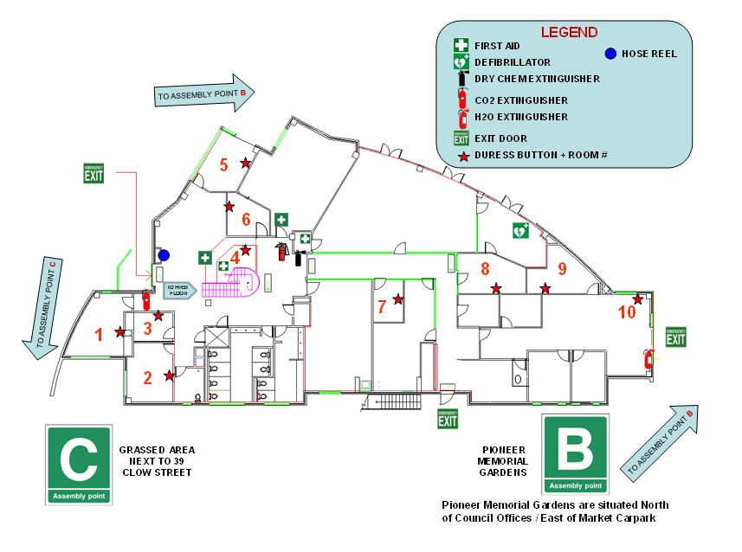

Ground Floor Plan

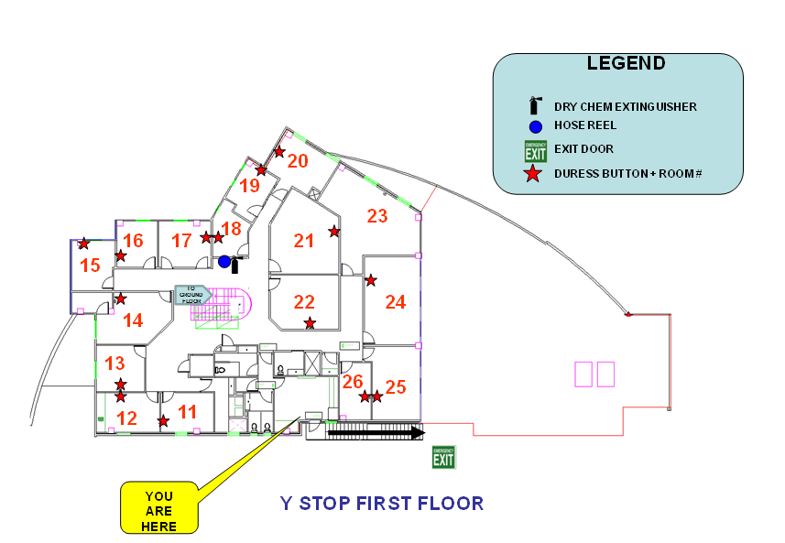

First Floor Plan

