Who we are
Occupational Health & Safety Committee Management Representatives


Jacqui Weatherill
Chief Executive Officer - Dandenong
8571 5200


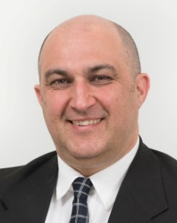
Anthony Jurkov
Health & Safety Consultant - Dandenong
8571 5276

Richard Stevenson
Coordinator Statutory Planning - Dandenong
8571 1661

Matt Berry
Manager Infrastructure Services Planning - Operations Centre
8571 1713

Matt Berry
Manager Infrastructure Services Planning - Operations Centre
8571 1713

Matt Berry
Manager Infrastructure Services Planning - Operations Centre
8571 1713

Matt Berry
Manager Infrastructure Services Planning - Operations Centre
8571 1713

Gavin Vogl
Team Leader Customer Service - Dandenong
8571 1539

Sally Goedheer
Senior Coordinator Integrated Community Services – ICSS
8571 5521




Matt Berry
Manager Infrastructure Services Planning – Operations Centre
8571 1713

Mel White
Manager Community Amenity - Dandenong
8571 1586




