Download background either (1) via Software Center or (2) Manually:

- Software Center (this applies to Corporate Computers on network/VPN)

  - Click the Windows Start button, type "Software Center", then open
  - Search for and select "Teams Corporate Background" as follows:
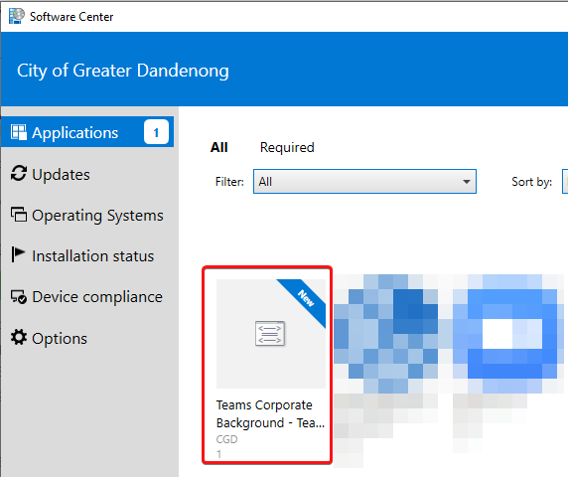
  - Select Install (will take about 30 seconds to download the new background for you)
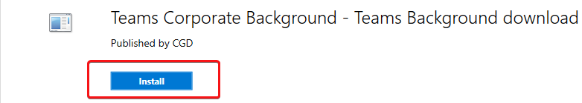
  - Within a video call, select More actions button (three dots)
  - Select Show background effects
  - Scroll to the bottom, where you should find the new background (installed earlier) - apply this.
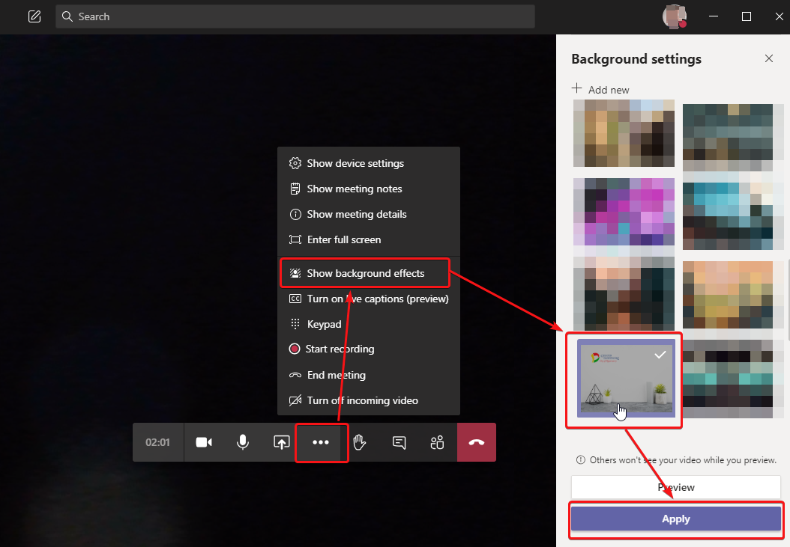

- Manual Download/add of image

  - Download and save the corporate background from the below link
https://forms.cgd.vic.gov.au/wp-content/uploads/2020/07/CGD.jpg
  - Within a video call, select the More actions button (three dots).
  - Select Show background effects.
  - Select Add new
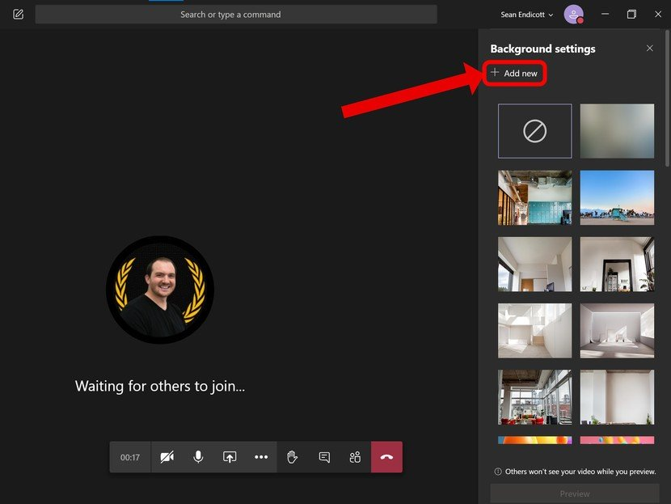

  - Select the image you just downloaded
  - Select Open.
  - Scroll down and select the image you've uploaded.
  - Select Preview to preview how your background will look (optional).
  - Select Apply or Apply and turn on video if your webcam is currently off.

