Adding a Purchase Order Number to an Invoice
Reminder: Staff should be advising the supplier of the PO number to quote on the invoice submitted for payment and then you won’t need to manually attach the PO number.
- Make sure you have the PO number handy
- Click on ECM Exec Invoice Approval from the G2 portal main menu.
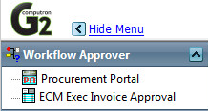

- Click Assign PO icon for an invoice.
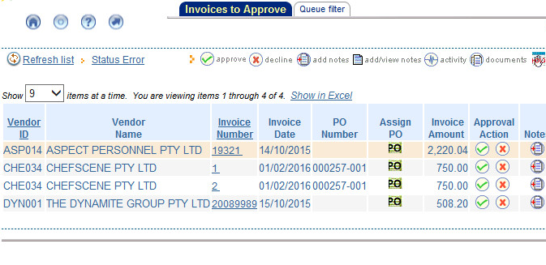
- Type in the Purchase Order Number – remembering to include the - 001 at the end of the PO

- Press Save button to save invoice details.

- Press Approve/Submit for Changes button.
A message will appear confirming that the invoice has been associated with the PO.

