Microsoft Teams Meetings and Chat

IMPORTANT: MULTI-FACTOR AUTHENTICATION must be setup from a PC connected to the CGD corporate network prior to any attempt to connect remotely. This step can also be performed while connected to the CGD staff wireless network. See “How to Setup Multi-Factor Authentication for Remote Access to the CGD Network” for step-by-step instructions.

Accepting a Teams Meeting Invitation

- Invitations to attend a Teams Meeting will be sent to you as an email message and will appear in your inbox. To confirm your attendance, open the email message and press the Accept button.
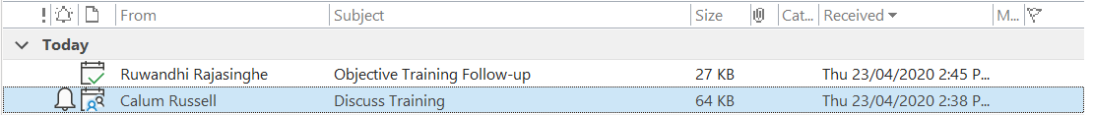
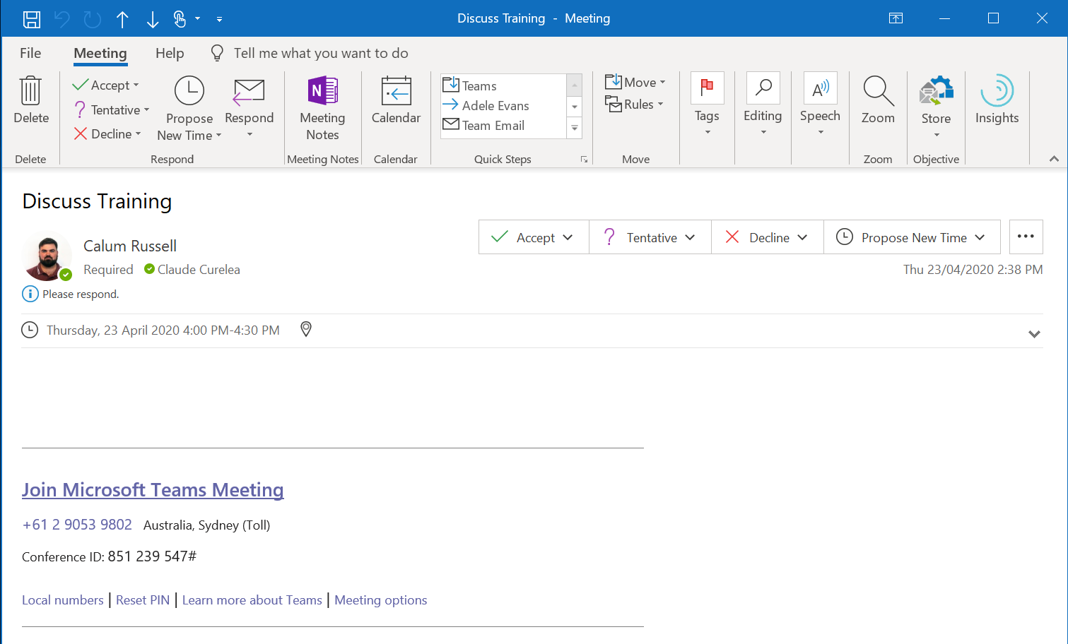
- Invitations can also be accepted from the Teams application installed on your computer. Click on the Calendar  icon and click on the meeting.
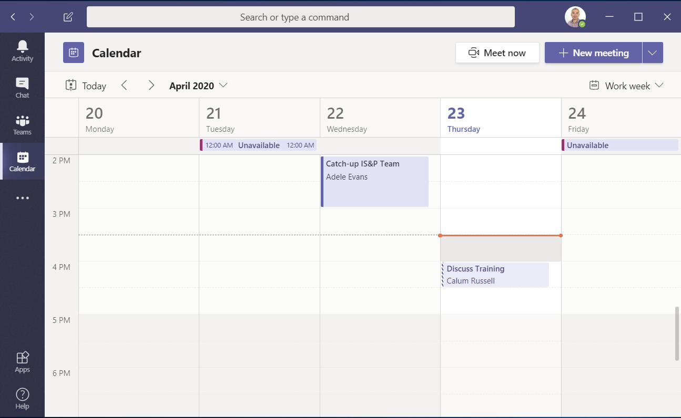
- Click the RSVP button and select Accept to confirm your attendance.
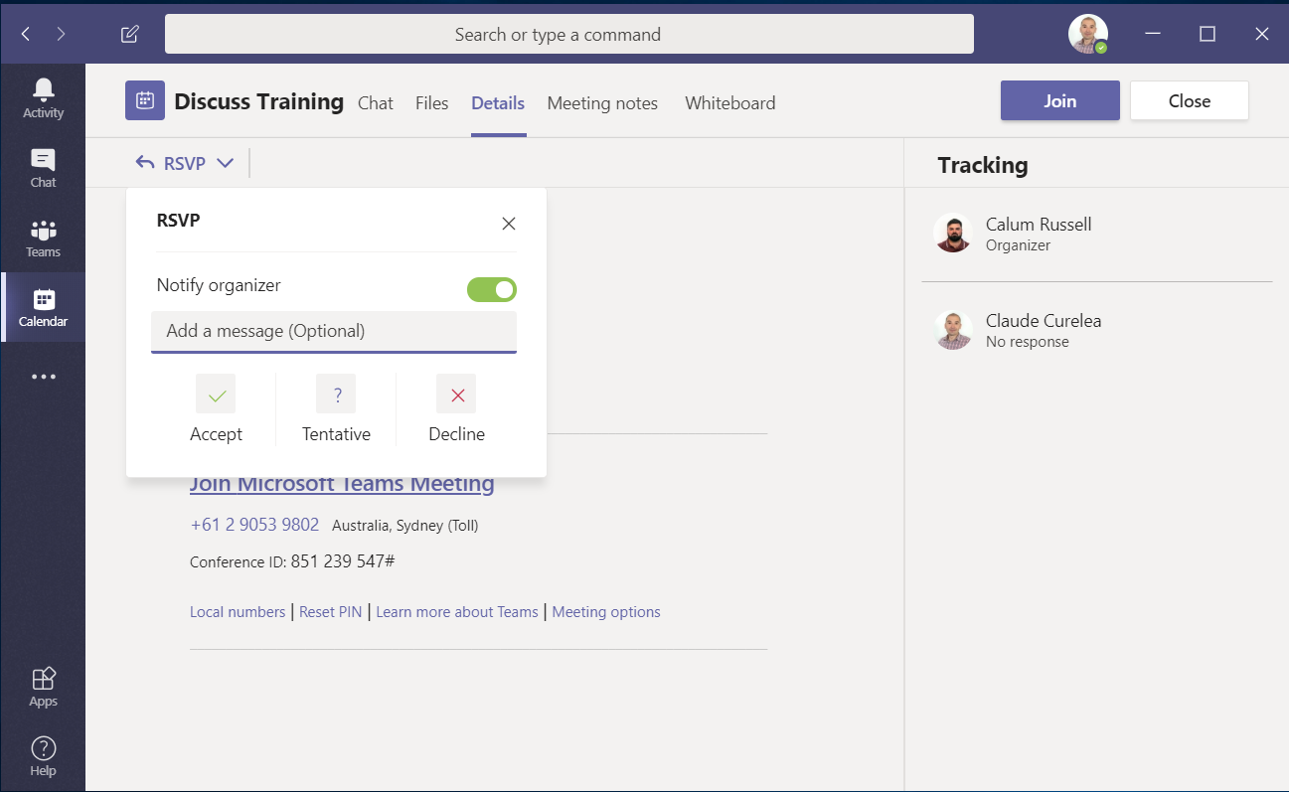
- You can also confirm your attendance for a meeting from your mobile device by pressing the Calendar 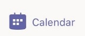button, clicking on the meeting and pressing the RSVP button and then the Accept button.
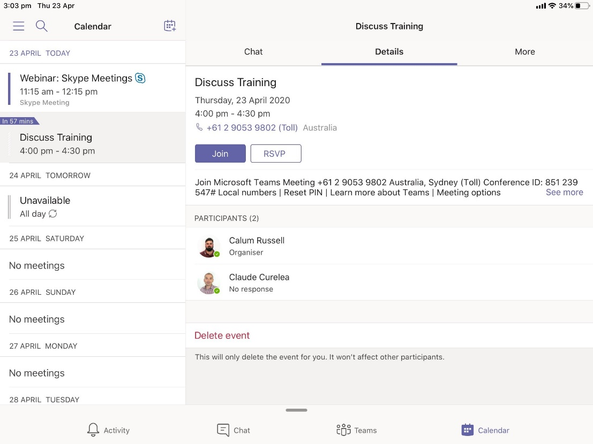
- If you have left the Notify organiser option selected, the organiser will now be sent an email confirming your attendance. If you have deselected the option, the organiser will not receive an email notification but will still be able to see your response when they open the meeting in Teams. Once you have accepted the meeting your response will change to “Accepted”.
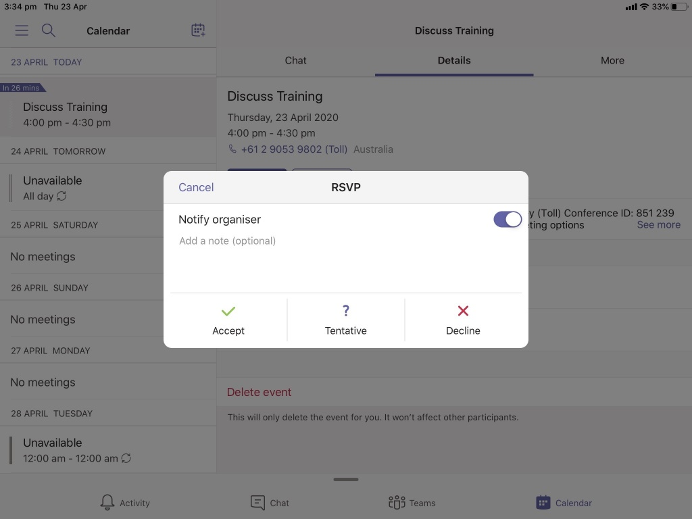

Logging In
- Click on the Microsoft Teams app icon on your mobile device or application icon from your Start  button on your PC.

- Depending on how your multi-factor authentication has been setup, you may now be prompted to enter your CGD network login / password and press the Log On button.
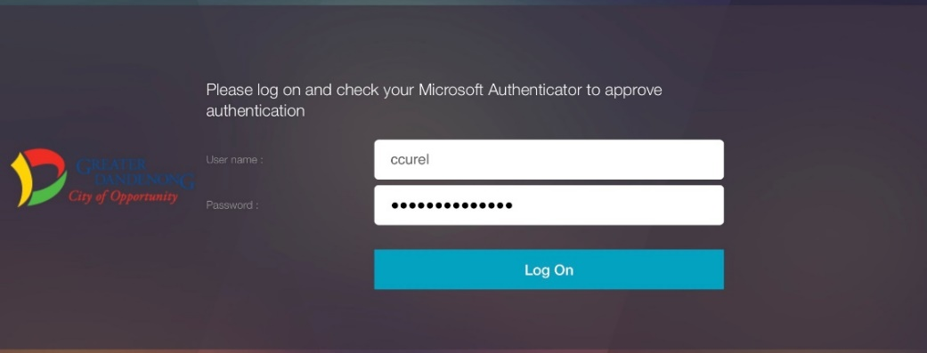
- Or you may be prompted to authenticate using Microsoft Authenticator app installed on your mobile device.
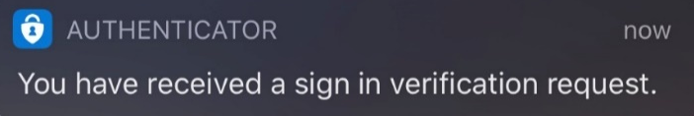
- Click the notification to launch the Microsoft Authenticator app and select “Approve” when prompted.
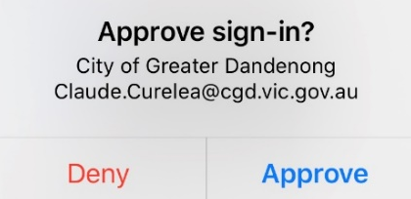

You will now be redirected to the Microsoft Teams Activity feed to see all your recent activity.
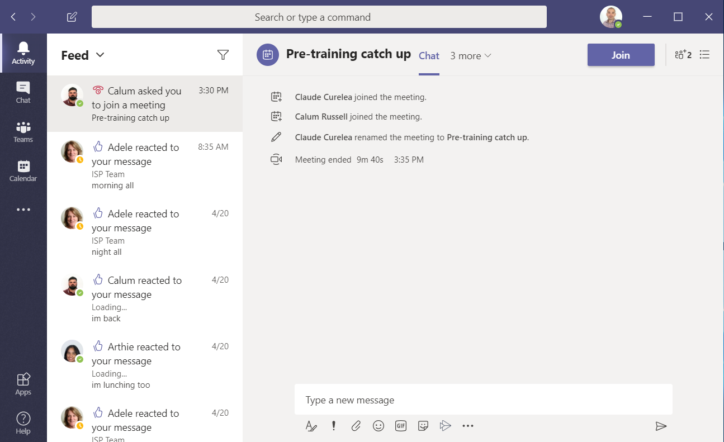

Starting a Chat Session

- Select the New Chat  icon to start a new conversation.
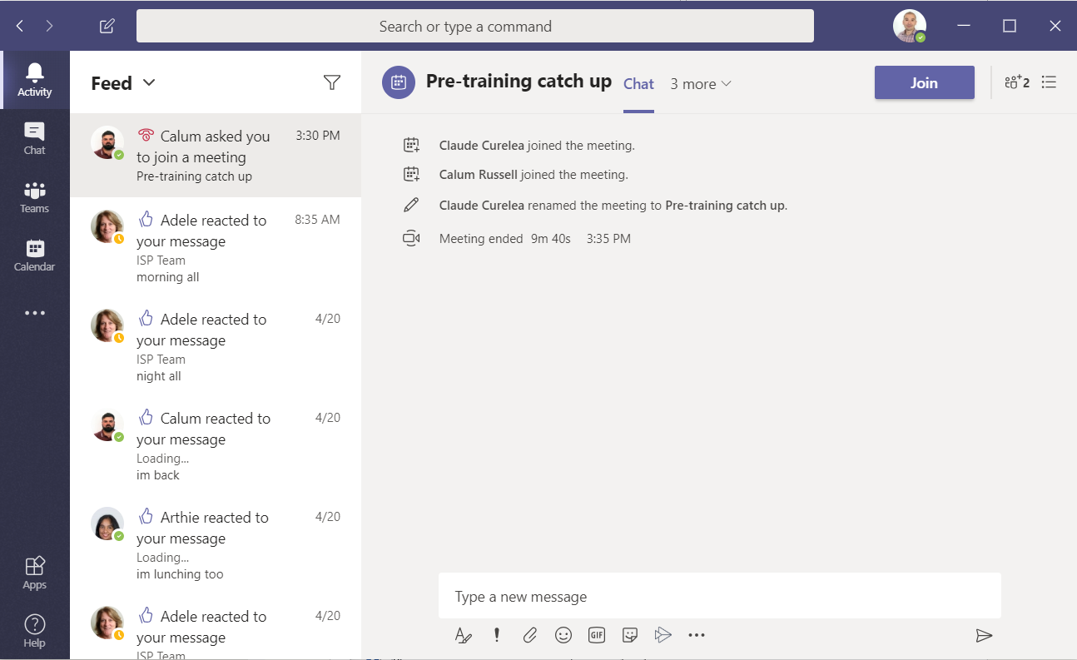
- Search for contacts to include in the conversation.
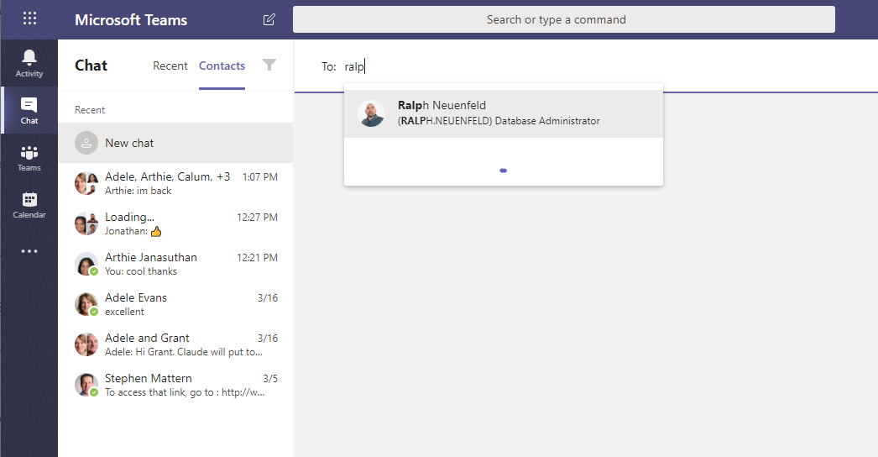

- Enter your text into the “Type a new message” field and press Send
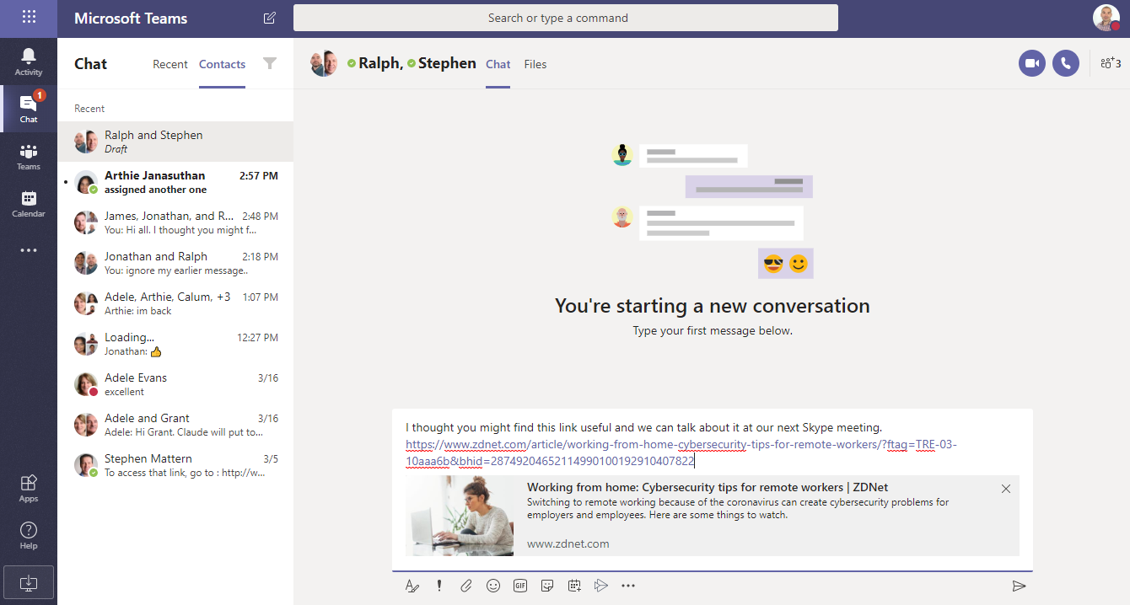
- The message will now be sent to all recipients.
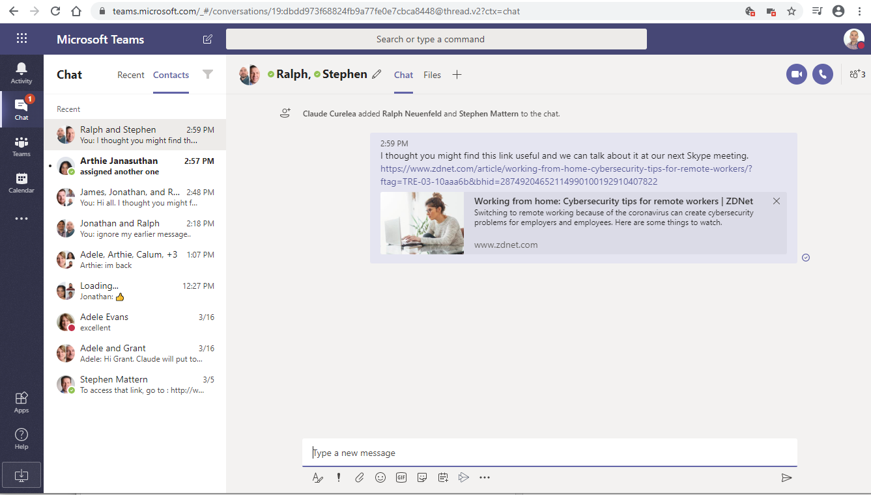

- When a team member replies to a conversation you will receive a screen prompt and the conversation will appear in bold.
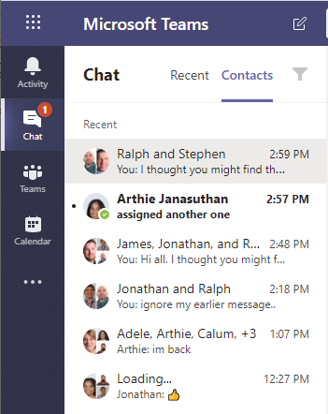

Arranging a Teams Meeting

1. Click on the Calendar icon in Microsoft Teams and select New Meeting.
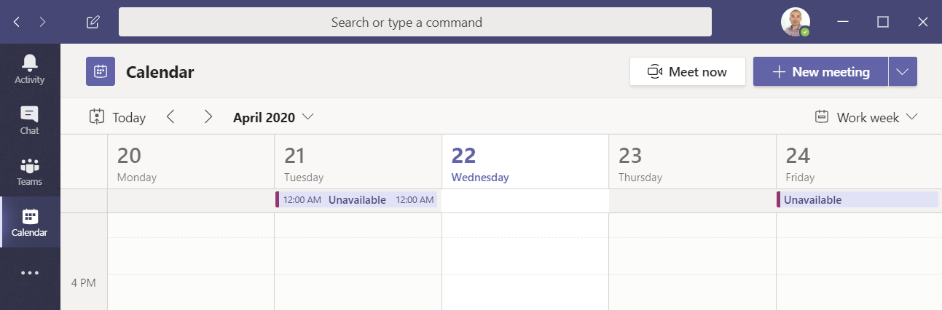

- Enter the meeting details along with the required attendees and press Send to send the meeting invitation. (You will need to enter the full email address when inviting External attendees)
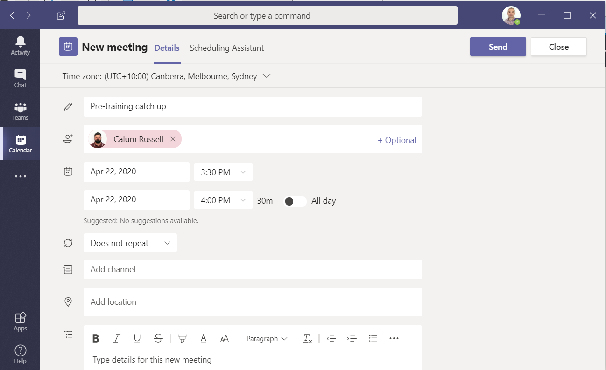

- The meeting will now appear in your calendar.
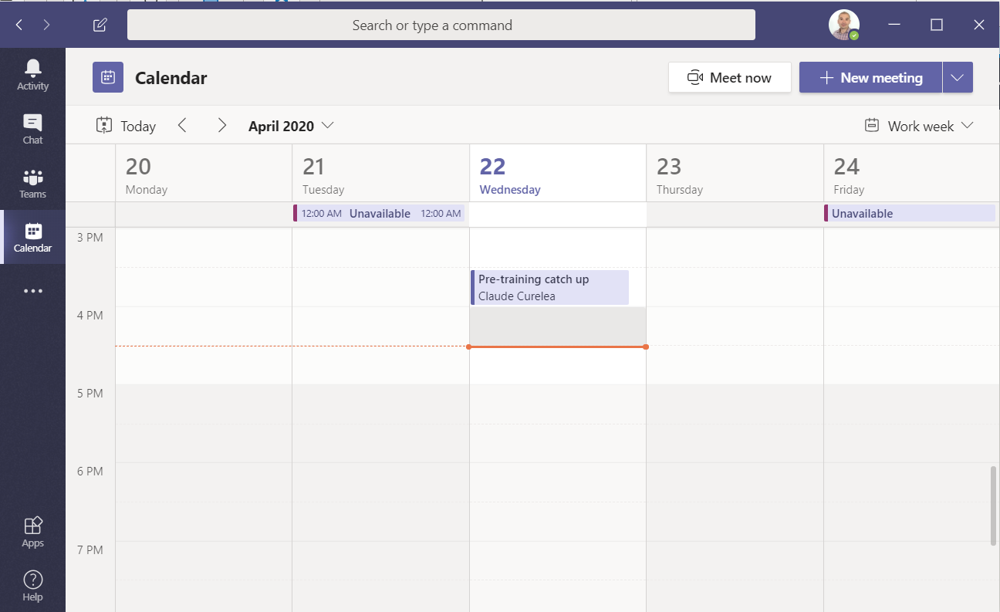
- Invitees will be sent the following invitation via email.
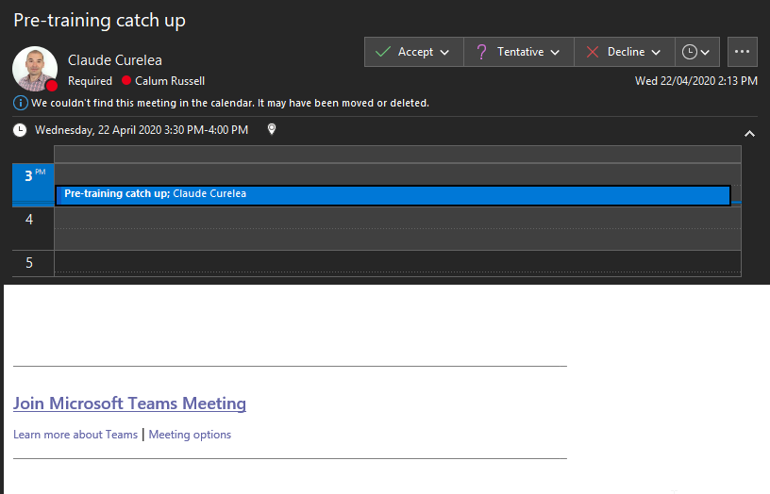
They will need to press the Accept button to confirm their attendance at the meeting and will need to press the Join Microsoft Teams Meeting link at the time to enter the online meeting.
- Open the meeting from the calendar to see which invitees have accepted the meeting. When an attendee accepts the meeting invitation you will see it in the main activity feed in Teams.
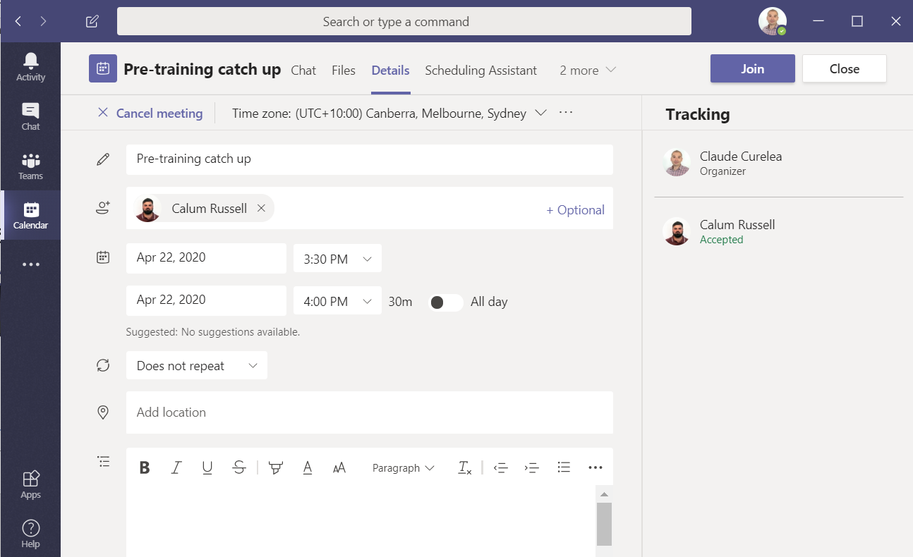

Joining a Teams Meeting

- To join a meeting click on the Join Microsoft Teams Meeting link in the invitation email or in by opening the meeting in your Teams Calendar  and pressing the Join button.

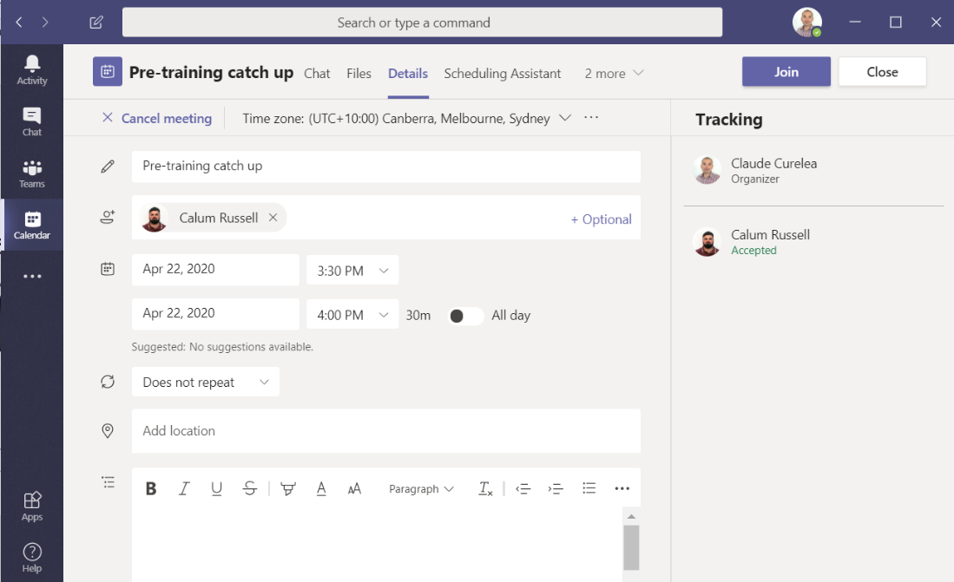

- You will now be directed to the meeting room along with any other participants in the meeting. You will not see a picture of yourself in the meeting room but the icons in the meeting bar relate to your involvement in the meeting. For example you can select to show your video, to mute yourself, to share content, to chat, to invite others to the meeting (if the host has enabled that feature) and to exit the meeting.
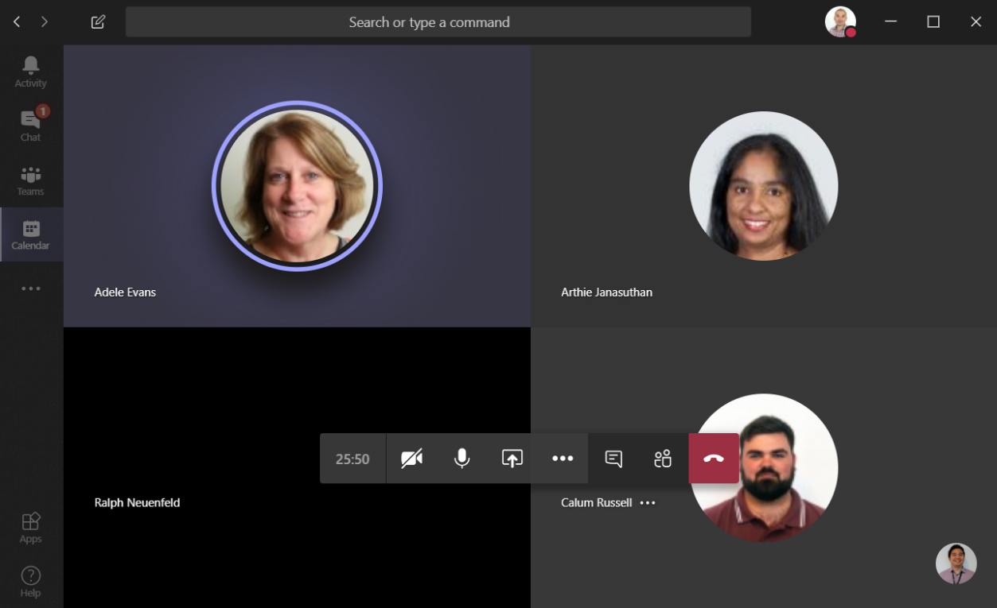

- The ellipsis button will display additional options that can be useful during the meeting, including the ability to take notes/minutes.
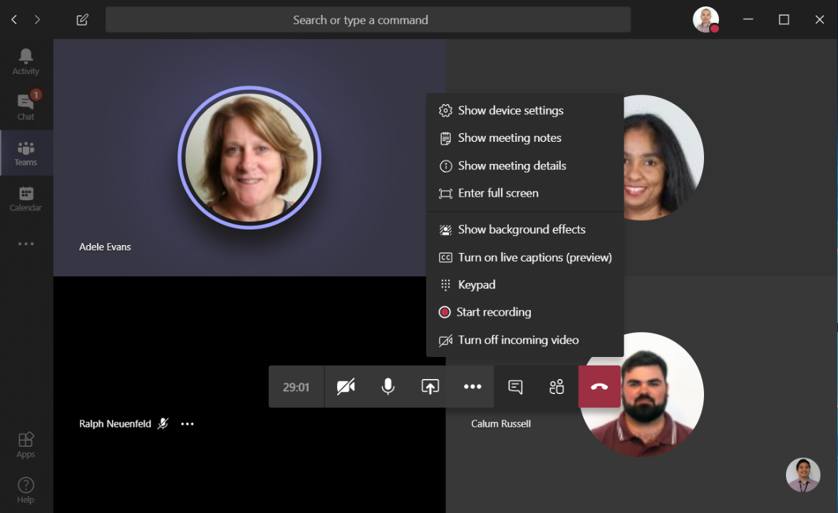
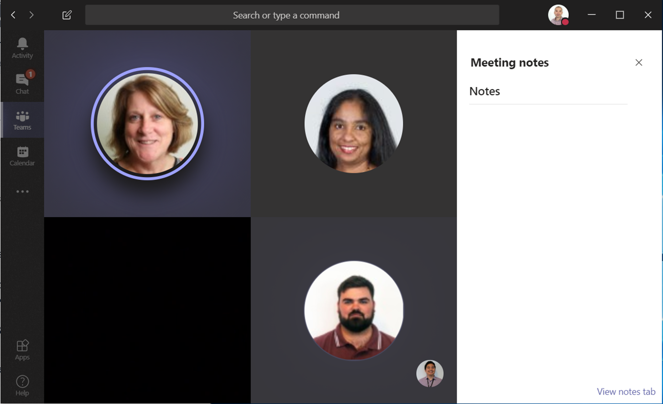
- Use the Share  button to share an application open on your pc, your desktop or the interactive Microsoft Whiteboard with participants. By selecting the Include system audio checkbox you are permitting any audio in a video presentation to be heard by the meeting participants, including any other system audio sounds that your pc would generally make.
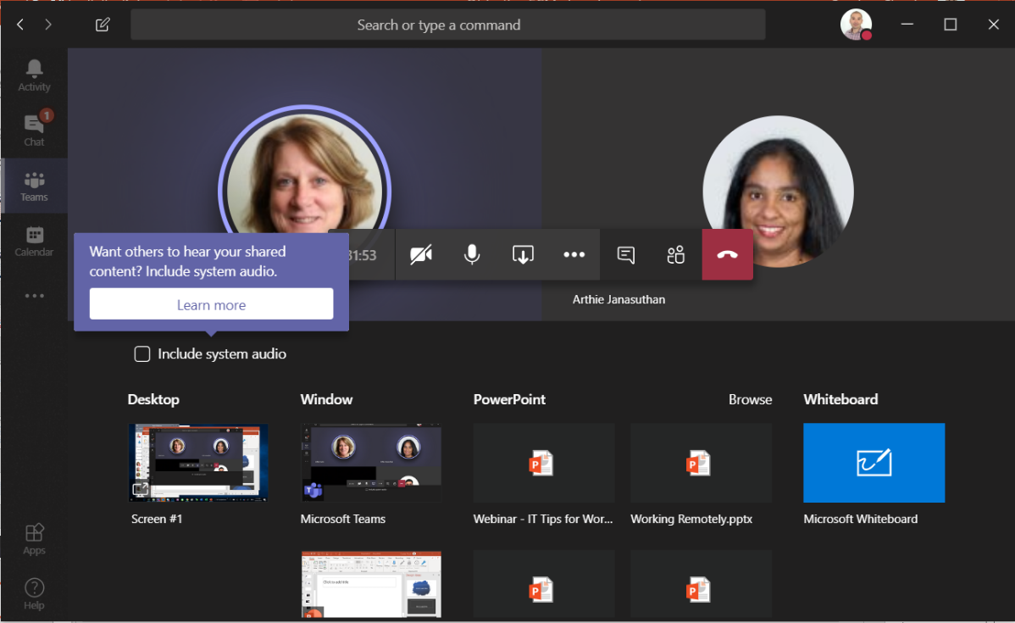

- If you click on a participant’s name you will see additional details and icons that will show you their status and enable you to chat with them individually during the meeting as well as email them directly.
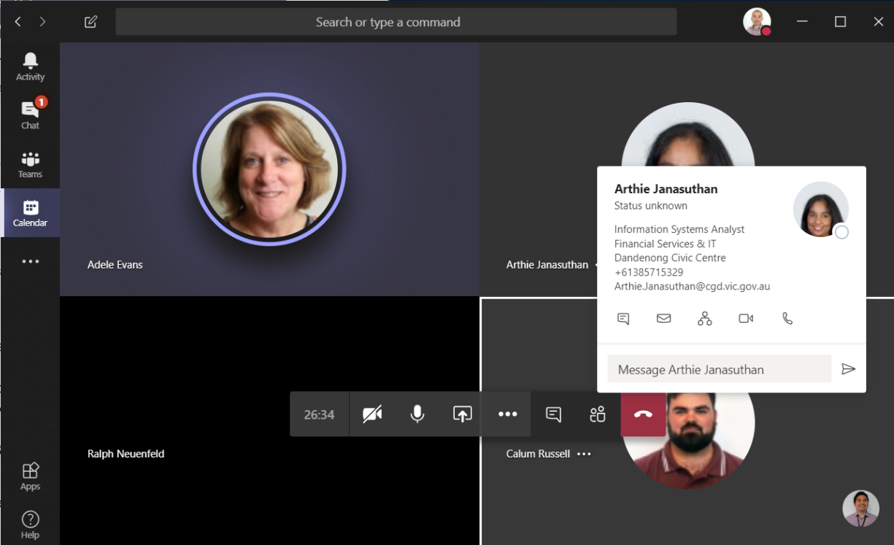

- Depending on how the meeting has been setup, other participants apart from the host may be able to mute or pin other participants by right-clicking on their names.
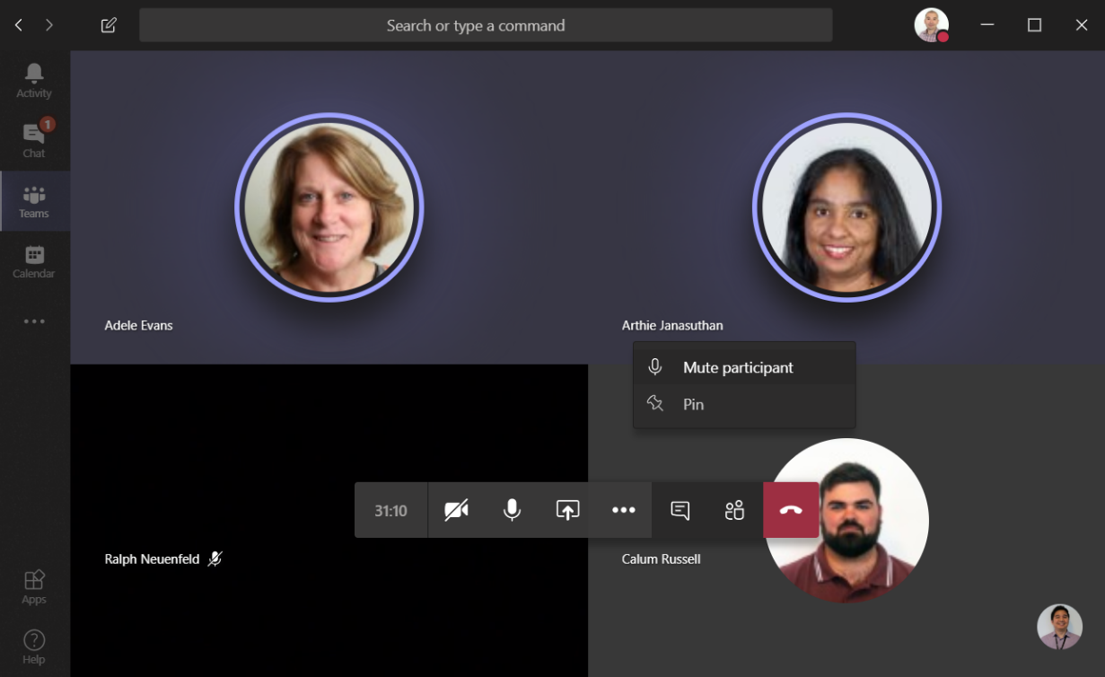

If you require assistance with Microsoft Teams please contact the IT Service Desk on 8571-5102.

