How to correct American dates in Office365
This guide tells you how to set the Date format in online Office Web Apps to dd/mm/yyyy when they are defaulting to the American format mm/dd/yyyy, for example in Excel Online. You also need to ensure your regional settings are correct – see section B.
If you need any further assistance please log a service desk call.

Date format settings
- Log into MyApps and click on “Office 365”
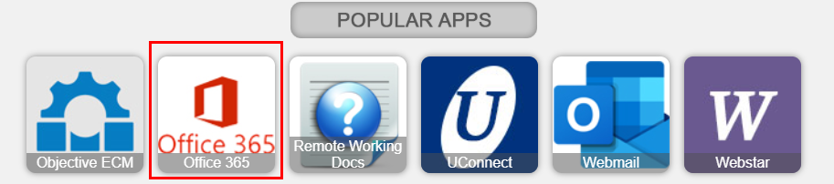

- In Office 365, click on OneDrive
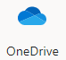
- OneDrive will open. Click on the Settings wheel at top right corner
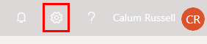
- Select OneDrive Settings
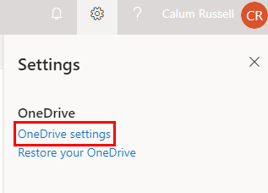
- In the Left sidebar, select “More Settings”
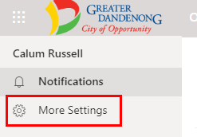

- Under the Region and Language section Select “Regional settings”
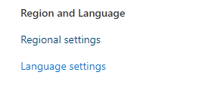
- Ensure the settings are as per the screen below
  - Make Sure Time Zone is (UTC +10:00) Canberra, Melbourne, Sydney
  - Make sure the Locale is set to English (Australia)
  - Click OK to save the changes
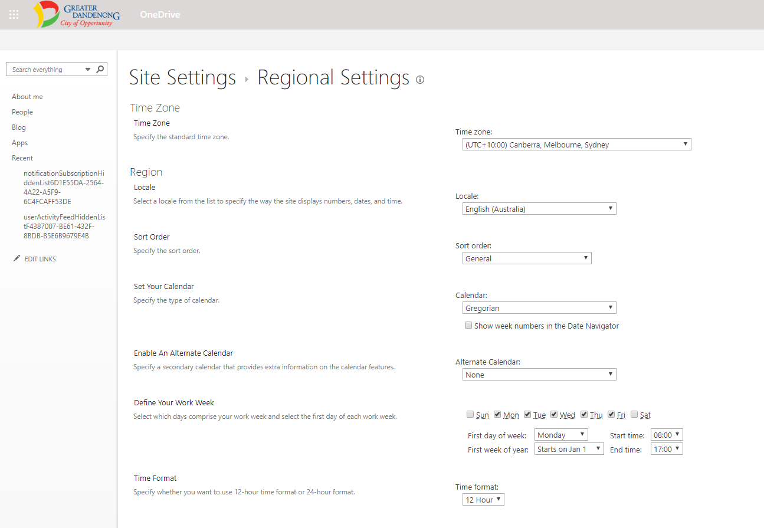

Date fields (e.g. in Excel Online) should now be ok. You may need to re-enter the dates to pick up the correct format

