To set your email signature, follow the steps below:
- Log in to MyApps (remembering to use the Microsoft Authenticator app)
- Click on Webmail
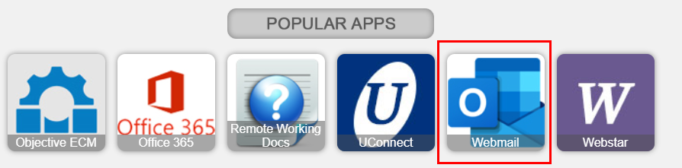

- In the upper right-hand corner of the screen, there will be a gear icon (settings), click on it
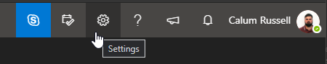

- In the Search box, begin typing “Signature”
- Select “Email signature”
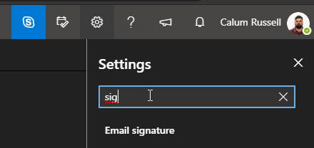

- Enter your email signature (see examples at the end of this guide)
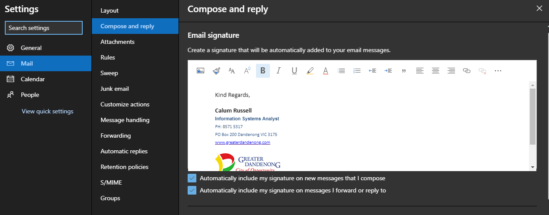

- You can choose to tick or untick the two checkboxes:
  - Automatically include my signature on new messages that I compose
  - Automatically include my signature on messages I forward or reply to

Signature Examples

Calum Russell
Information Systems Analyst
PH: 8571 5317
PO Box 200 Dandenong VIC 3175
www.greaterdandenong.com


Calum Russell | Information Systems Analyst
PH: 8571 5317
PO Box 200 Dandenong VIC 3175
www.greaterdandenong.com

Calum Russell Information Systems Analyst
PH: 8571 5317
PO Box 200 Dandenong VIC 3175
www.greaterdandenong.com

Contact Media and Communications regarding the style guide rules regarding your email signatures, including custom banners.

