It is possible that by default, Outlook Webmail is set to display in “Conversation View”.
This could mean that when you drag and drop your emails into the Outlook folder created in the Objective ECM - Saving emails into Objective from home (A6449765) guide, all emails in that email thread will save, rather than just the email/s you dragged across.

To disable Conversation View, follow the steps below:
- Log in to MyApps (remembering to use the Microsoft Authenticator app)
- Click on Webmail
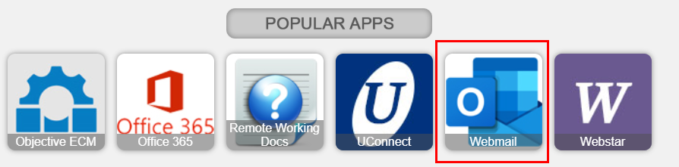

- In the upper right-hand corner of the screen, there will be a gear icon (settings), click on it
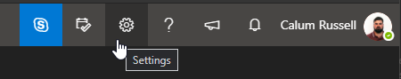

- Under the Conversation View section, select “Off”
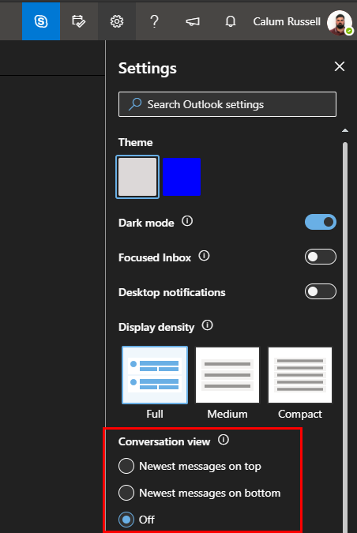
- Your emails will now display in order of time received.

