Setup Teams on a mobile device
- On your iOS / Android device, go to the App Store and download "Teams" (*iOS Images used)

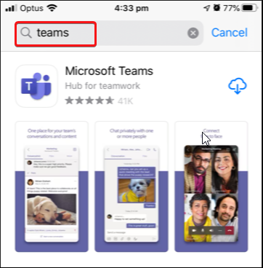

- Open the Teams app once downloaded.

- Select your credentials if they are listed or select "Sign in with another account” if they are not listed. Enter your Short Email address and press the Sign in button.

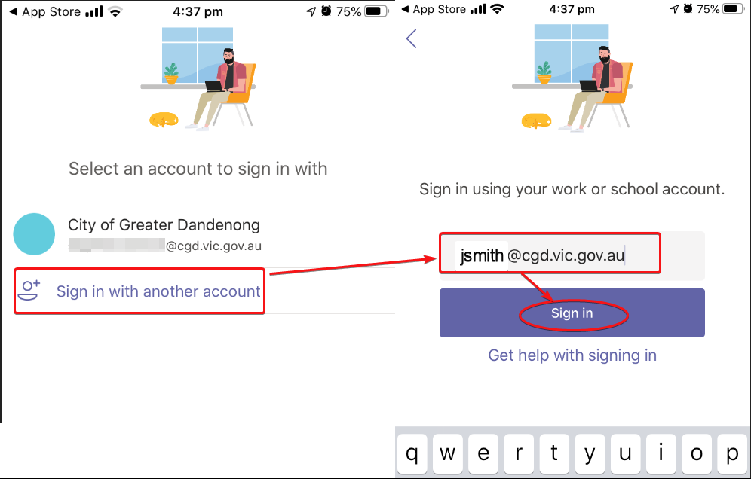

- When prompted with Teams would like to Access the microphone select OK

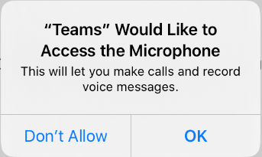

- Please swipe though any information pages that might appear like the following:

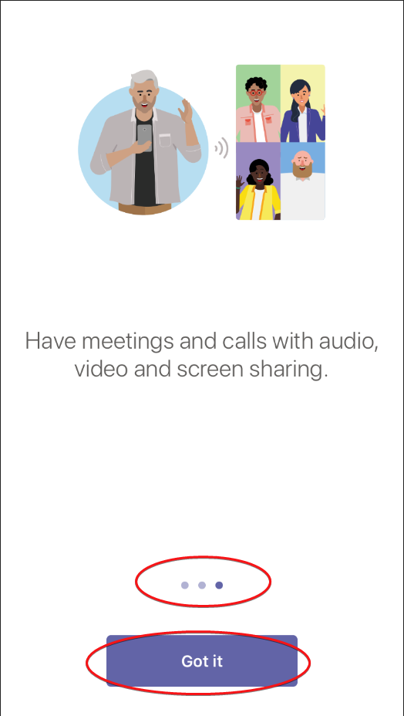

- One you are signed in you should see the following Client as follows – to send a simple Chat message, select Chat button on lower menu, then the Chat icon in the upper menu.

- Type a staff member’s name in the To: field and enter a message in the Type a new message field to begin a new chat.

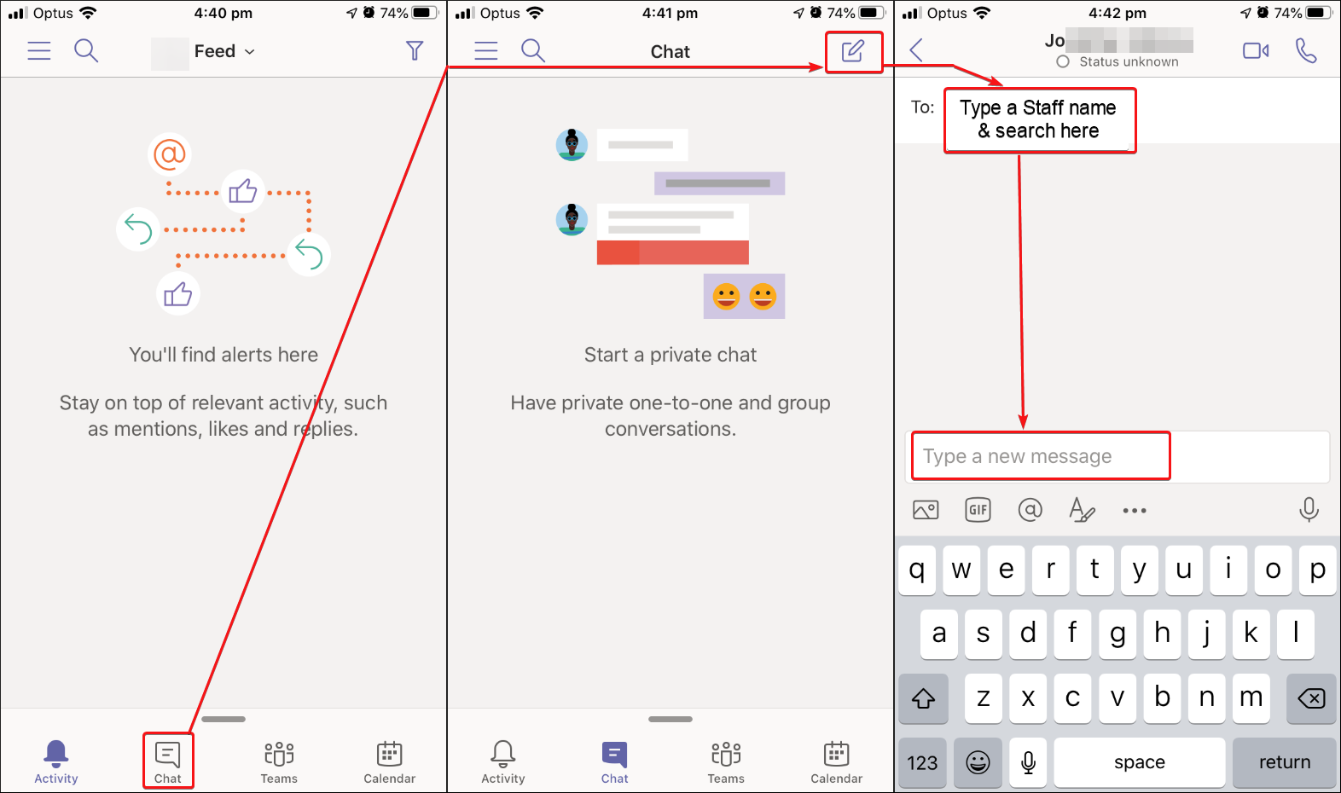

Logging Out

To stop receiving messages on your phone you will need to log out of the client by clicking on the Menu Button (), then select Settings and Sign out.
