3 Ways to Change Your Password While Working Remotely

IF YOU DO NOT REMEMBER YOUR CURRENT PASSWORD YOU WILL NEED TO CONTACT THE IT SERVICE DESK AND PROVIDE THE NUMBER ON THE BACK OF YOUR SECURITY TAG FOR IDENTIFICATION PURPOSES. THIS IS THE ONLY WAY FOR YOU TO BE ISSUED WITH A NEW PASSWORD.
TO CARRY OUT THE BELOW PROCEDURE YOU WILL NEED TO KNOW YOUR CURRENT PASSWORD.

METHOD 1: Using the CGD My Password App on a CGD Mobile Device

- Start the Comp Portal app.
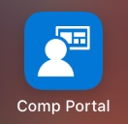
- Click on Apps and launch the CGD My Password app if it is installed. Note: the CGD My Password App can also be accessed from the CGD My Apps Portal at myapps.cgd.vic.gov.au.
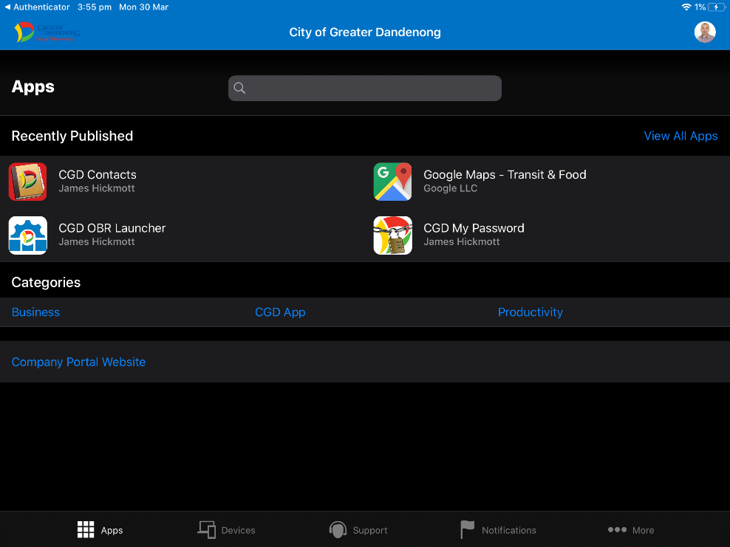
- If the CGD My Password app is not installed you will need to install it.
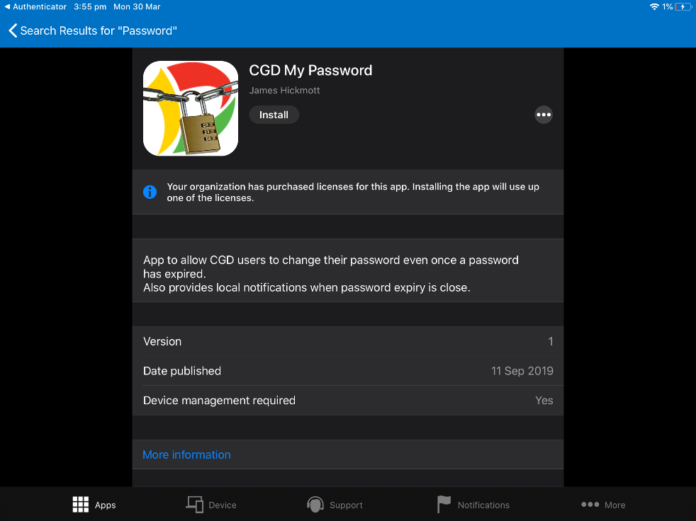

- Launch the CGD My Password app and sign-in with your login name and password.

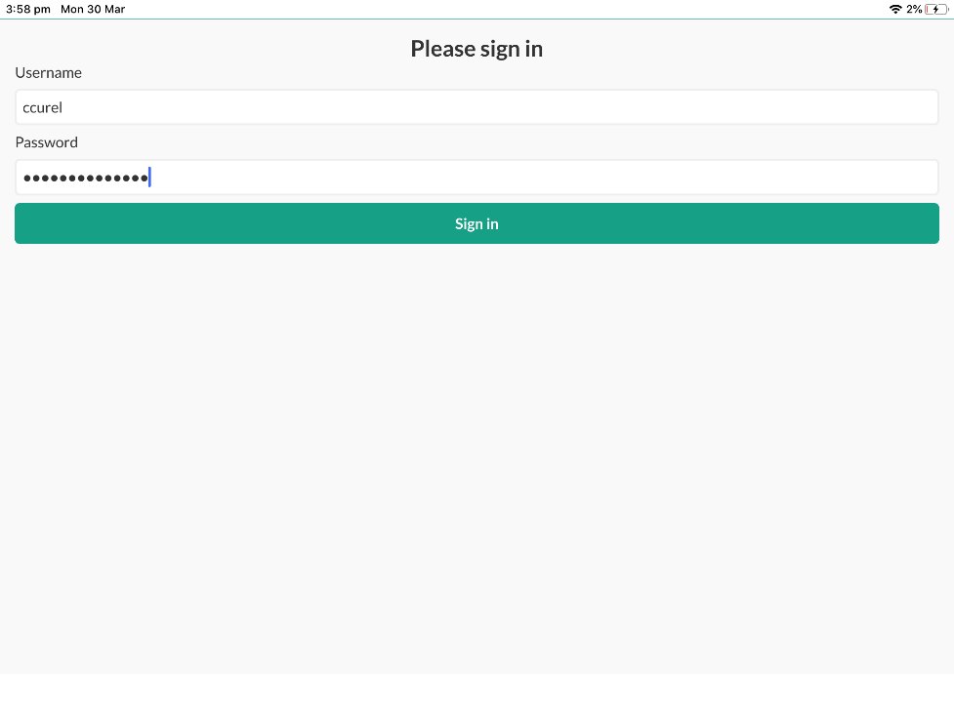
- You will see how long you have until your password is due to expire.
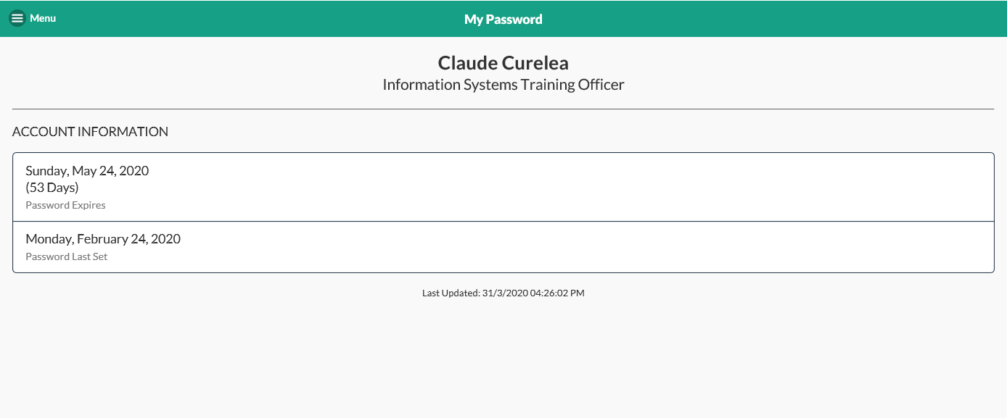
- Click on the menu button in the top-left corner and select Change Password.
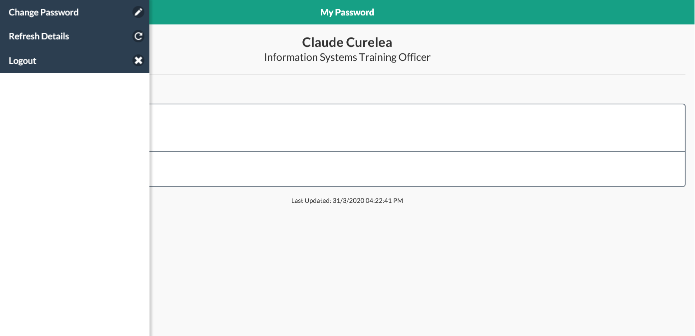
- Enter the Current password and the new password (minimum 15 characters) twice and press Change Password.
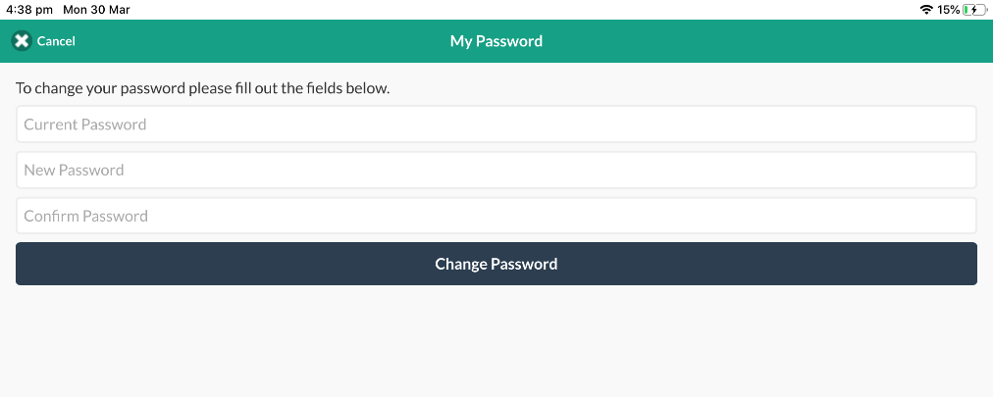
IMPORTANT: Once you have changed your password, wait for your other devices to prompt you to enter your new password. This delay is due to these additional devices syncing with the server. Failure to do so will result in the passwords not being updated and your account being locked out.

METHOD 2: Changing Your Password Using a Council Mobile Device

- Start the Comp Portal app.
- Click on your picture in the top-right corner and select Change Password.
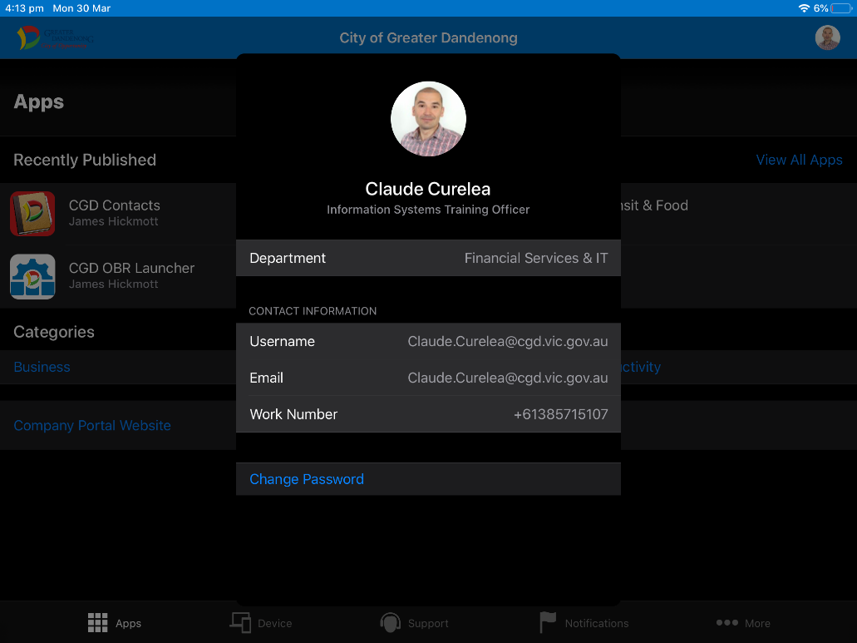
- Sign-in with your shortened email address.
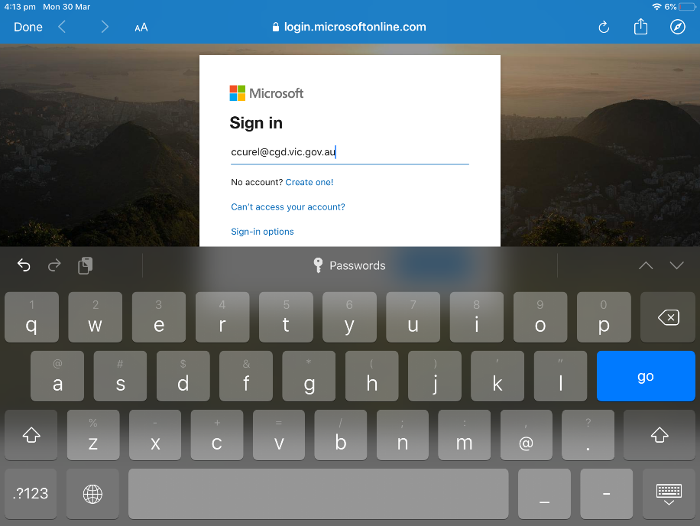
- Enter your password and press Sign-in.
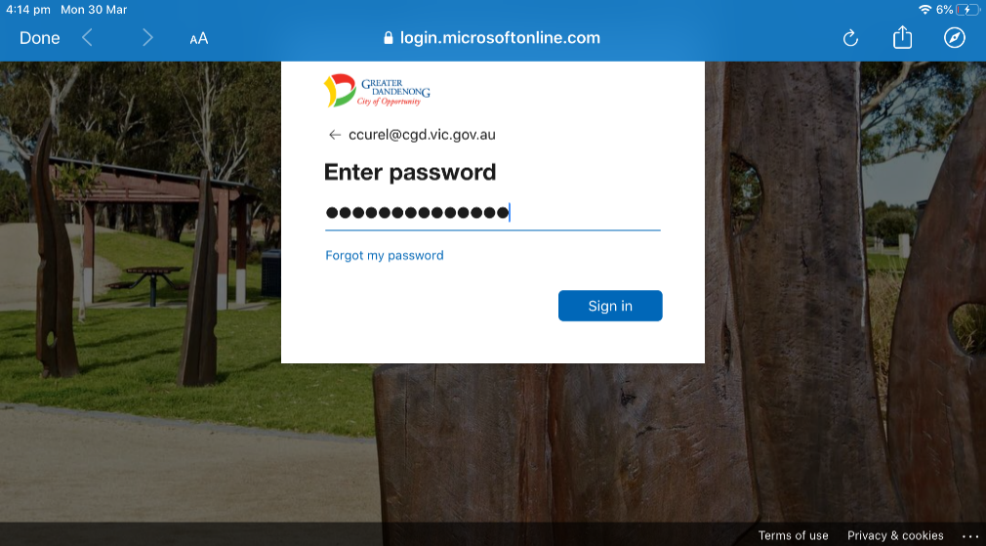
- Enter the old password and new password (minimum 15 characters) at the prompts below and press Submit.
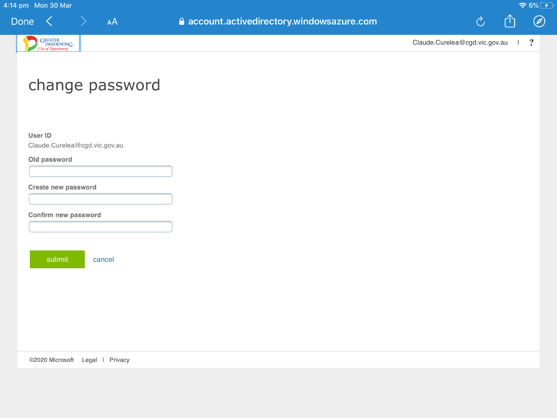

IMPORTANT: Once you have changed your password, wait for your other devices to prompt you to enter your new password. This delay is due to these additional devices syncing with the server. Failure to do so will result in the passwords not being updated and your account being locked out.

METHOD 3: Using the Office 365 Portal

- Visit https://www.office.com/

- Click Sign in.
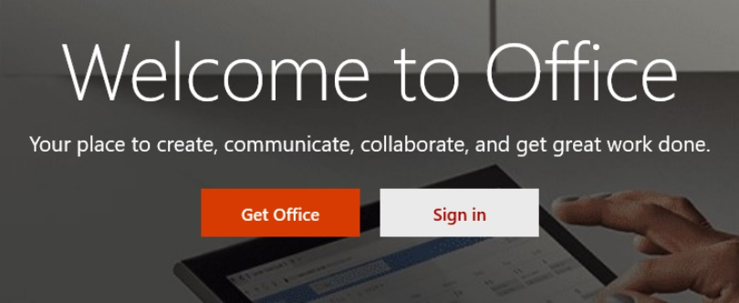
- Enter your short email address and click Next.
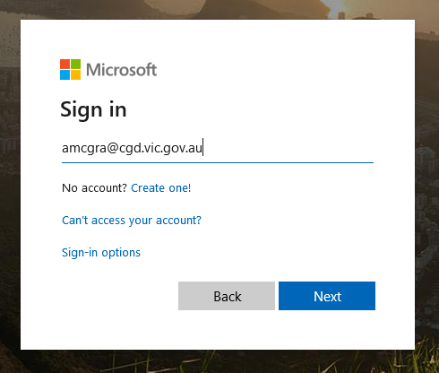
- Click your name in the top-right, then click My Account.
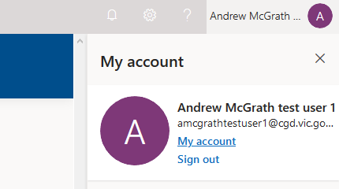
- Select Security & privacy, then Password.

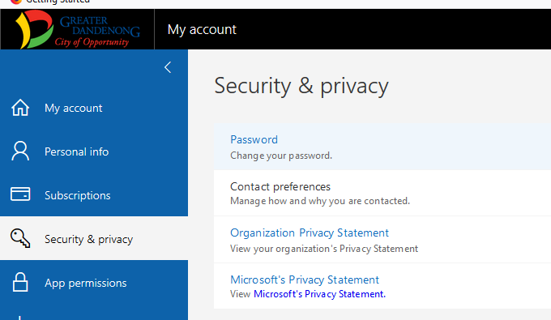
- Enter your old password, then new password (minimum of 15 characters) and click Submit.
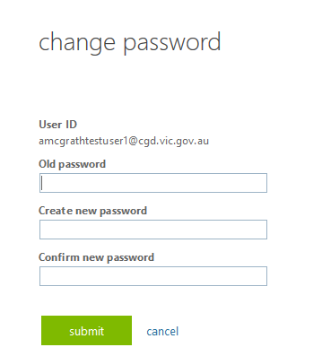
Your password should now be changed.

IMPORTANT: Once you have changed your password, wait for your other devices to prompt you to enter your new password. This delay is due to these additional devices syncing with the server. Failure to do so will result in the passwords not being updated and your account being locked out.

