- Navigate to https://www.citrix.com/receiver

- Click on “Download for Windows”
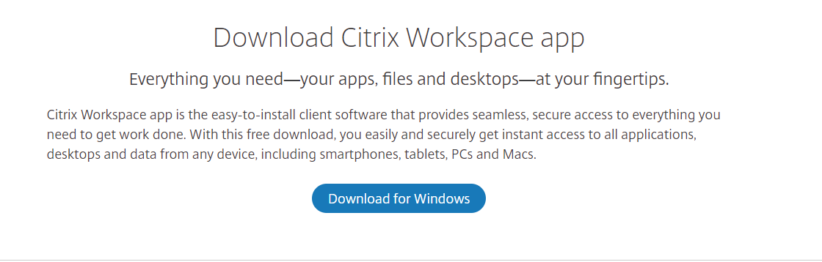

- Click “Download Citrix Workspace app for Windows”
  - This will download “CitrixWorkspaceApp.exe”
  - Wait for the download to complete.
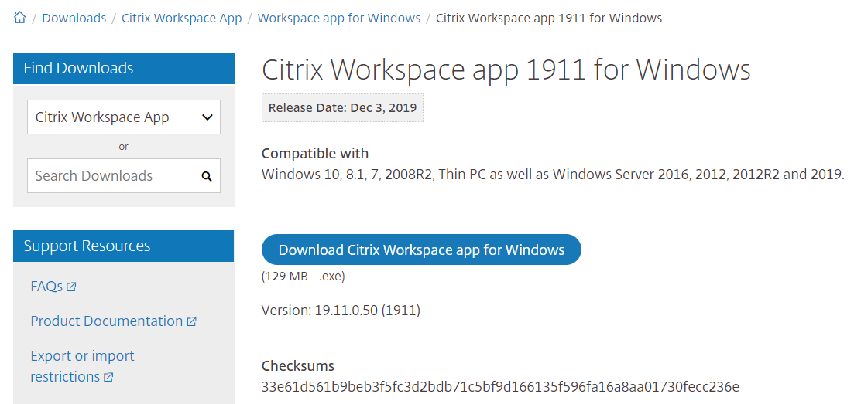
- Open the “CitrixWorkspaceApp.exe” file that downloaded.

- Click Start
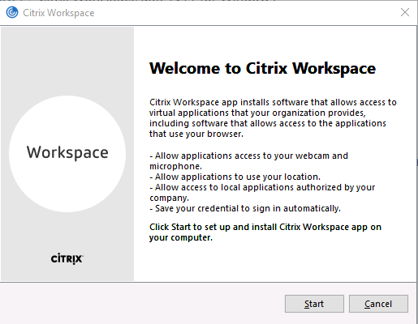

- Accept the license agreement and click “Install”
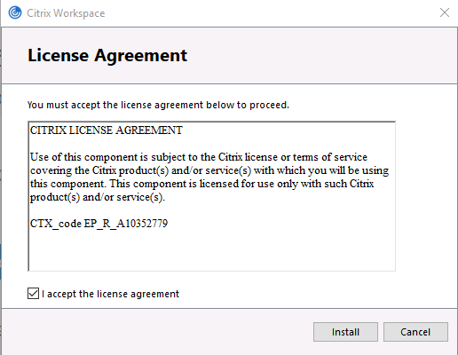

- Ensure the “Enable app protection” checkbox is unticked. Click Install
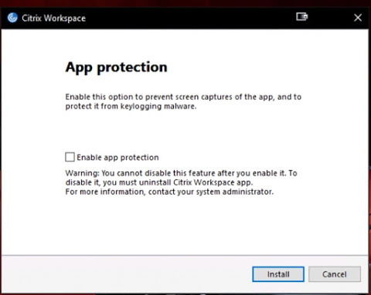

- Citrix Workspace will now install
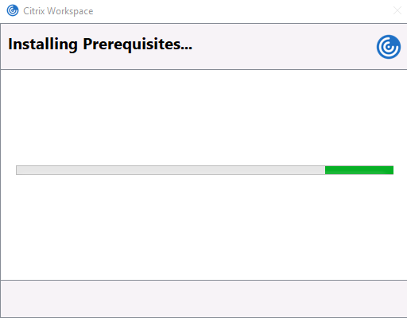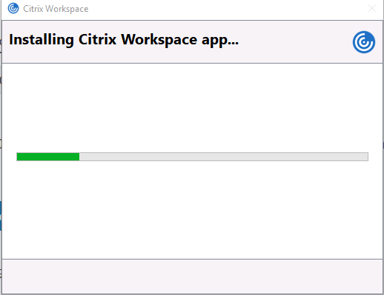

- When the install is complete, you will need to click “Add Account”.
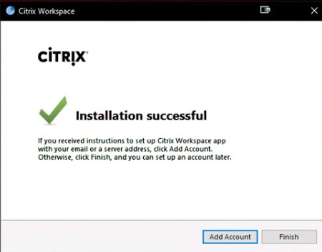

- Type in citrix.cgd.vic.gov.au and tick the “Do not show this window automatically at sign-in.” checkbox. Click “Add”
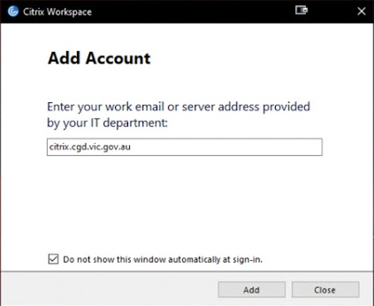

- Enter your user ID (eg jsmith) and password. Click Sign In.
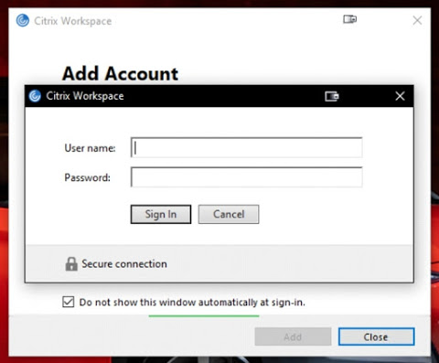

- If you are asked to restart your computer, please do so.
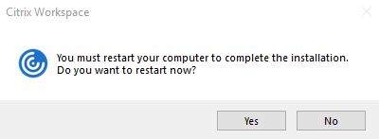
Citrix Workspace is now installed and ready for use.
**Black app Window with Citrix Workspace
If using a CGD laptop at home with display scaling set to the (recommended) 150%, and a hdmi monitor set to 100% scaling, some apps appear as a black Window.
One workaround is to set laptop scaling to 100%.
More details here: https://discussions.citrix.com/topic/391677-citrix-applications-open-as-partial-or-fully-blacked-out-window/

