Logging into Objective ECM
- Log into Objective ECM from Myapps (myapps.cgd.vic.gov.au)
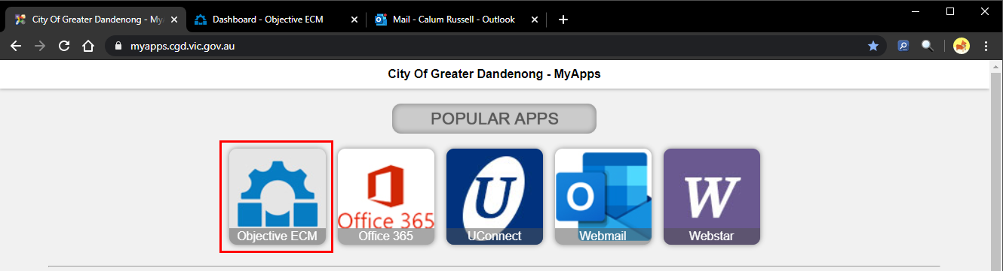
  - When presented with the Objective login scree, enter your username and password and click Log In.
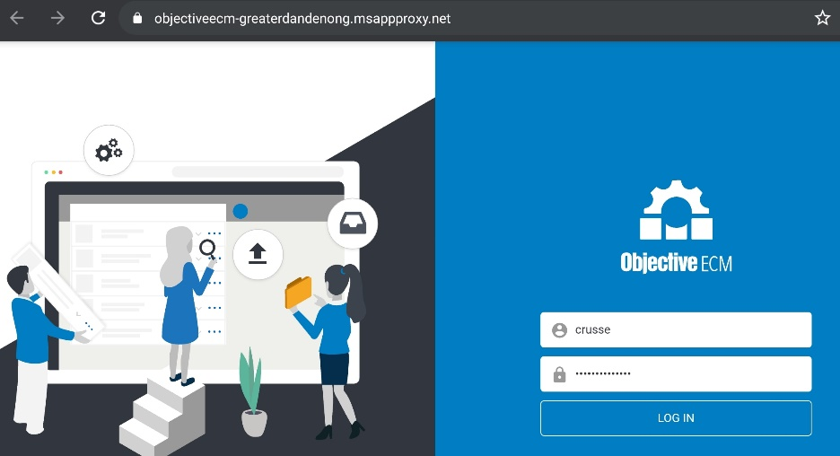

- Objective ECM will open to your dashboard
  - If Objective ECM opens as a blank page, please refresh the browser webpage (you can also press F5 on your keyboard to do this)
