**Disclaimer

If you already have Office installed on your personal computer, you do not need to follow this guide.

Installing Office Applications
- Navigate to https://portal.office.com
- Enter your short email address, eg jsmith@cgd.vic.gov.au
  - Have your Phone ready to approve your login via the Microsoft Authenticator app
  - Click next
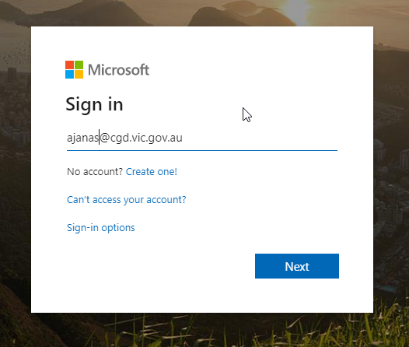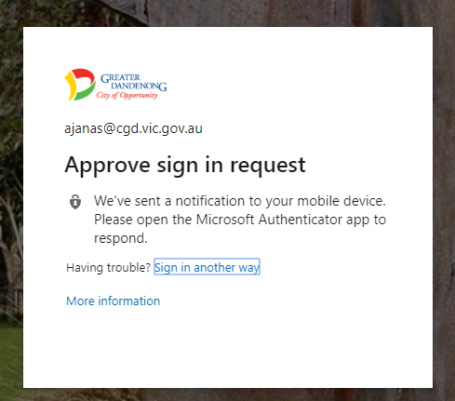

- You will now see the dashboard
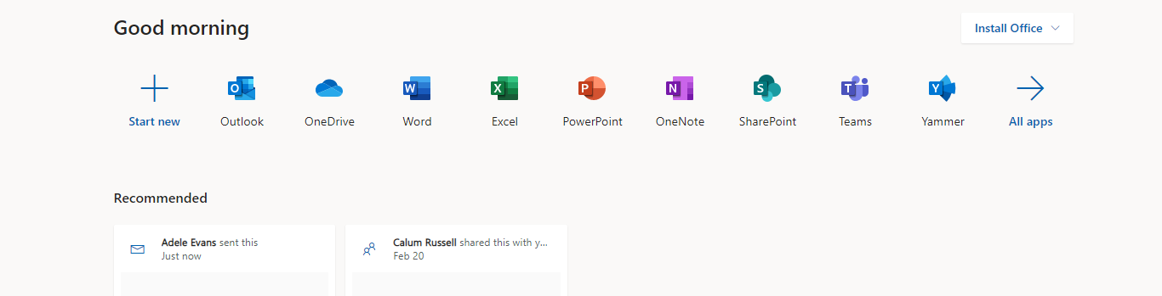

- Click on Install Office
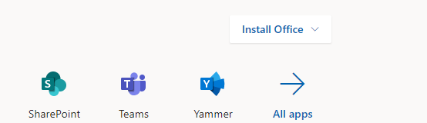

- Select Office 365 apps
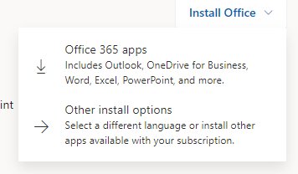
- An installer will download. Open and Run the installer.
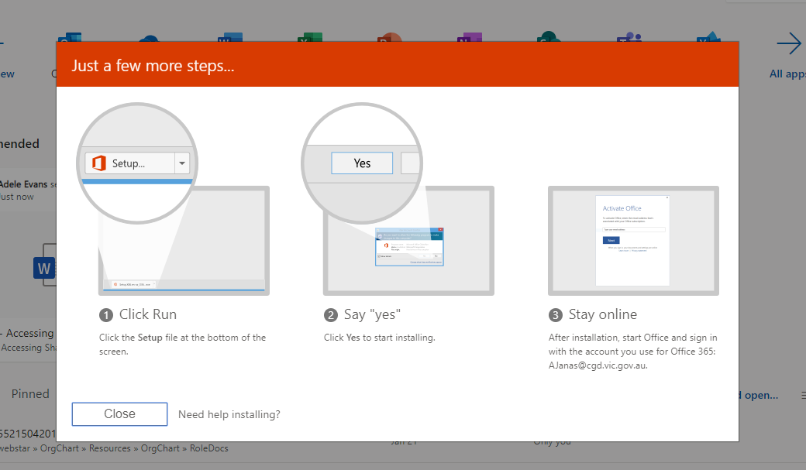
- If the following pop up displays, click yes
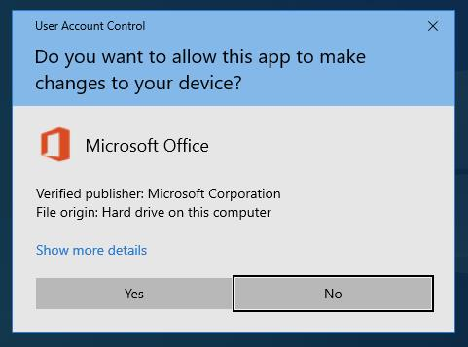
- Office will now download and install the applications. This may take some time.
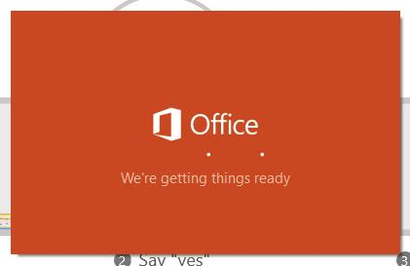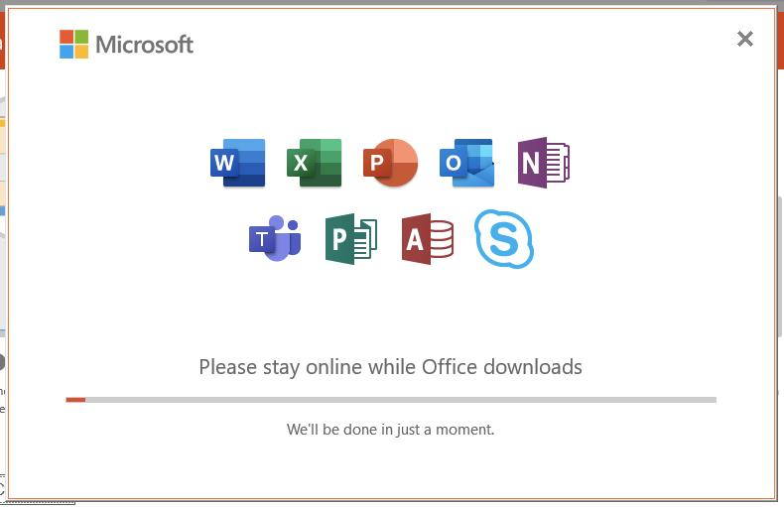

- Once the installation is complete, a notification will display. Click Close
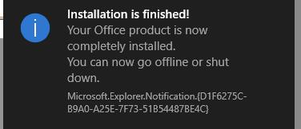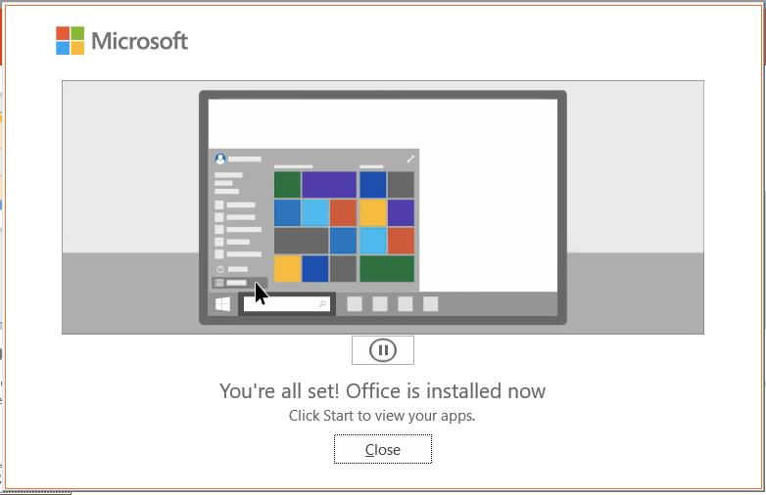

- Office is now installed

Open and sign into Office
- Open Skype and Sign in
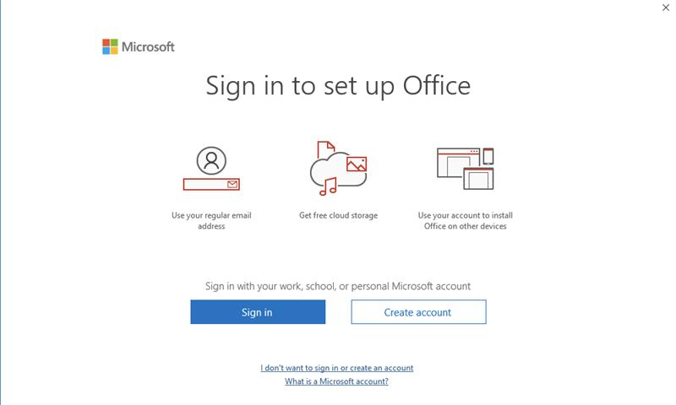
- Enter your short email (eg, jsmith@cgd.vic.gov.au) and click next.
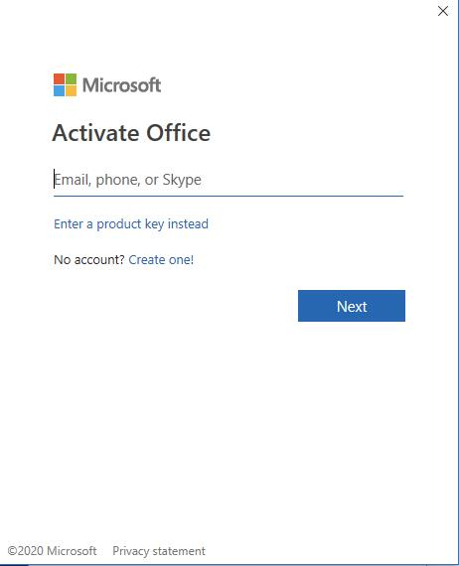

- Enter your password and click Sign in
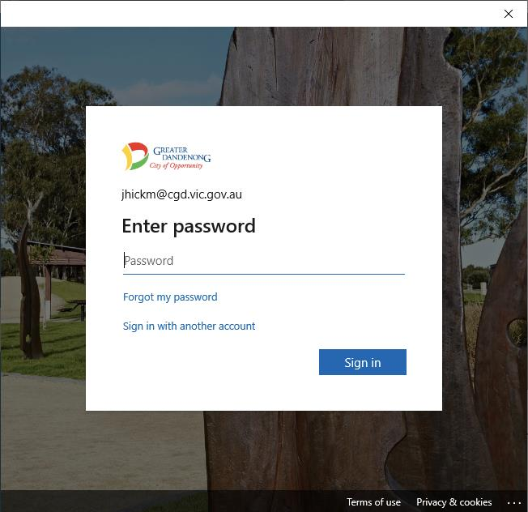
- Click Yes
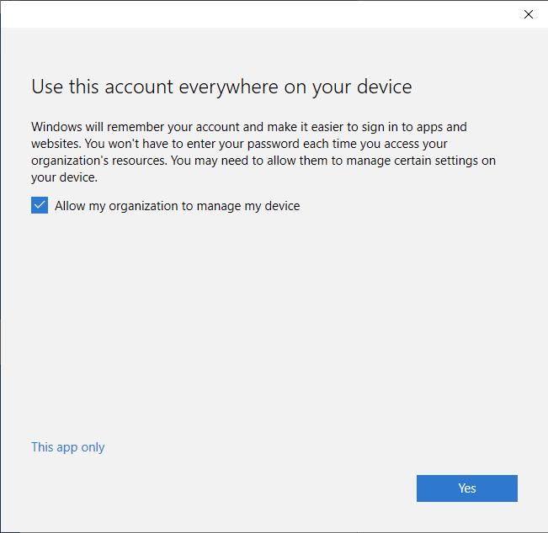
- Click Accept
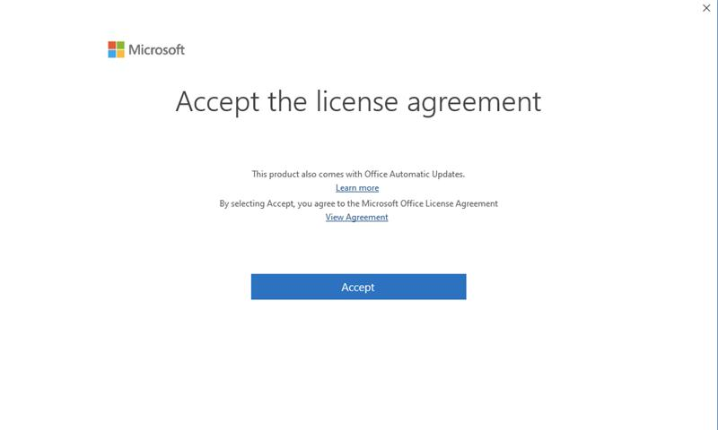
- Go back to Skype for Business and sign in
