Forgotten passwords
If you have forgotten your password and want a password reset, please contact the helpdesk at 85715102 or email ITservicedesk.

Current Password Policy
Before you change your password, please ensure your new password meets these requirements:

Minimum password length of 15 characters (not longer than 24).
MUST include:
- Uppercase letter
- lowercase letter
- number
and ideally a special character.
MUST NOT be weak password, ie contain single dictionary word and number (eg. NOT November2020 )
As of 1 June 2025 password expires every 12 months.
Cannot use previous passwords.
  - Recommended approach is to use a “Passphrase” e.g. IReadTheHeraldSun and then add number/s and special characters e.g. 1Re@dTheHer@ld5un

When and where to change your password
From 1 March 2025, all staff will be prompted to update their passwords from 12 characters to 15 characters. From 1 June 2025 the password reset period will change to 12 months. Ideally this change should be made while connected to the council network. Please refer to the section below Change Password & Restart using Windows 10 on how this is done while connected to the council network. If you allow your password to expire you will simply be prompted to change on your next login.
Note: If you change your password remotely (via the mobile app/Citrix) this will force a new password within all corporate apps (ie Outlook/Mail, MyApps, Citrix etc). However please be aware that if you are using a Corporate laptop remotely that the laptop’s login password will be cached/remain as the old password up until you physically login to the council network again.

Change Password and Restart using Windows 10

- Close/Save all running apps and Web-sites:

  - Close Outlook (and save or send pending Emails)
  - Sign out of Skype as follows:
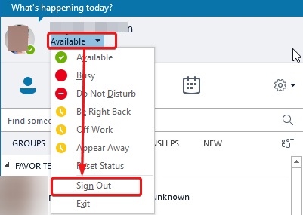

- Close OneDrive by right clicking OneDrive icon in system tray
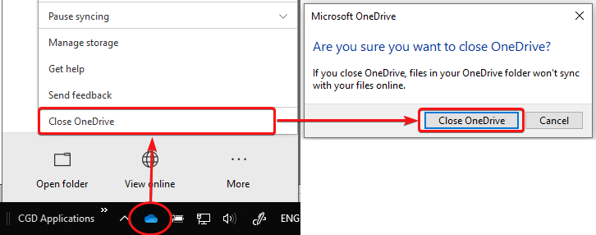

- Press Control-Alt-Delete on keyboard

- From the next screen you must:

  - Select "Change a password" (1)
  - Type your old password (2), new password twice (3), (4)
  - Select the continue arrow (5)
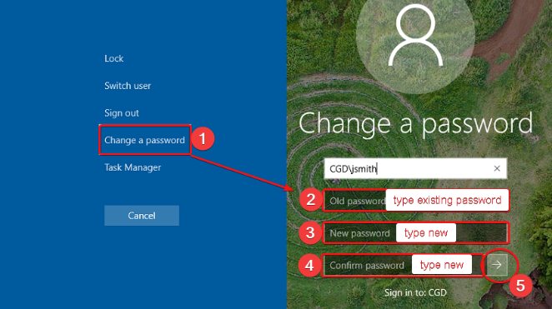

- Restart your PC as follows:
  - Click the 'Start' icon
  - Select the 'Power' option
  - Select the 'Restart option
    - 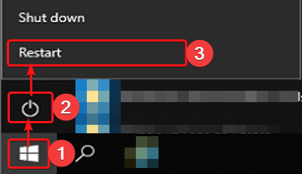

1st Log-in after password change

- Wait for your computer to restart and once prompted login using your new credentials.
- If you are presented with the following prompt after logging back into your computer. Please follow the 2 steps below to successfully complete this process:

- Select “Sign in with another account”
- Click on the section with your details (Name/Short Email)
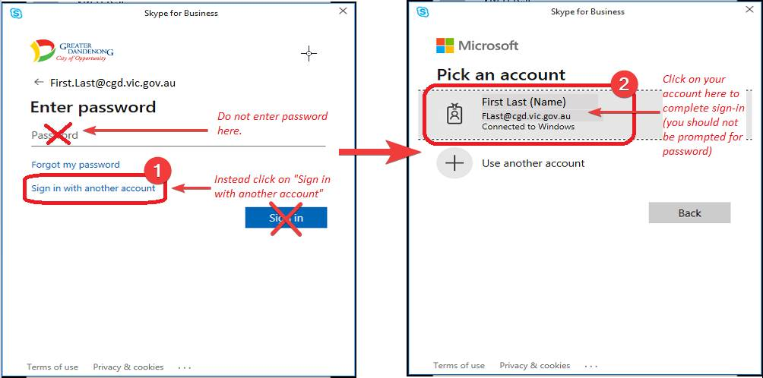

- Please contact the IT Service Desk if you have any difficulties changing your password.

IMPORTANT: Once you have changed your password, wait for your other devices to prompt you to enter your new password. This delay is due to these additional devices syncing with the server. Failure to do so will result in the passwords not being updated and your account being locked out.

