

OBJECTIVE ECM FOR BROWSER
Saving emails into Objective from home

March 2020

Contents
Logging into Objective ECM 3
Creating a Folder to store your emails 3
Creating an Electronic Object 4
Check Webmail for the newly created folder 7
Saving an email 7

Logging into Objective ECM
- Log into Objective ECM from Myapps (myapps.cgd.vic.gov.au)
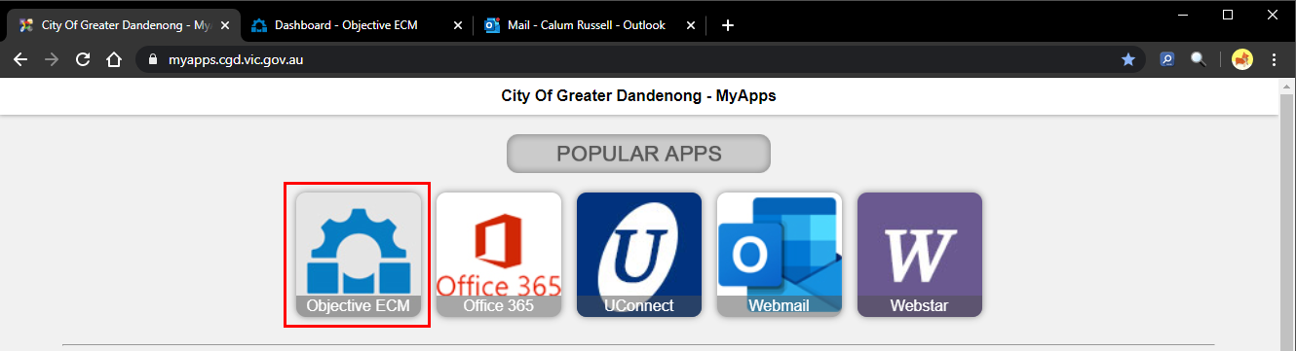
  - When presented with the Objective login screen, enter your username and password and click Log In.
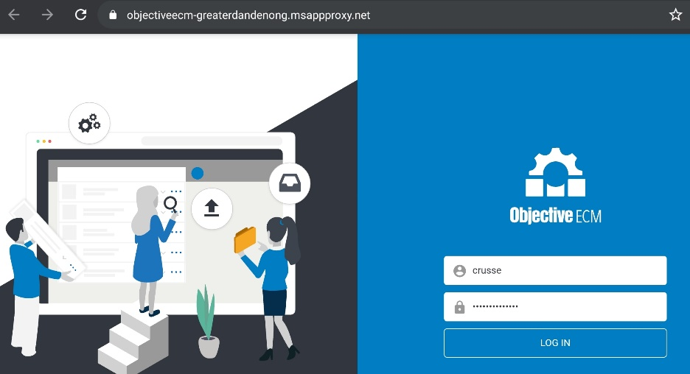

- Objective ECM will open to your dashboard
  - If Objective ECM opens as a blank page, please refresh the browser webpage (you can also press F5 on your keyboard to do this)
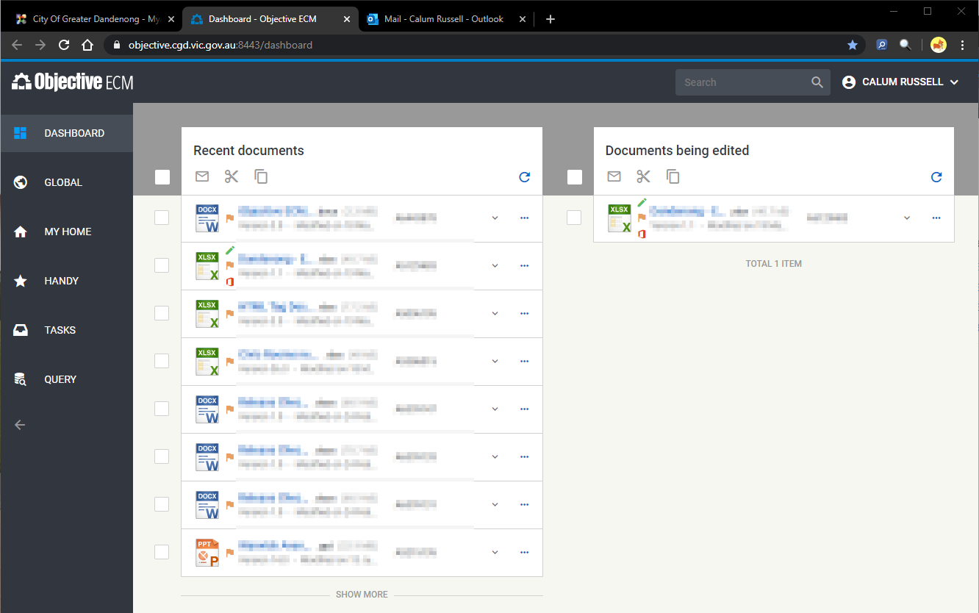

Creating a Folder to store your emails
- In the Sidebar, click “My Home” 
- Click on the “actions” button and select “Create object”
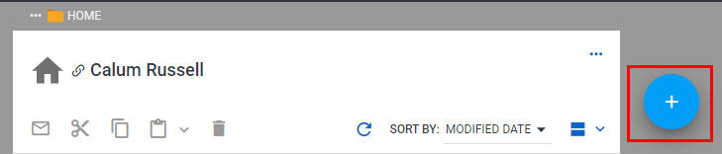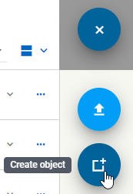

- In the blade that opens, select “Folder”
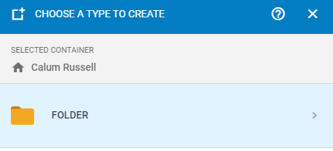

- Name the folder “Emails username from home” (replace “username” with your CGD login ID)
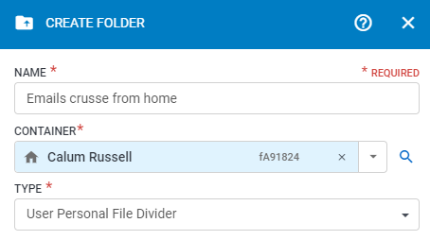

- Click “create”
The created folder will now display in your Objective Home Folder.
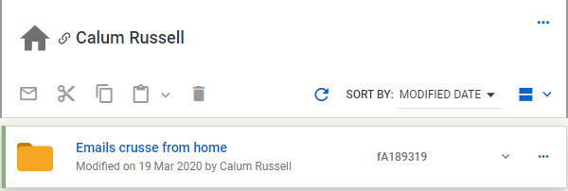

Creating an Electronic Object
- In your Home Folder, open your “Special Folder – Firstname Lastname”


- Open the “Exchange Links” Folder


- Click on the “actions” button and select “Create object” 
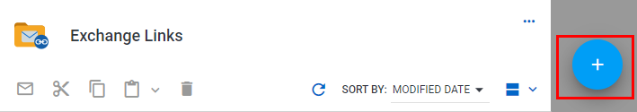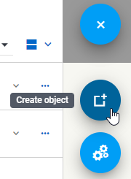

- In the blade that opens, select “Electronic Object”
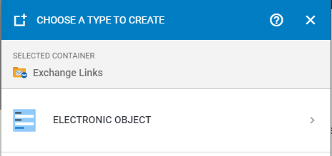

- Name the object “Emails username from home” (replace “username” with your CGD login ID)
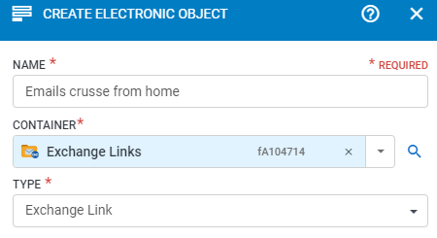
Continue to next page
- Expand the “Exchange Link Fields” section
- In the “Exchange Link Destination” field, begin typing “Emails username from home”
- 1 result should return. Ensure this is the folder you created when completing steps 3 to 7 in this guide.
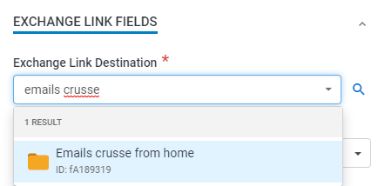

- Select the folder. It will now appear in the Exchange Link Destination field.
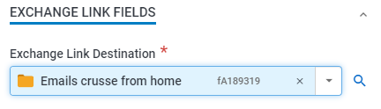
- Click “Create”

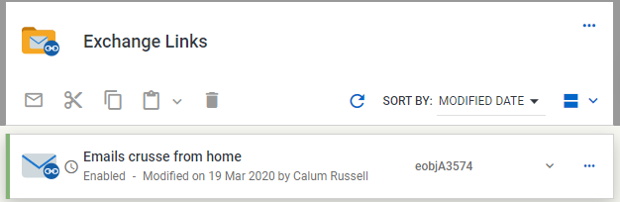

The Exchange Link has now been created. This is what integrates your Outlook to the Objective folder you created in steps 3 to 7

Check Webmail for the newly created folder
- Navigate back to myapps.cgd.vic.gov.au and Click on “Webmail”
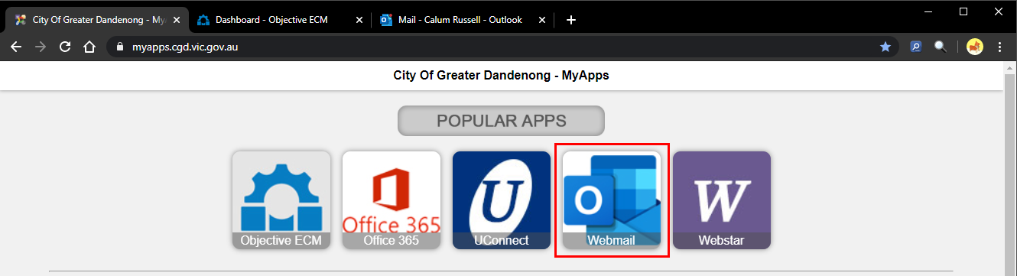

- A folder with the name “Emails username from home” will appear under your inbox.
  - You may need to expand the Inbox section, by clicking



Saving an email
- Drag and drop an email into the outlook folder “Emails username from home”
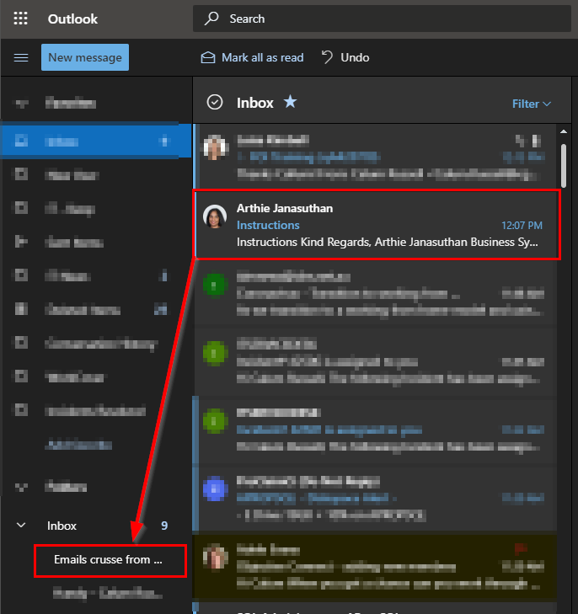
- Check the folder to ensure the email has moved successfully
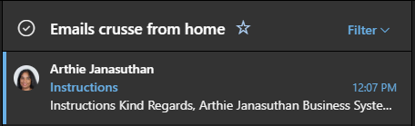
- After a small amount of time, the email will sync and display in the Objective folder created in steps 3 to 7 of this guide
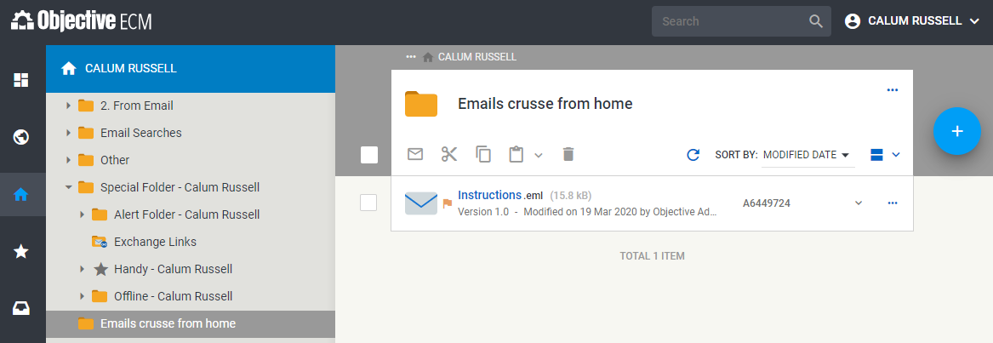
- Once the email can be seen in the Objective Folder, you can move it to the relevant location within the global folder. You can also delete the email in Outlook.

