

MERIT WEB 24/7 BROWSER VIEW
QUICK USER GUIDE
December 2019, Version 5.0.74
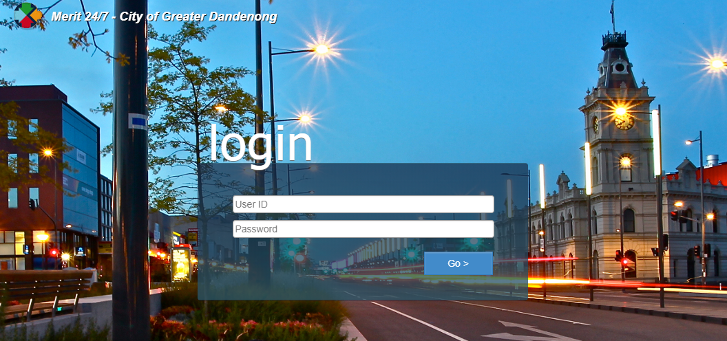

Contents
Getting Started 3
What is Merit 24/7? 3
1. The Basics 4
Accessing the Site. 4
Home Menu 6
Home Screen Shortcut definition 7
2. Navigation 9
Creating a New Request 9
Completing a Task 13
Reassign task to another officer 17
Recategorising Request 19
Using the Search function 20
Attaching an image or document to a Request. 22
Viewing an Objective Document 25

Getting Started

What is Merit 24/7?
Merit 24/7 is a web-based interface to Merit CRM system enabling you to track, create new requests, update, close actions, and view objective documents linked to Merit. You can quickly and easily perform actions – anywhere using a mobile device.

The Basics

Accessing the Site.
1. Enter the following URL in your default browser:

https://myapps.cgd.vic.gov.au/ and choose Merit 24 7

OR alternatively
https://merit247.cgd.vic.gov.au/merit247/

2. Type your username and password.
Important Note: Ensure Microsoft Authenticator is set up before logging in.

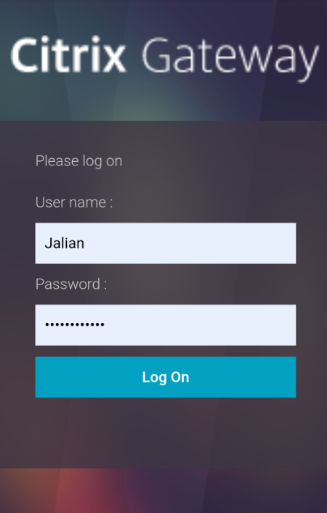
3. Press the Log On button.
4. Click Approve.
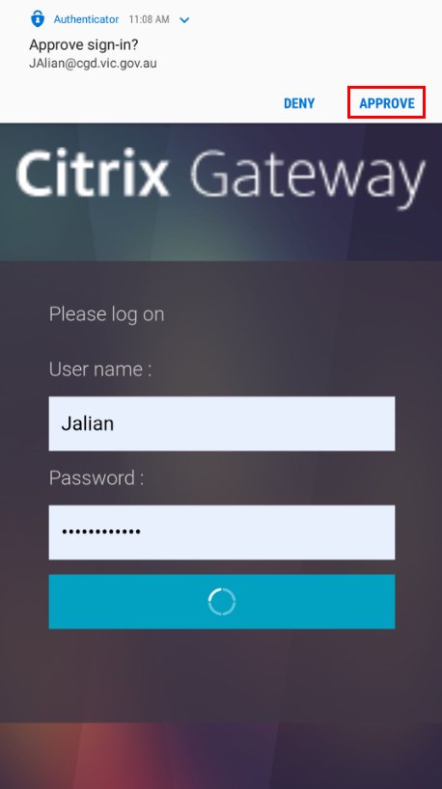

If you are using a laptop, you will be navigated to the browser view.
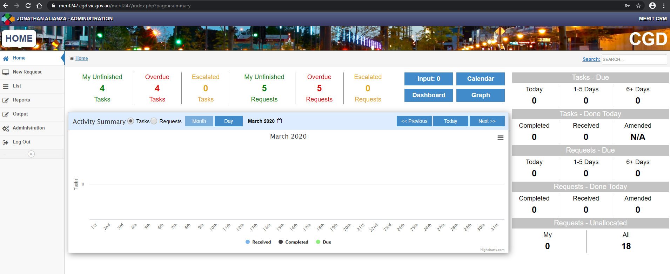
If you are using a mobile phone, you will be navigated to the mobile view, please refer to the user guide: Merit 24-7 Mobile Phone View v5.0.74 User Guide (A5725778)
To change views from browser to Mobile, Click on the Merit icon  at the upper left corner of the screen.

Home Menu
- Initial screen gives you a shortcut of the functions in the left and a dashboard of your unfinished tasks/requests in the mid and right section.

Home functions menu

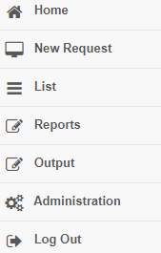

- Clicking Home navigates you back to your initial dashboard screen.

Home Screen Shortcut definition
All the available menu bar options are listed below. Depending on your security role settings, some options may not be available to you.
Menu Item |  | Description
 | Home Menu. Navigates you back to the home screen.
List of Requests and Tasks (default to unfinished actions that are assigned to you)
This is also used to access your team’s In-Tray.
 | Displays a list of dashboards and reports that you have access to run.
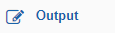 | Function to print and export reports.
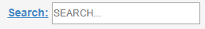 | Available in the upper right corner of the screen. Gives the function to search a request/task number.
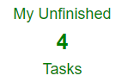 | Similar to Today’s work item.  Displays a list of tasks (default to unfinished actions that are assigned to you)  Use the drop-down option to filter by status and In-trays.
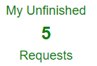 | Displays a list of unfinished requests.
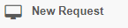 | Navigates you to the new request form. New Request ID will be generated.
 | Logs out of Merit.

Navigation

Creating a New Request
- Click on the New Request bar:

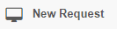

- Enter the required fields:

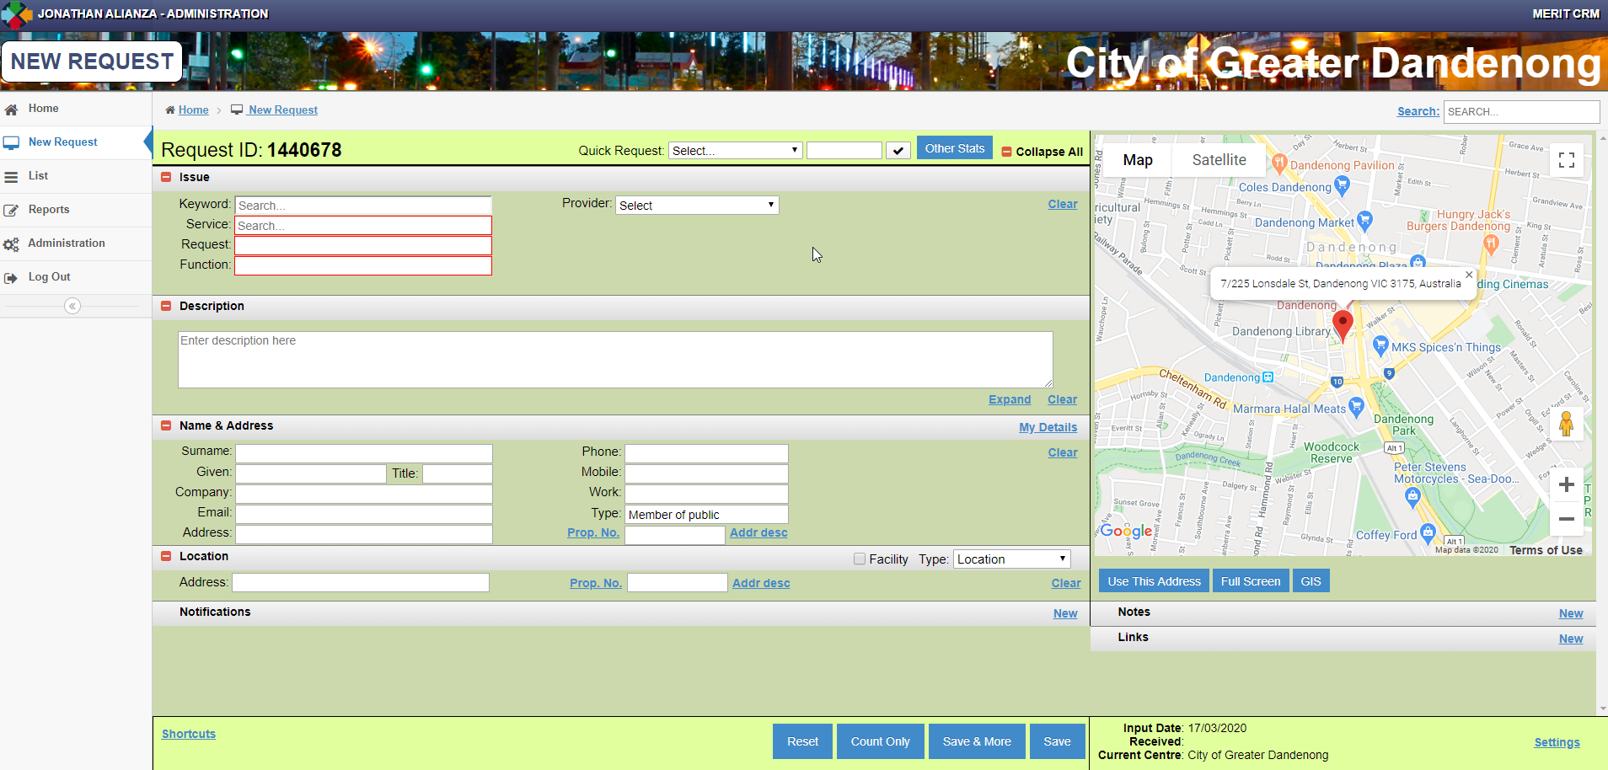

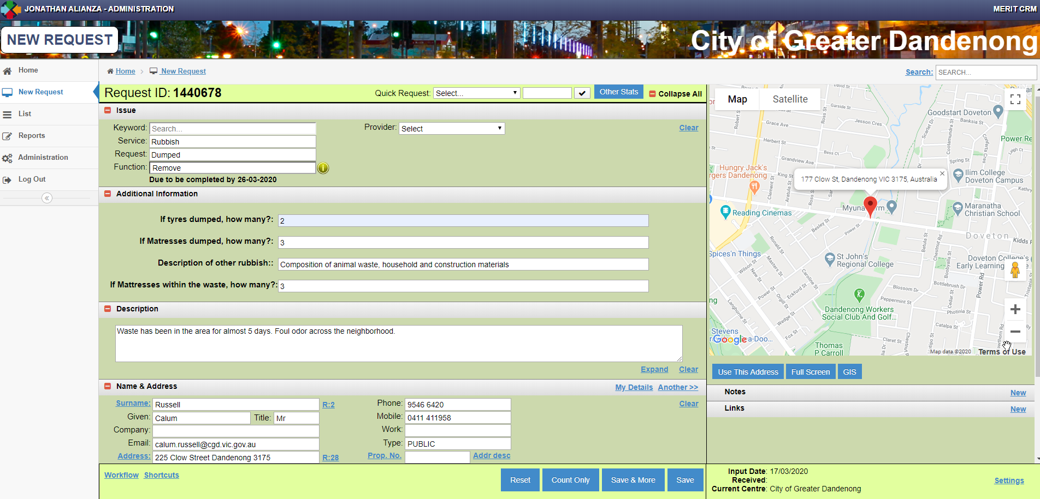

Note: Depending on the SRF selected, specific fields can be mandatory or optional.
Customer Name & Address matching name screen will pop up once Surname and Given is fi and Click to another field.

- In the Location, fill up the details until matching addresses drop down pops up. Select the address.

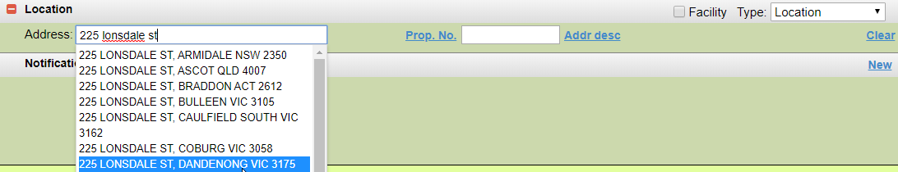

Note: Property No. will display once the request is saved (except for new address that needs to be added in Merit)
For Facility, tick on the checkbox.
You can also Search by Facility Type or Facility name.

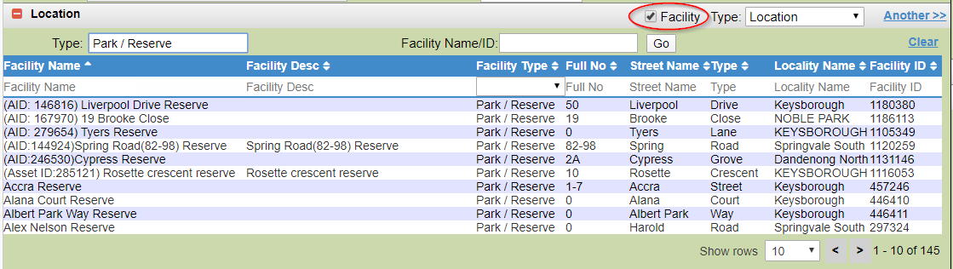

- Selecting the Facility will auto populate its succeeding fields.

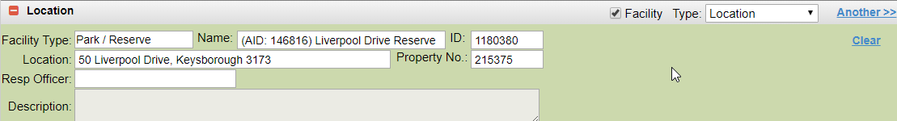

- To add Notes, Click on ‘New’ on the right side of the browser, below the map.

- Enter Notes and Save.

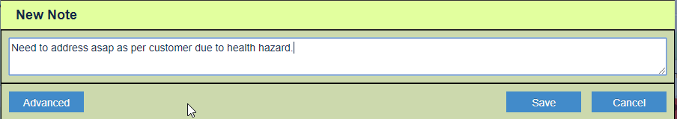

- If you want to link the new request to an existing request. Click link and enter the existing request number then Save.

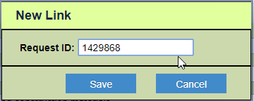

- The details of the linked request will be displayed under ‘Links’.
- Save the Request.

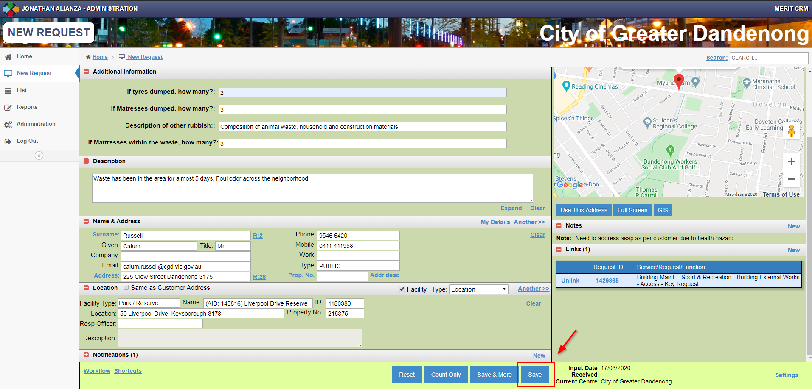

Completing a Task
You can quickly access your assigned tasks through Home > List > Tasks
OR by clicking Home > My Unfinished Tasks. See example below.

- Example, Click My Unfinished Tasks from the menu.

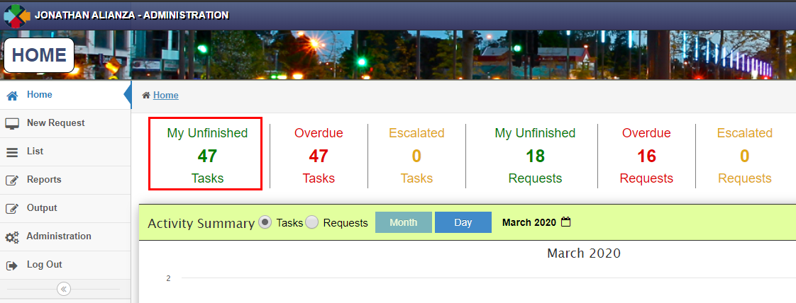
- Select one of the tasks and click to open it.
Note: If you want to select a task based on an In-Tray. Click the dropdown that is currently default to as ‘MY UNFINISHED’

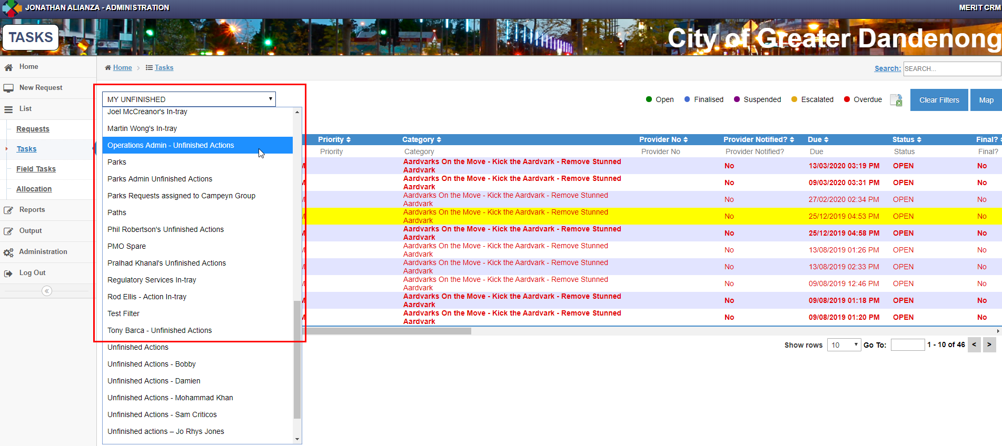
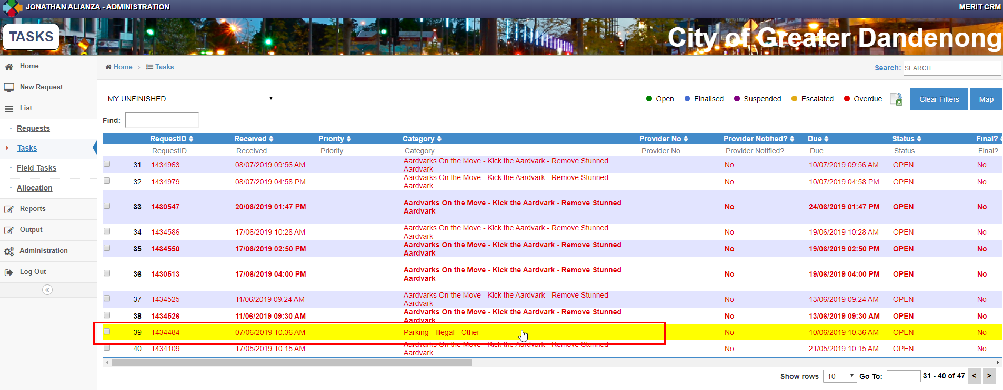

- Select the outcome of the Action from the drop-down list.
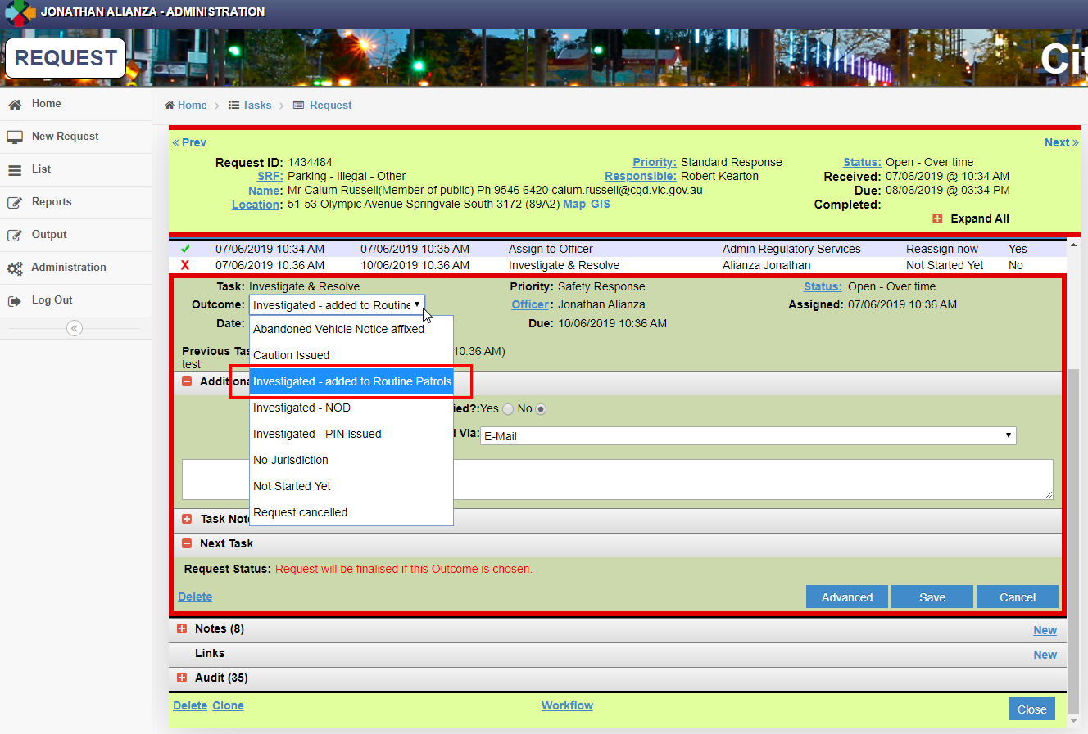
- Enter Notes and click Save

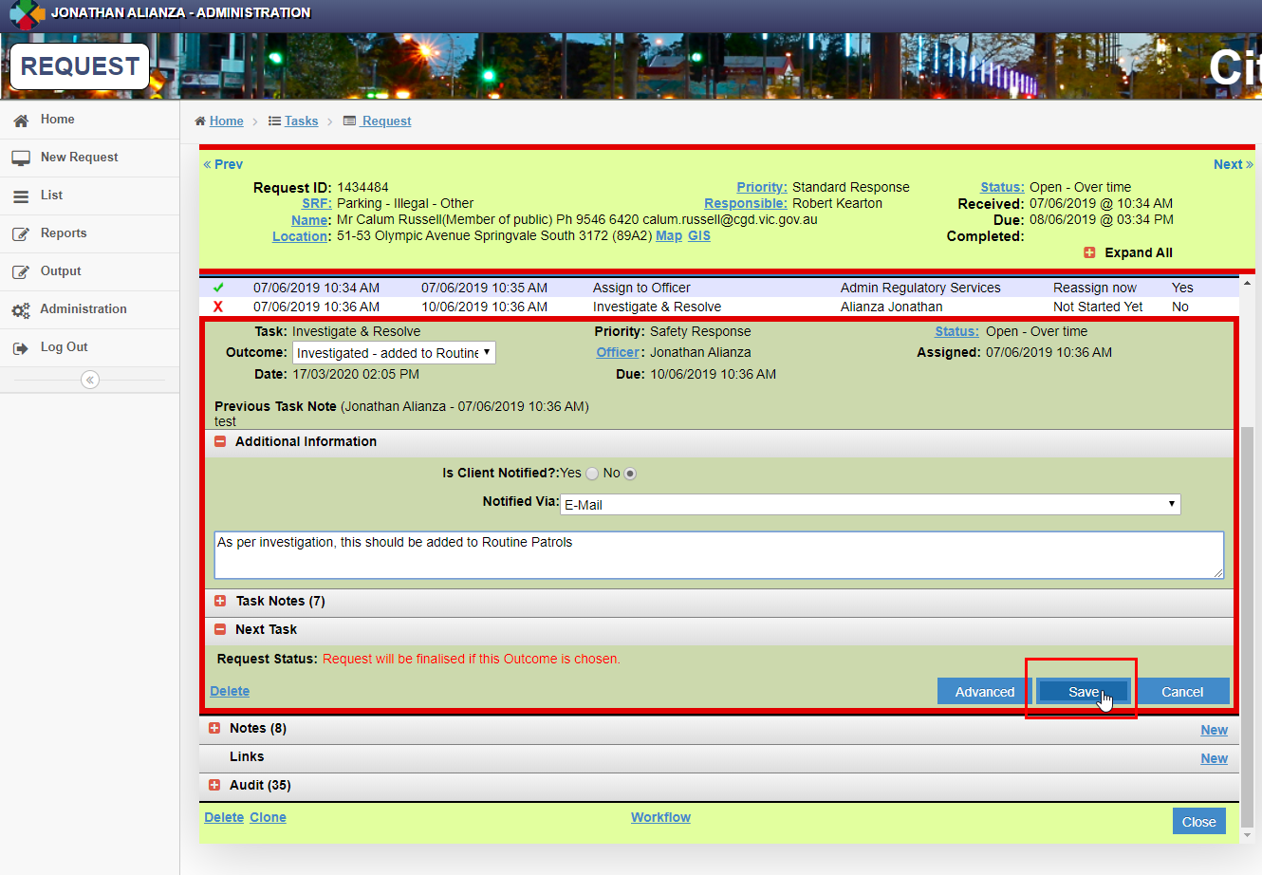

Reassign task to another officer
- Navigate to the relevant task and directly Click Officer .

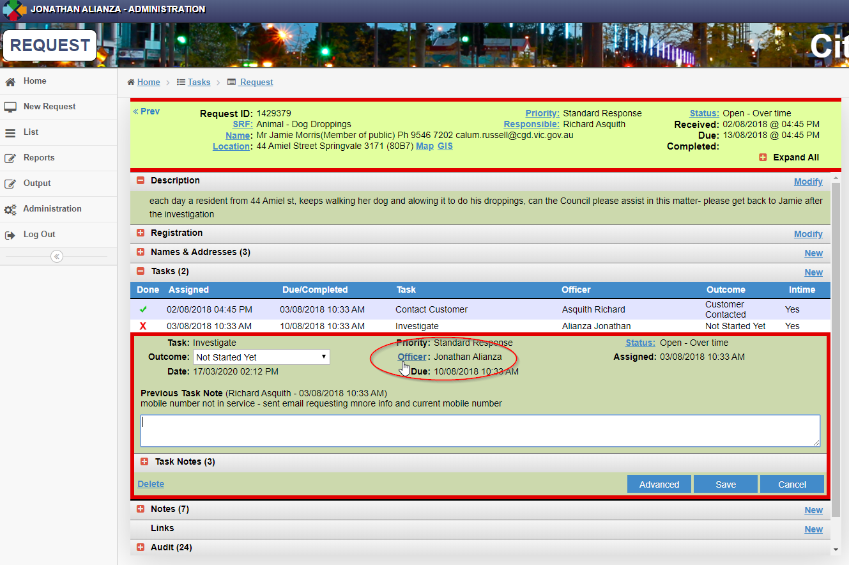

- Type the Officer name until matching names pop out.
- Select the Officer

- Enter Notes and ensure *‘This task only’ is selected unless you want to reassign all active tasks. Refer to the options.

- Click Reassign.
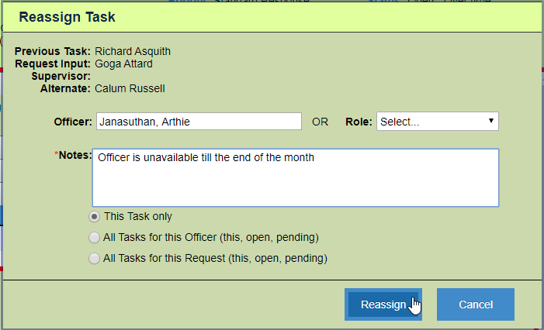

Note: If you want to reassign task to ‘Request Input Officer’ OR ‘Previous Task Officer’, these options are available by selecting Role.

Recategorising Request
- If you want to recategorise a request from an action assigned to you, Click “SRF”.

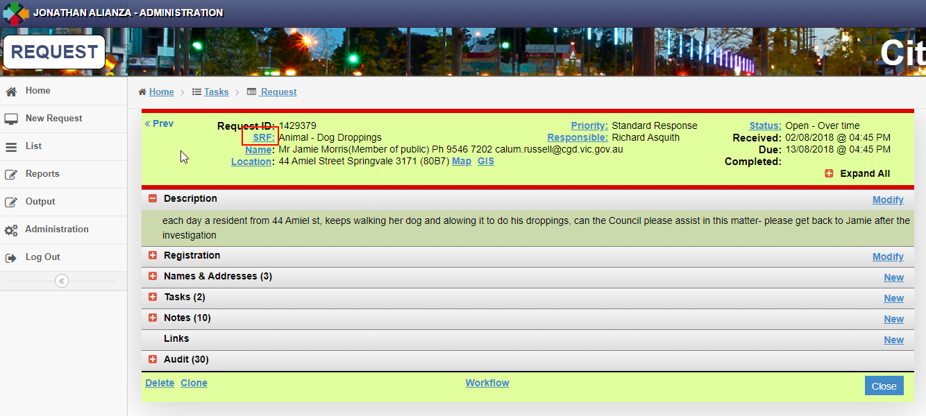

- The Recategorise Request screen will display as per screenshot below.

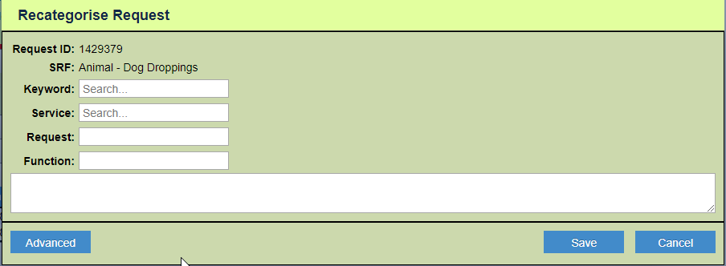
- (1) Enter the new SRF and the (2) reason for recategorising it. Then Click (3) Save

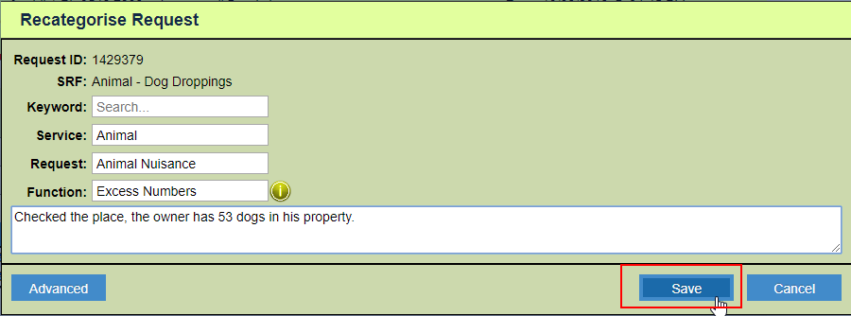

Using the Search function

- Open or search for the request. Search is available at the upper right-hand corner of the window.

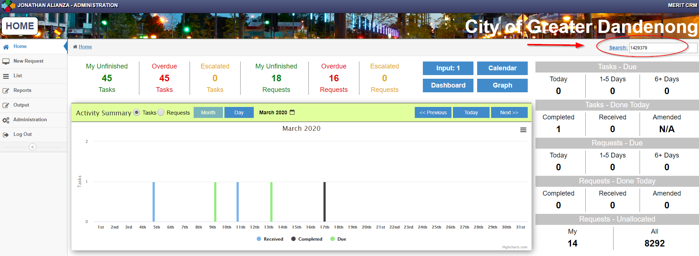

- Click Search.
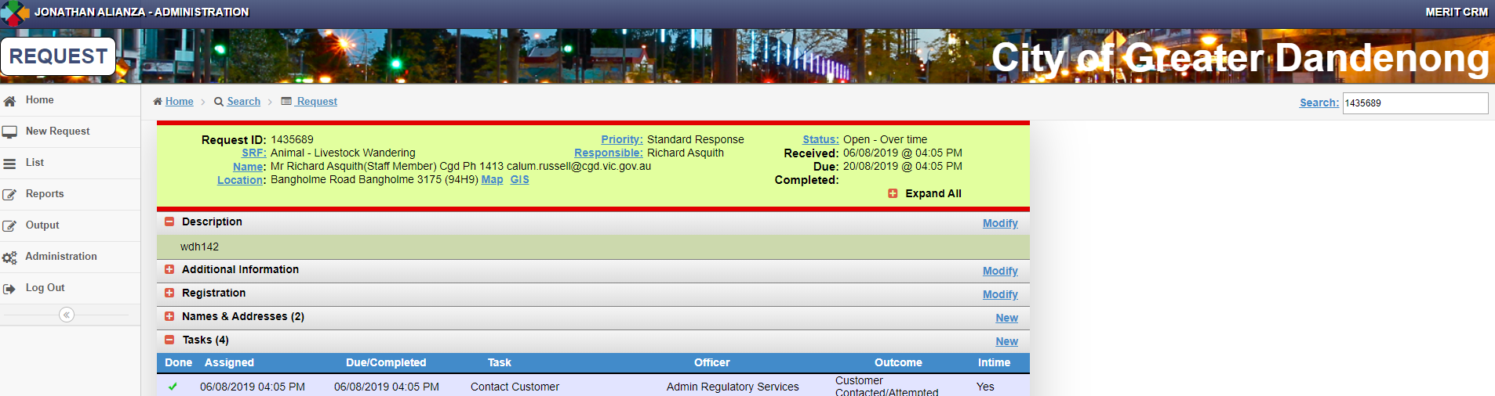
- Depending on your security role, other requests or tasks details may not display.

Attaching an image or document to a Request.
Note: For new requests, an image or document can only be attached after you saved the request. The attached file will automatically link to Objective.
- Open the request. In the Notes section, Click New.

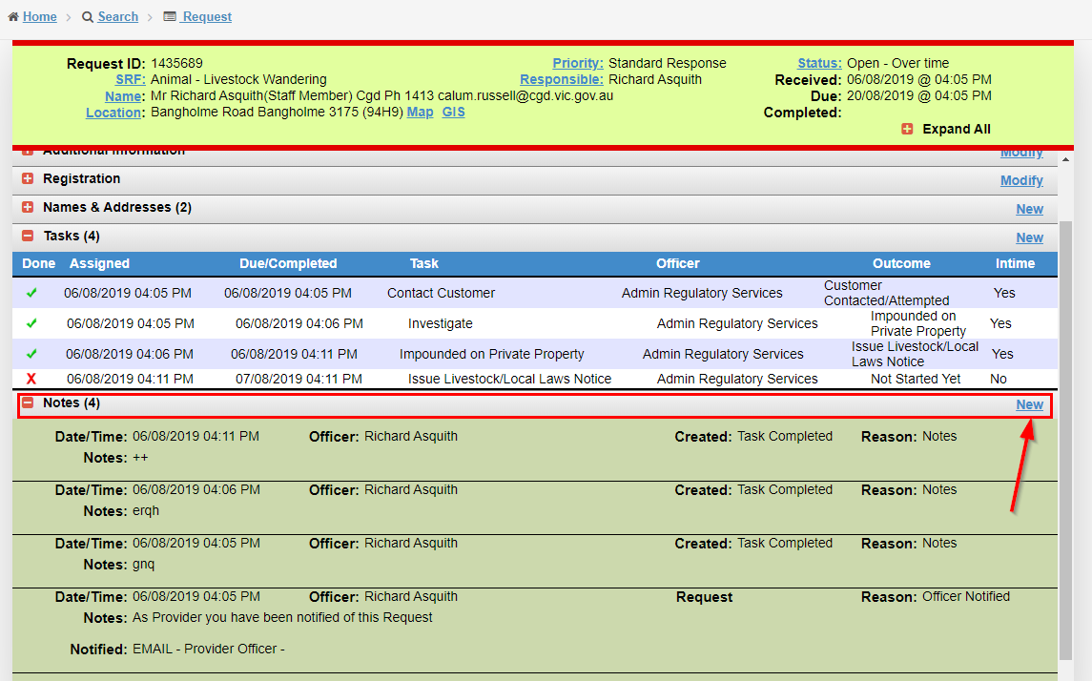

- Enter comments of the attachment and Click Advanced.

- Click Choose File and select image from your computer.

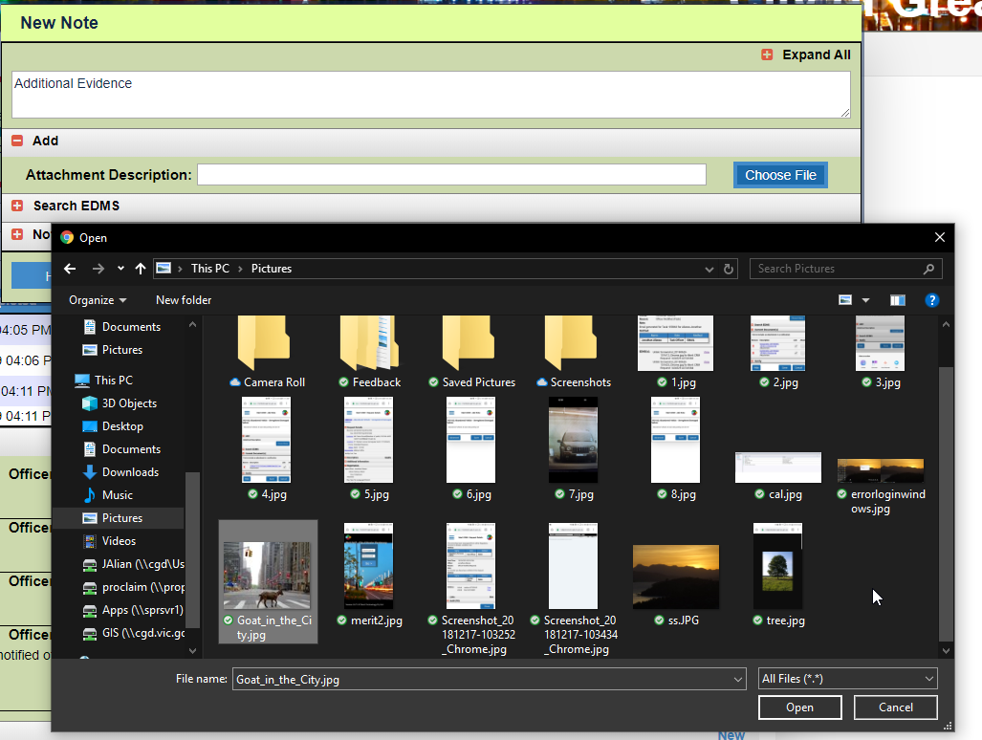

- Click Save.

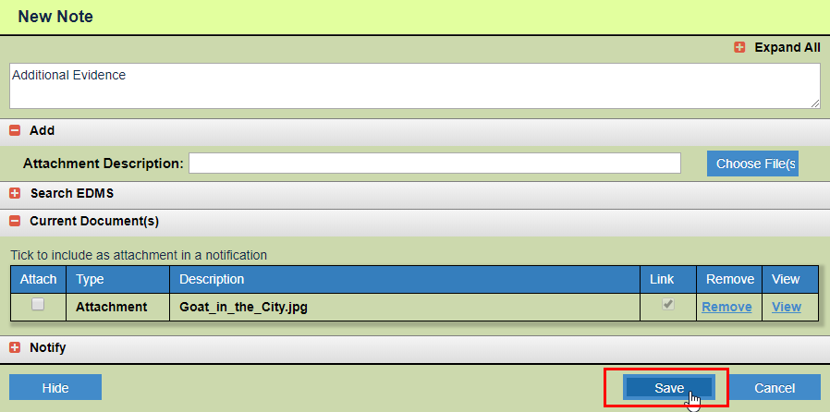

- The file will automatically be linked to Objective. It will also be available at the bottom part of you Notes section.

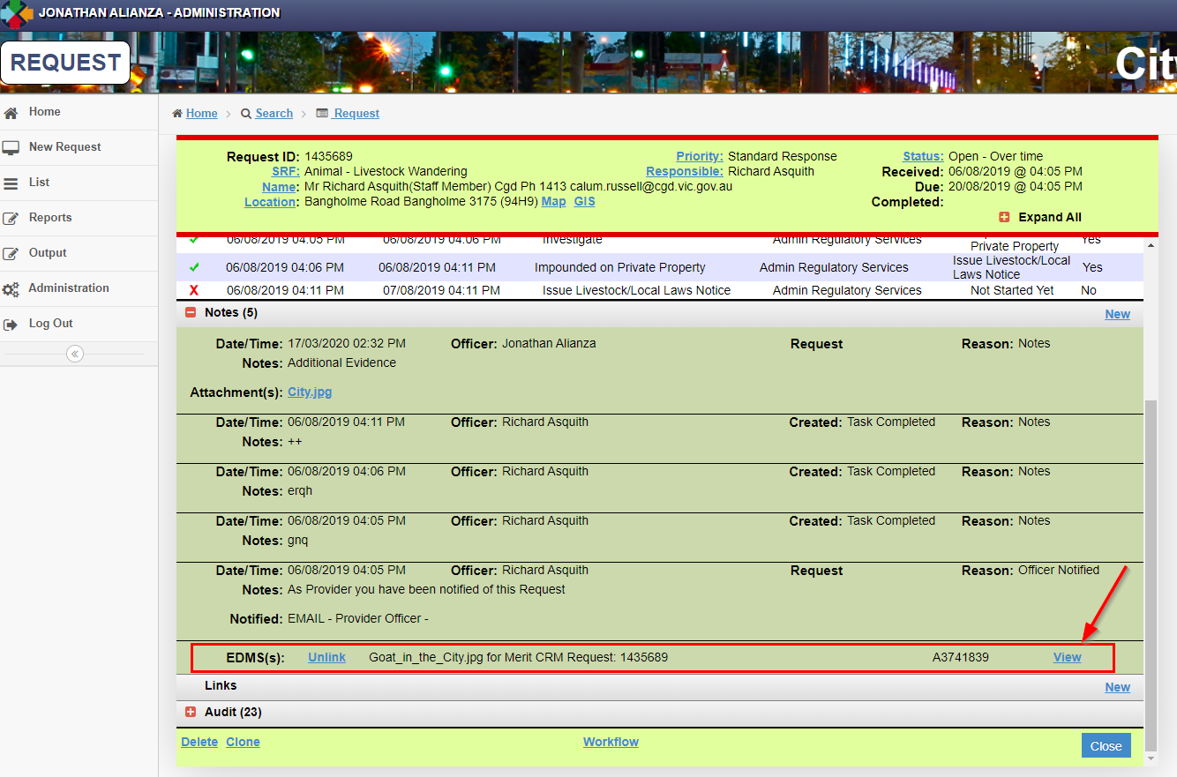

Viewing an Objective Document

- On your list of actions, Click on the Request (ID).

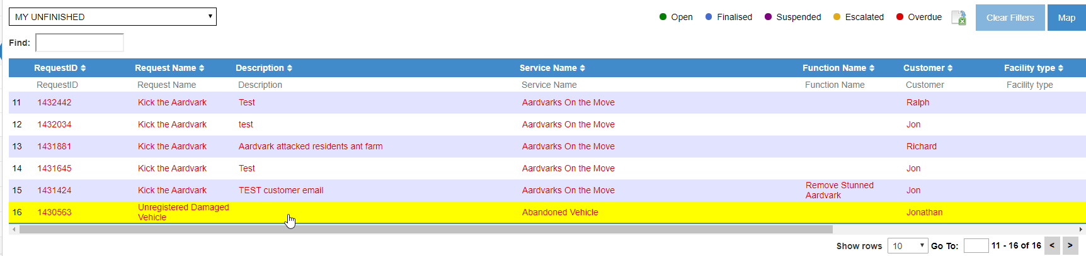

- Click on the Notes (+)

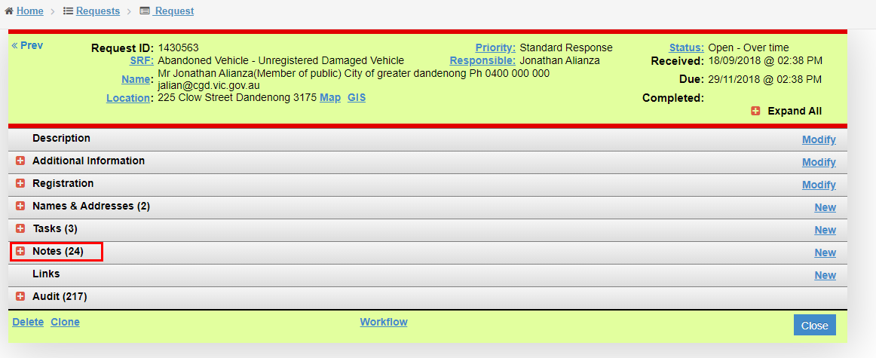

- Scroll down to the bottom of the Notes. All objective files linked to the request will be displayed. Click View.

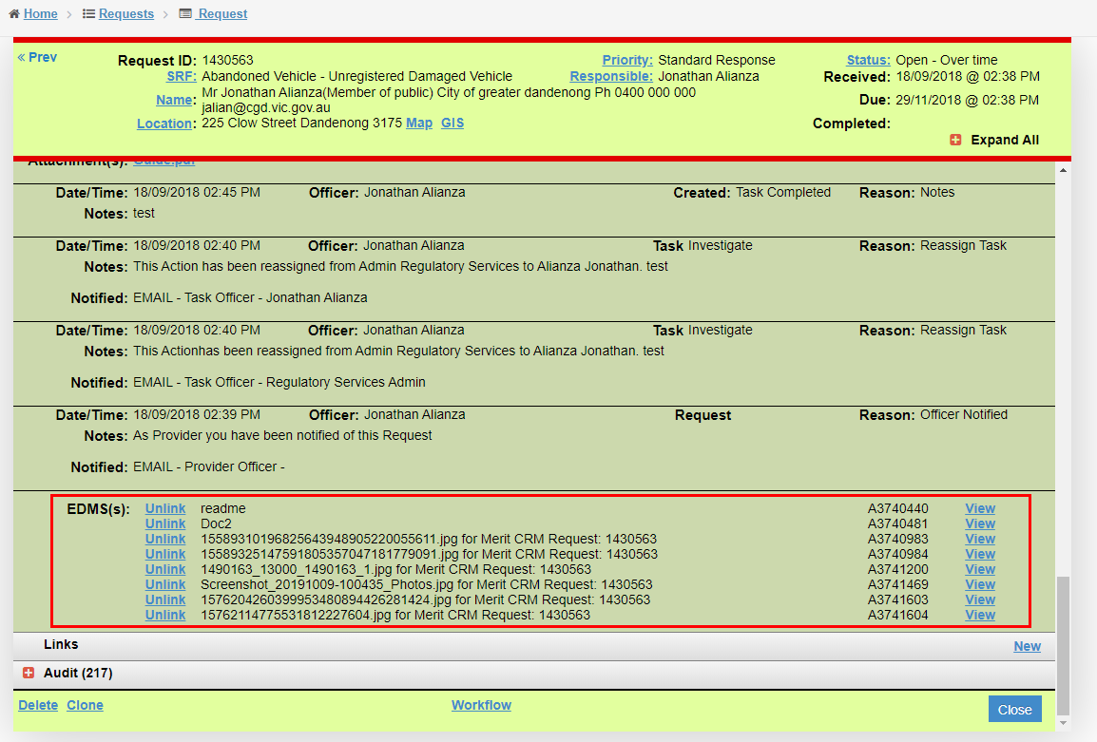

- Screen will open a new window and display the objective file.

Please contact the IT Service Desk on 8471-5102 if you require Merit support.

