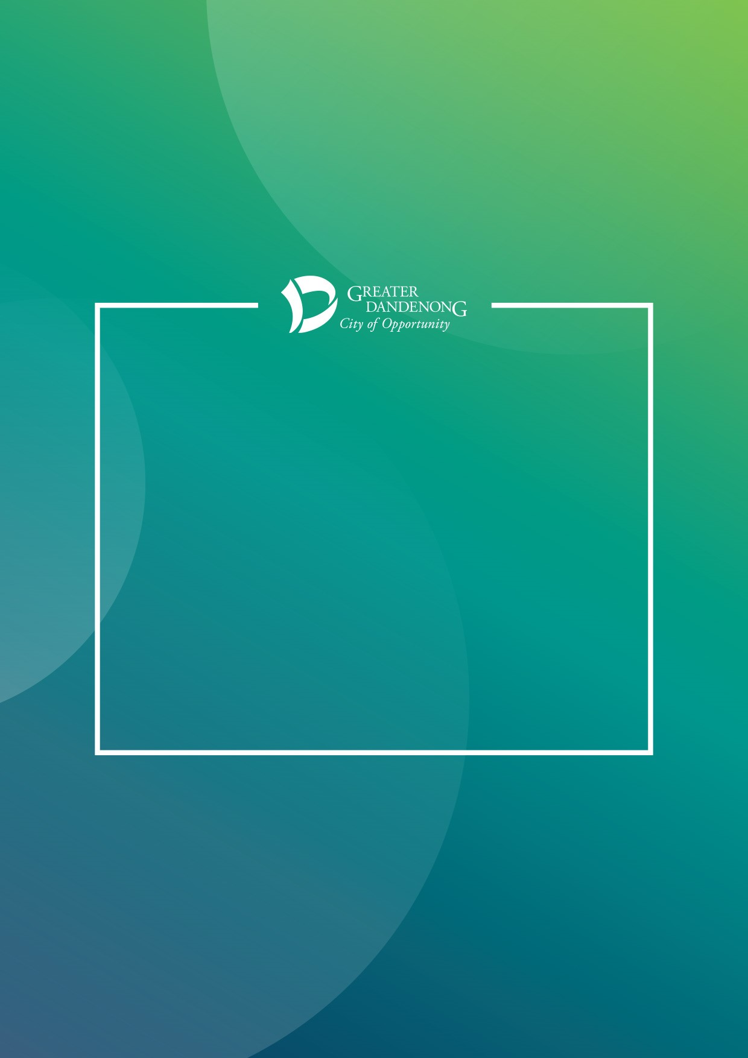

OBJECTIVE ECM FOR BROWSER
Edit in Office Online

March 2020

Contents
Logging into Objective ECM 3
Editing a document in Objective ECM when working from home. 4
Opening the document in Office Online 6
Viewing the document in Office online 7
Releasing a document that is being edited in Office Online 8
Editing a document with a co-author in Objective ECM when working from home. 10
Opening the document in Office Online 12
Viewing the document in Office online 13
Releasing a document that is being edited in Office Online 14

Logging into Objective ECM
- Log into Objective ECM from Myapps (myapps.cgd.vic.gov.au)
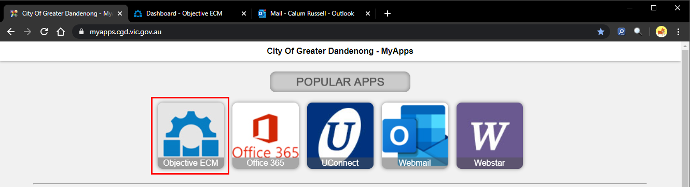

  - When presented with the Objective login screen, enter your username and password and click Log In.
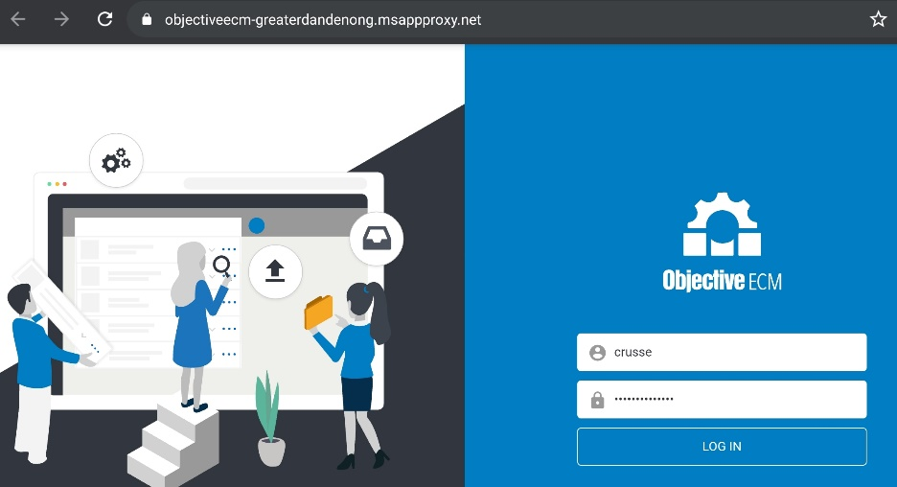

- Objective ECM will open to your dashboard
  - If Objective ECM opens as a blank page, please refresh the browser webpage (you can also press F5 on your keyboard to do this)
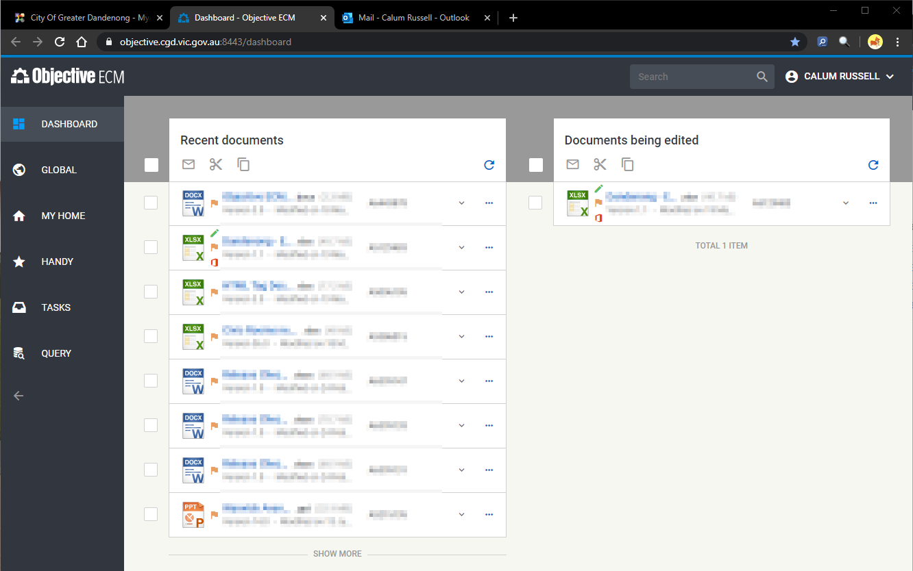

Editing a document in Objective ECM when working from home.
- Open the Ellipses menu for the document you wish to edit
- Click on “Edit in Office Online”
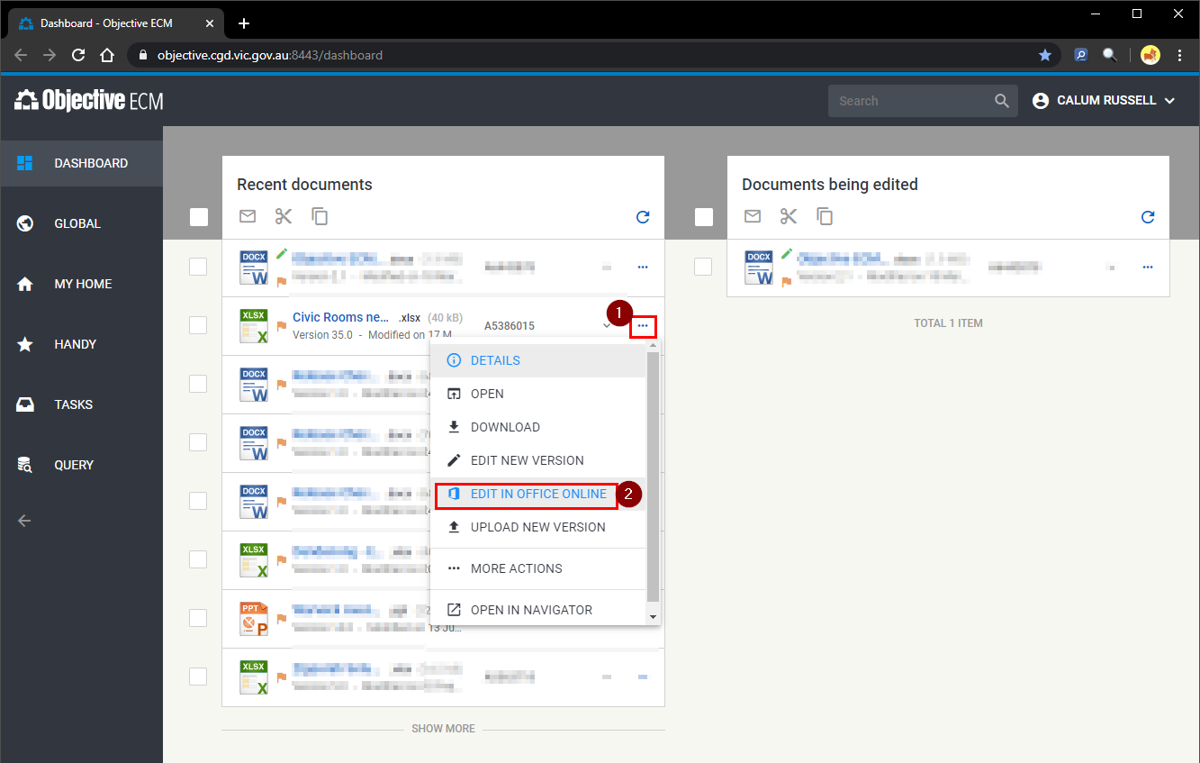
- Click “Start Editing”
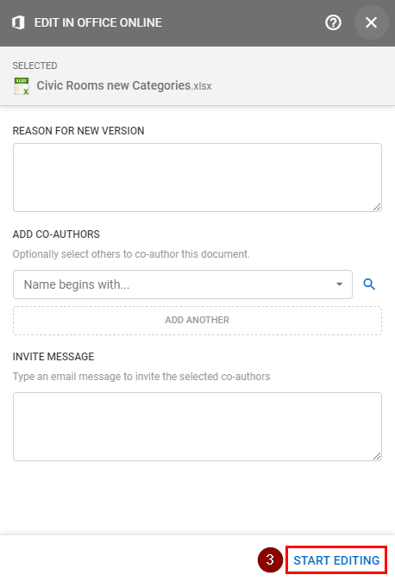

The following pop up will appear. You can click “continue working” or you can wait for the “Open in Office Online” button to display.
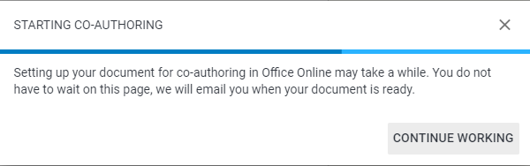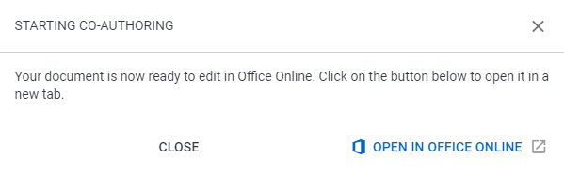
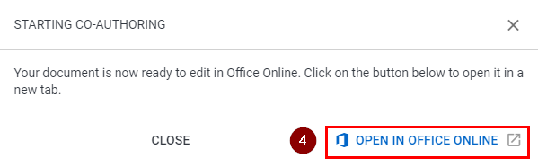
Once the document is in Edit, it will appear under the “Documents being edited” list on your ECM dashboard. You will notice the green edit icon, as well as the orange Office icon, which means the document is being edited in Office Online.
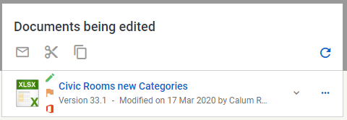

Opening the document in Office Online
- There are multiple ways you may access the document once it is being edited in Office Online.
  - Click on the “Open in Office online” Button from pop-up
  - Click on the “Edit Document” button from within the email you received
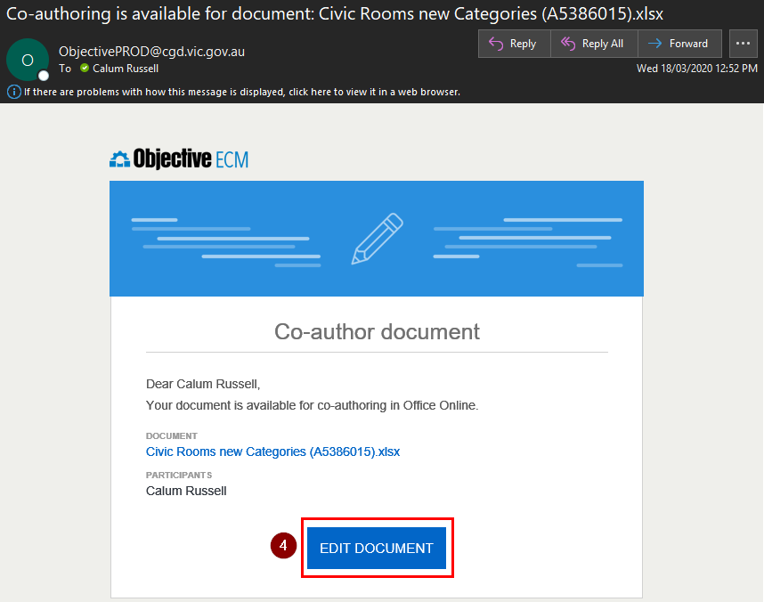
  - Click on the “Open in Office online” Button from the ellipses menu
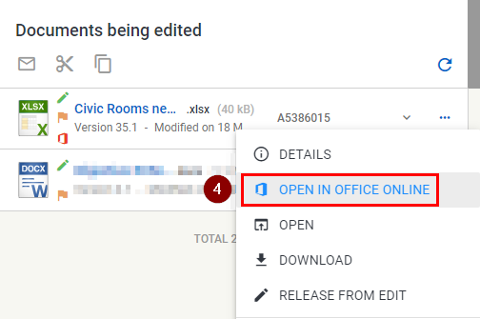

Viewing the document in Office online
The document will open in the relevant office web application.
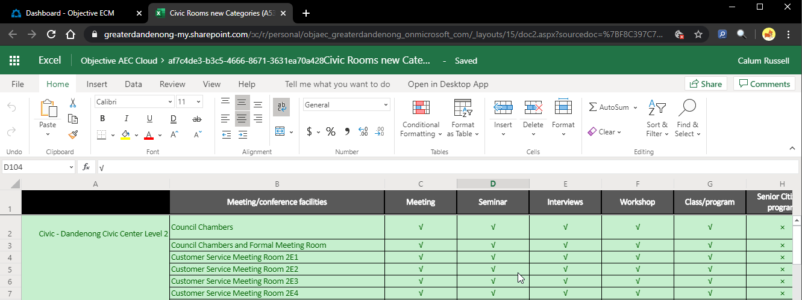

Releasing a document that is being edited in Office Online
- Open the ellipses menu and click “release from edit”
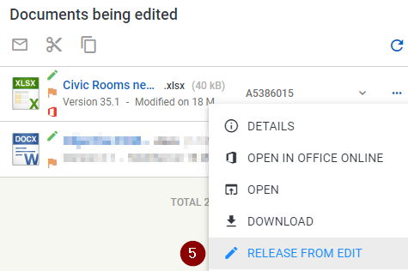
- Tick the two checkboxes, “Immediately publish” and “Set corporate value”.
- Click “Release”
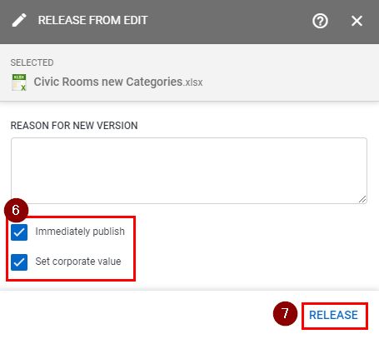

The document will release from edit, and you will also receive an email notification.

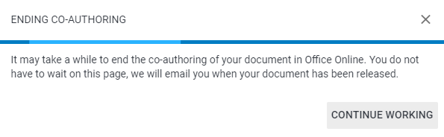
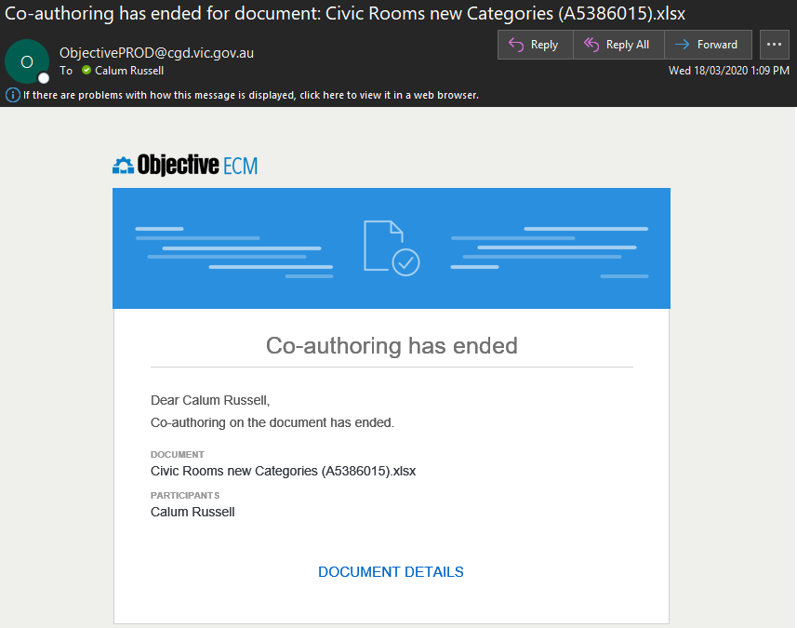

Editing a document with a co-author in Objective ECM when working from home.
- Open the Ellipses menu for the document you wish to edit
- Click on “Edit in Office Online”
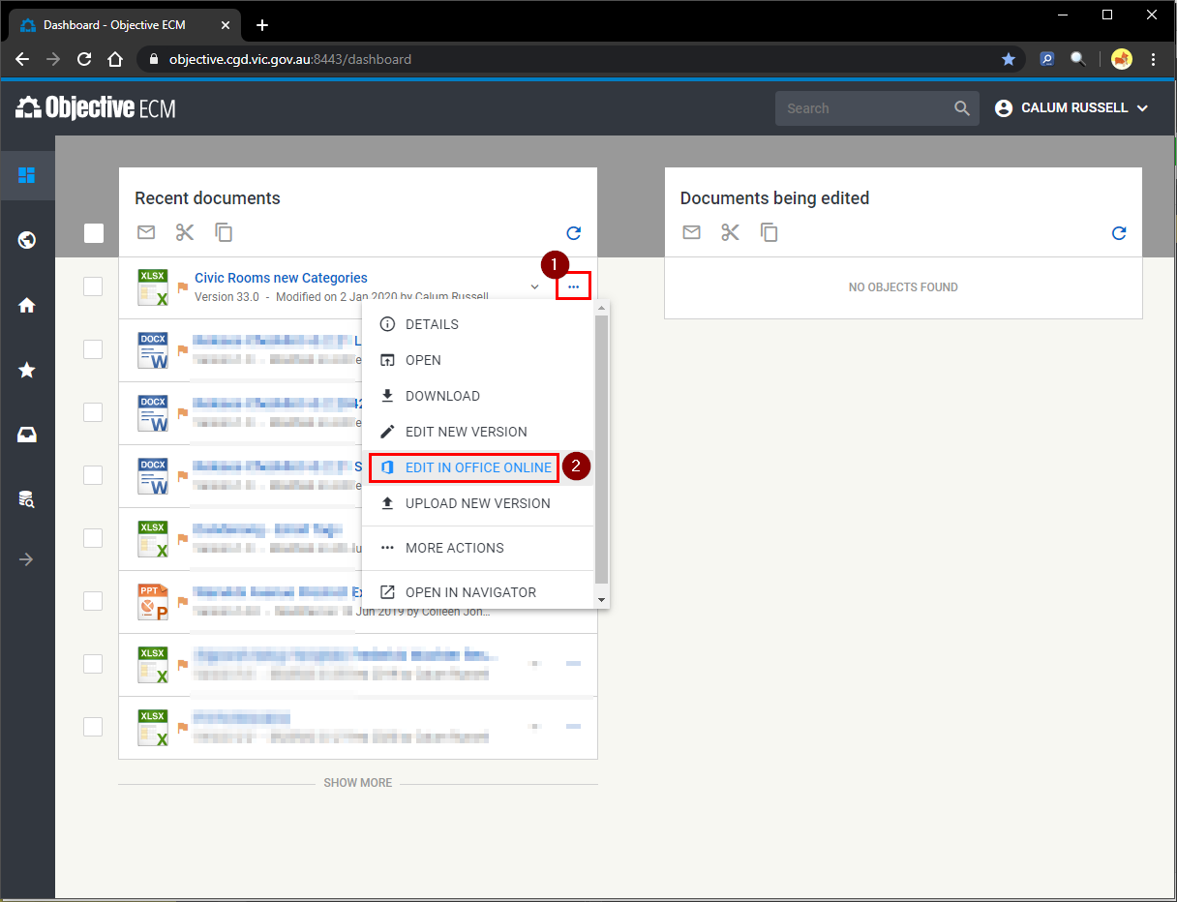
- Co-authoring
  - To allow another CGD staff member edit access, search for their name and click on the search result to add them as a participant.
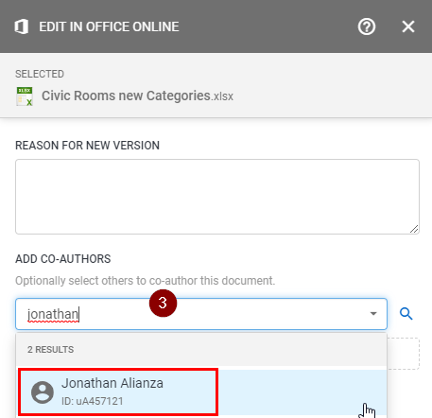

- Click “Start Editing”
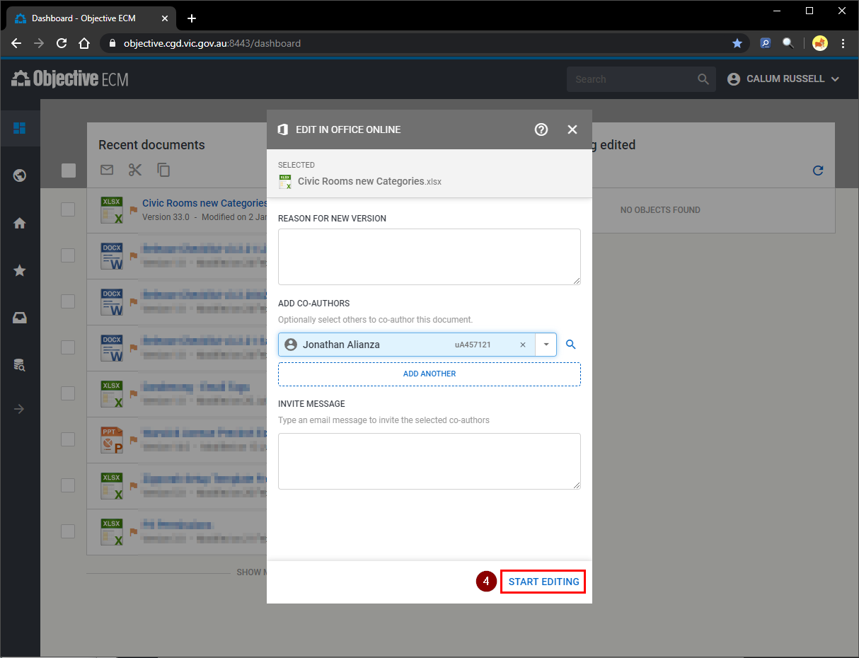
The following pop up will appear. You can click “continue working” or you can wait for the “Open in Office Online” button to display.
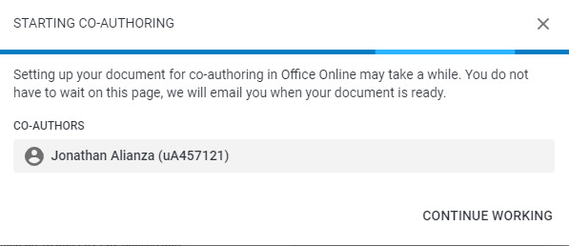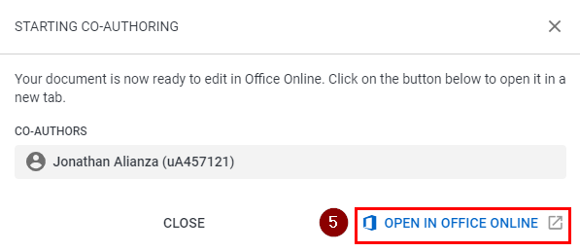
Once the document is in Edit, it will appear under the “Documents being edited” list on your ECM dashboard. You will notice the green edit icon, as well as the orange Office icon, which means the document is being edited in Office Online.

Opening the document in Office Online
- There are multiple ways you may access the document once it is being edited in Office Online.
  - Click on the “Open in Office online” Button from pop-up
  - Click on the “Edit Document” button from within the email you received
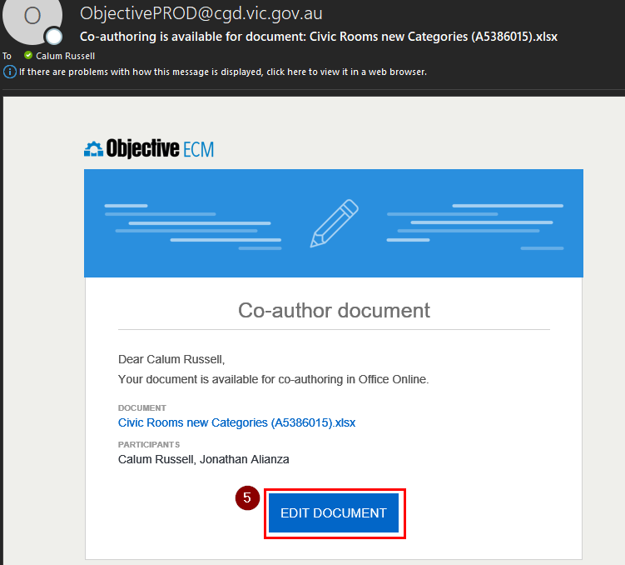
  - Click on the “Open in Office online” Button from the ellipses menu
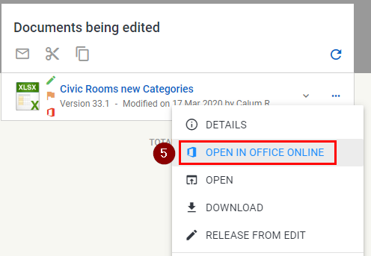

Viewing the document in Office online
If there are other participants in the document at the same time as you, another cursor will display to show where they are currently editing.
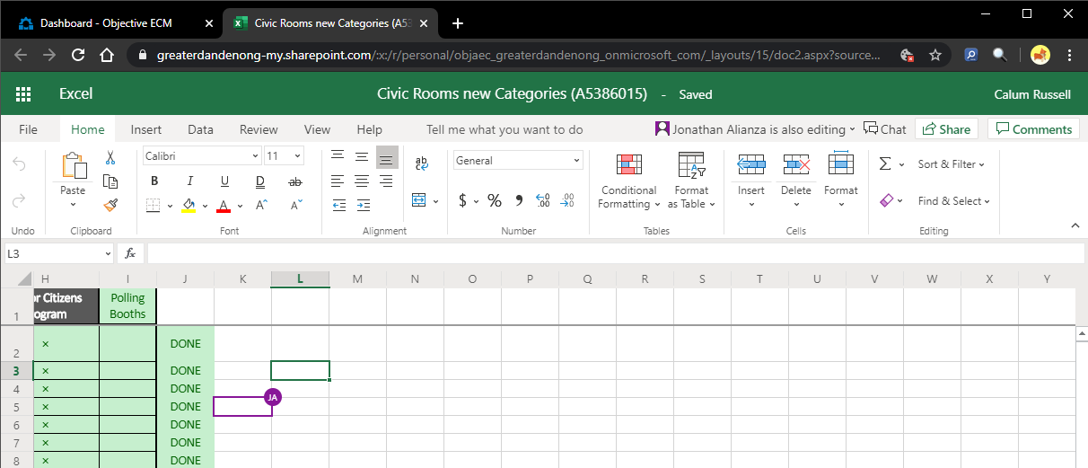
You can also see where the other participant is editing from within in the ribbon:
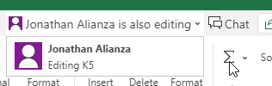

Releasing a document that is being edited in Office Online
- Open the ellipses menu and click “release from edit”
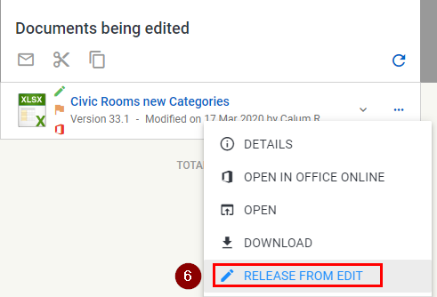
- Tick the two checkboxes, “Immediately publish” and “Set corporate value”.
- Click “Release”
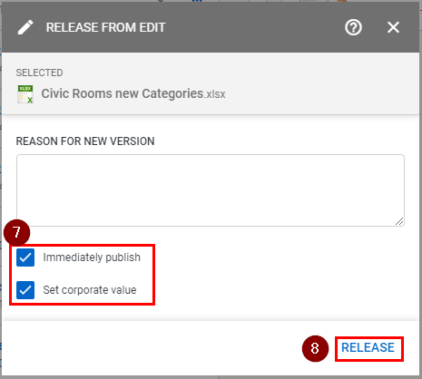
Any co-authoring will also end, and participants will receive an email notification.
