Printing from Apple iPad and iPhone

To print to the Sharp Multi-function devices please ensure your device is a corporate owned one and is connected to the CGD Staff WIFI network. The printing of spreadsheets, documents, emails, PDF’s, webpages and emails is supported.
It is recommended that the printing of Word and Excel files be done from the Microsoft Word and Excel applications on the devices (if these are installed) as the formatting may not print correctly. The formatting may also change when printing emails.

Printing an Email
- Open the email you wish to print from the device.

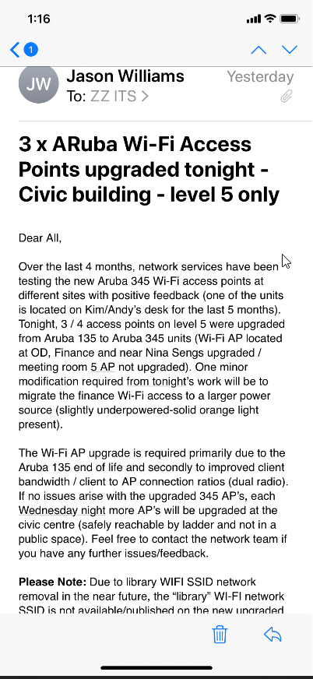
- Tap the Reply button.

- Tap the PRINT option.
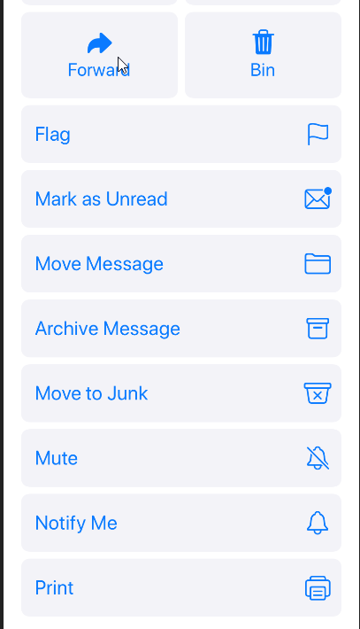

- Select from the following Print options and then select PRINT.
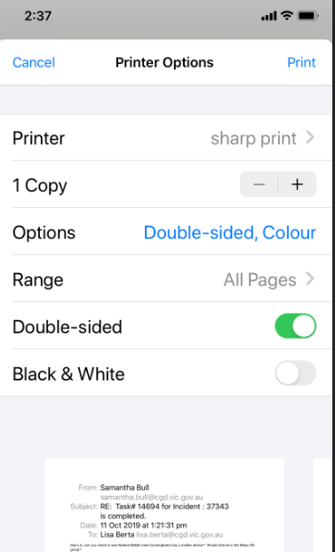

- If prompted to do so, enter your Network Username and Password and tap OK.

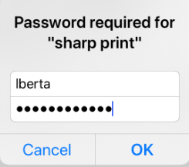

- Release the print job at the printer using your security card.

Printing an email attachment

- Open the email and tap on the attachment to download it.
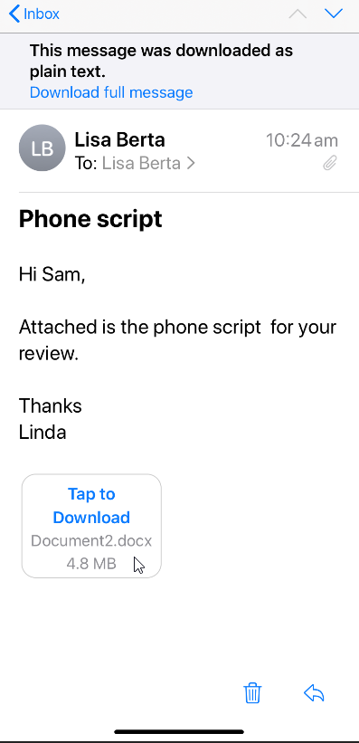

- Tap the Share button.

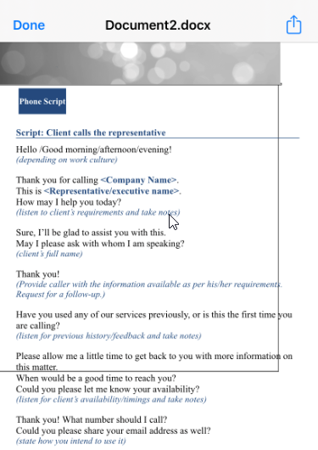

- Scroll down to and tap the Print button.

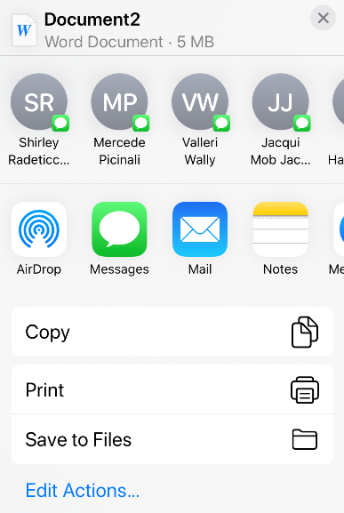

- Select from the print options and tap PRINT.
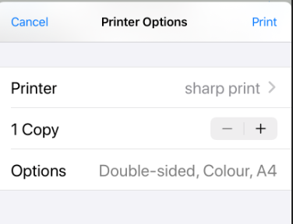

Printing from Microsoft Word or Excel App
The Microsoft Word and Excel app must be downloaded from the Apple App Store before these steps will work.
- Open the document you wish to print.
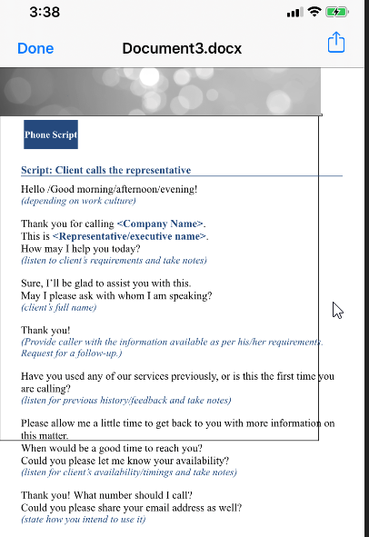

- Tap the Share icon.

- Scroll across and tap the More icon.
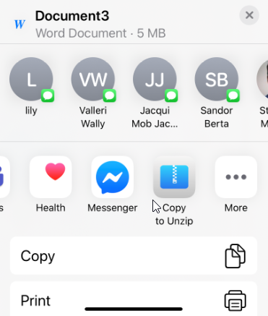
- Tap “Copy to Word”.
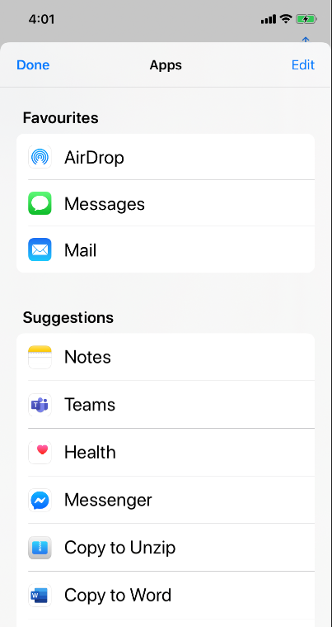

- Tap the ellipsis icon (… ).
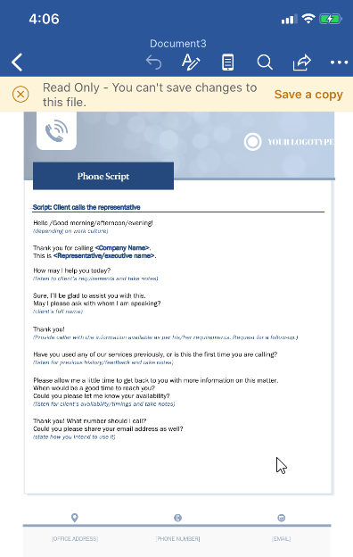

- Select Print.
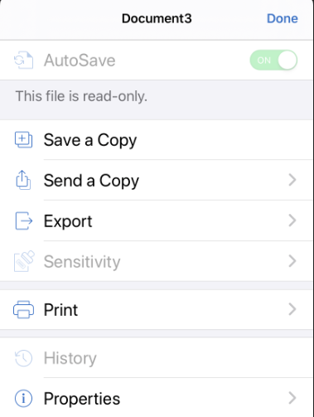
- Select Airprint.
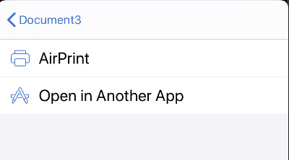
- Select from available print options.
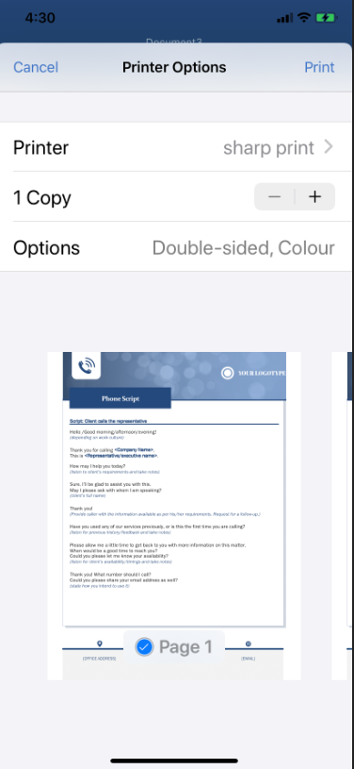
- Enter Network Username and Password and tap OK.

- Release the print job at the printer using your security card.

If you require further assistance contact the IT Service Desk on 8571-5102.

