How to Setup Multi-Factor Authentication for Remote Access to the CGD Network

- Download Microsoft Authenticator app on the mobile device that will be used to authenticate your login (personal non-council owned mobile phone can be used).
- Go to https://aka.ms/mfasetup from your work PC connected to the CGD network.
- Click Next at the “More information required” screen below.
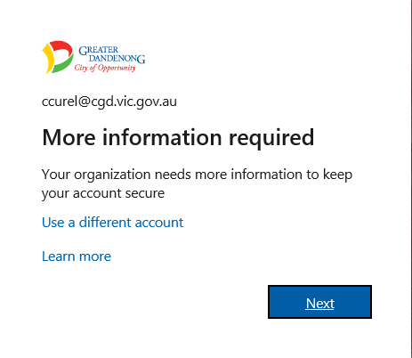
- Sign in with your full CGD email address (ie. claude.curelea@cgd.vic.gov.au) and press Next.
- Enter your network password and press Next.
- Click the “Don’t show this again” checkbox and press the Yes button.
- As the app has already been installed on your device (in step 1) click Next.
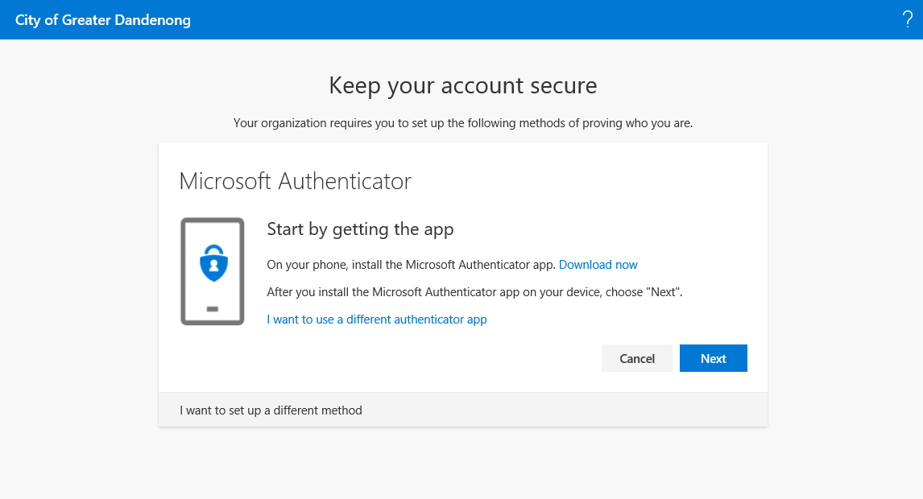
- Open the Microsoft Authenticator app on your device and if prompted allow notifications.
- Add an account on your device using the + icon or Add Account button below. Select “work or school account”. Allow access to your camera if prompted and do not close the app.

- Click Next at the “Setup your account” screen on your PC to continue.
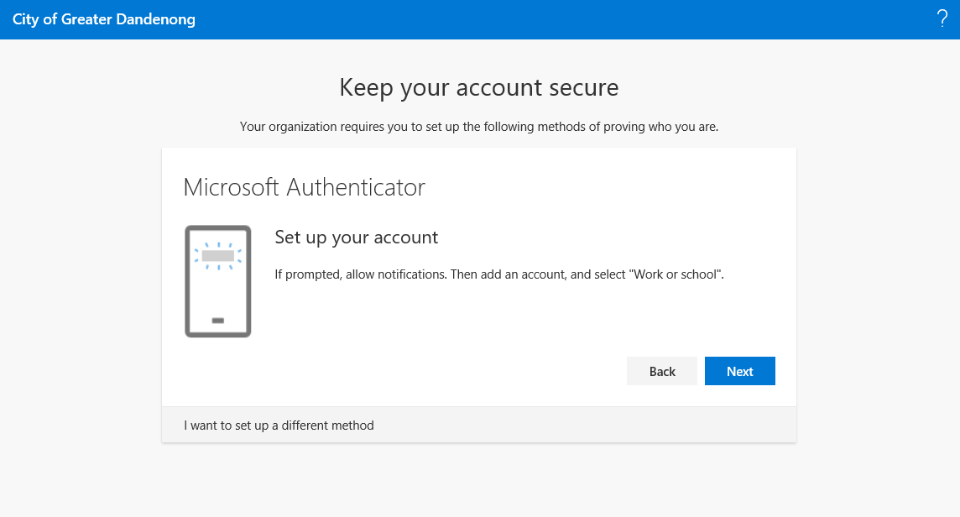
- Point the mobile device at the PC monitor to scan the QR code and press Next on the screen below.
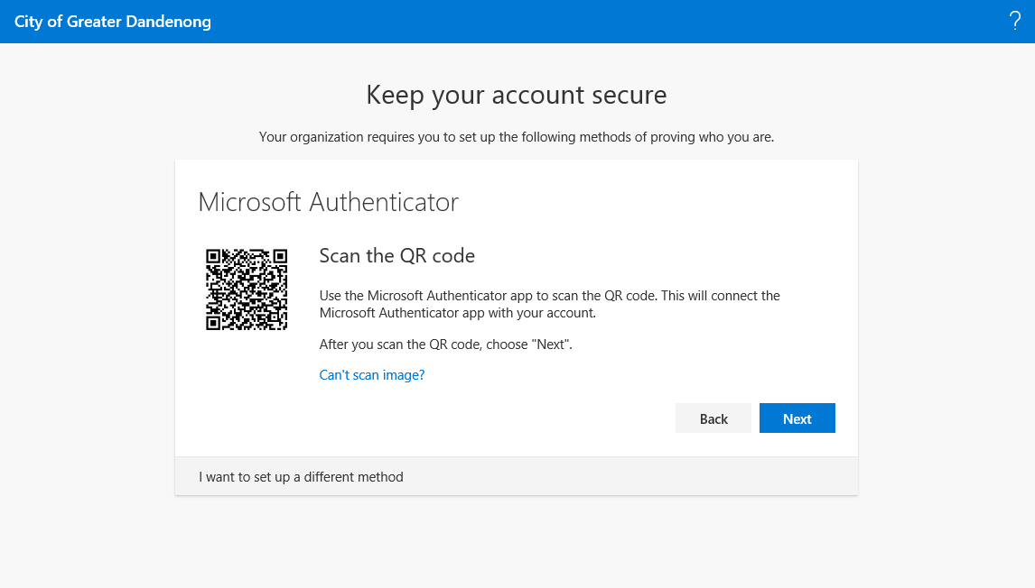

- Approve the sign-in verification request by pressing Allow on your mobile device.

- Once the sign-in has been approved from your mobile device, press Next on your PC browser.

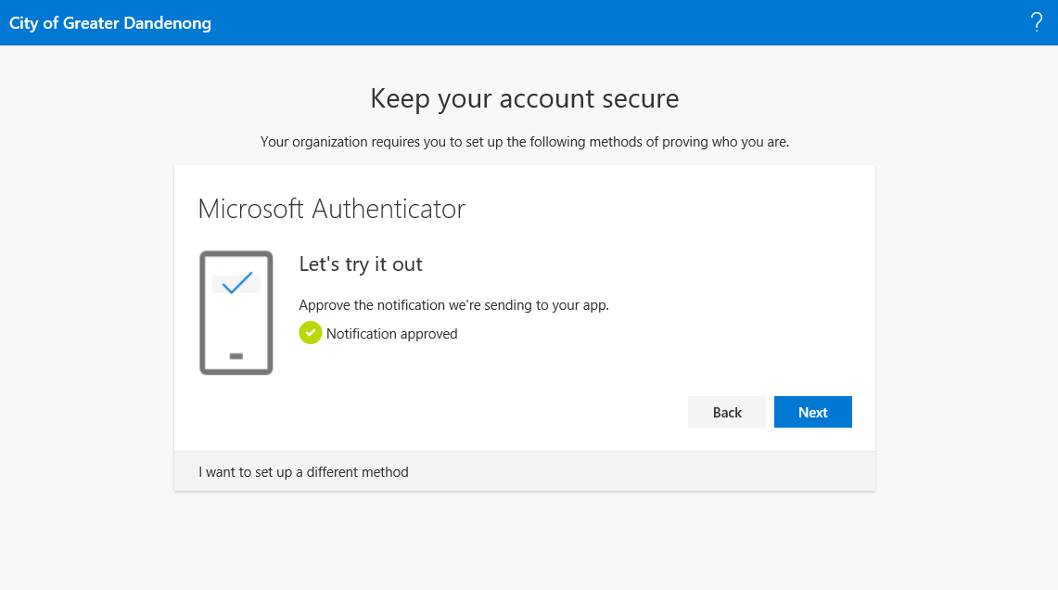
- Two-factor authentication has been successfully setup. Press Done to complete the process.
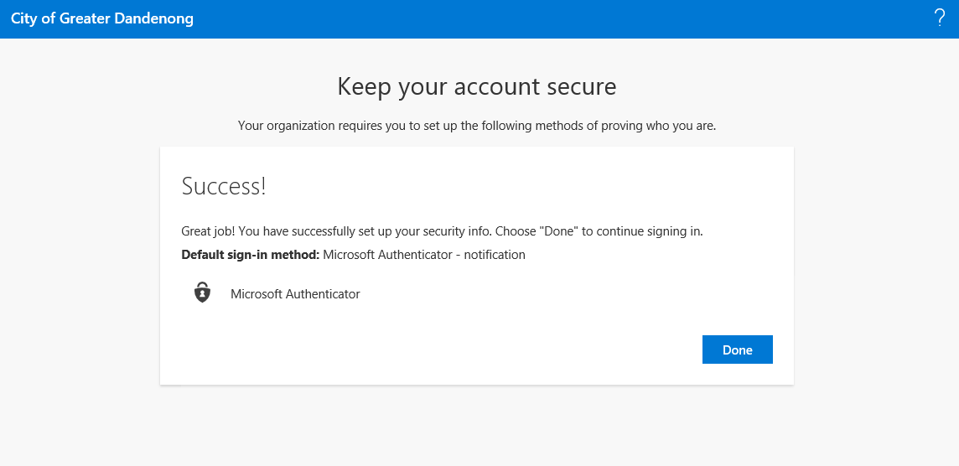
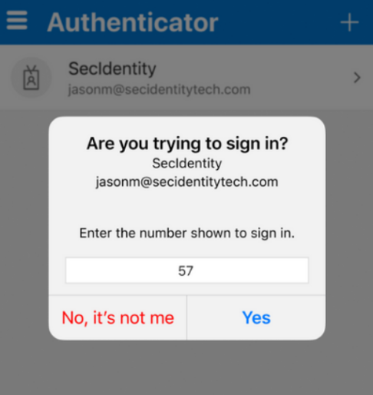

- When prompted to do so, either enter or select the same number that is displayed on the MFA approval screen.
If you require assistance setting up Multi-Factor Authentication (MFA) please contact the IT Service Desk on 8571-5102 or email IThelp@cgd.vic.gov.au

