Objective Query for ECM Browser

There are two main queries that we use: 1) Query and 2) Query and Search (with speed).

Running a Basic Query
To create and run a basic query follow these steps:
- Use the Query  button to create a new query.
- Select Query from the query types below.
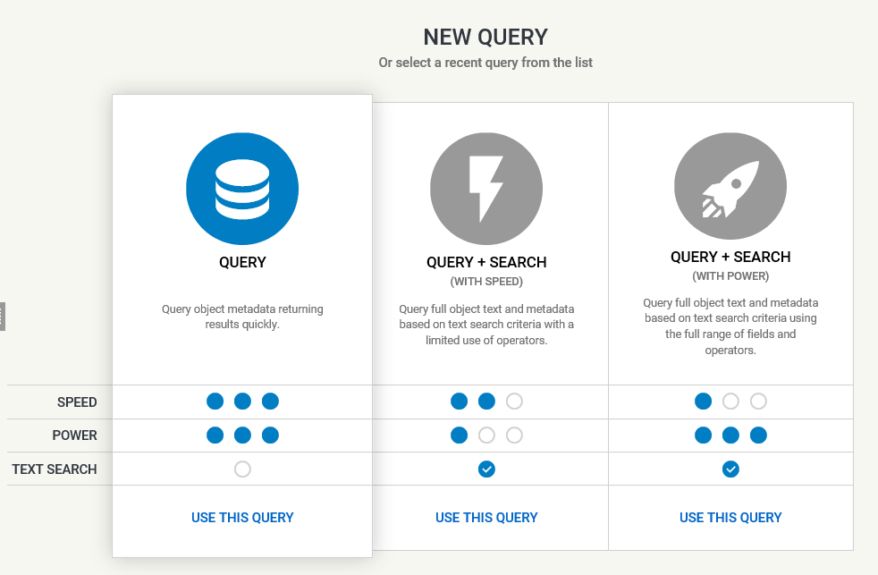
The query will display in edit mode and will need to remain in that mode while it is being edited.
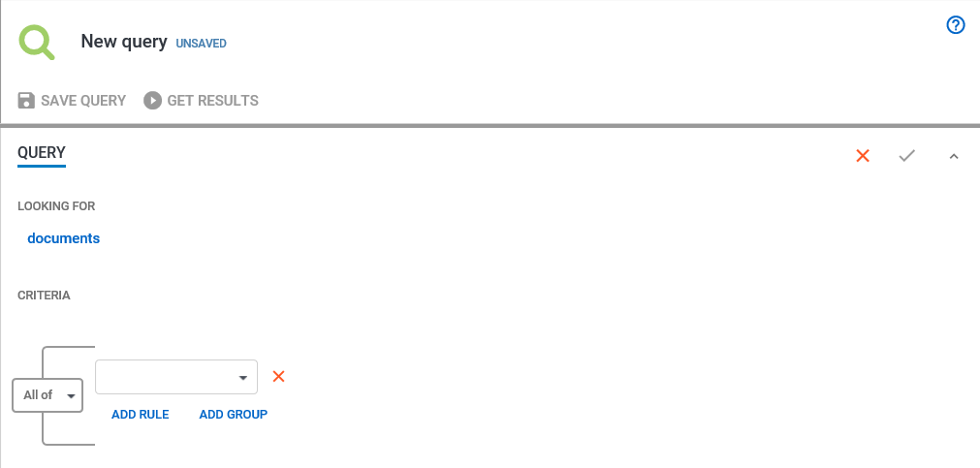
Note: A query can be edited using the Edit Query  button at the top-right hand of the query window. This icon will only be visible when the Save Changes to Query  icon has been selected.

- Select the object types by clicking on “documents” in the LOOKING FOR field.
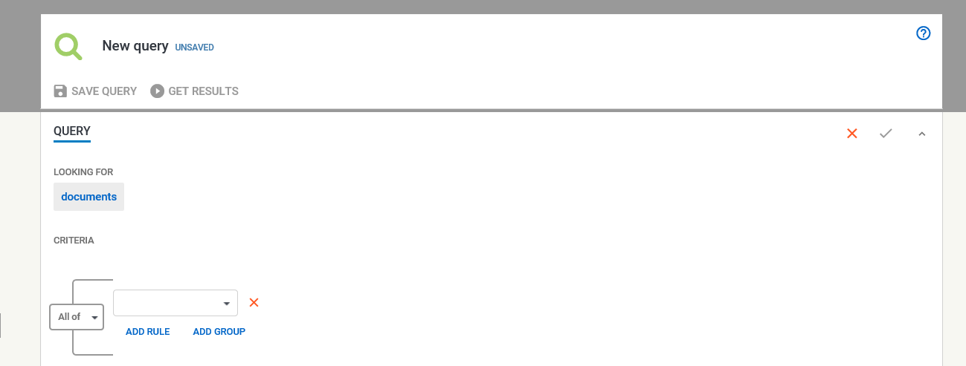
- Select the object types from the list and press Apply Changes.
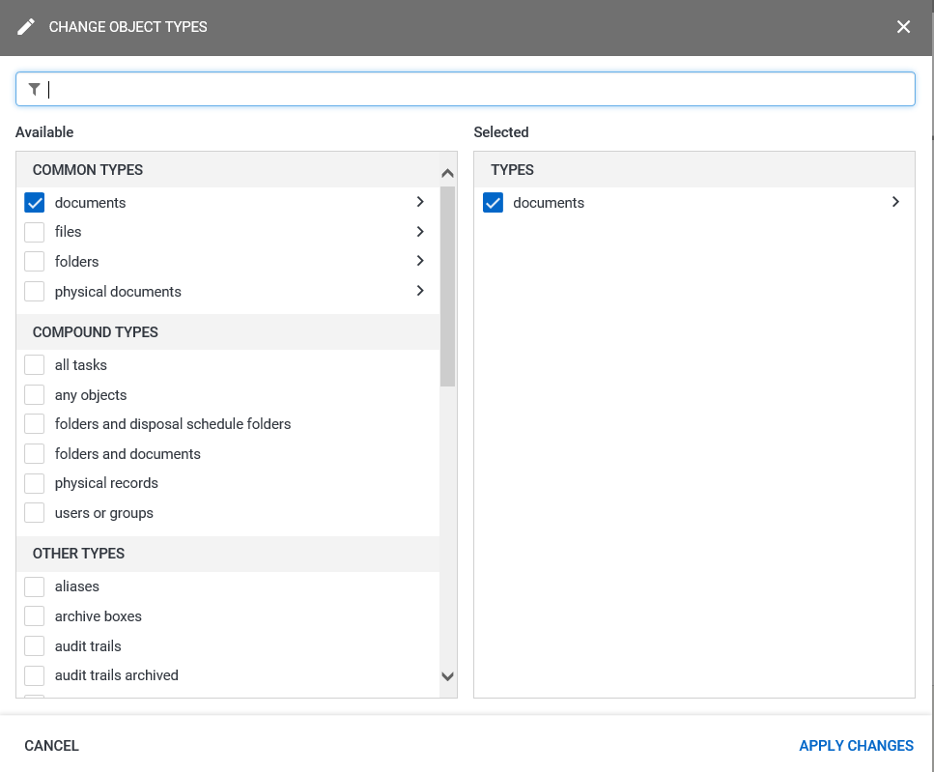
NOTE: Selecting the arrow next to “documents” in the right-hand column shows the sub-categories included in searching for documents. Searching for documents includes searching for Email Messages.
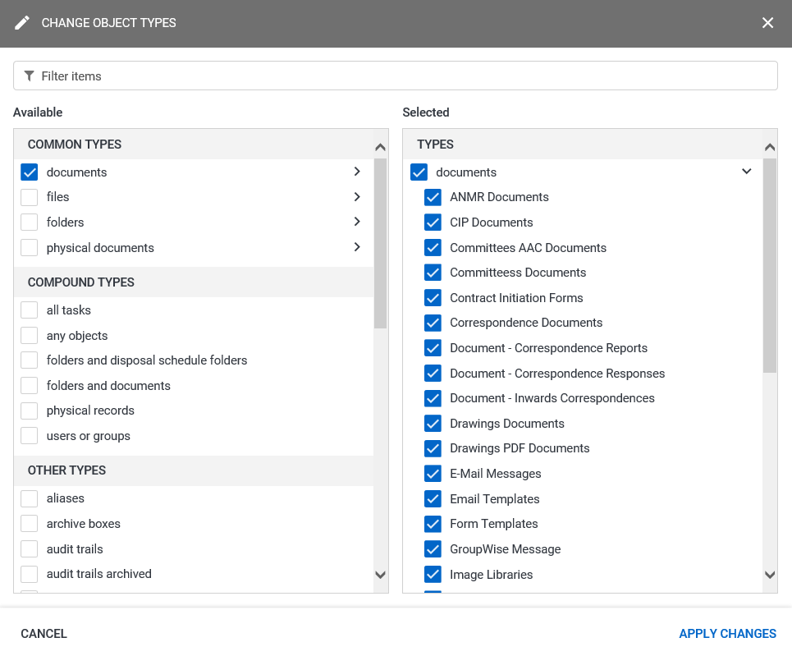
- Select the fields drop-down button  and a then select a metadata field for use in the query.
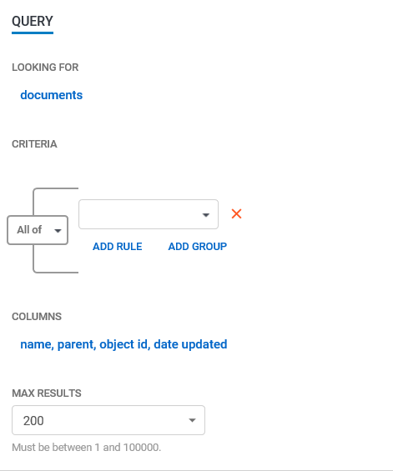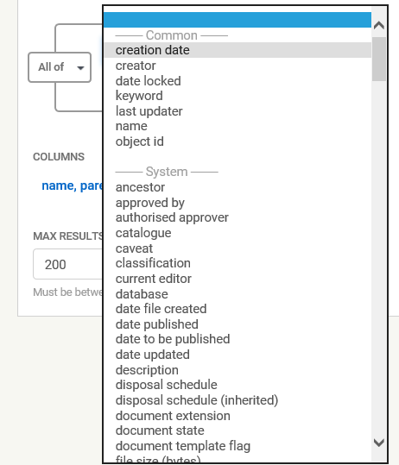
- Press the Add Rule button to add an additional field to the query.
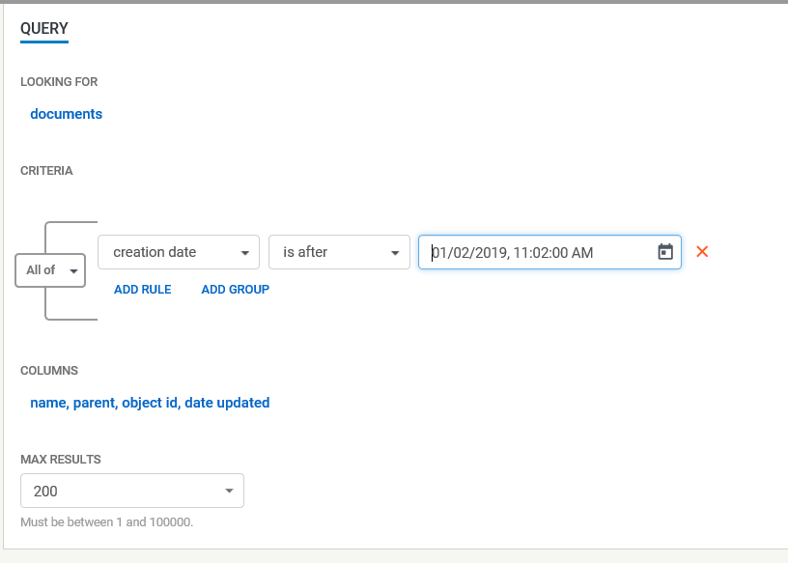
- Select your additional field and parameters and press Get Results to run the query.
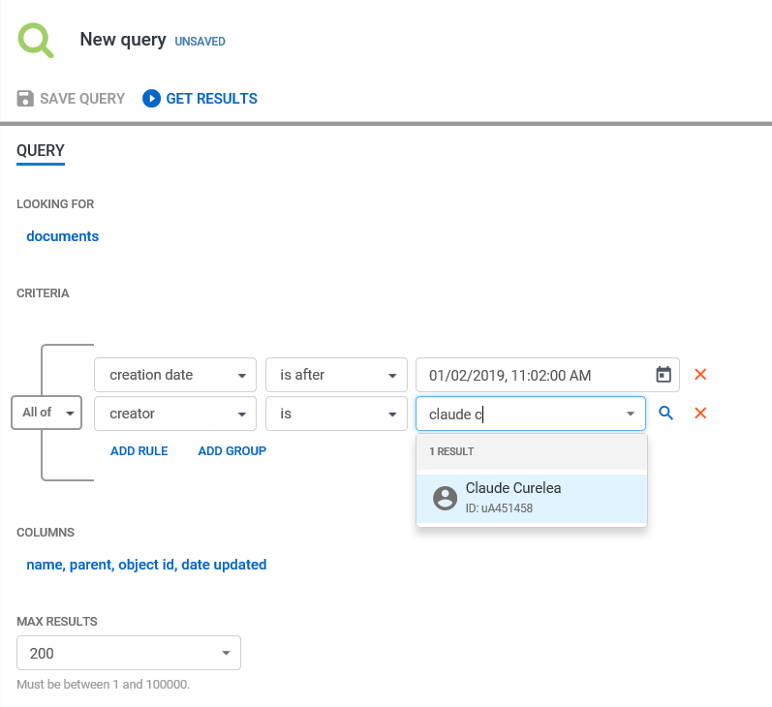
Note: Select “name, parent, object id, date updated” button under Columns to determine which columns will be displayed in the results of the query.

Running a Query and Search

A Query and Search is a query that includes the elements of a basic query (in the previous pages) and the ability to search for words and phrases inside objects (documents, emails etc).
When running a Query & Search always use the QUERY & SEARCH (WITH POWER) option to utilise the full range of metadata fields available at CGD.
- To crate a QUERY + SEARCH select query, select the Query button.
- Select Query + Search (With Power) from the listed queries.
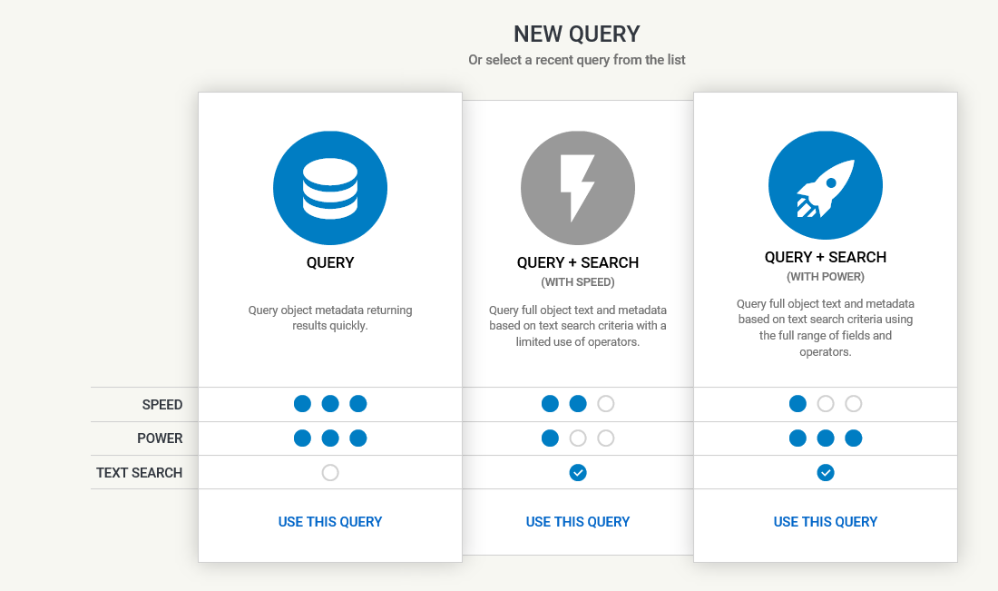

- Note in the Criteria section of the query, the option to add a metadata field along with the Searching text for field.
- The query below will search for all the documents and emails that have been added to Objective by the specified user since the first of July that contain the word “webstar” in the object name or inside the body of the email or document.
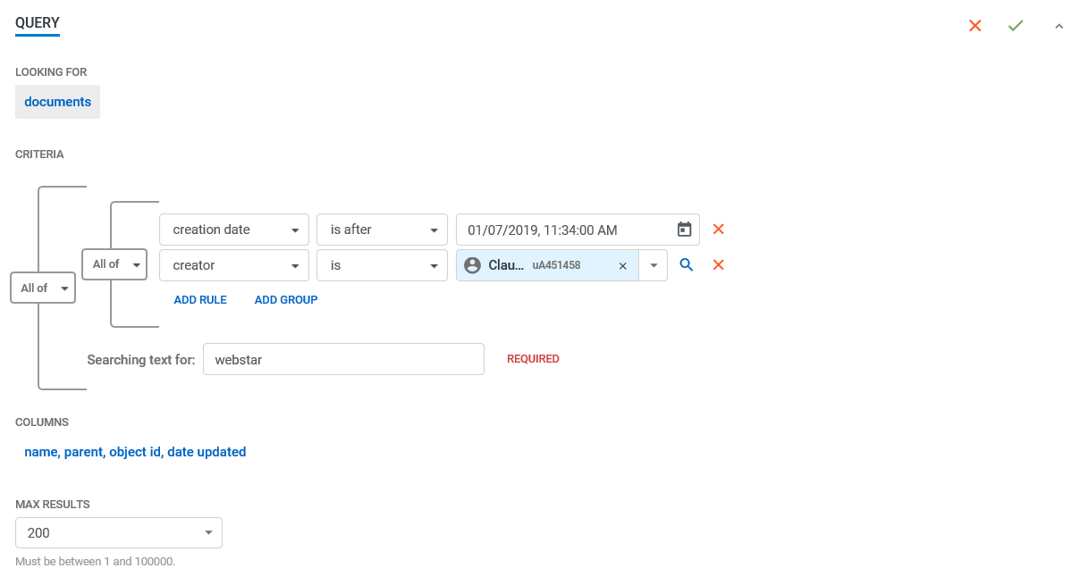
- Press the Get Results button to run the query.
Examine the results for the query below.
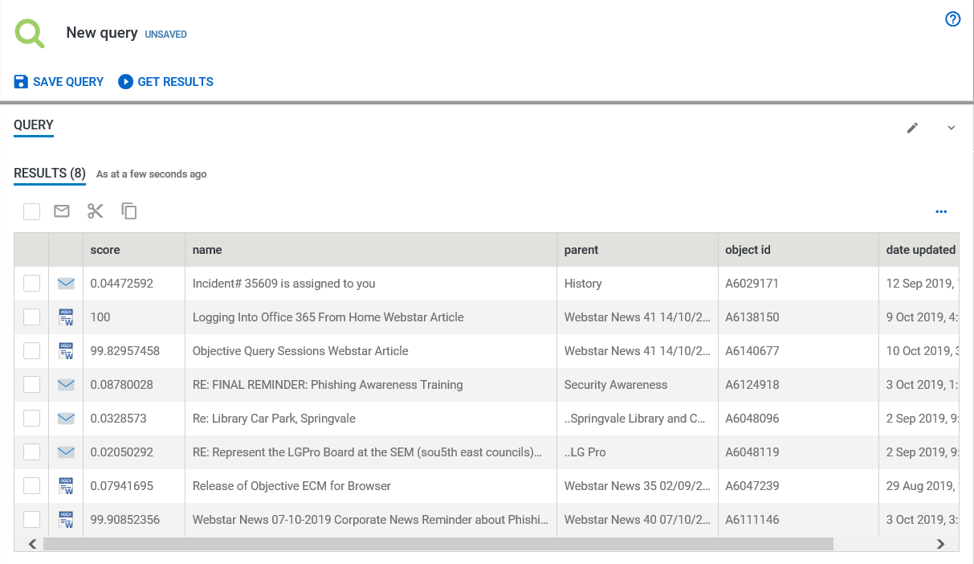
- Press Save Query to save the query results.
Specify a name for the query.
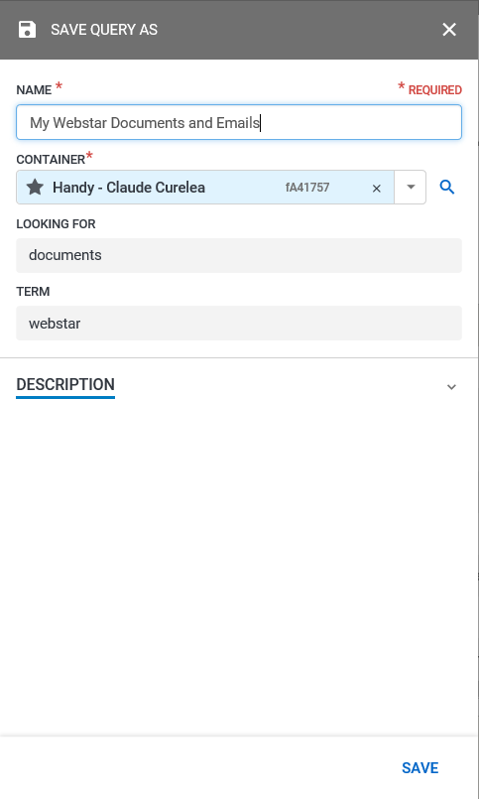
Note: Queries are saved to your Handy by default. To save the query to another location in Objective, click on the cross next to Handy in the CONTAINER field and drag and drop another Objective file or folder into the CONTAINER field.
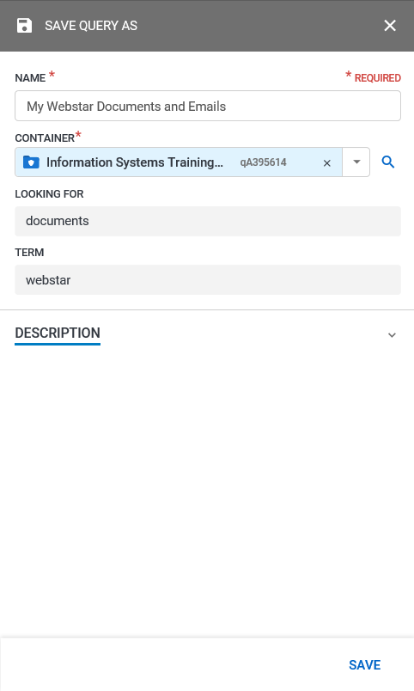
The query can be selected and run from where its saved location.
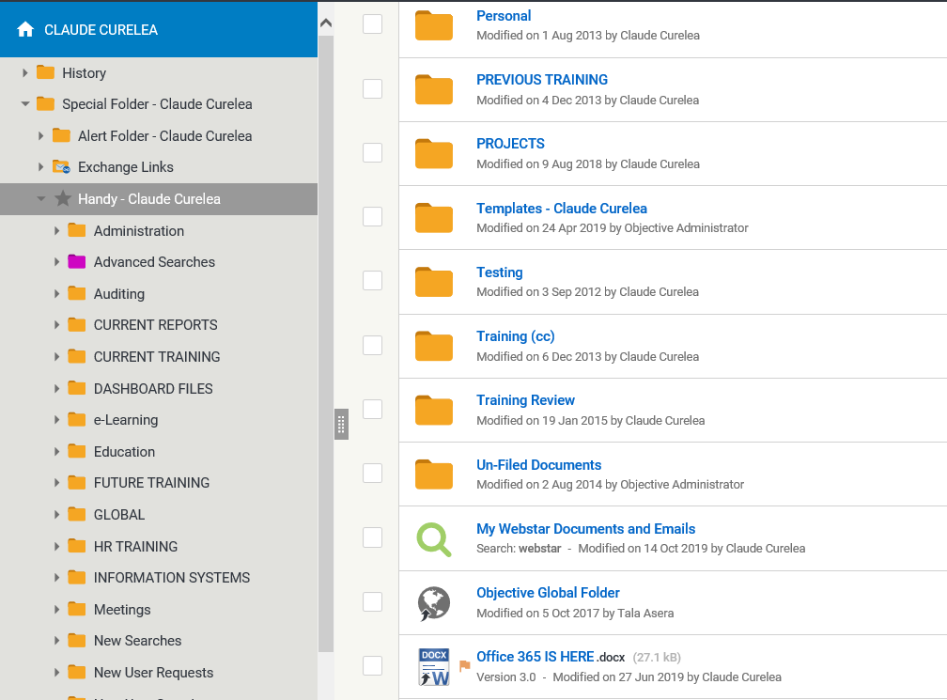

The query will also be listed in the list of recently used queries.
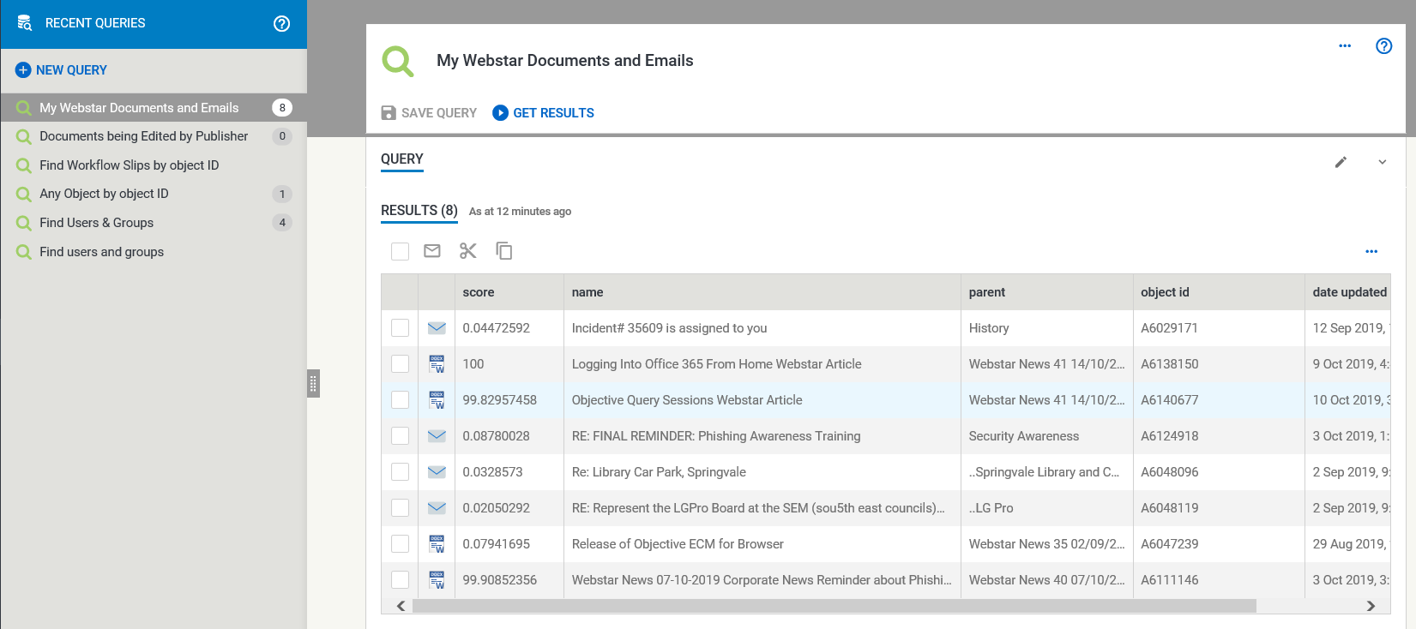

Examples of Queries

The following commonly used queries can be used to find the following:

Query Example 1: Finding Emails Stored in Objective

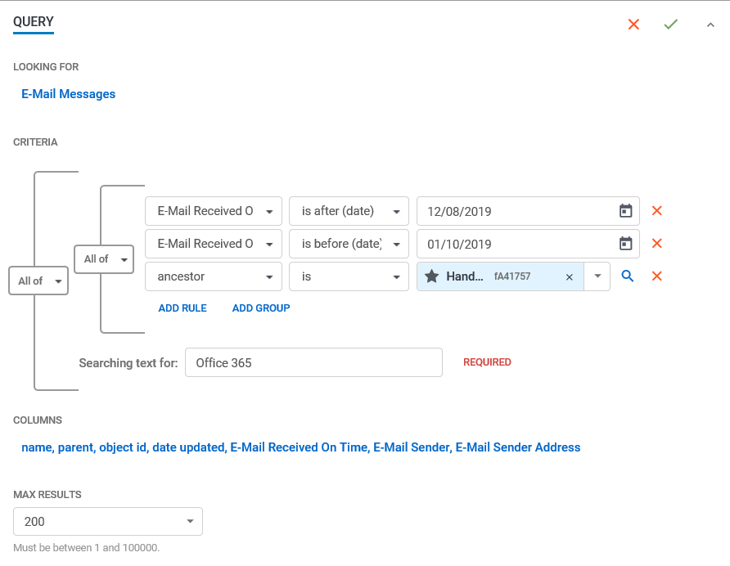
See results below.
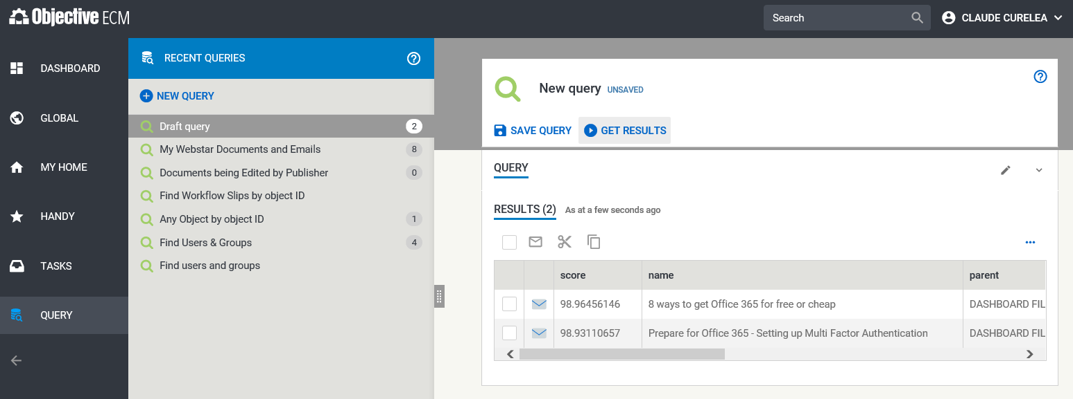
Slide the Navigation bar to the left to see more of the query columns.
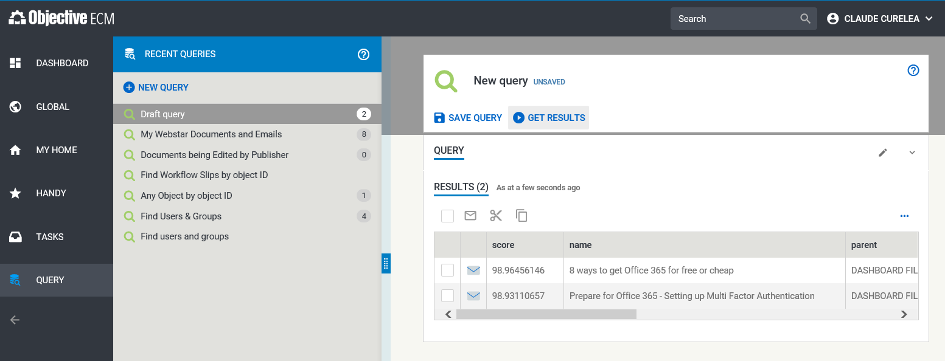
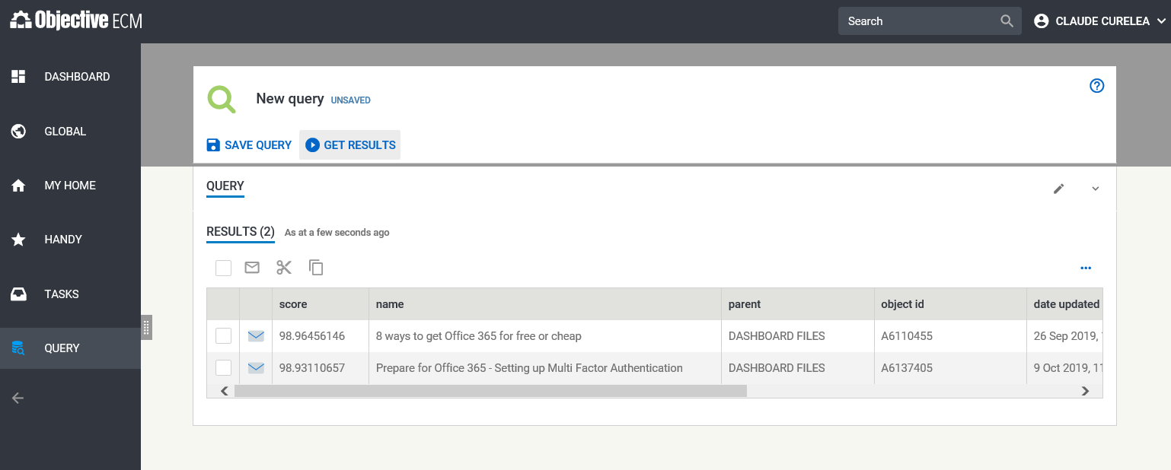
Use the horizontal scroll bar to see additional columns in the query results screen.
Query results can be downloaded as PDF or CSV files and can be sorted based on a column.
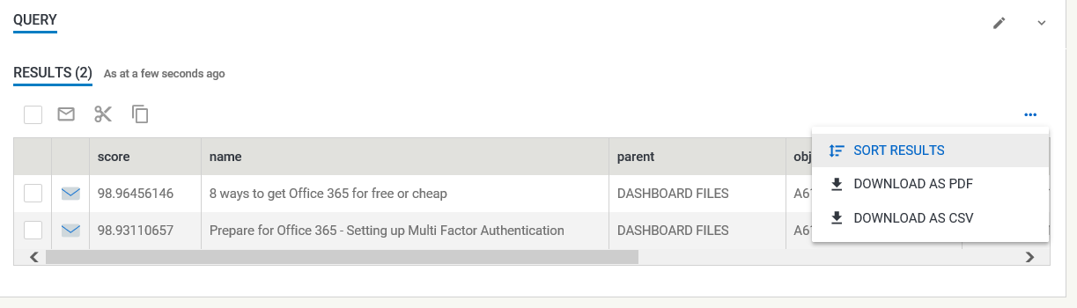
Sorting is only available based on the fields selected to be displayed in the query results.

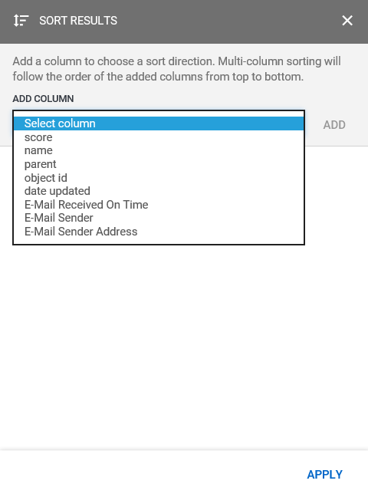
Click the Apply button to sort by a given column.

