

Training Guide - Basics
March 2021

Introduction to MAGIQ
Magiq develops, installs and supports application software particular to the budget management, enquiry, business analysis and reporting markets.

To open, select the Magiq icon from your desktop.

It should look like this.

If the icon hasn’t been installed on the desktop it can be accessed by clicking on the Window symbol and navigating to the Magiq application.
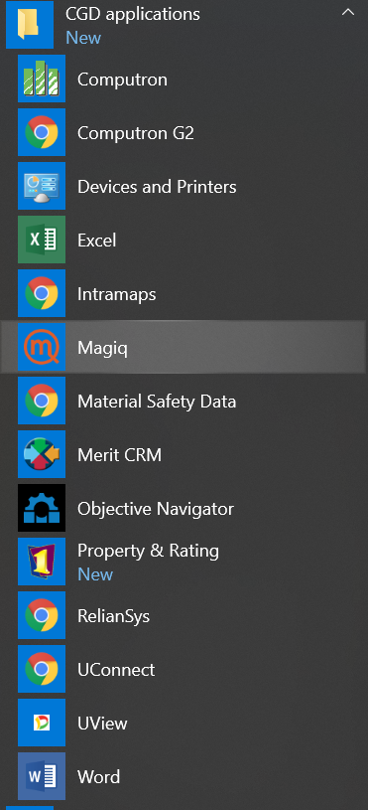
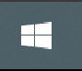

Another way is through the CGD Applications on the bottom of the screen.
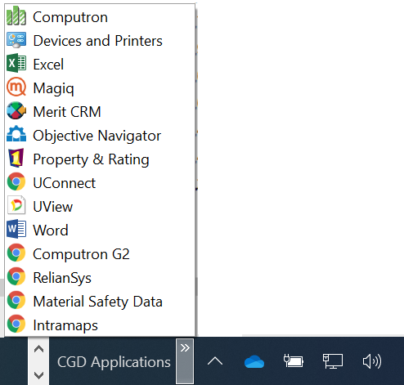

Start-up Screen

Once Magiq has been selected your system username and password will activate it automatically.

The CGD default log in screen will be similar to the one shown below, reflecting the individual user’s access and the directorate that they are allocated to.

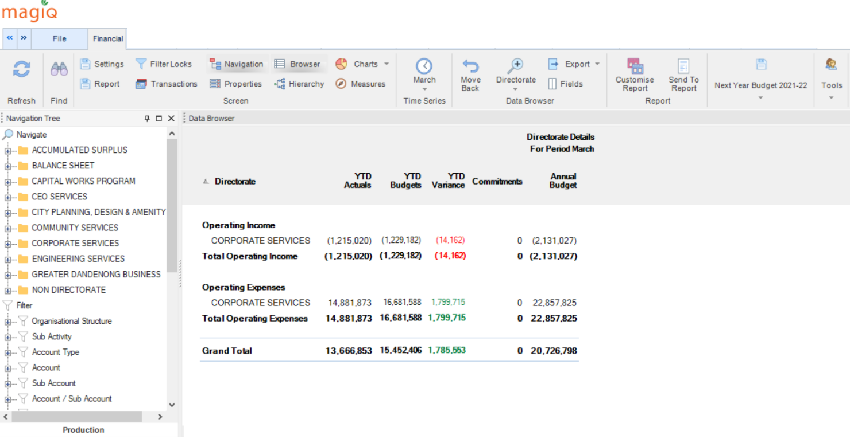

MAGIQ Framework
The main opening screen in Magiq consists of 3 key framework elements:
- Ribbon
- Navigation
- Data Browser

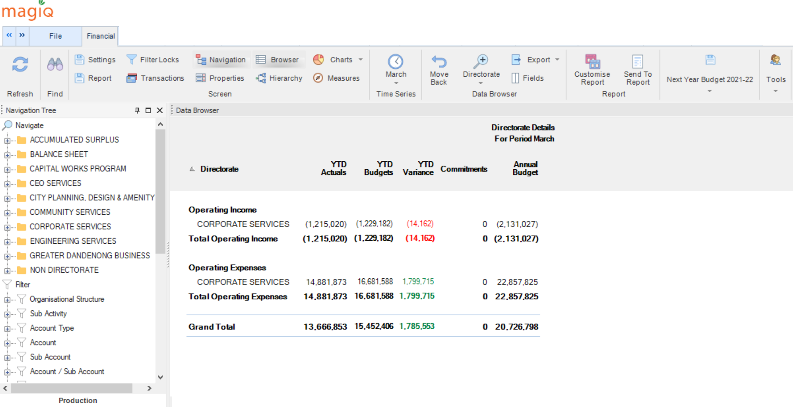

- RIBBON

3. DATA BROWSER
2. NAVIGATION

THE RIBBON AND MAIN FUNCTIONS
The Ribbon or Main Toolbar has a number of icons with functions that assist with navigating and extracting/retrieving data. The most used and popular icons (functions) are described below. Most of these functions can be activated by doing a right mouse click.

Time Series

The Time Series icon on the toolbar allows the user to view data from different periods. Click on this button and a drop down list will appear showing which month is currently selected a tick will appear on the month.

The data on your screen is dependent on the selected period. For example: If you have a field on your Data Browser called “This Period Actuals” and you have the month of “March” selected you will be looking at data for March. This is consistent with year to date fields as well in that if you have a field called “YTD Actuals” on your Data Browser and your time series is set to “March” the figure displayed will be the sum of the months of July through to March actuals.

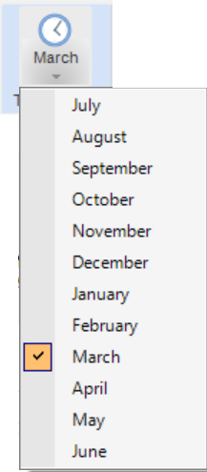

DRILLING DOWN TO THE ACCOUNT/SUB ACCOUNT LEVEL

Each user is allocated to a specific sub activity. The best way to access the accounts allocated to the sub activity is to drill down by double clicking through the layers – which will reflect the organisational hierarchy.

First screen – directorate level. Double click on the directorate in the data browser to drill down to the next level which will be the department (or business unit).

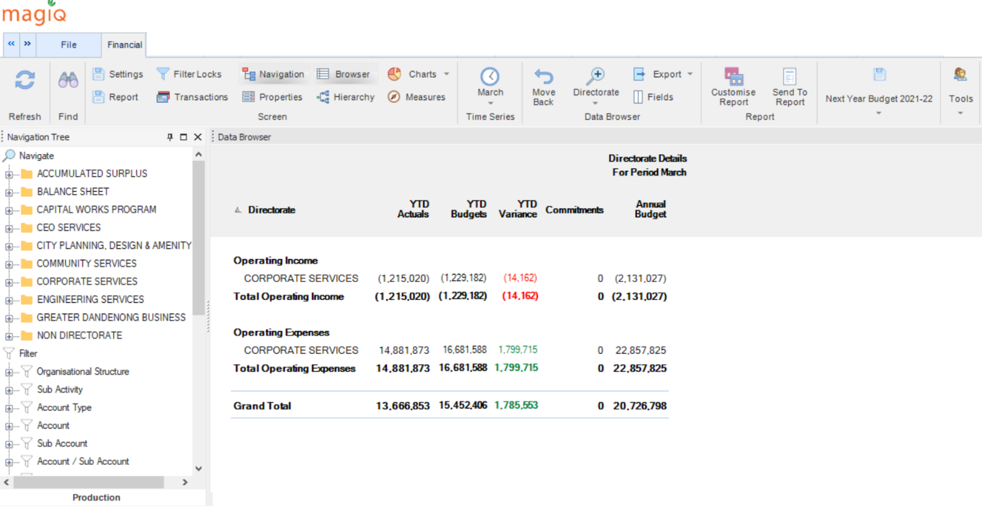

Second screen – department level. Double click on the department (business unit) in the data browser to drill down to the next level which will be the sub activity level.

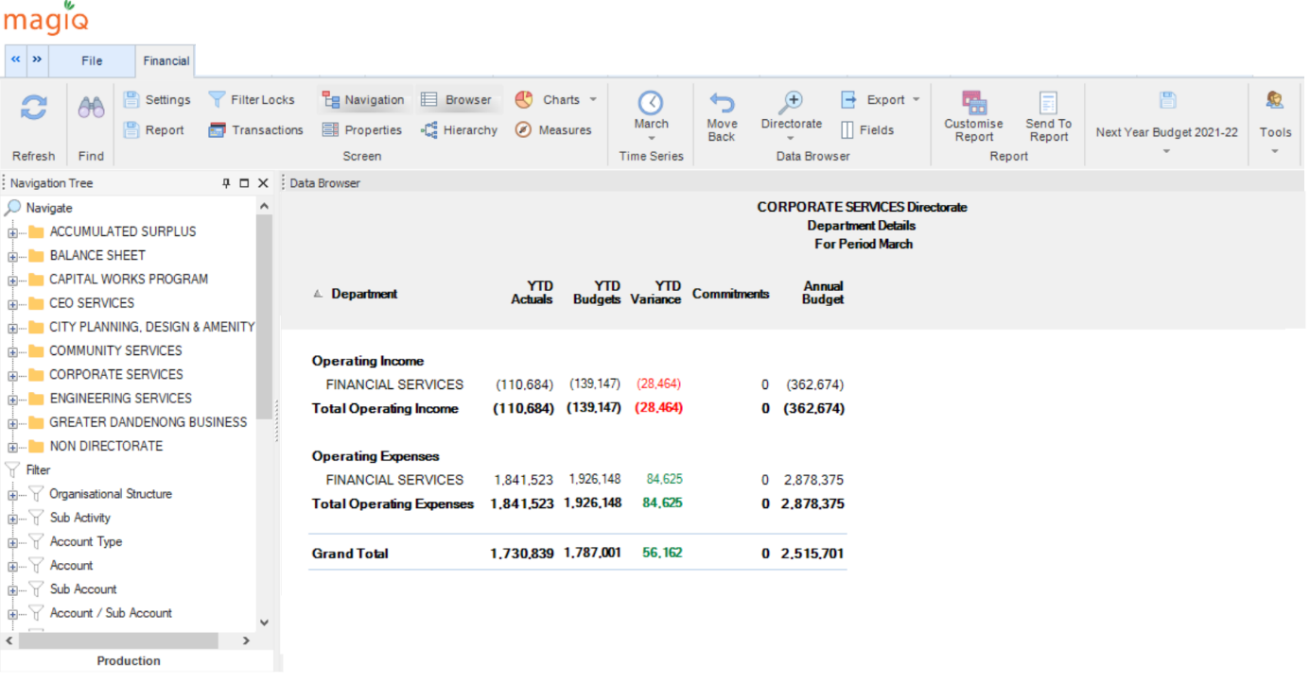

Third screen – sub activity level. Please note that not all areas will have more than one sub activity.
Double click on the sub activity in the data browser to view the specific sub activity required.
For this example it will be sub activity 1303.

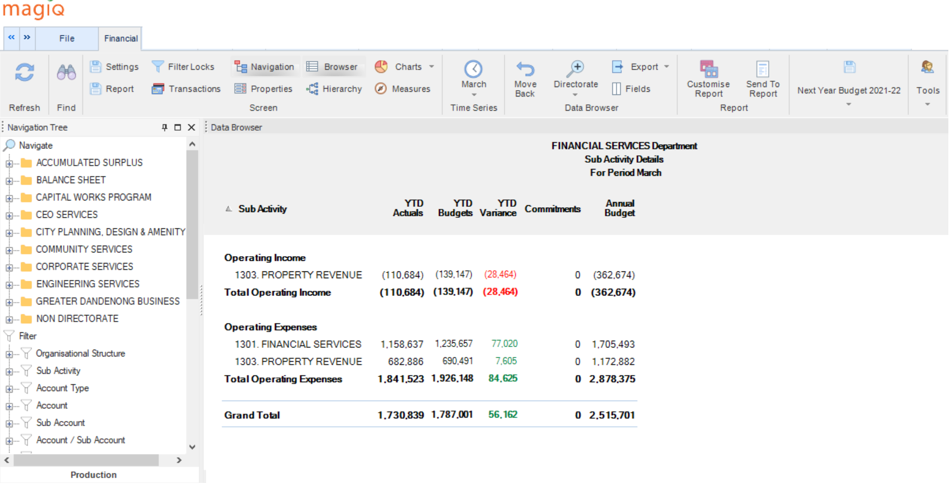
Fourth screen – income and expenditure level.

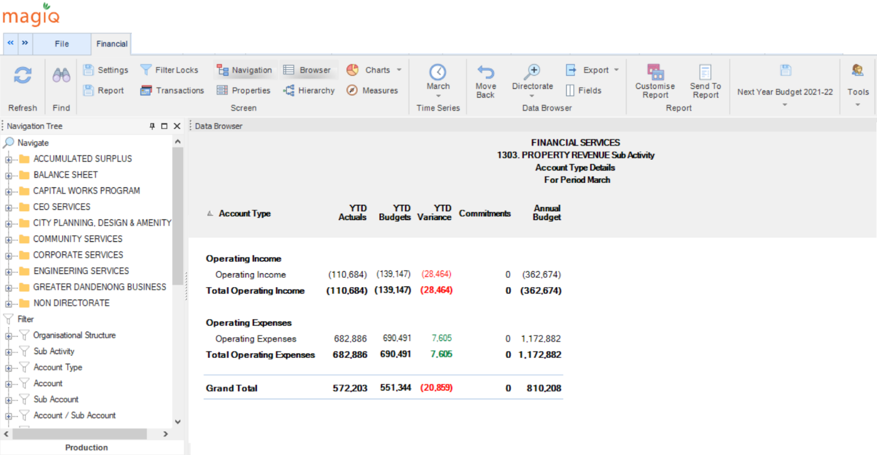

To drill further the “Zoom To” function is required. Place the curser in the data browser body and right mouse click and a menu will pop up. Select Zoom To

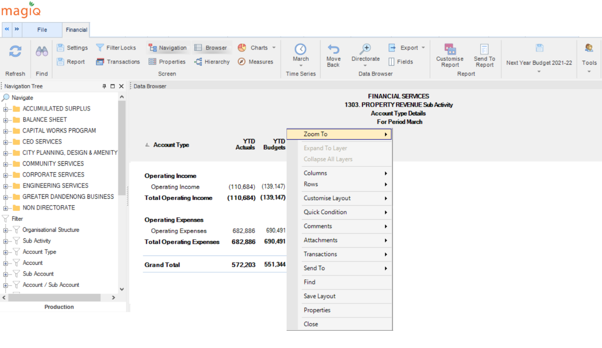

Zoom To

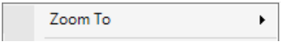

The list will display the layers in the dataset. By selecting one of these layers the information will display directly at that level rather than the user having to drill through each level.

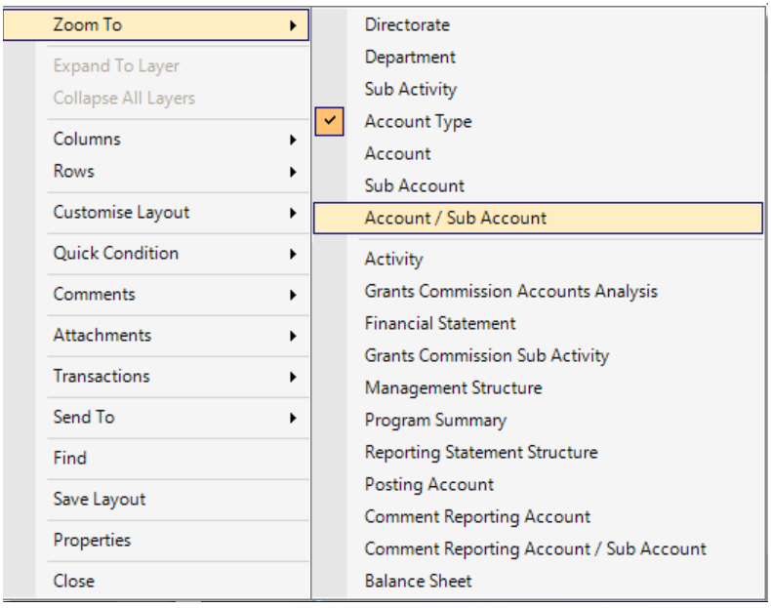

The data in this example is required to be viewed at the Account/Sub Account level.
There will be a tick against the level that the screen is currently displaying. Once the selection is made the screen will change to display the new selection.

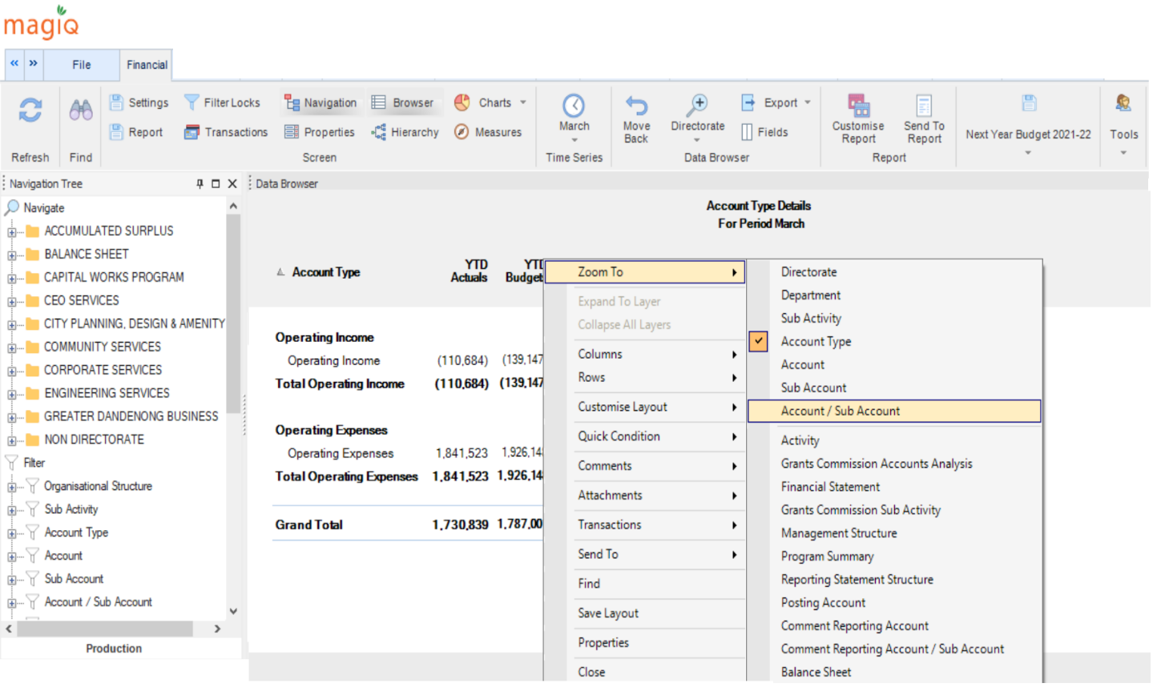

The information is displayed at Account/Sub Account
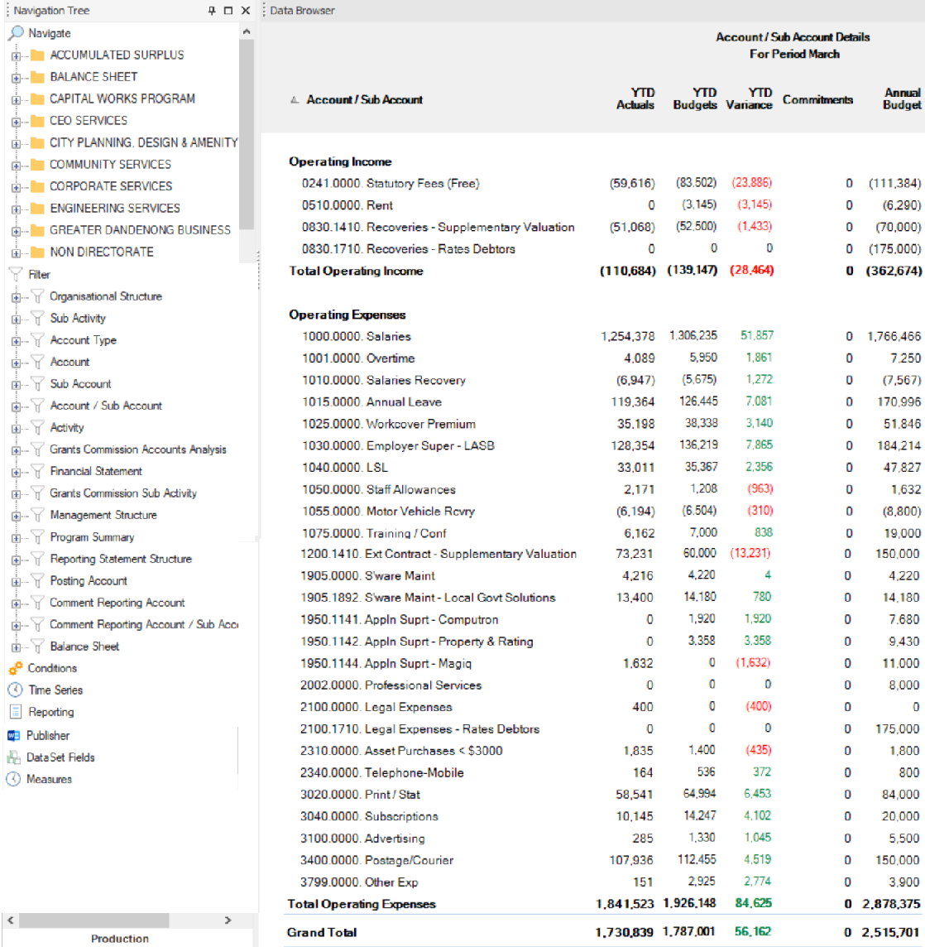

If further information is required the transactions can be viewed. Select the account that needs investigation and double click on the amount in the “YTD Actuals” column. This will activate the transaction list. For example account 1075 0000 requires investigation.

Transaction listing for account 1303 1075 0000.

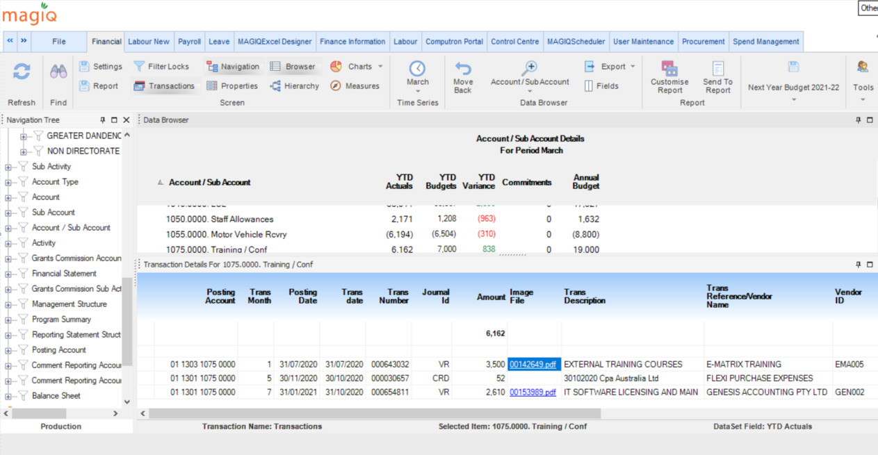

Under the “Image File” column there may be a reference that is in blue font. This is a hyperlink to the corresponding invoice. Clicking on the hyperlink will bring up the invoice. In this example there is a hyperlink next to the transaction of $3,500 – invoice is below.

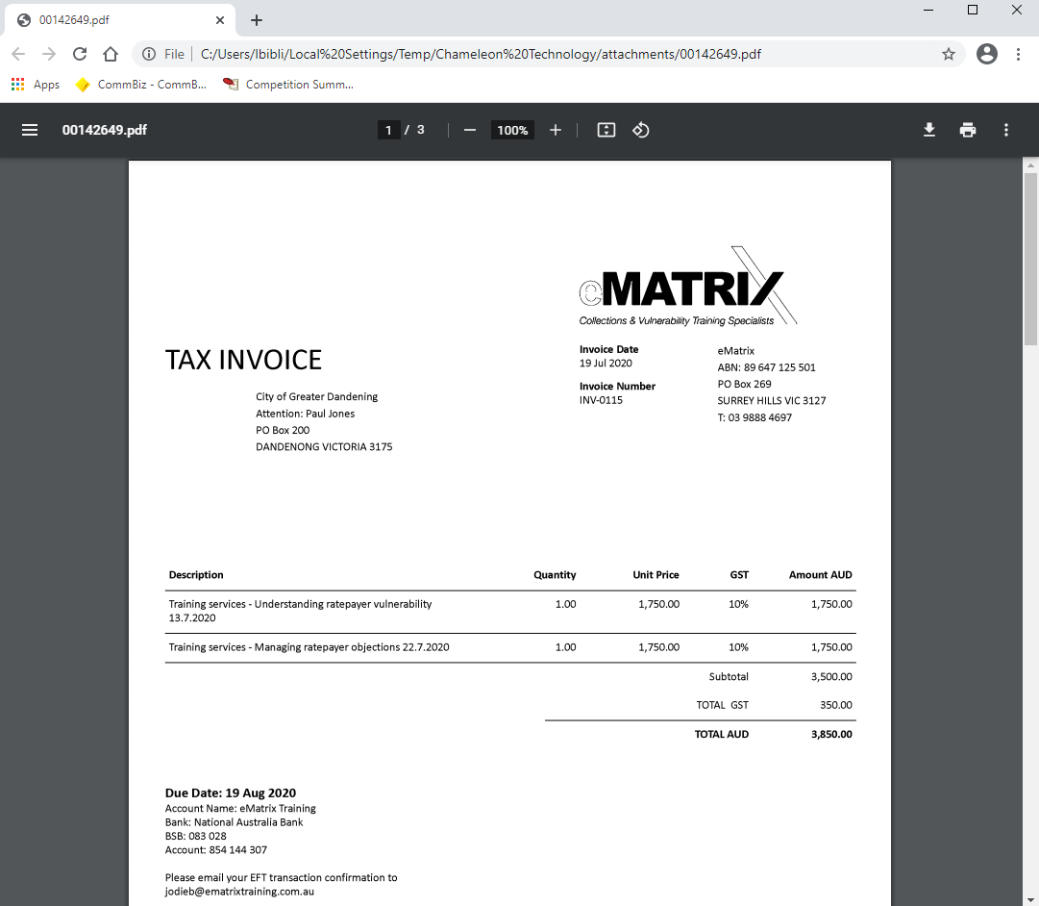

There is an option to download or print if needed. Simply click on the download or print icon in the toolbar.

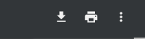

To exit from the invoice screen, click on the X at the top of the screen.

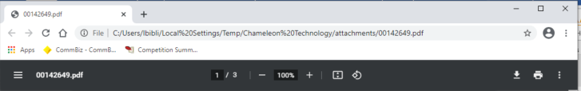

EXPORT

Any screen in the Magiq program can be exported. In this example the transaction listing will be exported.

Place the mouse in the transaction listing, right mouse click. From the menu that appears select “Send To”

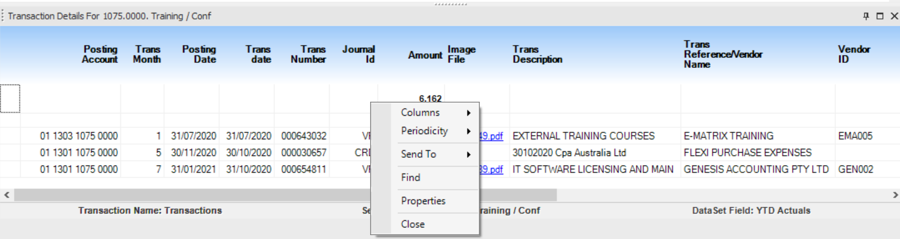

Then select Excel

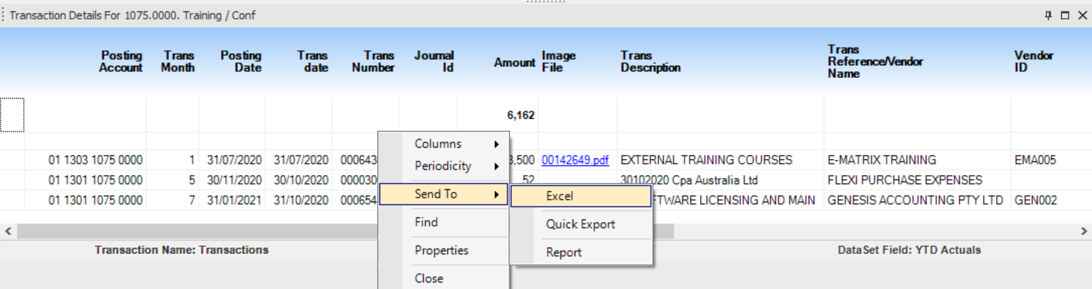

The dialogue box below will appear while the information is transferring.
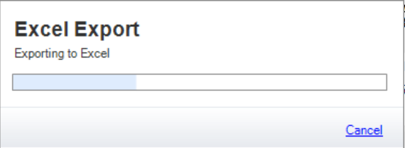
Once the dialogue box disappears the transfer is complete in Excel.
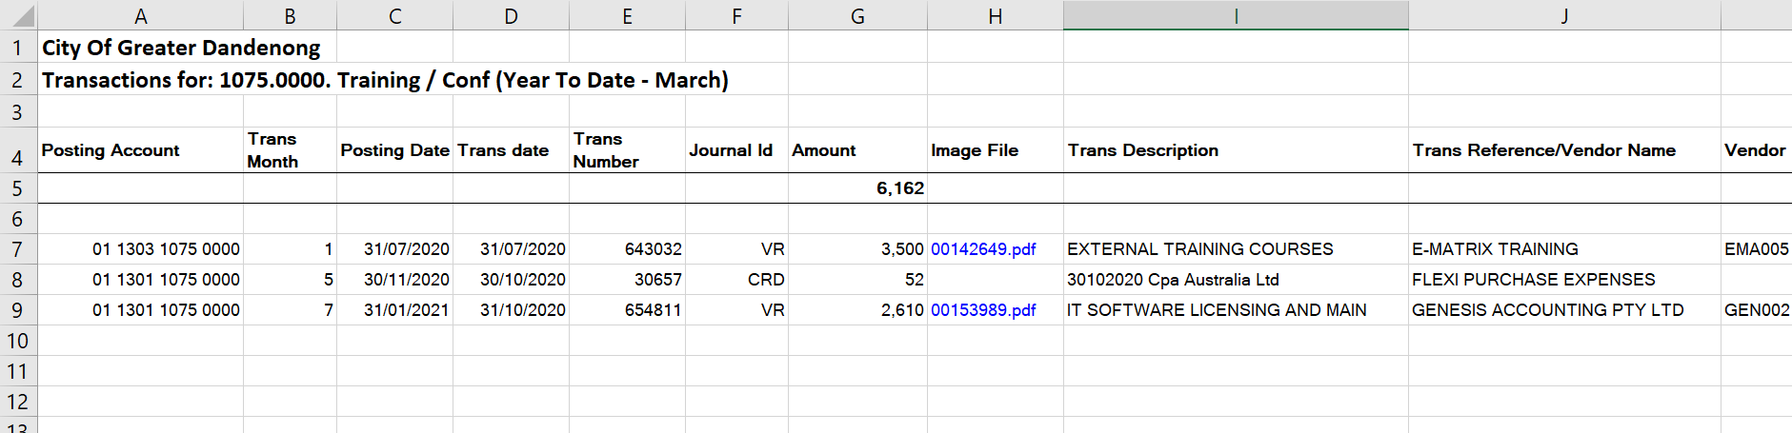

Another example – exporting the main screen. The pop up menu has more options but the export function is the same.

Select Send To.

Select Excel,

Then select As Is

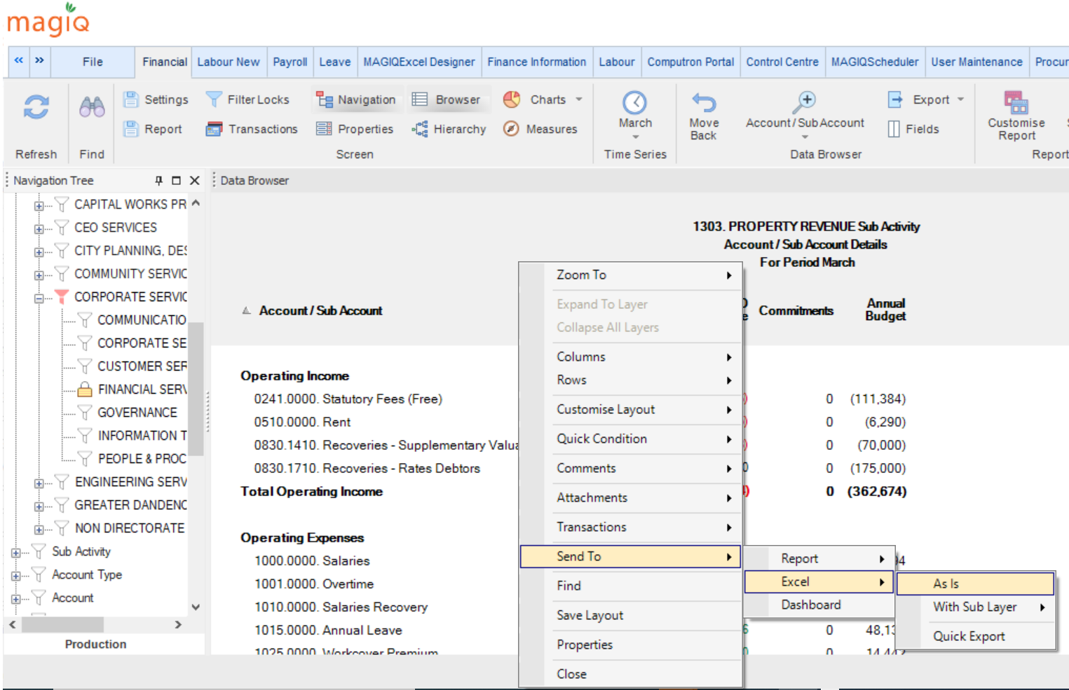

The information is now in Excel.

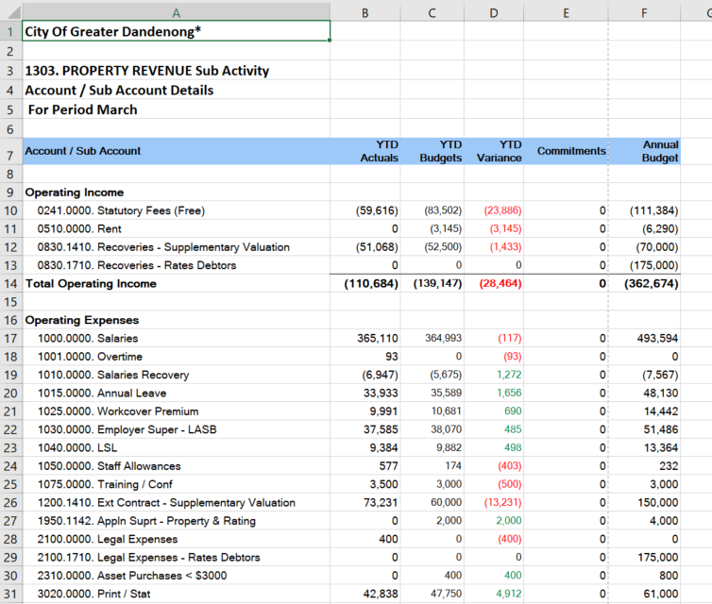

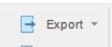
Another way to export is to use the Export button in Magiq toolbar.

Move back
Move Back allows you to go up one layer in the Data Browser window. There are a number of ways to move back.

- Using the Move Back icon on the Ribbon.

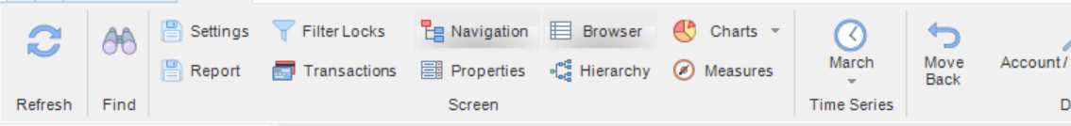

- Move back a layer is by clicking on the Grand Total. Double click to move back a layer at a time.
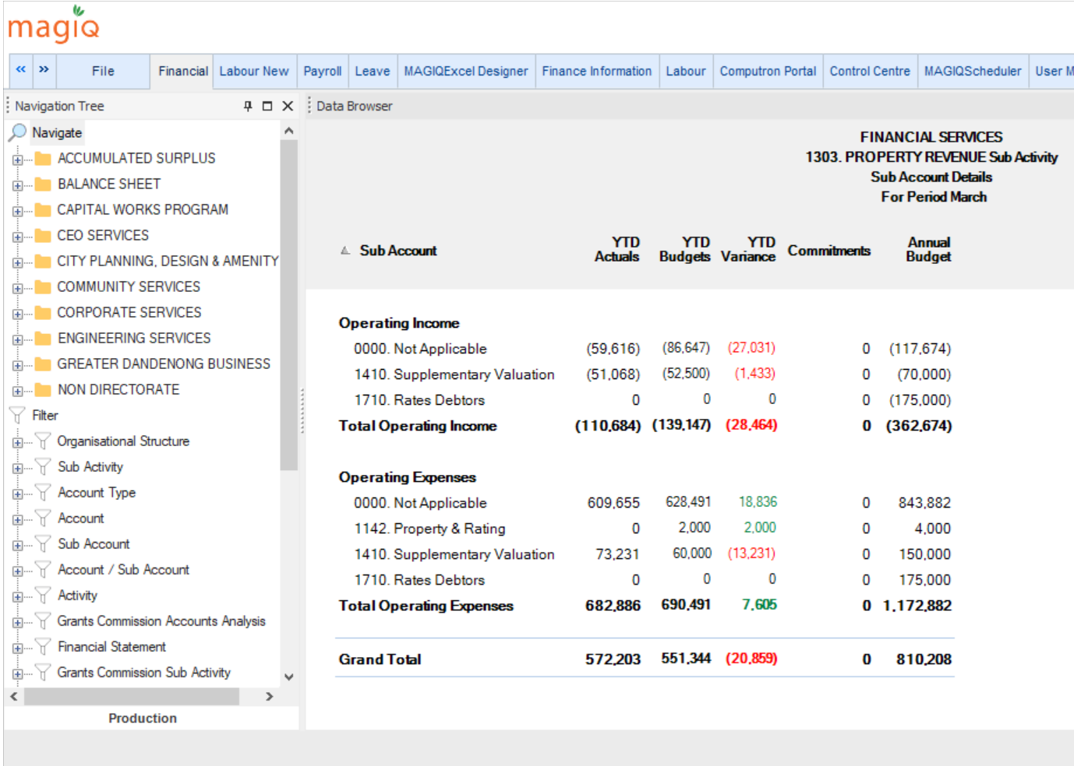

- The other way is by right mouse click and use the Zoom To function.
Select Zoom To then select the level. In this example department was selected to go to the highest level. By using this function a number of levels can be skipped.
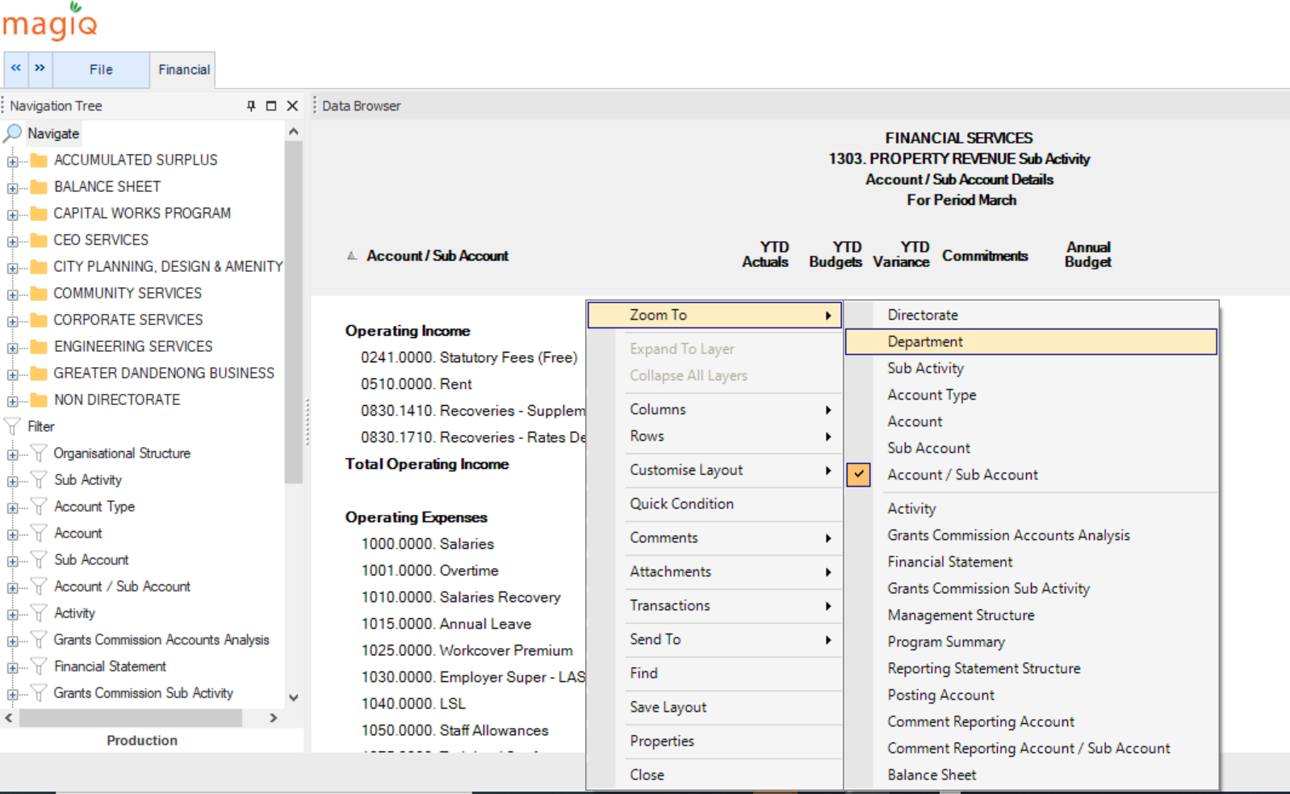

Refresh
A very useful icon located on the Main Toolbar is the refresh button.

Pressing this button will return you back to your home screen and restore all default unsaved settings. This is an excellent helper if you get lost or a shortcut to remove all formatting and collapse all layers.

REPORTING
The navigation tree has a similar feel to Explorer. Many functions that appear on the ribbon can be performed here as well.

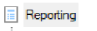

Reporting is one of the most used folders in Magiq as reports, screens and data browsers are saved here.

When the reporting divider is expanded where will be a number of folders attached to it.

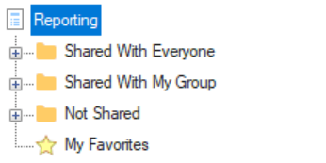

“Share With Everyone”. Contains specifically formatted screens, reports and data browsers that are set up by Finance for the rest of the organisation to access.
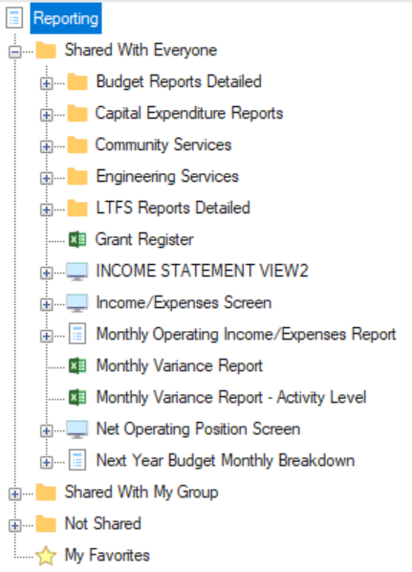

“Share With My Group”. Contains specifically formatted screens, reports and data browsers that are set up by a specific department for use for their team members only.

“Not shared”. Can only be accessed by the user – it is private and used to save specific reports of screens that only the user will access.

If a user requires a screen, report of data browser to be set up a specific way, Finance can assist with this. The screen will then be saved under “Not Shared” with the file name specific to the content of the screen. The user will then have to access this screen through the Navigation Tree panel by selecting Screen -> Not Shared.
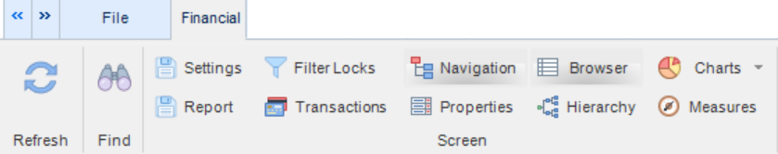

There is also a button “Report” on the Ribbon activates the menu to save, whereas in the Navigation Tree you can access the saved items.

