

OBJECTIVE ECM
FOR BROWSER
User Manual

September 2019

Contents
1. Getting Started 3
What is Objective ECM for Browser? 3
Accessing Objective ECM for Browser 3
Logging Out 3
Dashboard 4
App Bar 5
Toolbar 5
Action Button 6
Working with blades: 6
Content Pane 7
2. Navigation 9
Document States 10
Using Drag-and-Drop 11
3. Working with Objects 12
Viewing Documents 12
Displaying Object Properties 13
Details Page 14
Uploading Documents 15
Creating a File Request 16
Creating an Alias 17
Editing Documents 19
Uploading a New Document Version 20
Restoring a Previous Version 21
Emailing an Objective Reference 23
New Objective Icons in Microsoft Office 25
4. Searching 28
Easy Search 28

Getting Started

What is Objective ECM for Browser?

The Objective ECM browser app is the web-based interface to Objective's Enterprise Content Management (ECM) system from anywhere and anytime on desktops, laptops or any mobile devices. Users with a CGD laptop will be able remotely access Objective ECM for Browser externally while connected to the internet.
Users can work interchangeably between Objective Navigator and the Objective ECM browser app. Objective ECM for Browser does not offer all the functionality available in Objective Navigator, such as Approvals.

Accessing Objective ECM for Browser
1. While connected to the CGD Network, click on the Webstar  icon. If you are not on the CGD network type the URL: https://objective.cgd.vic.gov.au:8443 into your internet browser address bar.
2. Users on the CGD network be logged into Objective ECM for Browser automatically. The first time a user logs into a browser the Objective ECM login prompt will appear. Click the Single Sign-On button to login. Connections outside the network will need to be authenticated using a two-factor authentication method (ie. Google Authenticator).
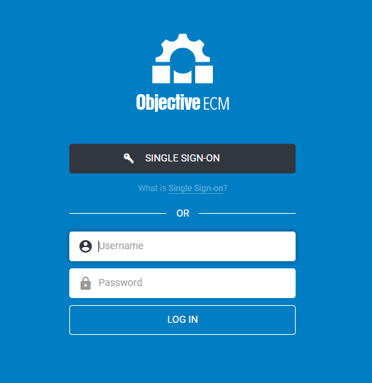

Logging Out

On a computer or mobile device close the internet browser/tab to log out.

Dashboard

Dashboard lists your recent documents and documents that you are currently editing.
The Menu Bar and Toolbar are some of the key elements on this screen.

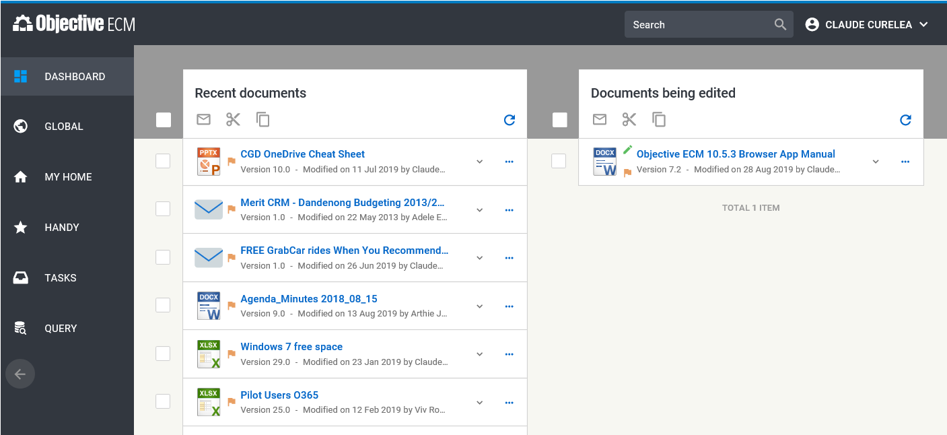
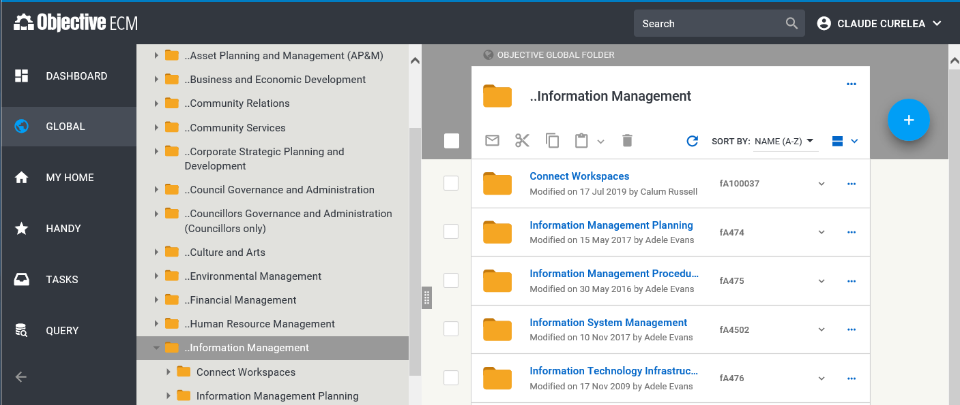
Browsing the Global, My Home or Handy menu items will also enable elements such as the Navigation Pane and the Action  Button.

App Bar
Use the App Bar to return to search for an object or access your profile and help menu.


Toolbar
Select one or more objects listed in the Content pane or Dashboard to enable the toolbar options below.

 | Email a reference to a selected object.
 | Cut a selected object from its current location and paste it in another location (to move it if you have privileges).
 | Duplicate a selected object by copying it in its current location then pasting the copy in another location (using the Paste button below).
Paste a cut or copied object to a new location if you have privileges to paste objects into the folder or file.
This option is not available on the Dashboard.
 | Delete an object from your Home or Handy where there is no corporate value applied.

Action Button
Actions are available by selecting the Action  button.

 | Upload documents to the selected location.
 | Create a new folder in the selected location.
 | Create a new file request.

Working with blades:
Selectin the Action button opens a blade to the right side of the Content pane.
Several blades can be open simultaneously. Use the horizontal scroll bar to scroll to additional blades. Each blade displays the container (file/folder) you selected to perform the action.
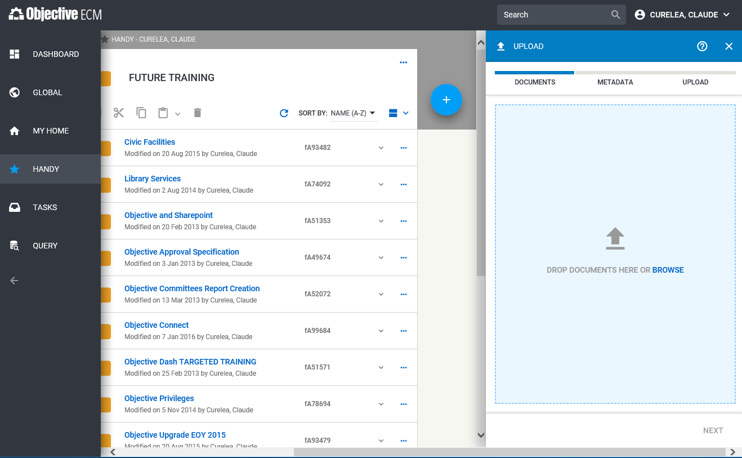

Content Pane
The Content pane lists all the objects for a selected file, folder or an object’s properties.
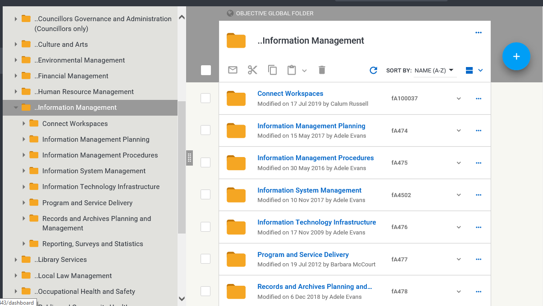
Select the object card () to view a summary of the object.
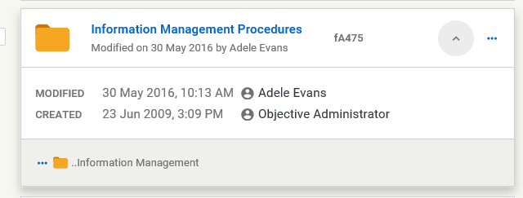
Select an object by ticking its checkbox to then choose an action from the toolbar.
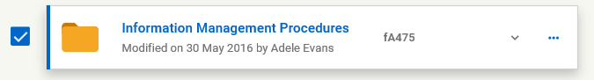
Select the ellipsis icon for a list of action options associated with the object.
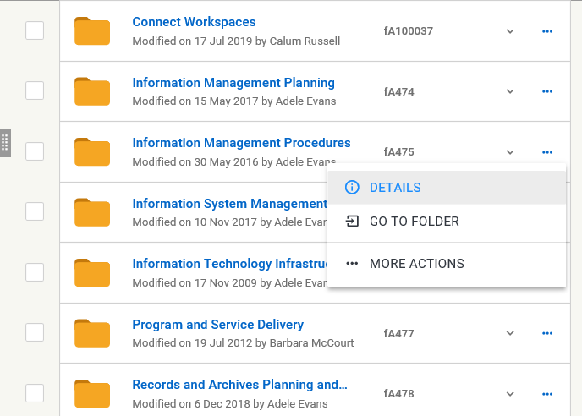

The options available will vary depending on the type of object selected.

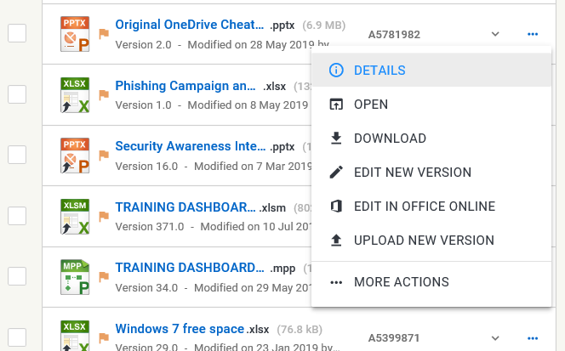

Navigation

Use the Navigation pane or the Navigation path to browse the contents of the file plan.

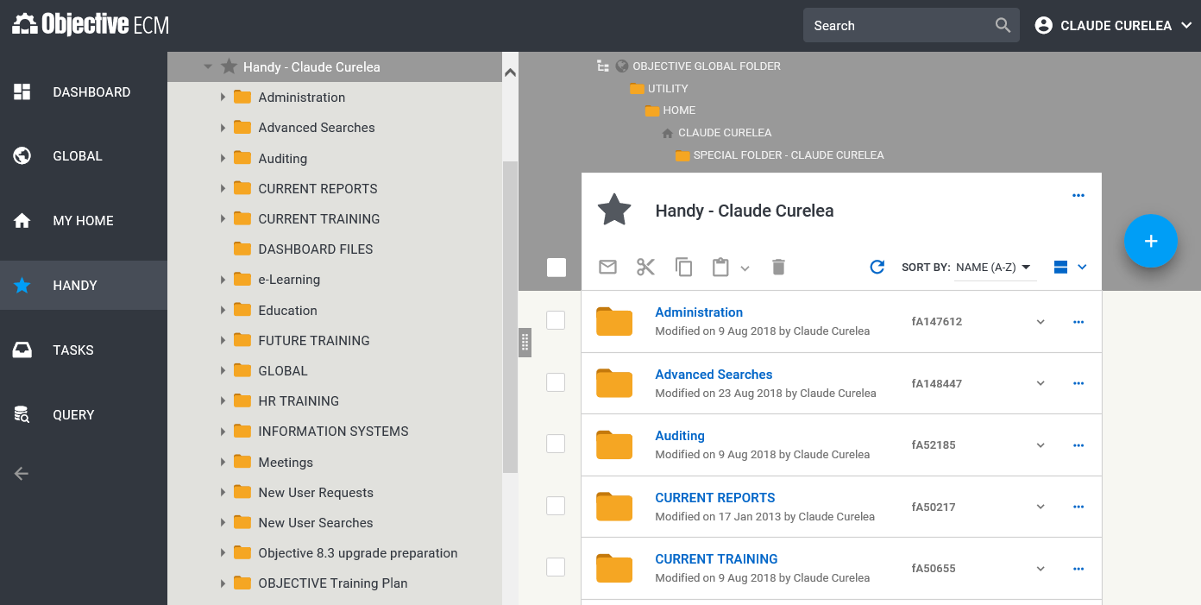
Note: Select the Expand hierarchy button to expand and collapse the file plan.

Document States

Icon | Description
Editing state
This icon indicates that you are currently editing the document.
An will display to everyone else.
This icon indicates that the document is locked for editing by someone else.
If you hover your mouse over, the date the document was locked for editing and the name of the person who is editing the document displays.
 | The object is in Draft state.
Approval state
 | The document is awaiting approval.
 | The document is awaiting publication.
 | The document is approved.
Others
 | On an object icon indicates that it’s an alias.
 | Indicates that the object is a template.
 | A creation request is in progress.
 | A creation request has been cancelled.
 | A version of the document has corporate value applied.
 | File is a virtual file.
 | Object is shared in an Objective Connect workspace.

Using Drag-and-Drop
Objects can be moved to other areas of the existing browser, other browser windows, tabs, or other applications using drag-and-drop.

Drag from the white space next to the object icon or near the objective id number.
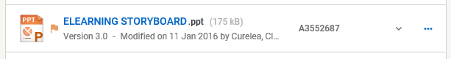

Objects can be dropped into a destination that becomes highlighted as you drag over it.

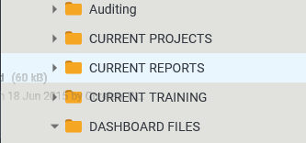
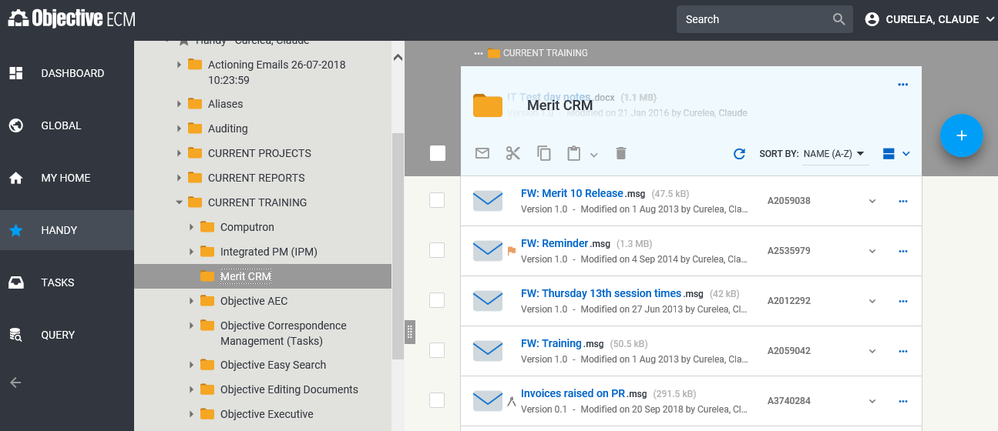

Working with Objects

Viewing Documents
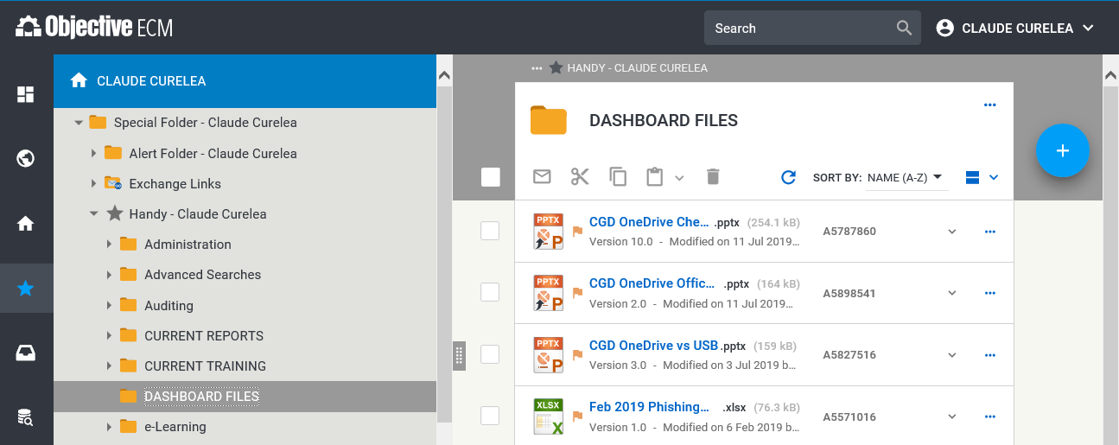
To open an object for viewing click on the object name. The object will open in the associated application.

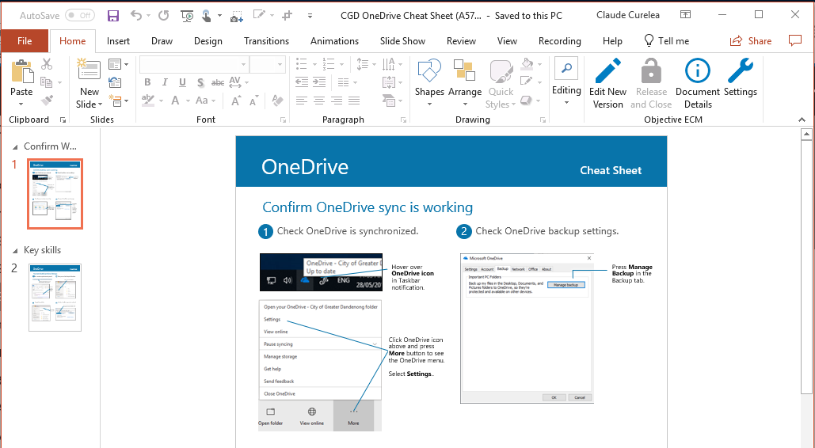

Displaying Object Properties
An object’s basic properties can be viewed by clicking the Expand object icon.
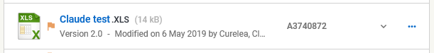

The basic properties along with the ability to edit a new version will become available.
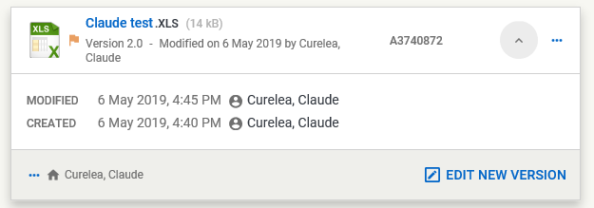

From the expanded object select the Expand hierarchy icon to see the parent location of the object.
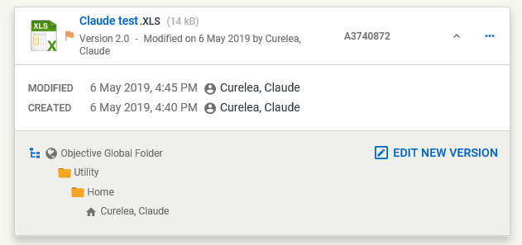

Details Page
The Details page of an object provides more details about the object including information regarding versions, security settings, notes and audit events.
Select the ellipsis for the object then select Details to open its Details page.
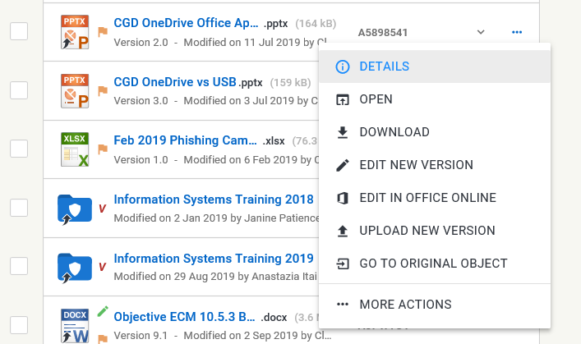
Use the expand and collapse icons to show and hide information in each tab.
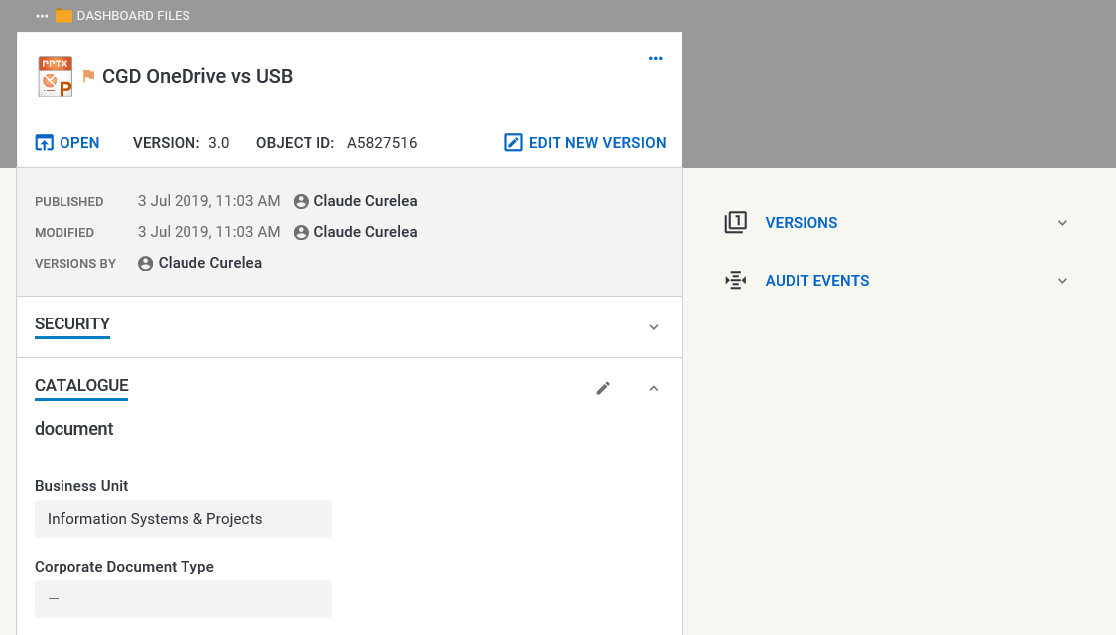

Uploading Documents
Documents from your computer or mobile device can be added to Objective ECM by dragging-and-dropping them directly into an existing location in the browser.

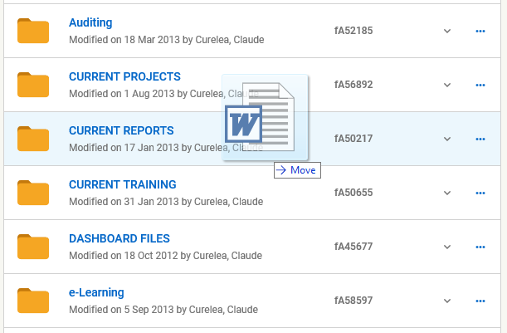
Note: If you drag-and-drop a folder (which contains sub-folders and documents) its entire contents will be uploaded into the Objective destination file or file divider.

Alternatively, the Actions  button can be used in conjunction with Upload  . Then simply drag and drop the document into the Upload blade.
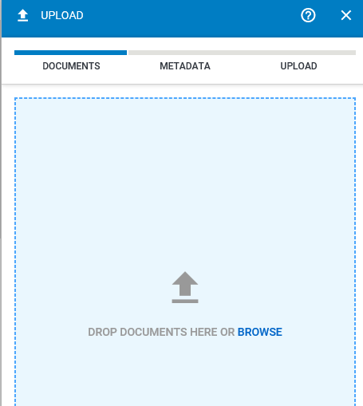

Creating a File Request
Request files by clicking the Actions button and then the Create Object  button and selecting the File Request option.
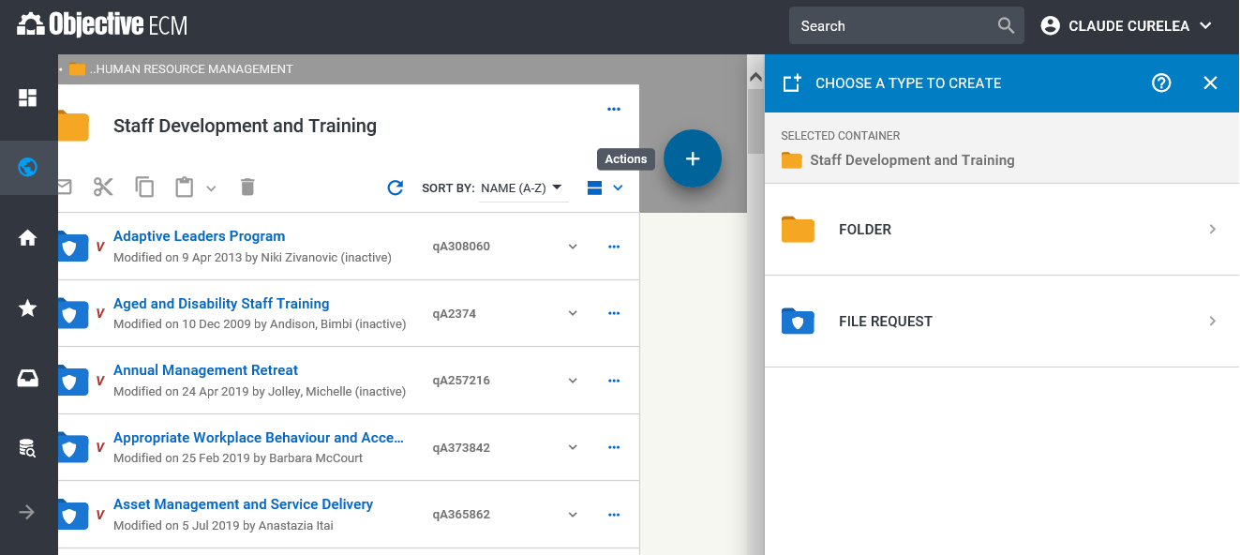
Enter the file name in the Name field and “File Creator” in the Delegate To field. Expand the File Fields tab and select your Business Unit from the drop-down list in the Business Unit field. Press Create to request the file once these fields have been filled in.
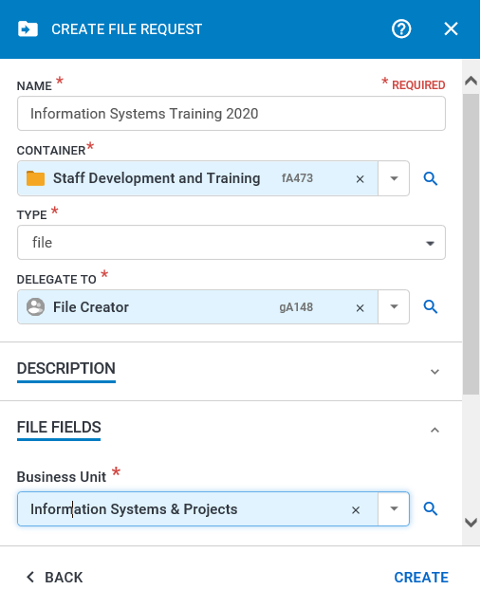
The file will be created with a yellow star next to it to indicate approval from the Records department is pending. Content can be added to the file in the meantime.

Creating an Alias

Aliases can be used to create a shortcut to an object and they can be placed in other parts of the file plan. To create an alias, Drag-and-drop a file or document to a destination in the file plan.
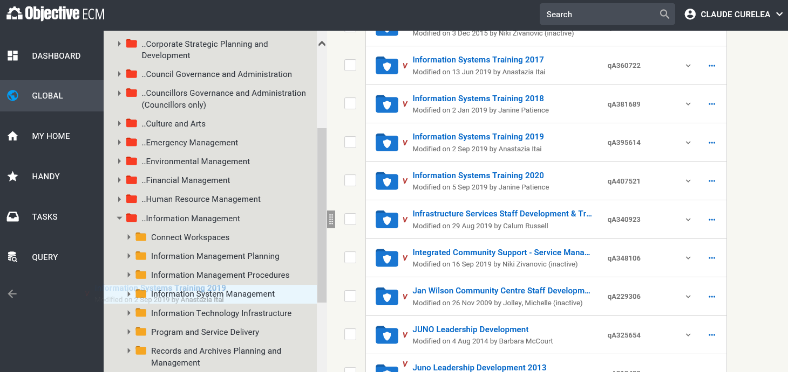
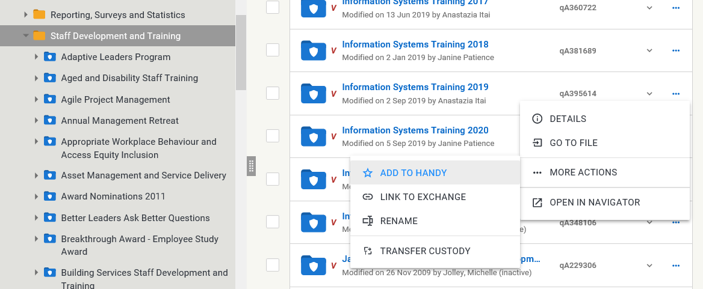
Note: Objects can be dragged to the Navigation Pane (as above) or to other windows or tabs in Internet Explorer. Objects can also be sent to Handy by selecting the ellipsis button and the Add to Handy from the More Actions menu item as below.

Once an object is dragged to a destination, select Alias at the Move Objects prompt.
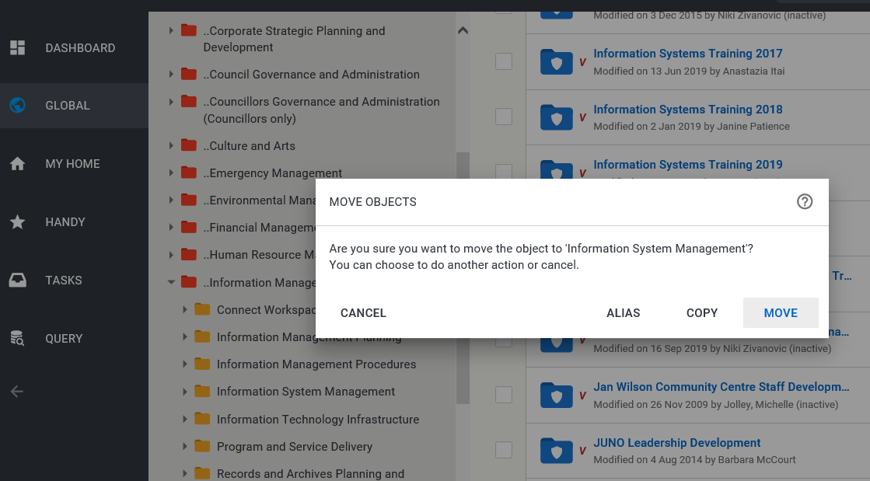
The alias will be created in the destination as an object with an arrow at the bottom of the icon.
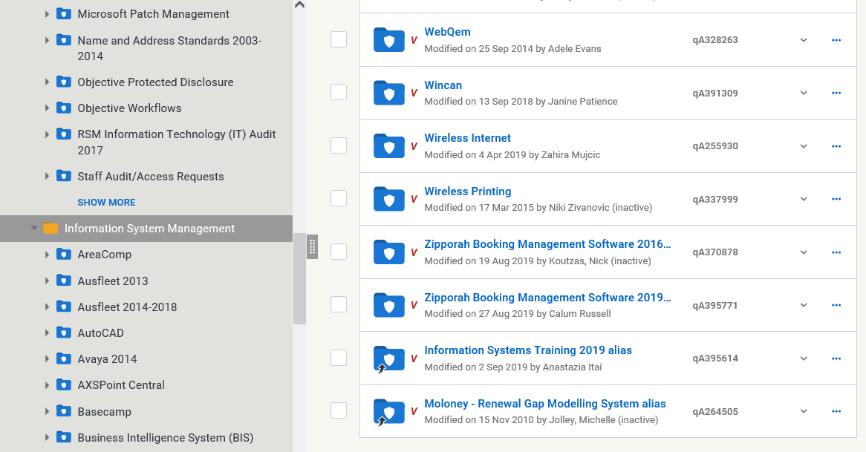
Click an alias to browse the contents of the original object or use the ellipsis button and Go to Original Location to go to navigate to the original object in the file plan.
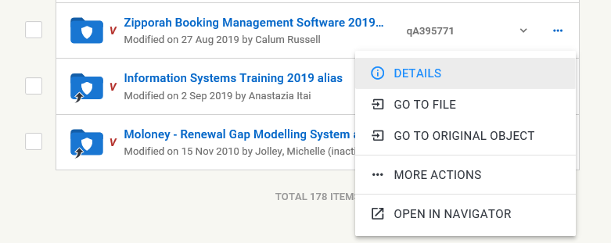

Editing Documents
Documents can be opened for editing using the ellipsis for the object and selecting Edit New Version.
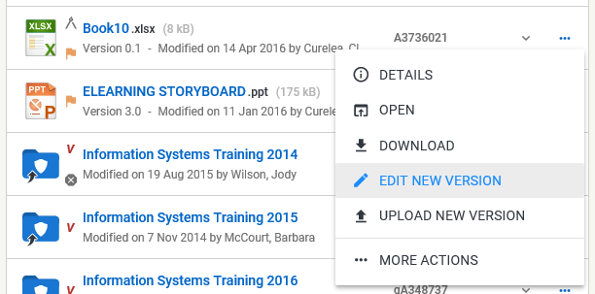
Note: When selecting Edit New Version using an iOS tablet the document is not automatically downloaded and opened. This is a limitation of the Safari browser. As a work-around, after selecting Edit New Version, go to the document’s Details page and select to download the document manually.

Select Edit to begin editing the document.
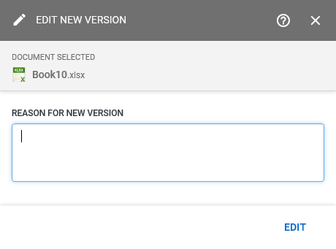

Once changes have been made to the document save and close the document. At the Release from Edit prompt select Release and Immediately publish.

Uploading a New Document Version
To upload a new document version from a file on your computer, drag and drop it directly onto the document in the browser.
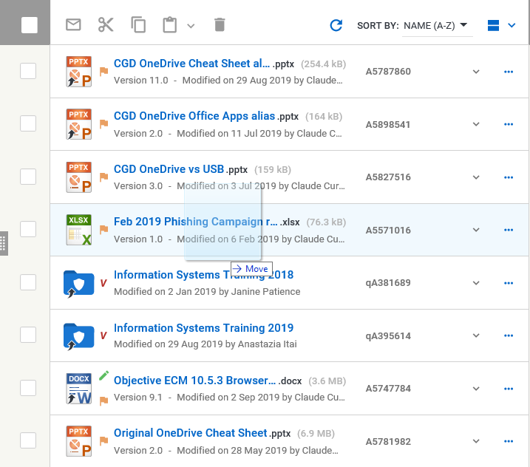
From the Upload New Version window select Immediately Publish and Upload.
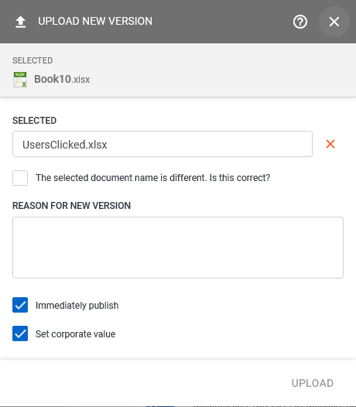
Note: If the Upload button is not available the name of the file that is being used as the new version is different to the file in Objective. If this is the case, select the “The selected document name is different. Is this correct?” checkbox.

Restoring a Previous Version
Documents can be restored from previously edited versions from the Details tab.
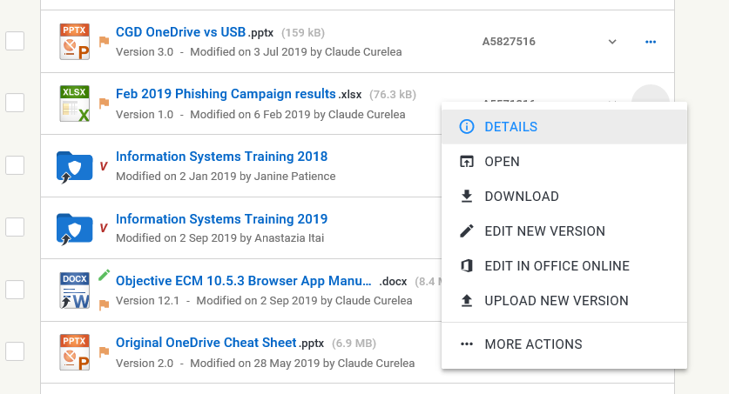
Use the Expand button to expand the Versions tab.
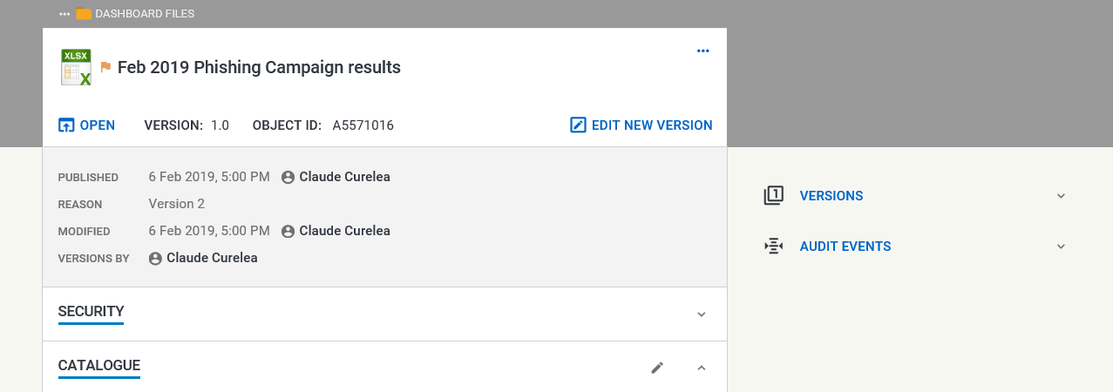

Clicking on a version will open it for viewing.
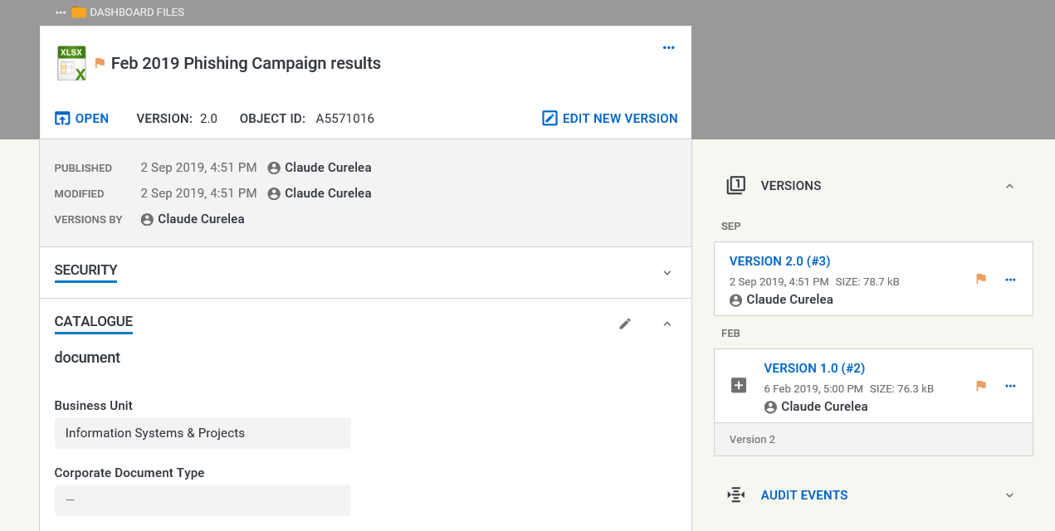
To restore a version to the latest version, click on the ellipsis  button and select Restore and Edit and press the Restore and Edit option at the prompt. The file will now be downloaded for editing.
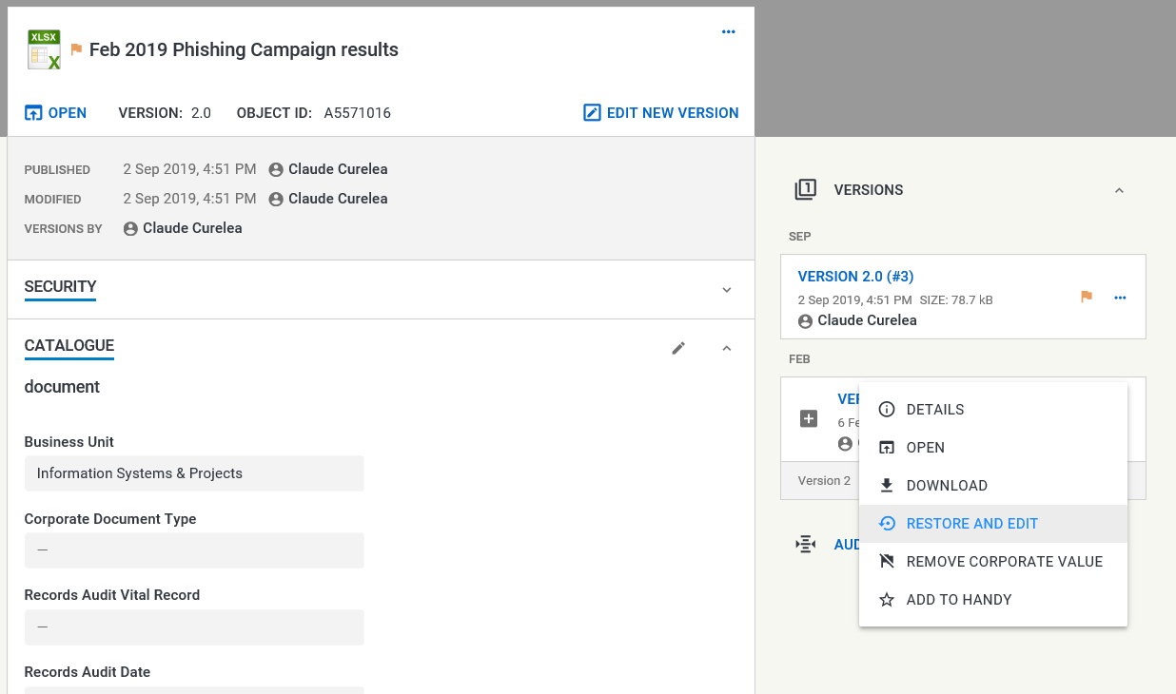
Save and close the file in the usual way by using Release with Immediately publish.

Emailing an Objective Reference
Select the checkbox next to the object and select the Email reference icon on the toolbar.
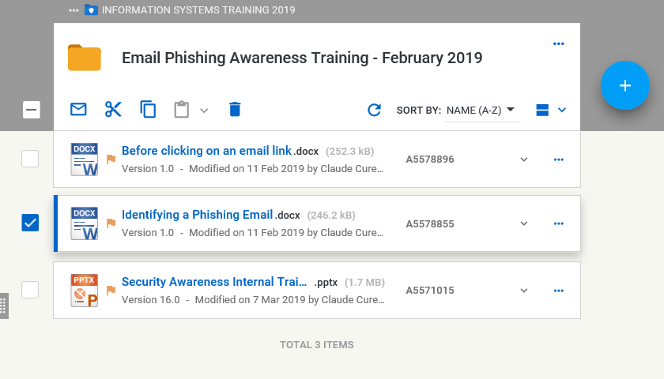
A new email displays with links to the objects. Complete and send the email.
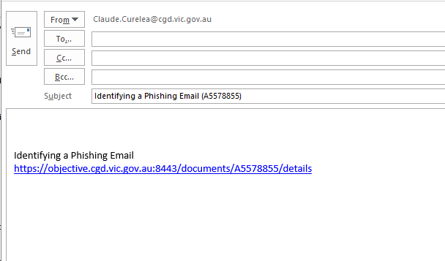
Note: When you drag-and-drop an object from the browser to email applications that support HTML formatted content, a link to the object is displayed as hyperlinked text.

When an email reference link is selected, a browser window opens at the Details tab of the object. In the case of a document, the Edit New Version is available to open the document for editing. 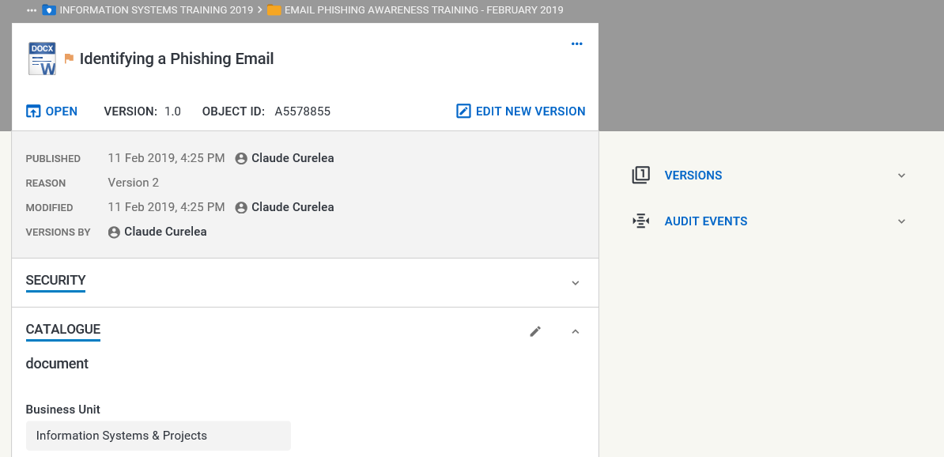
Objective references that have been sent using the Objective Navigator client will still contain the .obr attachment but the link can now be used to open the object in the browser.
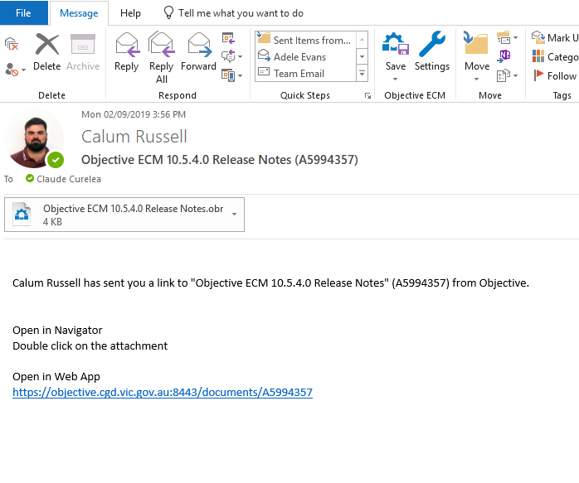

New Objective Icons in Microsoft Office
A new Objective ECM group of icons is available in the Home Tab of the Microsoft Word, Excel and PowerPoint applications.
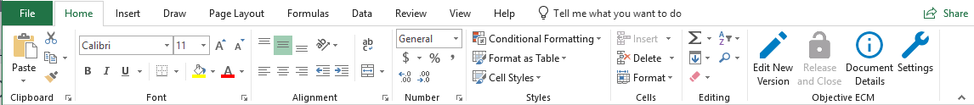
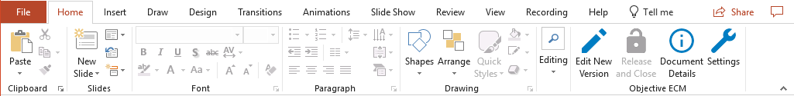
When a document is opened for viewing (read-only) users will be prompted to open if for editing if Objective detects any changes being made to the document. Select the Yes and then Edit options at the Edit New Version prompt to keep editing the file. 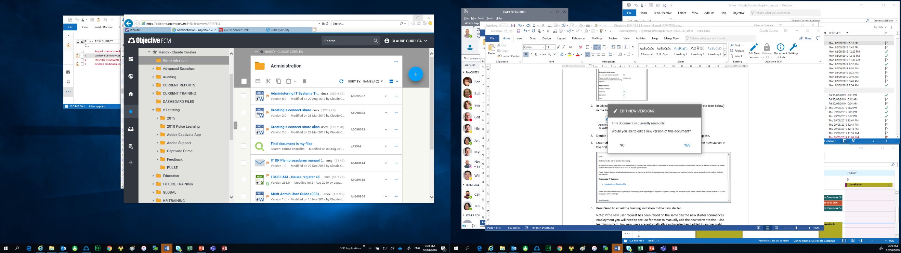
Once the document has been edited press the Release and Close  button in the Objective ECM group of icons in the Home tab of the Microsoft application. Select Immediately publish and Release from the screen below.
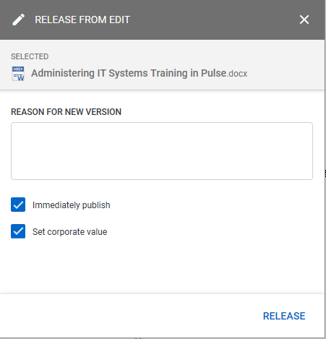

The changes made to the document will be published to Objective.

Searching

Easy Search
To find an object using easy search type the words and phrases into the search field and press Search.
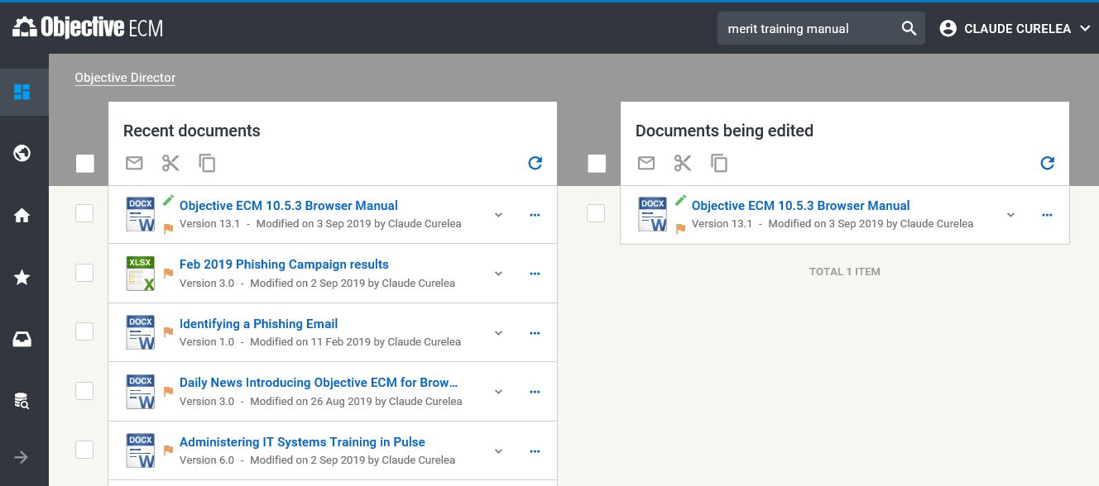
Search results will display in the content pane and can be refined using the filters in the Refine Results pane.
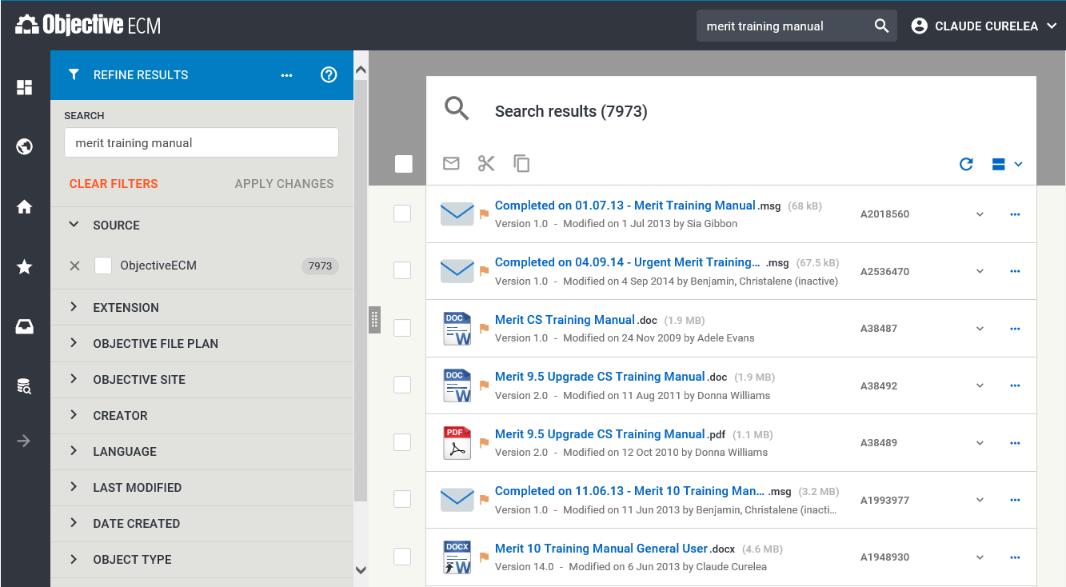
Note: The number next to Objective ECM indicates the total number of results found.
To filter results so that only PDF documents are visible, expand the Extension category, select PDF and press Apply Changes.
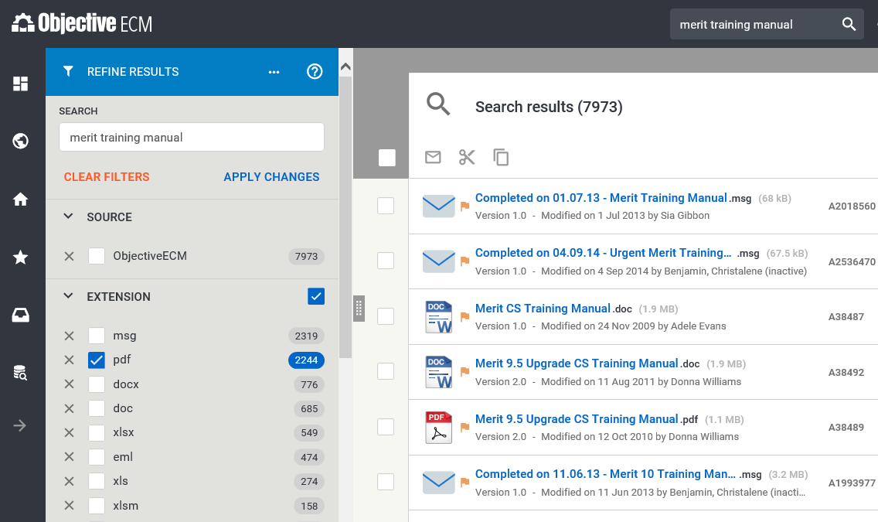
The search results will now be narrowed down to PDF documents. Additional categories can be used to refine search results.
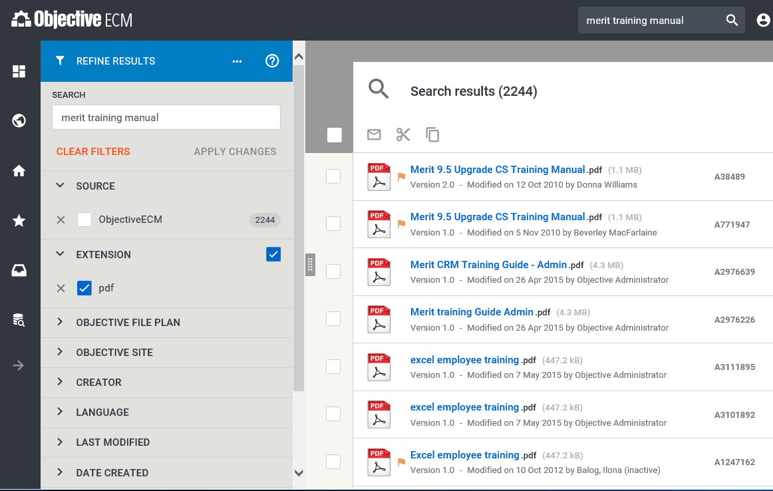
Note: Use the ellipsis  icon in the Refine Results pane to save the search.

