Objective Connect for CGD Objective Users

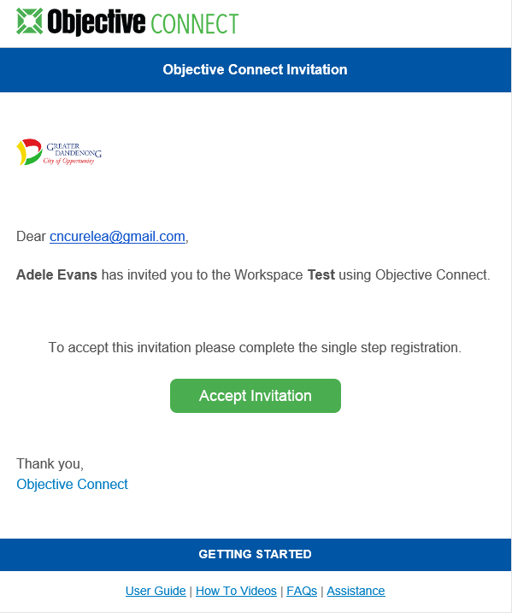
Logging In

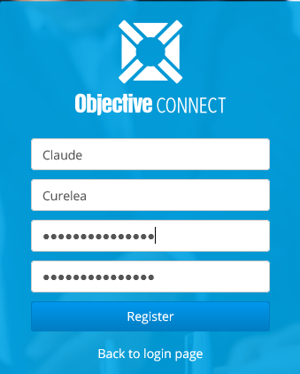
Once you have received you email invitation you can start collaborating with other participants. To accept your invitation:
- Press the Accept Invitation button in the email.
- Enter your name and password and press the Register button. Password must be at least 13 digits long.
- Press the Accept button to accept the terms of use.
- Press the Accept Invitation button inside the Workspace.
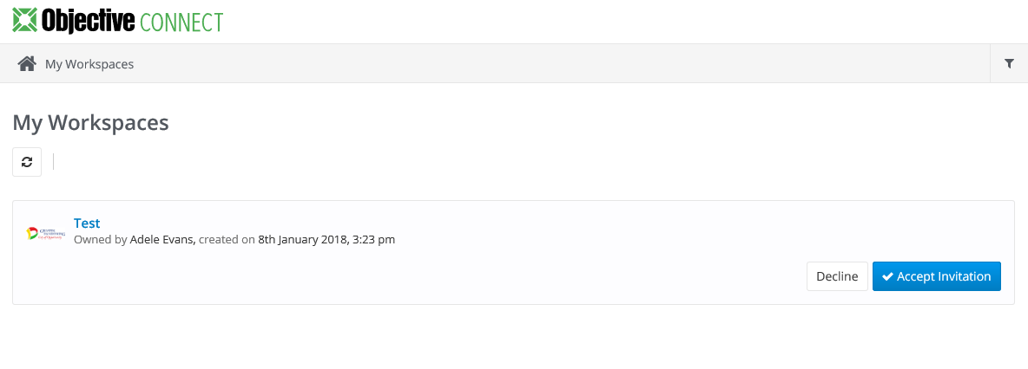

Getting Started

Once you have logged into Objective Connect, you will see your available Workspaces, Conversations (Mentions) and Tasks.

Navigation
In your secure private Workspace, you can:
- Add documents* or click on documents to download them to your desktop.
- Post, view or respond to Comments.
- Click the Filter button to sort and search for files.
- View and complete Tasks that are assigned to you.
- Invite additional Participants*
* Note: Connect Share Administrator must set up your permissions to perform these functions.

Adding Documents in Connect as a CGD Objective User

To add a document to a Workspace:
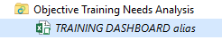
- Make an alias of the original document.
- Drag-and-drop the alias into Connect share with same same name as your workspace.
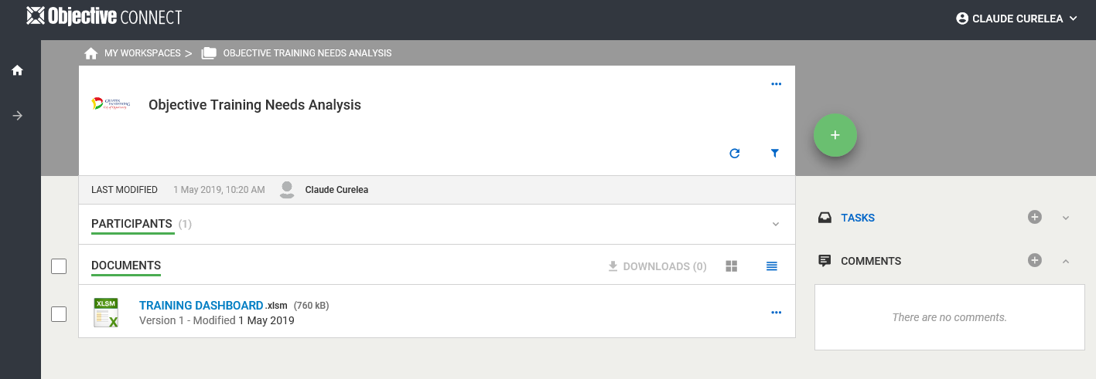
- The document will now appear in the Connect workspace in the browser.

Adding Folders

To create a folder:
- Click Create Folder button.
- Type in folder name.
- Click the Create button.

Note: The Create button will only be visible if your administrator has assigned you permission to create folders.

Searching Documents

Search for the document or alias using Objective. To search for a document using the Connect browser:
- Click the Filter icon.
- To search by document name, enter search criteria in Filter by Name box.
- Select the criteria to sort documents.
- Press Sort button.
- Click Close button to exit the Filter menu.

Editing Documents in Connect as a CGD Objective User

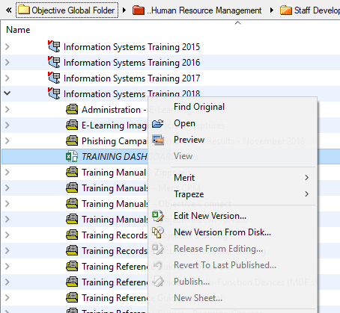
Edit documents in Objective and they will update in Connect.
To edit a new version of a document:
- Browse to the document to be edited in Objective
(Note: Edit the document from its original location or from an alias, including the alias in the Objective Connect folder .
- Right-click on the document and select Edit New Version.
- Press the Create button.
- Once you have finished editing the document close and save it, selecting Publish document immediately and press the Release button.

If you require further assistance, please contact the IT Service Desk on 8571-5102.

