

MERIT 24/7 MOBILE PHONE VIEW
USER GUIDE
Version 5.0.74
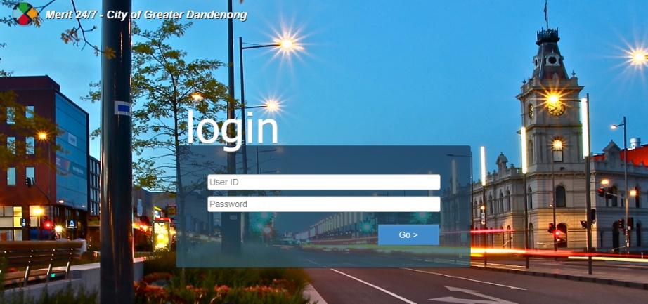

Contents
Getting Started 3
What is Merit 24/7? 3
1. The Basics 4
Accessing the Browser App 4
Home Menu 7
Menu Bar 8
Officer Options 10
Logging Out 11
2. Navigation 12
Creating a New Request 12
Completing a Task 16
Reassign task to another officer 18
Recategorising Request 21
Using the Search function 24
Attaching an image or document to a Request. 26
Viewing an Objective Document 33

Getting Started

What is Merit 24/7?
Merit 24/7 is a web-based interface to Merit CRM system enabling you to track, create new requests, update, close actions, and view objective documents linked to Merit. You can quickly and easily perform actions – anywhere using a mobile device.

The Basics

Accessing the Browser App
1. Enter the following URL in your mobile device default browser:

https://myapps.cgd.vic.gov.au/ and choose Merit 24 7

OR alternatively
https://merit247.cgd.vic.gov.au/merit247/

2. Type your username and password.
Important Note: Ensure Microsoft Authenticator is set up before logging in.

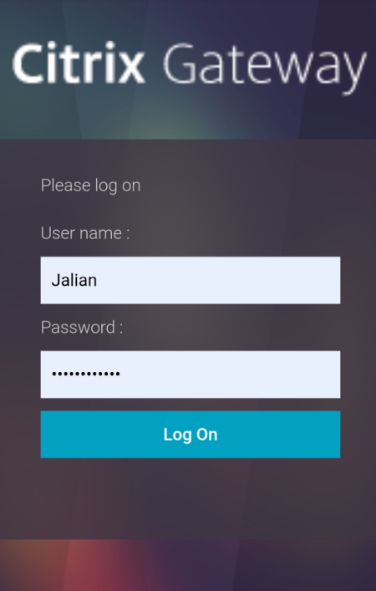

3. Press the Log On button.
4. Tap Approve.
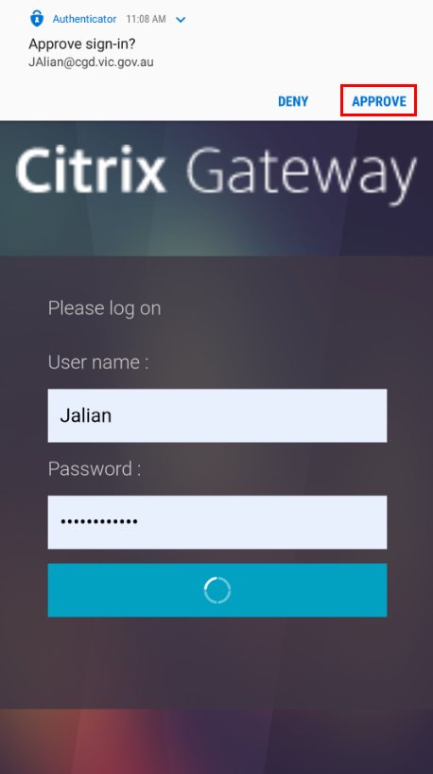

Important:
If you are using a laptop, you will be navigated to the browser view, please refer to the user guide: Merit 24-7 Browser View v5.0.74 User Guide (A6444220)

In your mobile phone, refer to the screenshot below for the mobile view.
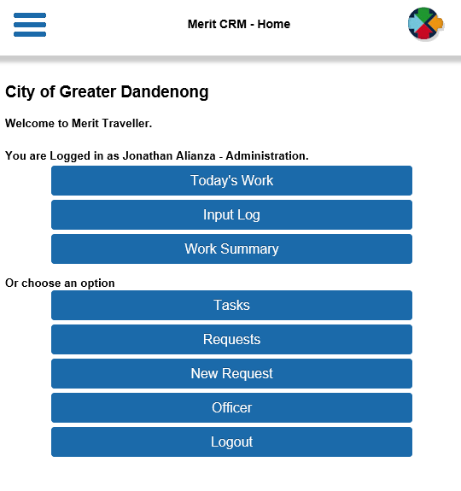
If not, tap on the Merit icon  at the upper left corner of the screen.
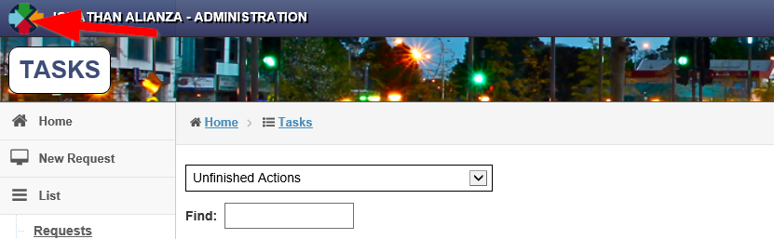

Home Menu
- As seen below, the initial screen gives you options through a menu bar.

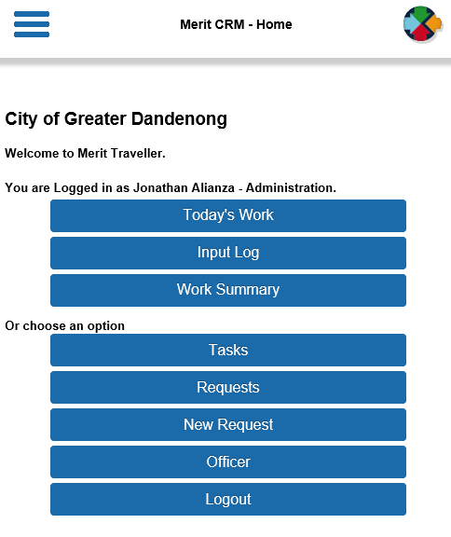

- Taping on the Menu Bar Launcher navigates you to the following quick menu screen.

Note: Search function is only available on this view.

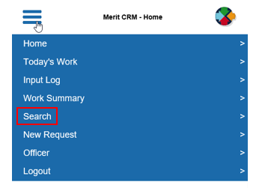

Menu Bar
All the available menu bar options are listed below. Depending on your security role settings, some options may not be available to you.
Menu Item |  | Description
 | Menu Bar Launcher
 | Home Menu. Navigates you to the Welcome Menu window. Available only in the Menu Bar Launcher.
 | List of Tasks (default to unfinished actions that are assigned to you)  Use the drop-down option to filter by status and In-trays.
 | Displays a list of open requests that you created within the day.
 | Tabular display of counts of actions and requests and their status.
 | Search function. Available only in the Menu Bar Launcher.
 | Similar to Today’s work item.  Displays a list of tasks (default to unfinished actions that are assigned to you)  Use the drop-down option to filter by status and In-trays.
 | Displays a list of unfinished requests.
 | Navigates you to the new request form. New Request ID will be generated.
 | Displays the Officer Options (Login timeout, roles, change password and views)
 | Logs out of Merit.

Officer Options
Login Timeout: The maximum amount of time Merit will be online when you’re idle.

Change Role: If you have multiple roles, use the drop down to swap to other roles.

Change Password: Merit Traveler password change option.

Change Your Defaults:
Filter (Request / Task): This is the default In-tray when opening the list of tasks.
Tablet View: Default setting should be Mobile.

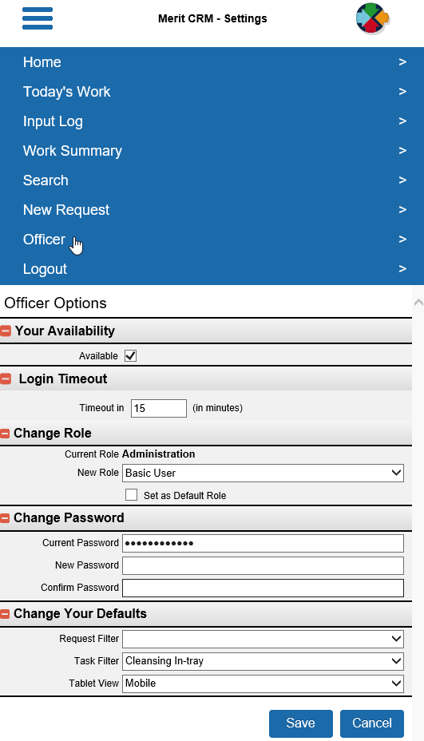

Logging Out
Tap in the top left-hand corner of your screen, then Log out from the menu bar options.
Note: Depending on how your system is set up, you may be logged out automatically if you’re not using Merit after a certain period.

Navigation

Creating a New Request
- Tap on the New Request bar:

- Enter the required fields:
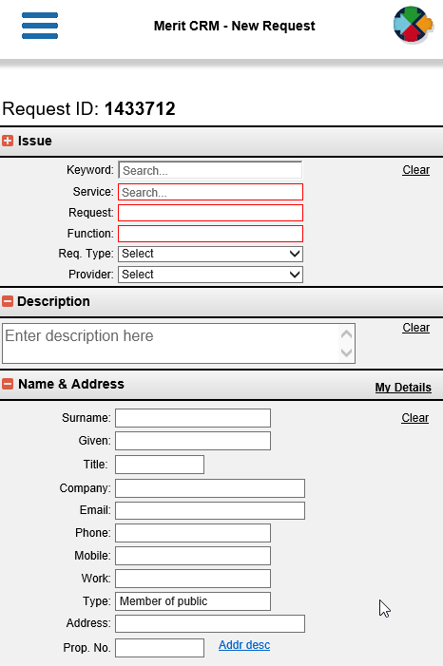

Note: Depending on the SRF selected, specific fields can be mandatory or optional.
Customer Name & Address matching name screen will pop up once Surname and Given is fi and tap to another field.

- In the Location, fill up the details until matching addresses drop down pops up. Select the address.

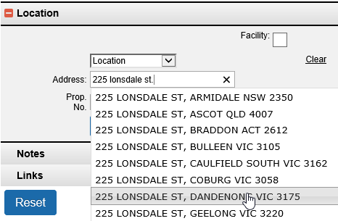

Note: Property No. will display once the request is saved (except for new address that needs to be added in Merit)
For Facility, tick on the checkbox.

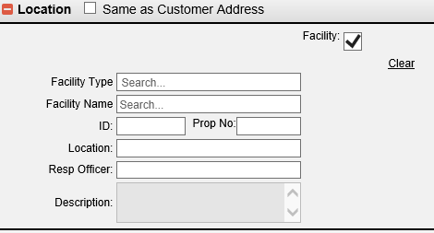

Search by Facility Type or Facility name.

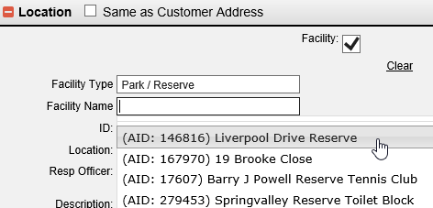

- Selecting the Facility will auto populate its succeeding fields.

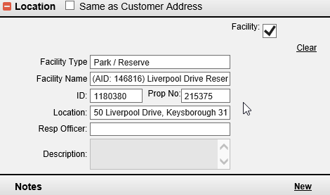

- To add Notes, tap on ‘New’.

- Enter Notes and Save.

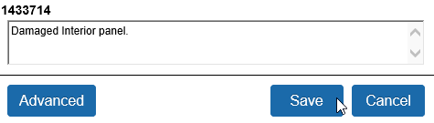
- If you want to link the new request to an existing request. Tap link and enter the existing request number then Save.

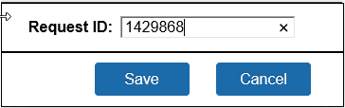

- The details of the linked request will be displayed under ‘Links’.
- Save the Request.

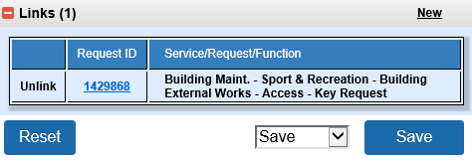
Note: The Save drop down gives you the ‘Save & More’ option. This will save the request and copy the Name, address and location details to a new request form.

Completing a Task
You can quickly access your assigned tasks through Today’s Work, Work Summary and Tasks in the Menu bar.

- Example, Tap Tasks from the menu.

- Select one of the tasks and tap Complete to open it.

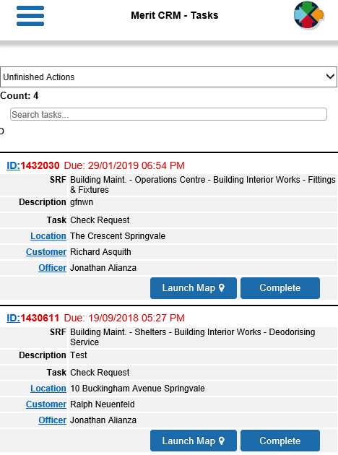
Note: Red font on the Request ID means task is already overdue.
- Select the outcome of the Action from the drop-down list.
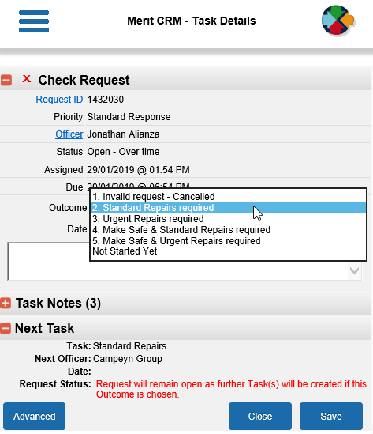
- Enter Notes and tap Save
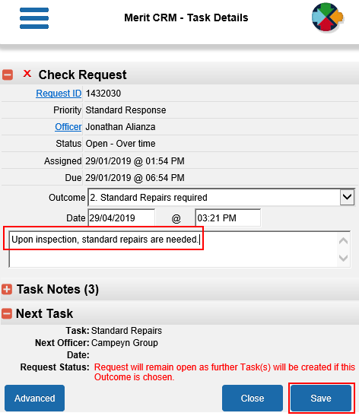

Reassign task to another officer
- Navigate to the relevant task and tap Complete.

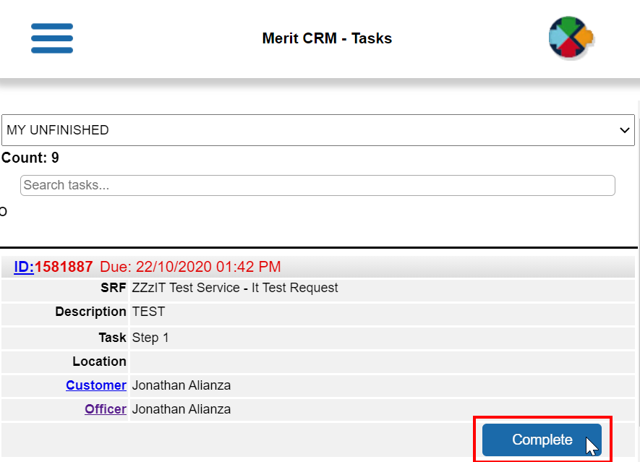

- Tap Officer
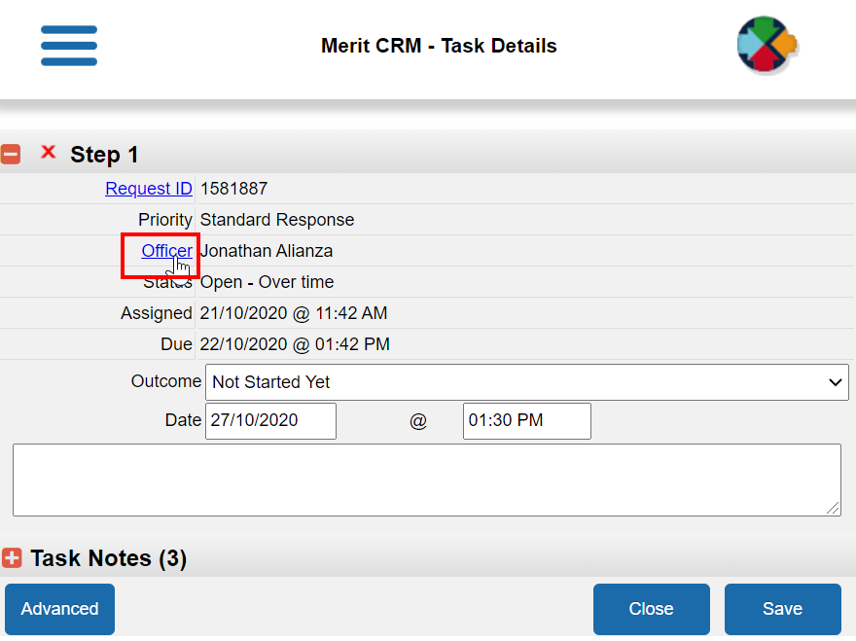
- Type the Officer name until matching names pop out.
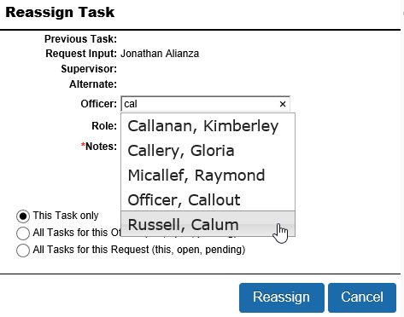
- Select the Officer

- Enter Notes and ensure *‘This task only’ is selected unless you want to reassign all active tasks. Refer to the options.

- Tap Reassign.
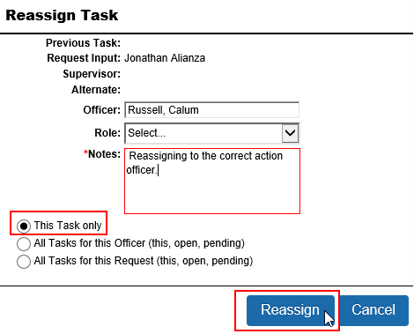

Note: If you want to reassign task to ‘Request Input Officer’ OR ‘Previous Task Officer’, these options are available by selecting Role.

Recategorising Request
- If you want to recategorise a request from an action assigned to you, tap “ID”.

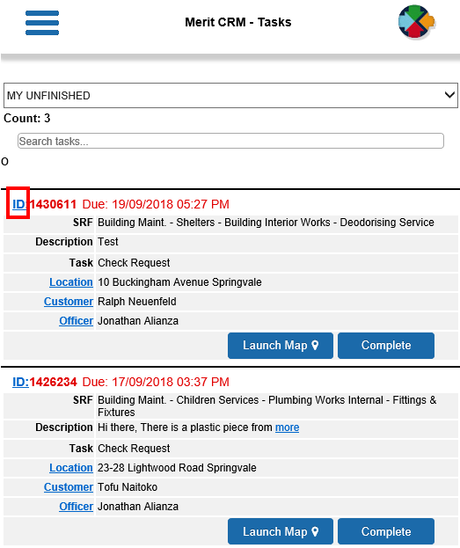

- Tap the Request number.

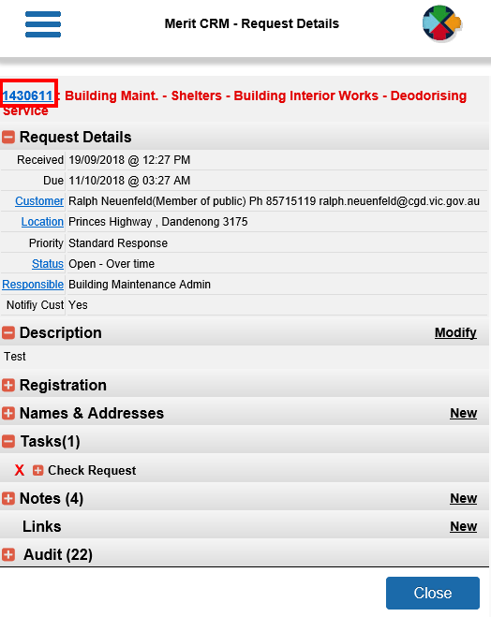

- The Recategorise Request screen will display as per screenshot below.

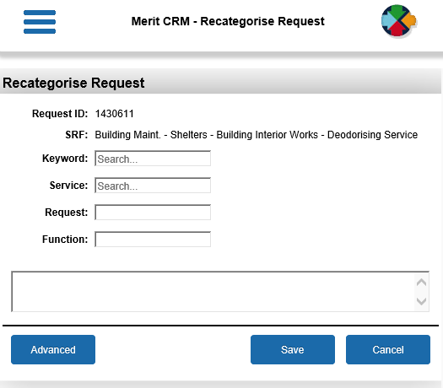
- (1) Enter the new SRF and the (2) reason for recategorising it. Then tap (3) Save

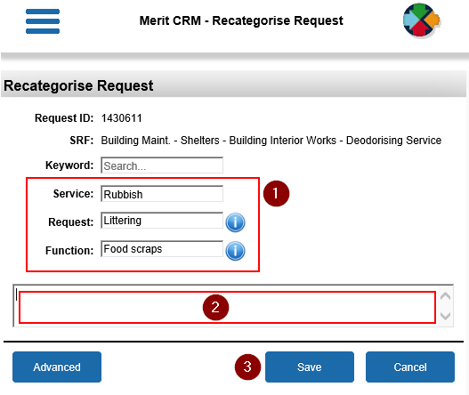

Using the Search function

- Open or search for the request.

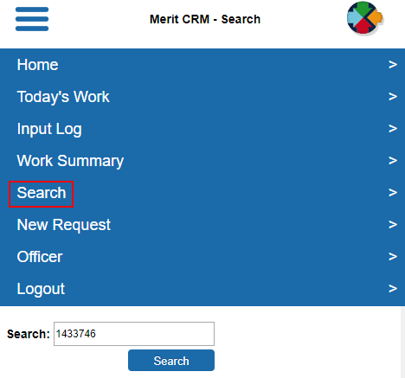

- Tap View.
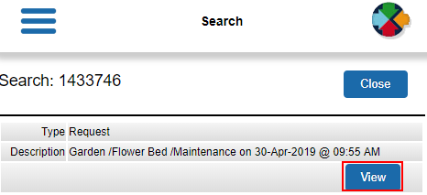
- Depending on your security role, other request details may not display.

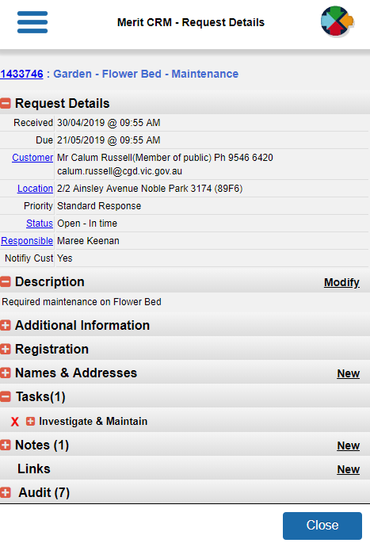

Attaching an image or document to a Request.
Note: For new requests, an image or document can only be attached after you saved the request. The attached file will automatically link to Objective.
- Open the request. In the Notes section, Tap New.

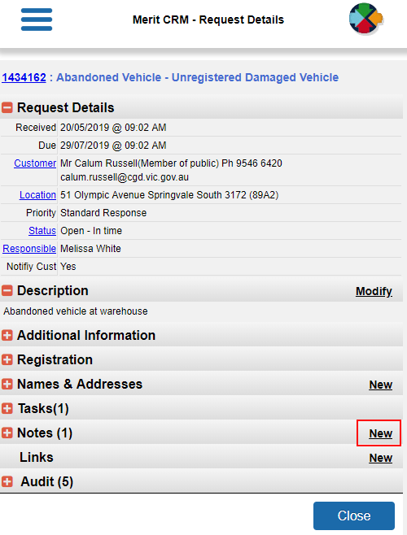

- Enter comments of the attachment and tap Advanced.

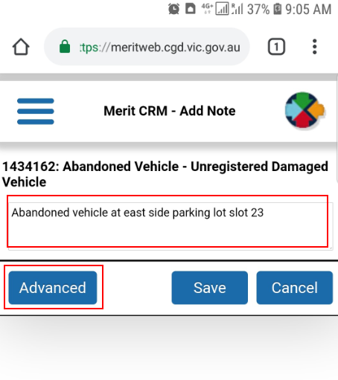

- Tap Add then Choose File.

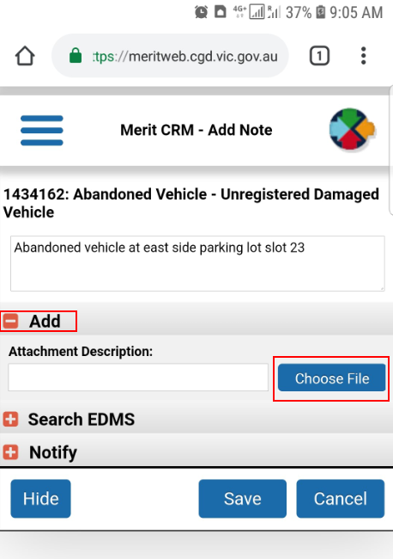

- Select an action: You can choose either Camera or existing files.

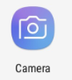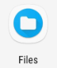

- Take a picture or select a file from your mobile device and tap OK.

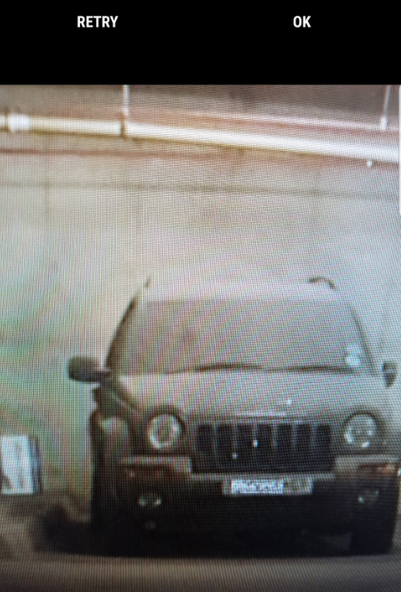

- The file should be available on the list of current documents. Link is checked by default for Objective Integration. Tap Save.

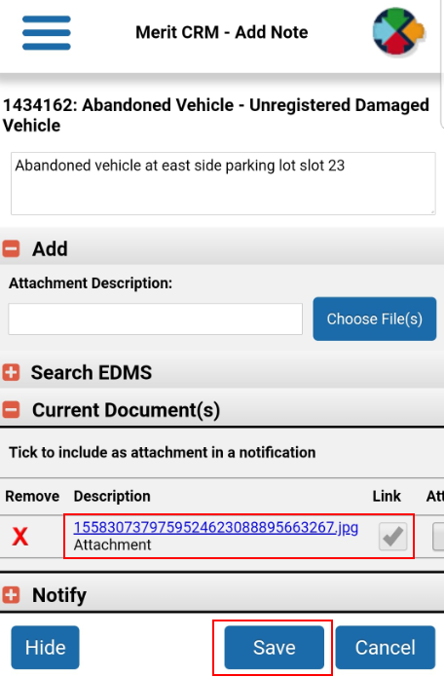

- Image or document has now been saved. You can view these files by taping ‘View’ at the bottom part of the Notes Section

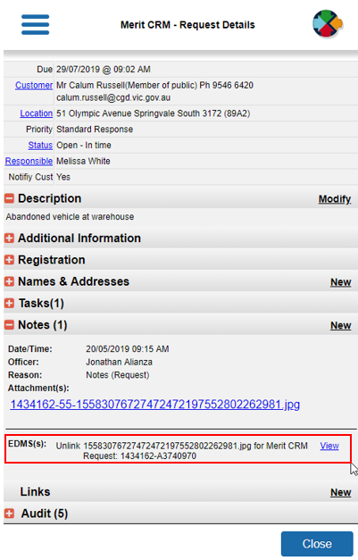

Viewing an Objective Document

Note: You should be on the Request level to open an Objective file.
- On your list of actions, tap on the Request (ID).

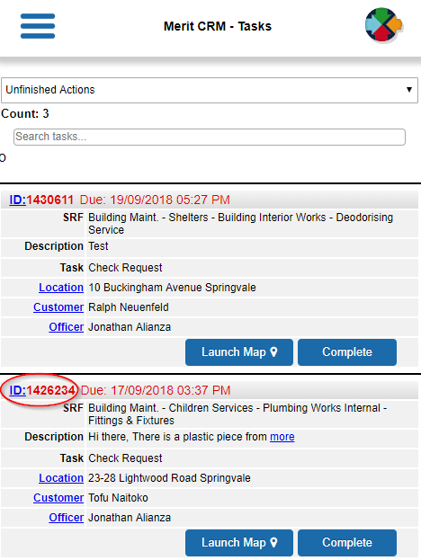

- Tap on the Notes (+)

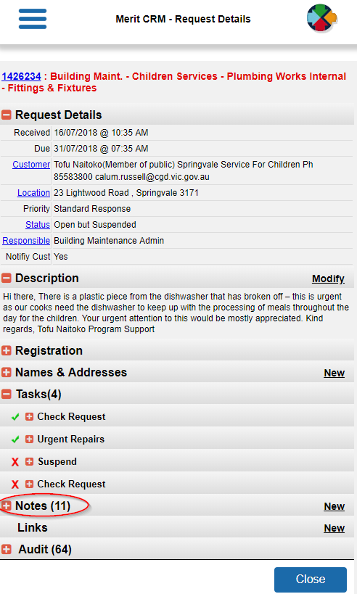

- Scroll down to the bottom of the Notes. All objective files linked to the request will be displayed. Tap View.

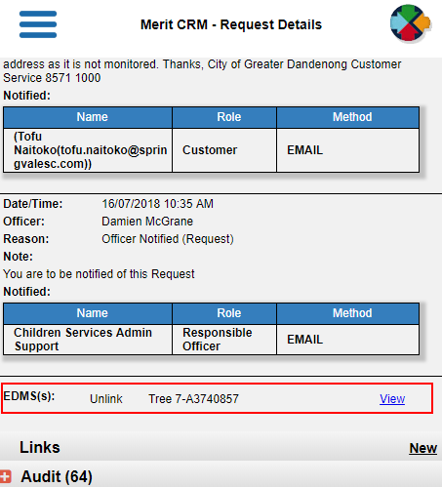

- Screen will open a new window and display the objective file.

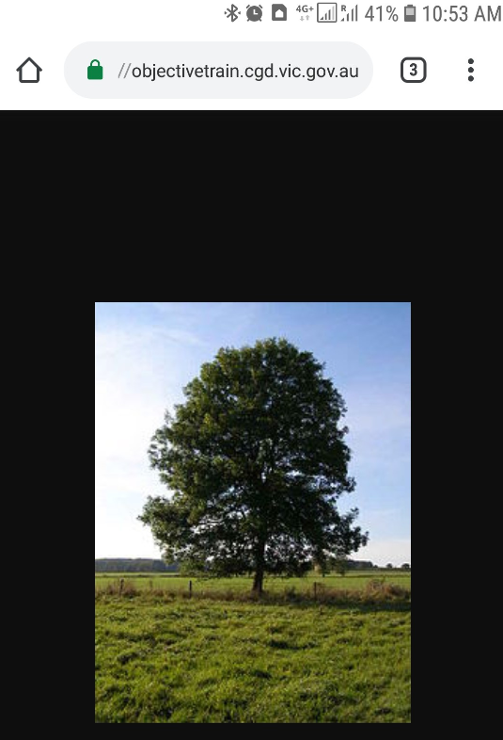

Please contact the IT Service Desk on 8471-5102 if you require Merit support.

