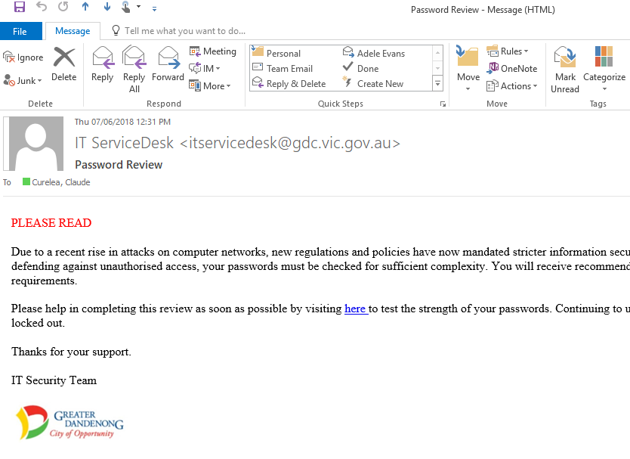
Before clicking on an email link, ask yourself:
Do I know the sender and is the email address legitimate and correct?
Is there an urgent appeal to emotion or impulse in the tone of the message?
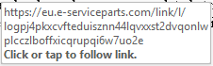
Do any links point to a different web address other than the official web address of the sender? Hover over links – do not click links unless you are 100% certain they are legitimate!
While sender and logo may be correct, is this the usual way I receive this kind of correspondence from this sender? If in doubt, call the sender.

