Overview  You can submit requests for new files in Objective when the required file does not exist. Requests are delegated to Records staff members who will process your request.  To request creation of a new file  - Right click the parent location.  - Select New > Add File to open the Add File...  - Provide a Name for the file.  - Choose “Request Virtual File as the Creation State.      - Choose “File Creator” as the Delegate to option.  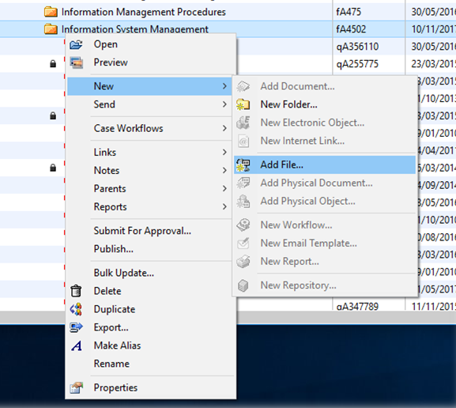  - Click OK to save the new file request. | 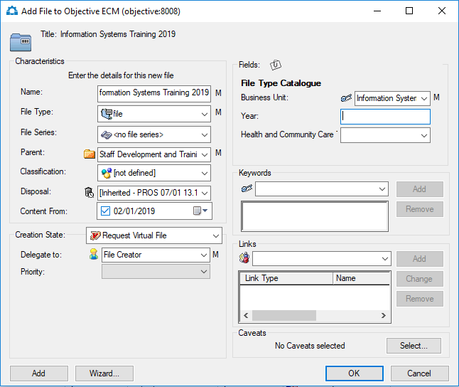        Note: A requested file will appear with an asterisk (below) until the request is processed.

