How to Load Paper into the Multi-Function Devices (MDF’s)

- ALWAYS LOAD THE PAPER WITH THE UNDERSIDE FACING UP OR THE PAPER WILL JAM. Do not flip it – insert it facing the same way it is when you open the packet with the smooth side on the bottom and the matte / rough side on the top. (SEE BELOW PICTURE).
- Before loading the paper, fan the stack of paper from all sides to make sure the sheets are separated.
- Then tap the stack on a flat surface to align the edges and load the paper into the MDF.
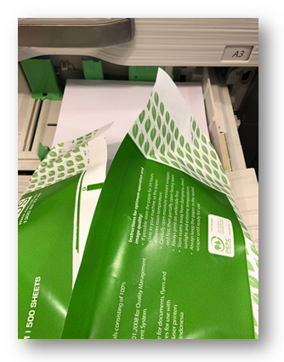
If you need assistance with loading paper into the MDF’s please contact the IT Service Desk on 8571-5102 or click here.

