

PURCHASING CARD

Cardholder guide and Procedure

FlexiPurchase

Table of Contents

Cardholder guide Error! Bookmark not defined.
1. Introduction 3
1.1. Cardholder Responsibilities: 3
2. Logging in 4
3. Changes In This Release 4
4. Coding a Transaction…………………………………………………………………………………5
5. Other Coding Scenarios………………………………….……………………..…………………..9
6. Other Actions…………………………………………………………………………………..…….14

Introduction

Welcome to the Card Transaction Coding User Guide. This guide will take you through the process of coding expenses made on your corporate card.

If you have any questions or issues regarding FlexiPurchase, please contact your Administrator within City of Greater Dandenong.

Cardholder Responsibilities:

- Comply with the Corporate Purchasing Card Policy – https://objective.cgd.vic.gov.au/id:A1963568/document/versions/latest
- At the end of each month the cardholder must reconcile the current month transactions in the card expense management system (FlexiPurchase) - a green tick beside the transaction means all mandatory fields have been completed.
- Attach your hard copy of the tax invoices/receipts to your statement and forward to your purchasing card administrator.
- Cardholders must at all times ensure that all purchases on the card comply with applicable Council policies including Council's Procurement Policy.
- Cardholders are at no time to use their card in conjunction with any rewards programs for personal benefit. There shall be no personal gain whether it is monetary or other reward when using the purchasing card. Refer to (Attachment D) for Prohibited Purchases Prior to taking leave, you are required to delegate another user to complete your statement.
- Inform your administrator of any changes to your details (e.g. Supervisor, Department or role)
- Use the correct account codes and GST codes for your Card transactions.
- Ensure a description of what the expense relates to is included in the FlexiPurchase coding section.
- Cardholders must return the purchasing card to the Council’s Purchasing Card Administrator upon cessation of employment with the Council or during significant periods of absence (exceeding 6 months).

If you have any difficulties regarding FlexiPurchase please contact:

Subi Nathan X5129
Email: purchasingcards@cgd.vic.gov.au

Logging in

Step 1: Go to http://flexipurchase.cgd.vic.gov.au and login in with your City of Greater Dandenong network username & password. (If you have problems with username and password please send an email to the contact persons listed above).

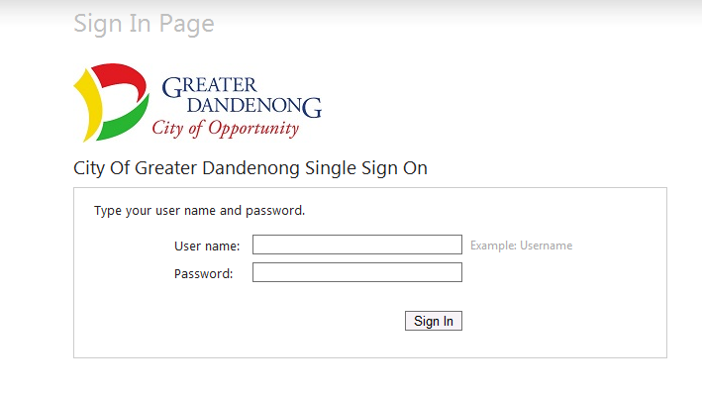

Step 2: Click on “Accept” if you agree to the Terms and Conditions.
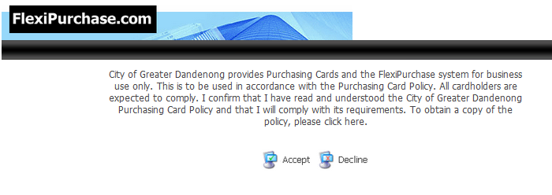

Changes in this release

In this release, a new Accounts added. This screen gives users easy access to balances and statements for their own accounts as well as accounts delegated to them.
It enables them to view mapped and delegated accounts, expenses for the accounts during specific periods, and payment details, where applicable.
The Accounts screen is accessed via the main menu or the Recent Periods drop-down on the Home screen. Users can go straight to their delegated accounts by clicking the Account Details link in the Delegated Accounts area of their Home screen.

Coding a Transaction
Step 1: Once logged in, you will see the number of transactions in the Expense Panel under Action Required.
  - Either click on Expenses or the number under the Action Required field

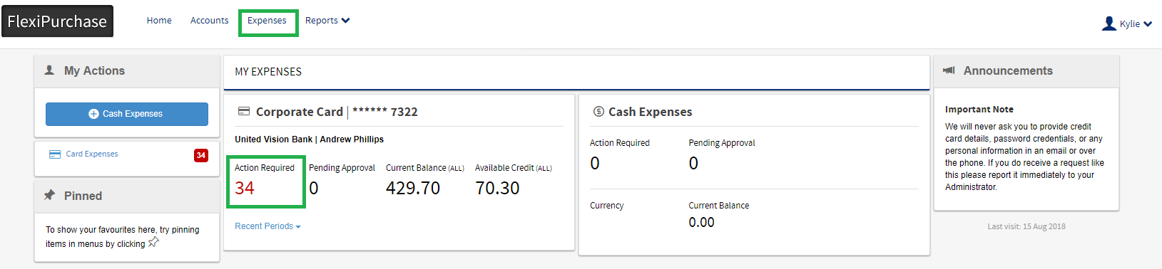

Note: By default, the system will display only transactions that require your action. However, you can change the filter to view transactions that have been completed or waiting for approval as per the screenshot below

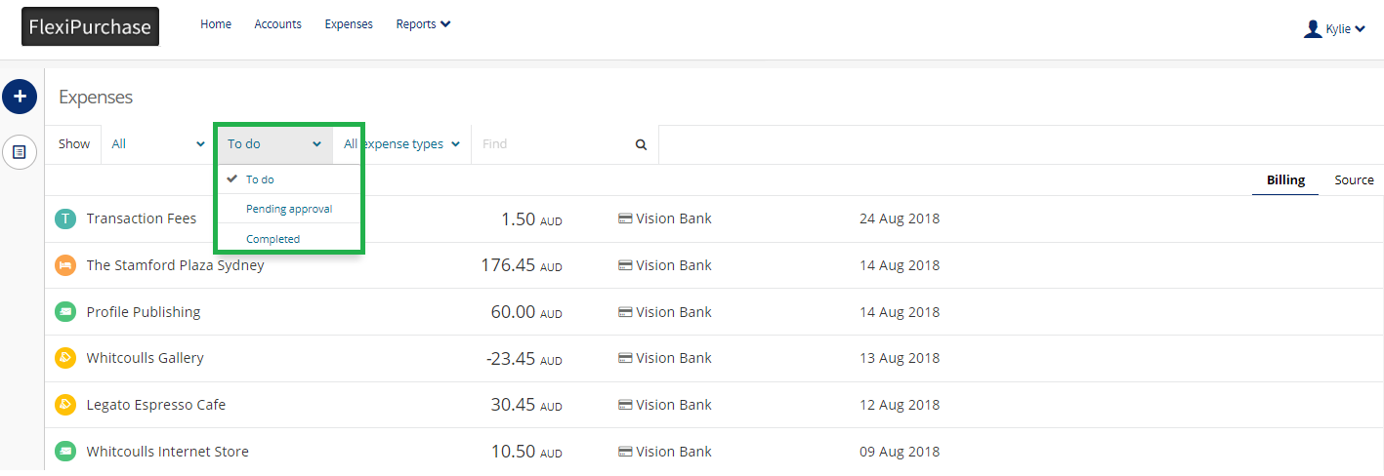

Step 2: Click on a transaction that you want to code on the screen. This opens the Transaction: Details window

The transactions are loaded daily into FlexiPurchase so generally they will appear within a day or two of spending.

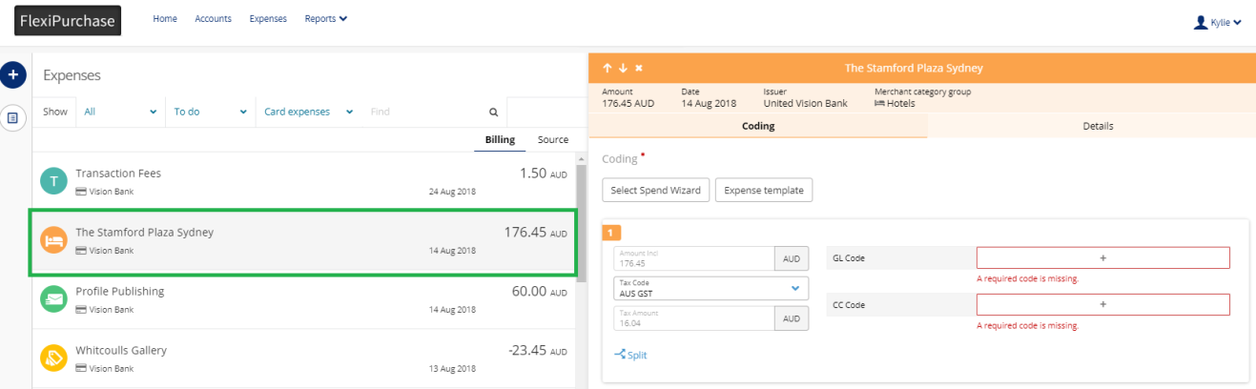

Step 3: Click on the Select Spend Wizard button. (The Spend Wizards are configured to assist with the coding process and default some or all of the required Financial Codes.)

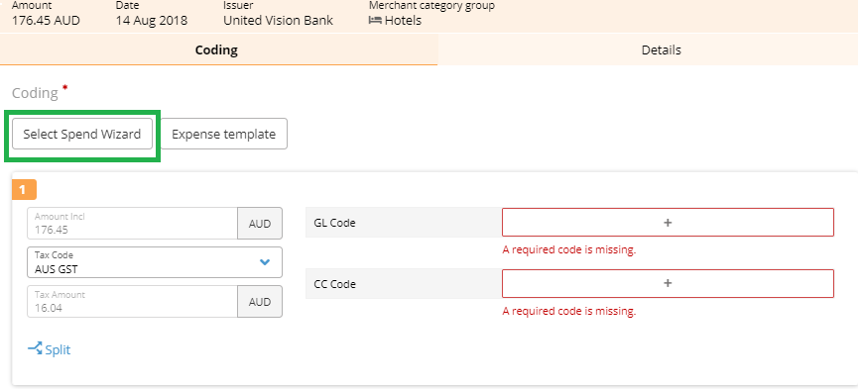


Note: You can search by keywords to display the Spend Wizard that relates to the expense category of your transaction. Click on the expense spend wizard to display the Allocation section.

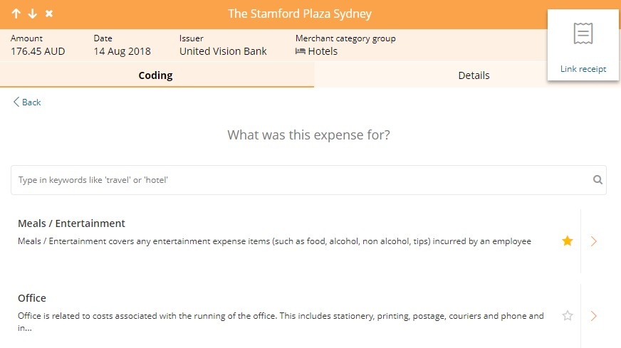

Note: Commonly used Spend Wizards can be added as a favourite by selecting the star symbol. This will always display the stared Spend Wizard/s at the top of the list.

Step 4 Click on the appropriate Spend Wizard

Step 5. To allocate the balance to the appropriate expense type/field, click on “Allocate remaining balance”
Note: You can also split the transaction across multiple expense types by manually entering the amounts in the respective fields of the Spend Wizard

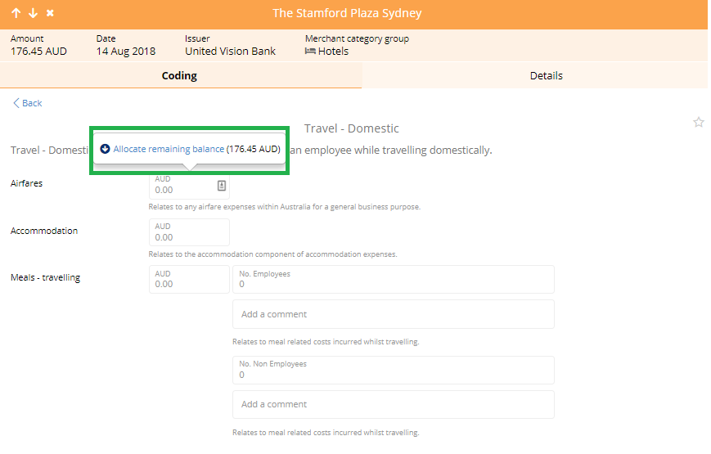
Note : If you choose to split the transaction amount across employees and non employees then, using the Meals/Entertainment Spend Wizard as an example, you would need to indicate how many of each type there was.

Step 6 Select Next

Note: The GL codes should pre-populate from Spend Wizard

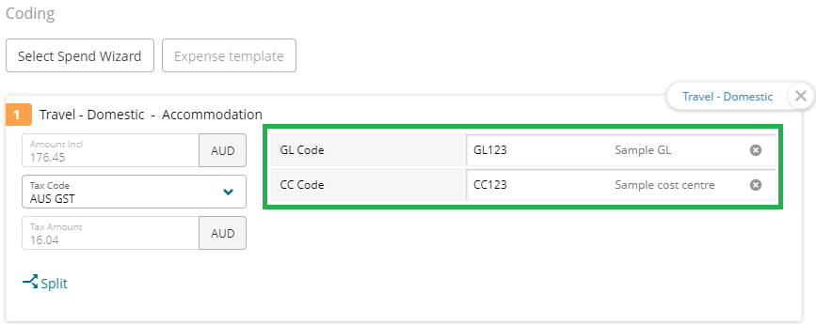

Step 7 Attach an image of your Tax Invoice by selecting the Link Receipt and then Image Library (This is mandatory)

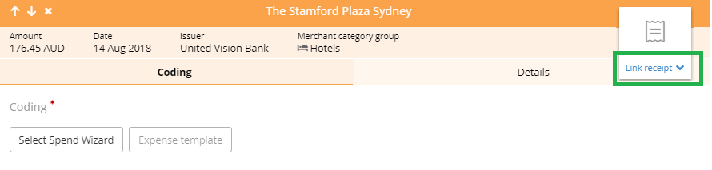

  - The image library stores all your purchase documents (e.g. receipts, invoices). An image is uploaded by:
    - Taking a photo with the mobile app when you incur the expense
    - Dragging and dropping an image from your desktop into the image library.
    - Pressing the Upload button
    - Sending an image to your unique email address by pressing the Upload via Email
button

Step 8. To apply an image(s) to a transaction click on the image and select the Link button. You can view all linked images by pressing the Linked Images button on the top of the screen.

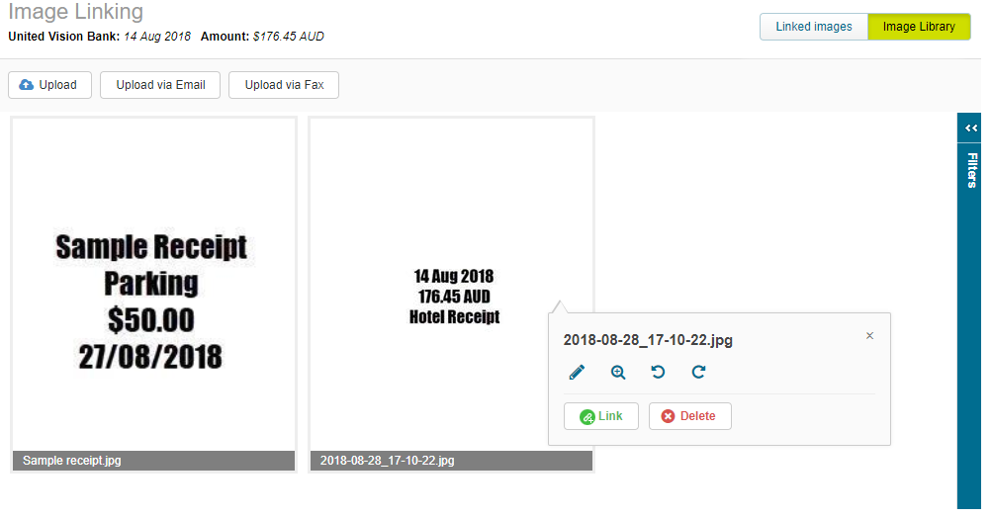
Step 9 In the Expense Description field enter a detail, description or comment for the expense.

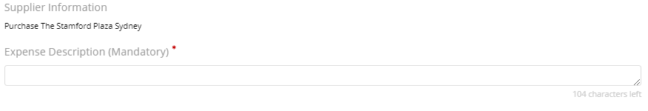

Before completing your transaction coding, it is recommended that you review the summary of the Spend Wizard, amount, tax code and coding applied to ensure that you have entered the appropriate information – completed screen should appear like below screen.

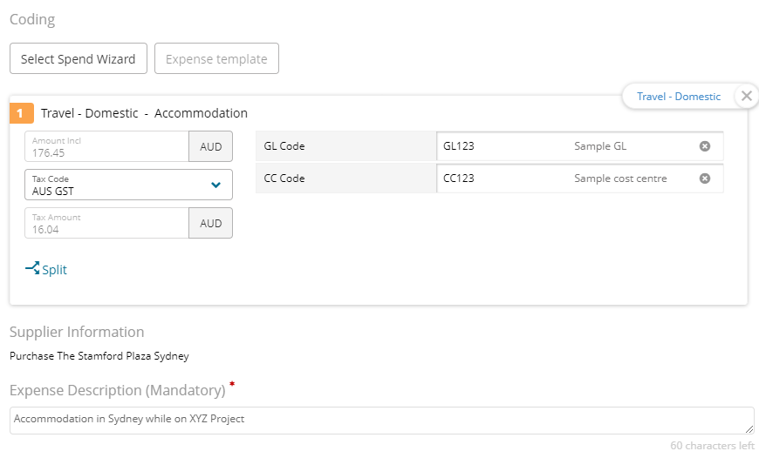
Step 10 Select Complete.
Note: You have successfully coded your expense! The transaction will now move from the To Do list to Completed or Pending Approvals

Other Coding Scenarios

  - Searching for Codes
If a charge code has not defaulted from the Spend Wizard or your individual profile it can be added or changed via the transaction details screen. Missing mandatory codes will be highlighted in red and the code can be selected by clicking on the + button

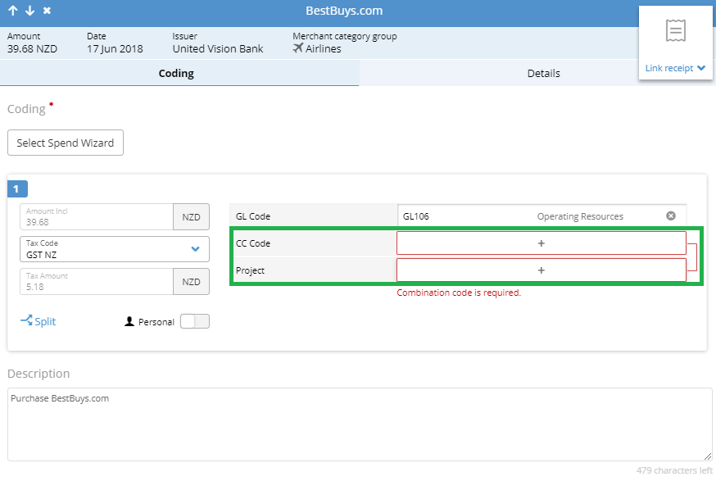
When the (“+”) button is pressed, codes set as favourites will appear in the drop-down box. You can select the code that needs to be used for the transaction from the list. Favourite codes are denoted by a solid . A favourite can be removed from the list by clicking the star. It doesn’t disappear immediately – in case you change your mind – but it will not be listed next time the list is accessed.

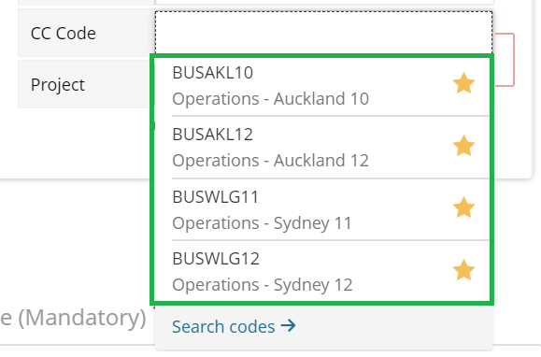

If the desired code is not listed as a favourite simply click the Search Codes button. The Search codes pane displays the first 60 valid codes. To view other codes that are not listed, enter the search criteria in the Code value and/or Description fields. Both fields accept the “%” wildcard. The % sign allows users to search using part of the description or code value.

Three options are displayed when clicking on code:
Select – This adds the code to the coding field and closes the Search codes pane.
Favourite /Un-favourite – This is to mark the code as a favourite, or if it is already a favourite it will un-favourites the code.

Info – This displays additional description for the code and lists any code manager(s) set against the code by an administrator. When additional information is displayed, re-clicking Info hides the information

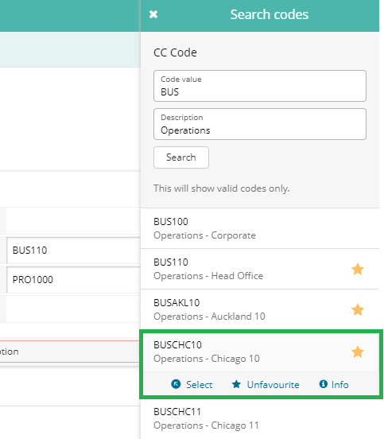

  - Removing an allocated code

To remove a code, click on the .

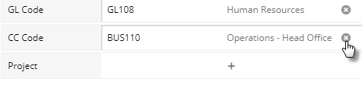

Note: Some fields may automatically contain values based on default coding and may not be available for editing.

4.3 FBT related expenses
For Fringe Benefits Tax (FBT) purposes, you need to split entertainment related transactions between multiple categories such as Employees and Non-Employees and you may also need to provide participant details. The process is as follows:

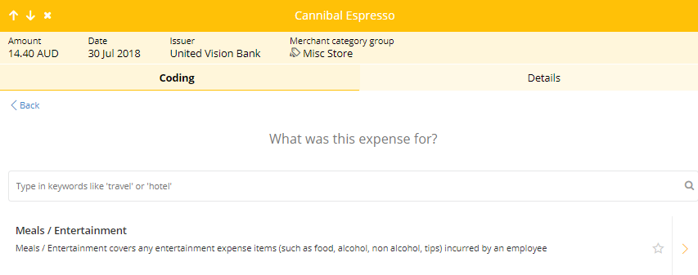
Follow the same process as described in “Coding a Transaction” and select the Meal Entertainment Spend Wizard.

- In the respective fields, enter the number of participants involved in the transaction.
Enter the names of the individuals.

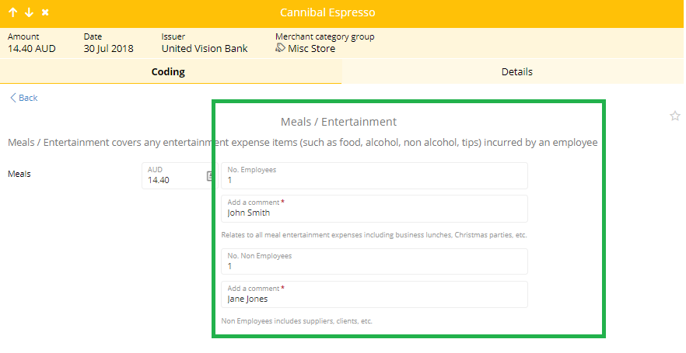

On the coding screen the transaction can be split into two lines as employee and non-employee – (non-employee is not-FBT)

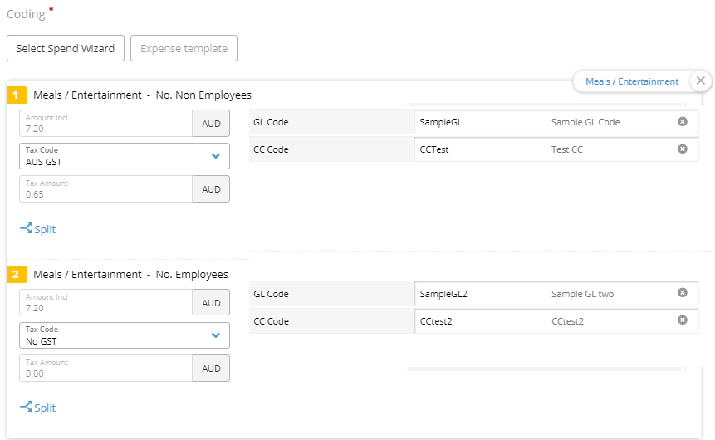

4.4 Splitting transactions GST/Non GST

A transaction can be easily split by selecting the Split option on the coding screen. You can choose to split the transaction evenly or chose your own split percentages.
Select Split once ready.

Once the transaction has been split you will be able to apply different tax codes and charge codes to each line. Where a transaction has an odd amount of GST then type in the amount that has no GST in a separate line. Then choose No GST.

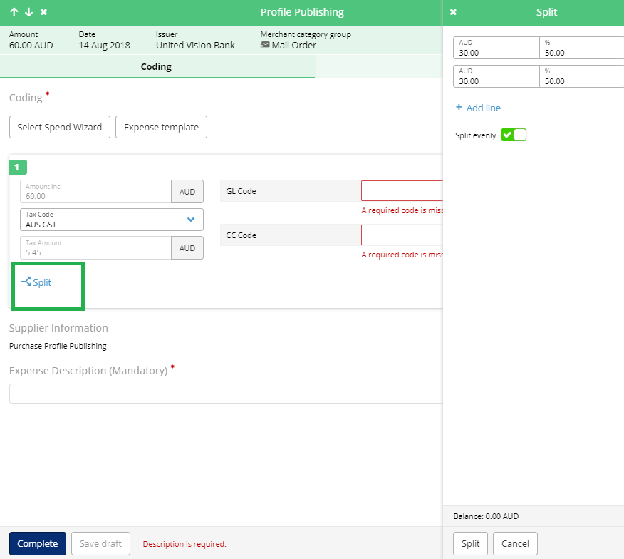

- Other Actions
Under the Options button on the coding screen you are able to:
- Go to the Advanced coding area for the transaction
- Dispute a transaction
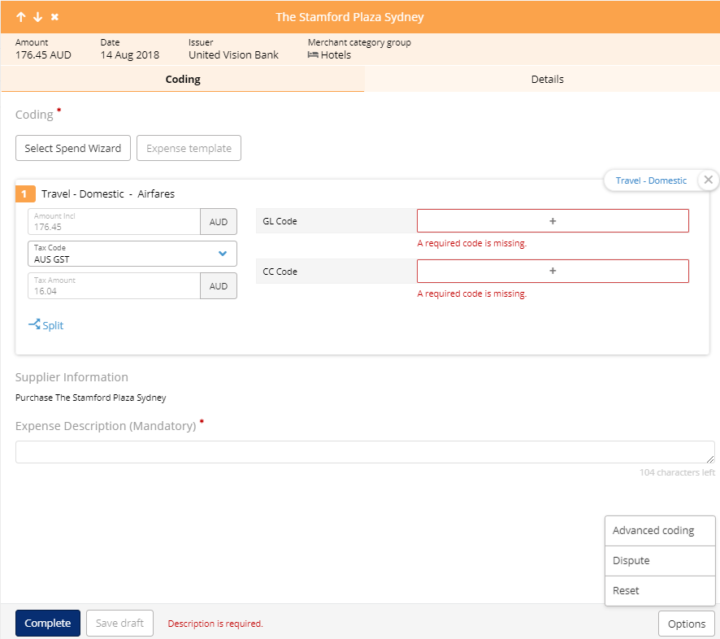
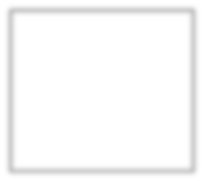
- Reset the transaction

5.1 Advanced Coding

The advanced coding option will take you to the old coding flow. These screens will allow you to view Approval details on the transaction such as which approver the transaction is sitting with under the Approvals Tab.

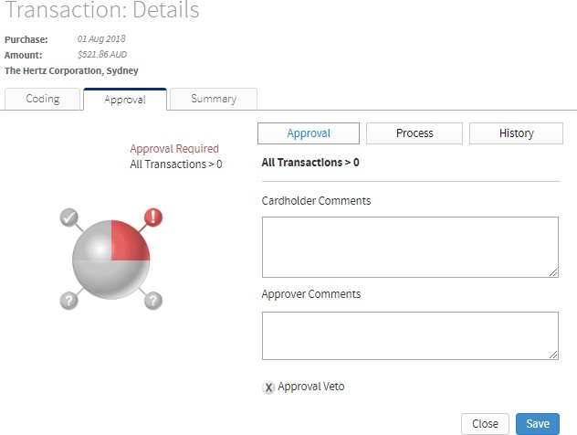

5.2 Disputing a transaction
If you think your card has been charged incorrectly select Dispute. This option will allow you to mark the transaction as disputed in FlexiPurchase, however you must separately lodge a dispute for the transaction directly with the bank.
To do this:
- Select the dispute button under options
- Read the instructions and select Dispute at the bottom of the page

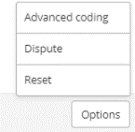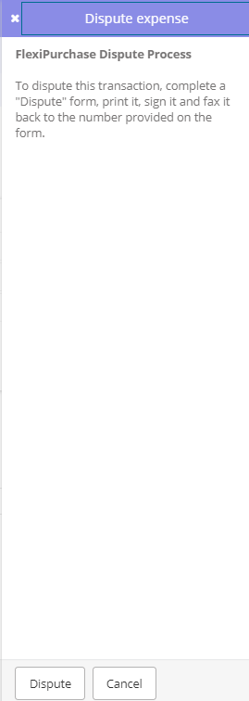

Follow the instructions on the dispute form and email it to the NAB disputes team for processing.

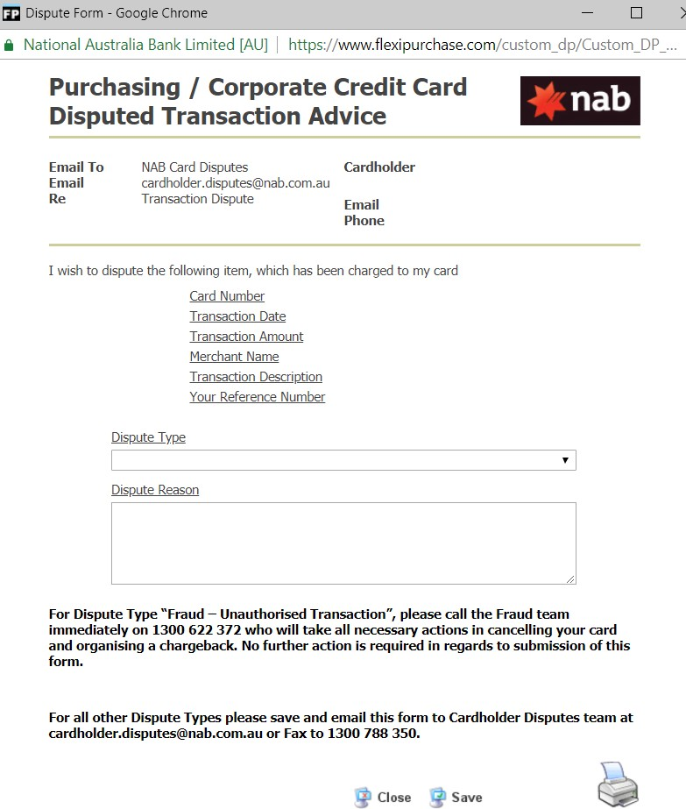

  - Resetting a transaction
The reset function:
- Removes any Spend Wizards the user applied
- Removes any codes the user added but leaves any default codes
- Removes any descriptions the user added
- Leaves any receipts or files the user attached.

  - Delegated accounts

If you are a delegate to another cardholder, you can now view the DELEGATED ACCOUNTS widget on the Home screen. Clicking Account tab takes to the Accounts screen and opens the relevant delegated account.

Delegated users can view account details for other users
- Current period or older statement periods.
- Latest expenses - are displayed when the Current Period is selected, including credit limit, balances and the option to download statements.
- Statement periods provide historical details for the account, including all transactions and bank-provided statements.
- For cards that have recently closed or expired, can still access the recent historic statement periods from the drop-down list.

Note: There is no way to access delegated cash or card expenses directly from the Home screen.

CARD

Cardholder guid

