Making Purchase Order and Invoice Enquiries in Computron G2 Portal
(as at 25/10/2019)

Once you have logged into the Computron G2 portal use the following steps to check if a purchase order has been paid or to see when it is scheduled to be paid:

- Click on Computron Webdesk from the Computron G2 portal main menu.

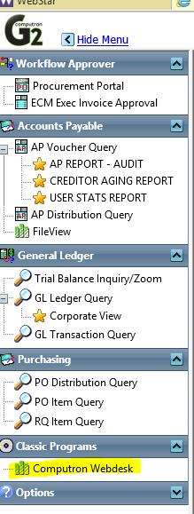

- Select General Ledger.
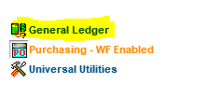
- From the Start Menu select Trial Balance & Ledger Reports.
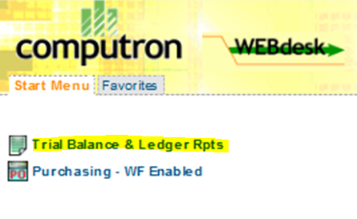
- Select Purchasing Zoom Enquiry for purchase order enquiries or Accounts Payable Zoom inquiry for invoice enquiries.
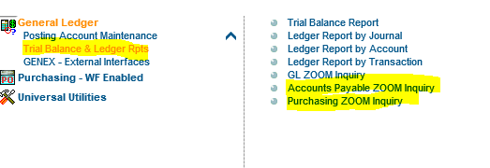

Making Purchase Order Enquiries using Purchasing ZOOM Inquiry

When you select Purchasing ZOOM Inquiry from the Trial Balance & Ledger Rerports menu (previous page), you will see the screen below

- Press the Continue button.
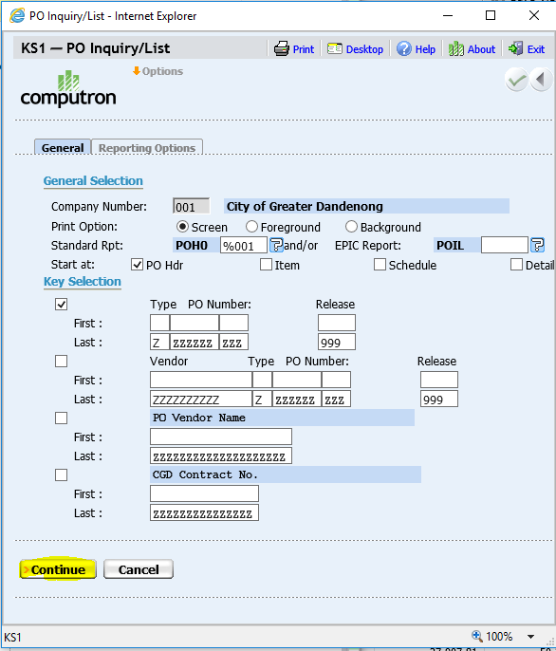
- If you know any of the following details enter them in the appropriate fields and press the Continue button. Leaving this screen blank will enable you to search by PO number.

Note: Entering buyer code will display only your PO’s.
Entering vendor code will display your PO’s for that vendor only.
Use From/To Order Date fields to see only PO’s raised in that date range.
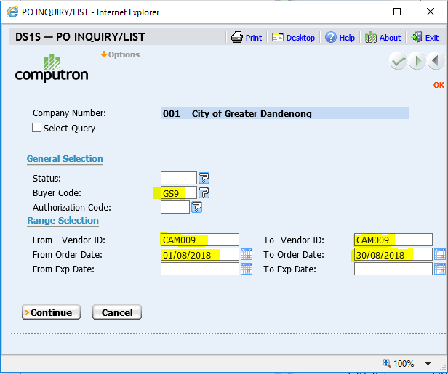

- In the PO Header Inquiry/List screen click on Database Reselect tab.
- Enter the PO number and press the Fetch button.
- Note: If your purchase order has been approved it will have the CLSD status.
If there is an amount specified in the Invoiced Amount column it means that Invoices have been applied to this purchase order.
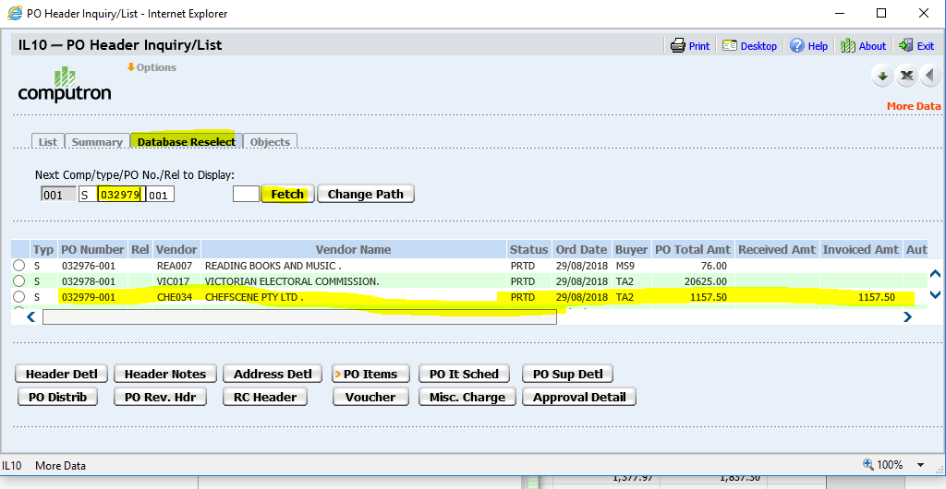
- Click the Voucher button to see all the info on the voucher.
Note: If the status is open the invoice has not been paid (see scheduled pay date).
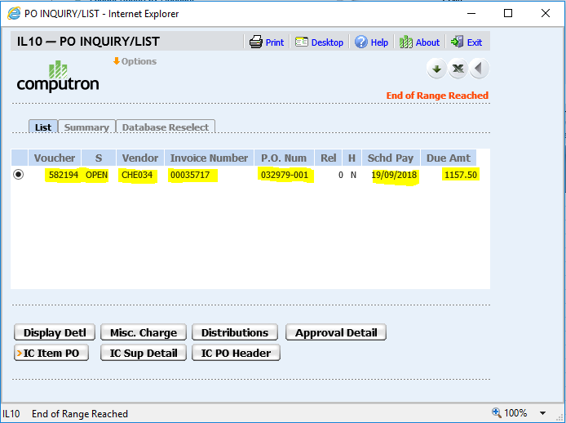
Note: If a voucher has been paid the status will be closed and the scheduled pay date will be in the past.
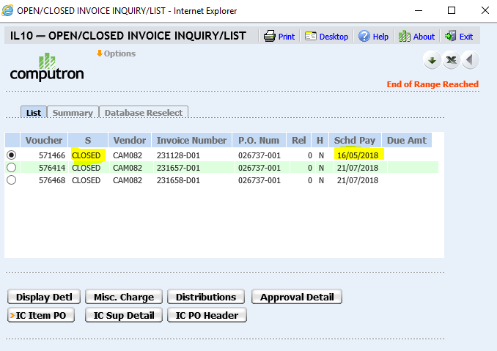
- Click on Approval Detail button to see the approver and the approval process.
- Use the Workflow Activity Log and Workflow Notes buttons to see any the history and any notes on this voucher. Press the Display Image button to see the document.
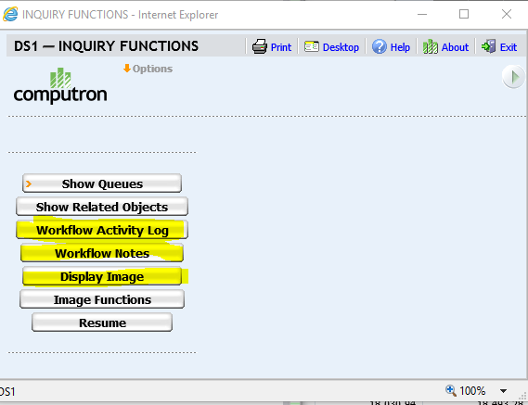
- At the Workflow Activity Log screen below, press the Cancel button to go back to the previous menu.
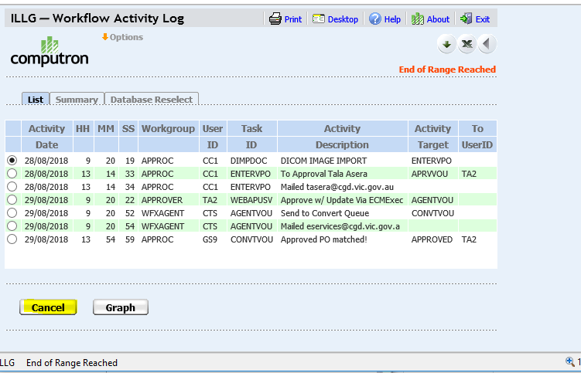
- Press the Resume button to go back to the previous menu.
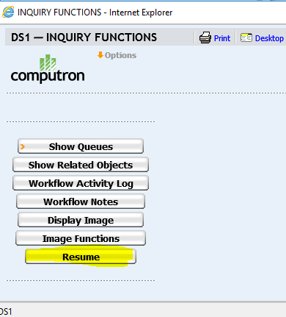
- Use the Back button repeatedly to go back to the main menu.
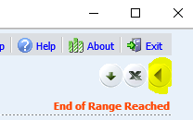

G2 Invoice Enquiries

- Click on G2 Icon in Webstar.

- Once in G2 Click on Computron Webdesk
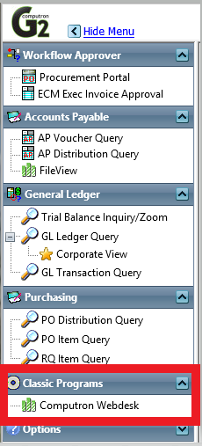

- On next screen click on Trial Balance & Ledger Rpts an then Accounts Payable Zoom Inquiry
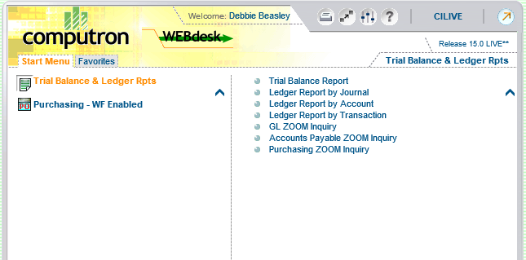
- On screen below enter vendor ID EFC001 for refunds or search by options below always include history and choose Continue
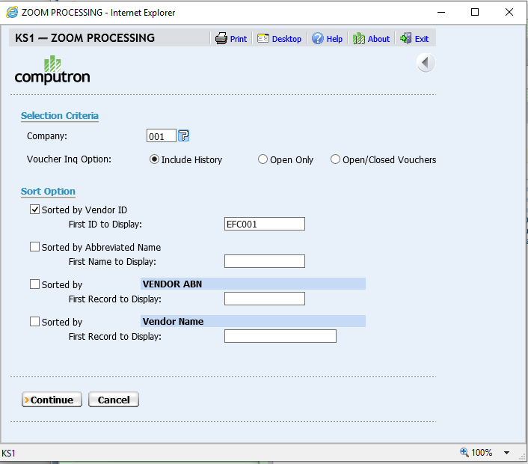

- Click on Vendor Line to view vouchers
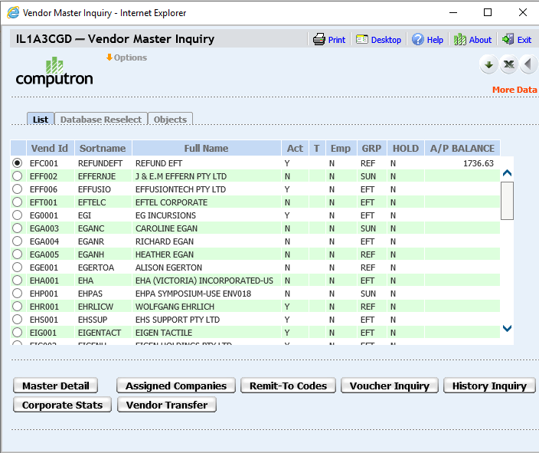
- To search for a voucher click on Database Reselect and enter the invoice number(or part of) and select Fetch
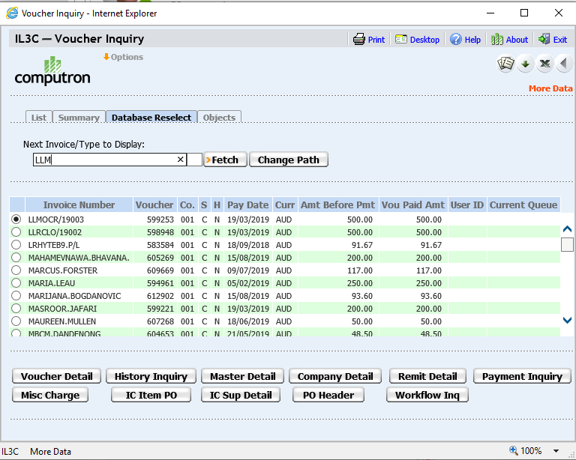

For payment enquiries, select voucher in question. If there is no amount in the paid Amount Column (highlighted in red), it is not Paid. The pay date is when it will be paid.

- If there is an amount in the Paid Column, the invoice has been paid. Click on Payment Inquiry to see how it was paid. ie CCK or EFT
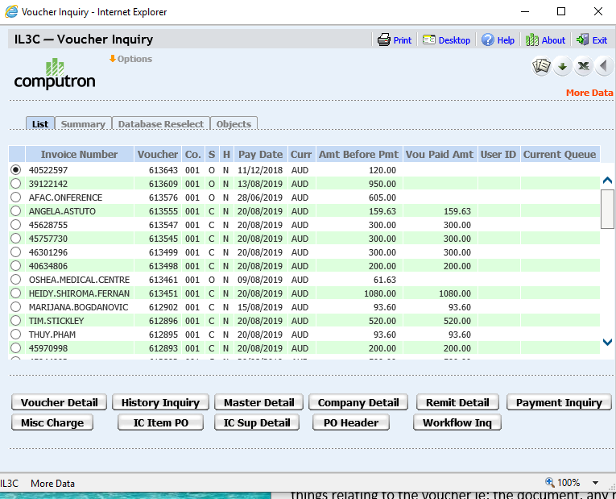

- Payment Enquiry screen will show you the cheque number if paid by cheque, you can then click on Check Reconciliation to see when the cheque was cashed
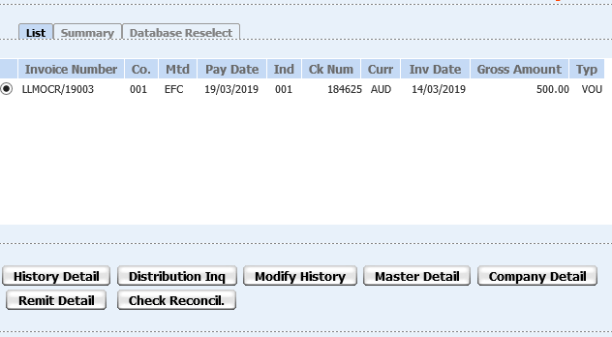
Below shows status of cheque and date it was cashed
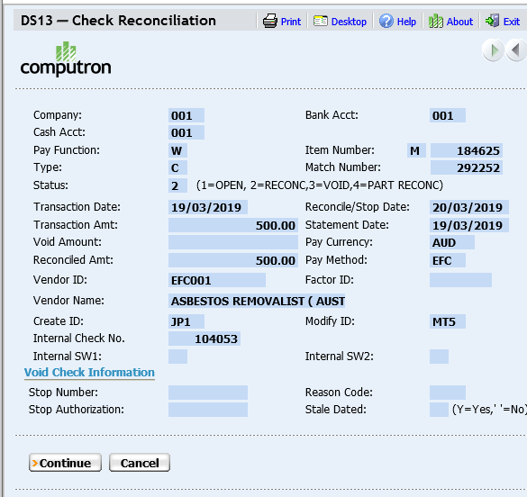

Once the selected voucher comes up you can click on Workflow Inquiry and see different things relating to the voucher ie; the document, any notes and the process of the voucher
You can click on any of the below you can’t make any changes or break anything these are only enquiry screens
- To go back click on Resume

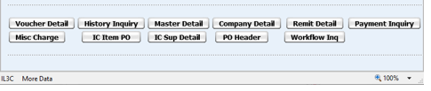
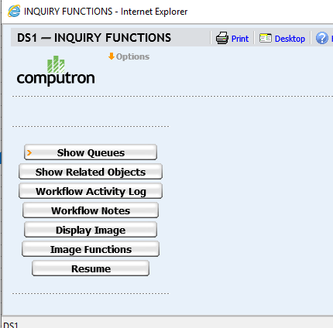

- To go back on any other screens click on arrow back

