Overview  More White Space  Objective ECM 10.4.2.0 comes with a lot more white space which makes for a cleaner and simpler interface. Add more columns in this space by following the steps below.  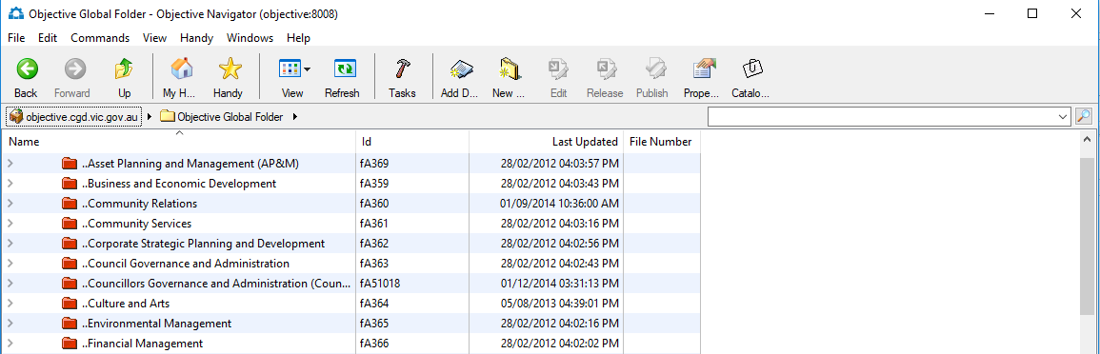  - Click on View in the command menus and select Show Columns.  - Scroll down to and select the Email Sender field in Available Fields.  - Press the Add button to add the field to Fields Displayed.  - Select the Email Received on Time field from Available fields.  - Press the Add button to add the field to Fields Displayed and press the OK button.  The new fields will make it easier to work with emails in Objective.  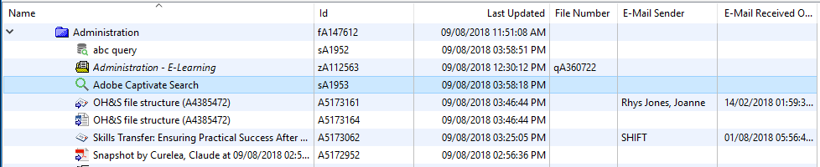  New Icons  Saved Searches and Saved Queries are now represented by new icons. | Searching  Easy Search is now called Search and Advanced Search is now called Query.  To Run a Search  - Click the Find icon to open the Find Objects window.  - Press the Switch to Search button if it is visible (if you see the Switch to Query button it means you are already in Search, so go to step 3).  - Enter your search words in the Search for the following words and phrases field.  - Press the Get Results icon. Your results will now be displayed.  - Use the icon to narrow your results down by a category or the icon to exclude a category from the search results.  - If you have selected any categories using the icons in step 5, they can be removed by using the icon.  To Run a Query  - Click the Find icon to open the Find Objects window.  - Press the Switch to Query button if it is visible (if you see the Switch to Save button it means you are already in Query, so go to step 3).  - Press the Edit button and using the button to select an object type such as documents or email messages.  - Click the Add button to include the object type in the query or use the Remove button to remove the object type from the query. Press OK.  - Click the Show text search box if you are searching for words and phrases.  - Enter search word(s) in Search for the following words and phrases field  - Click the Results should satisfy the following properties checkbox.  - Click the button and select from common, system or category fields.  - Use the button to add additional properties to the query.  - Press the Get Results button to run the query.

