Objective ECM 10.4.2.0 User Training Manual

August 2018

Contents
1. Introduction to Objective 4
What is Information Management? 4
What is Objective? 4
Logging In 5
Navigation 6
Overview 6
Definitions 7
Exploring Objective 9
Colour Coding 10
Handy Features 13
Overview 13
Why use Aliases? 13
Finding an Original Object from an Alias 17
Manage Objects using Aliases 18
Add to Handy 20
The Handy Folder 21
Working with Columns 22
Display Additional Columns 22
2. Working with Objects 25
Overview 25
Object Types 25
Object Properties 26
Metadata 26
Working with Folders 35
Overview 35
Privileges 36
Overview 36
What are Privileges? 36
Types of Privileges 36
Object Privileges 37
Working with Files 38
File Creation Requests 38
Overview 38
New File Requests 38
File Naming Conventions 38
Working with Documents 41
Overview 41
Creating New Documents 41
Adding Documents 43
Overview 43
Adding Documents 43
Document Status 47
Open a Document 48
Edit a Document 49
Publish a Document 49
Adding Notes 50
Documents Being Edited, Documents Awaiting Approval, Recent Documents 51
Editing Documents 53
Release a Draft 55
Release as Published 56
Version Management 57
Overview 57
Document Properties 57
Documents Audits 57
Document Versions 59
Restore a Version 60
Using a Template 62
3. Searching Objective 66
Overview 66
Search Types 66
The Find Objects Window 67
Search Results 72
Saving Search and Query Results 73
Snapshot (only available in Query) 74
Creating Links 77
4. Microsoft Outlook and Objective 79
Overview 79
Accessing Objective from Outlook 80
Adding an Email to Objective 81
Adding Multiple Emails to Objective 82
Opening Stored Email 83
Send Object via Email 84
Email a Reference to an Object 84
5. Appendix A: Icons and Shortcuts 86
Objective Icons 86
Mouse Shortcuts 87
Keyboard Shortcuts 88
Action Shortcuts 90
Folder shortcuts 91
6. Appendix B: Automatically Adding Emails to Objective 93

Introduction to Objective

What is Information Management?
An organisation’s information is derived from many sources. For example, existing documents, legacy information and correspondence. Information forms an organisation’s most valuable asset. Electronic document management and records management are two components of managing an organisation’s information.

What is Objective?
Objective is an Electronic Document & Records Management System (EDRMS) developed for Greater Dandenong Council, which provides a structured method for storing, organising and locating electronic information. When information is managed efficiently, many challenges associated with large volumes of information can be overcome. For example:
The latest information is always available;
- Access can be controlled and monitored;
- Changes to information are recorded;
- Information can be shared; and
- Information is easy to find.
Objective stores information in a database on a central server where information is kept current, protected and accessible. Storable information includes documents, folders and files.

Logging In
End users with permission to access information stored within Objective can log on via the link installed on their computer.
End users can view and access objects stored within Objective hierarchy depending on their level of security access. By using a range of menus, commands and navigation techniques, you can move around the hierarchy and access information.
Objective users functionality similar to Microsoft Windows Explorer including a combination of drop-down menus and pop-up (or right click) menus to provide access to commands such as create, open, copy and delete.
The Objective Global Folder is the main system folder. It is the starting point for the Objective folder hierarchy. All folders branch from this main folder. The Home Folder (also known as the Special Folder) is your personal workspace. Only you and the system administrator can see the contents of this folder.

Logging In
Double-Click Objective Navigator Icon on your desktop. You will not need to enter a login and password as Objective will use your Windows logon password to authenticate your login.

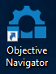
Objective Shortcut
The Objective Navigator will open at the first screenshot on the next page of this manual.
If you have difficulty logging in, contact IT Help on x5102 for assistance.

Navigation

Overview
Objective uses a logical structure to organise the contents of the system in the same manner as Microsoft Windows Explorer. Items stored in Objective are referred to as ‘objects’. Once logged in you will be presented with the screen depicted below.
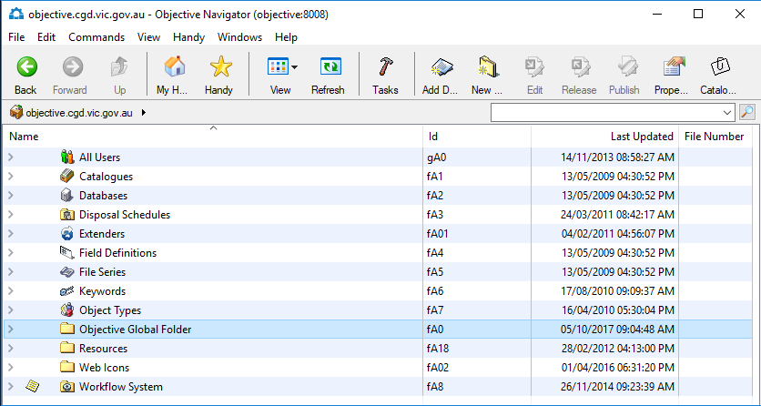
Double-click the Objective Global folder to be directed to the CGD folder structure
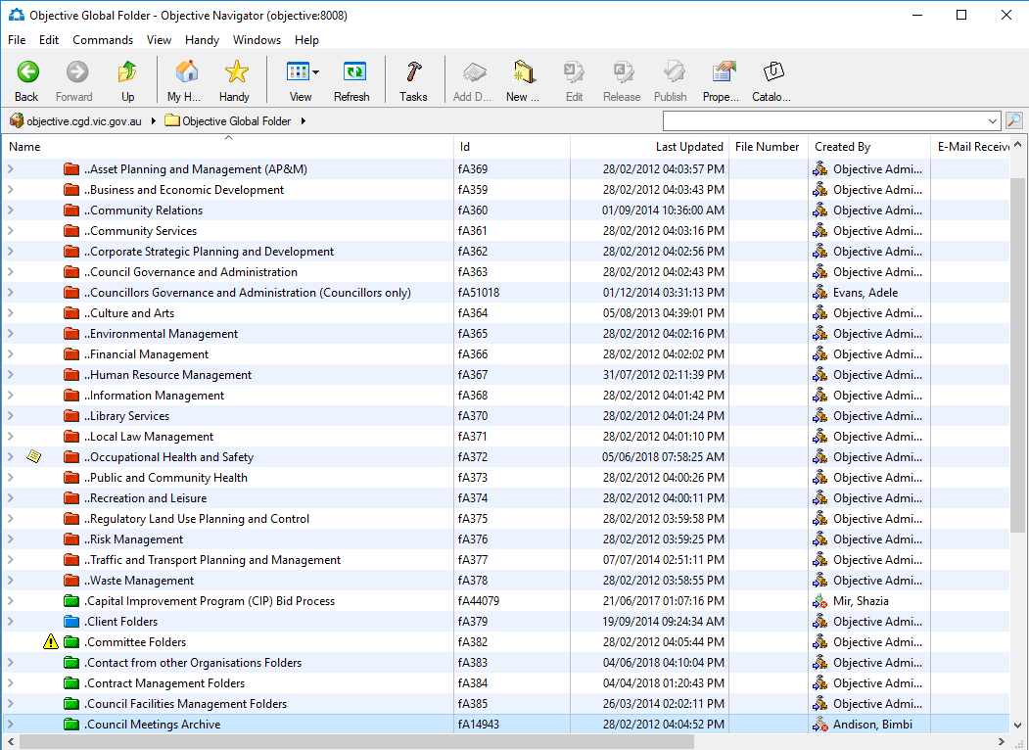
The Objective Global Folder

Definitions
Folder Hierarchy – a logical structure which displays the organisation of folders, files and documents. This structure is based on the Public Records Office of Victoria (PROV) best practice Recordkeeping standards and guidelines for Local Government.
Breadcrumb trail – represents the series of folders that lead to your current location in much the same way as a file path does in Microsoft Windows applications.

Folder Hierarchy
Folder Hierarchy
Drop down menus – when opened, display comments and functions.
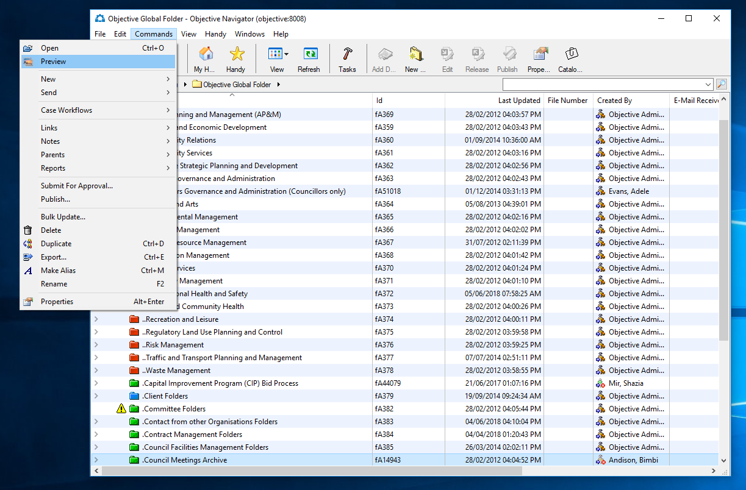

Tool bar buttons – to access key commands and navigation functions.
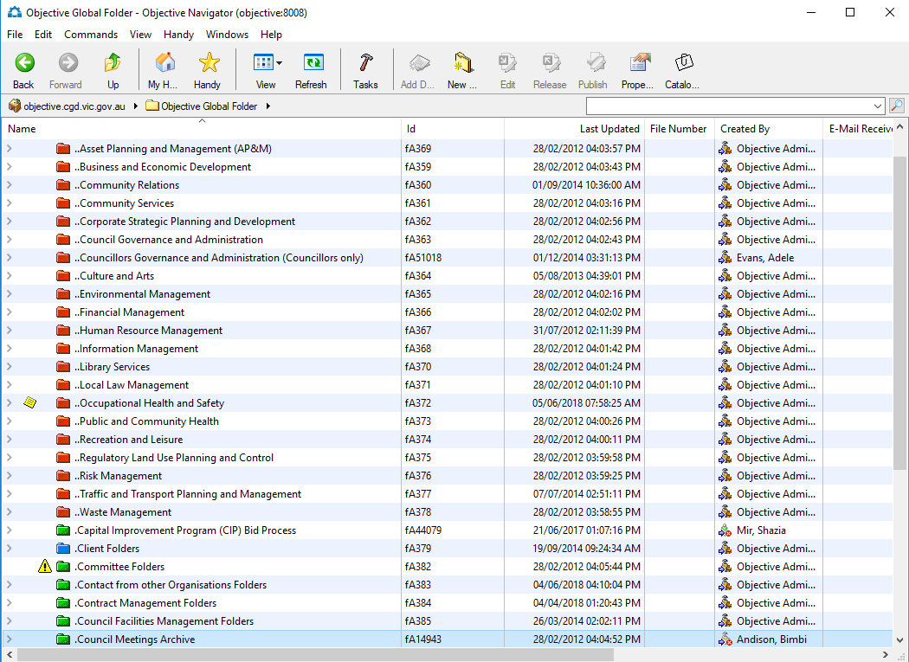

Exploring Objective
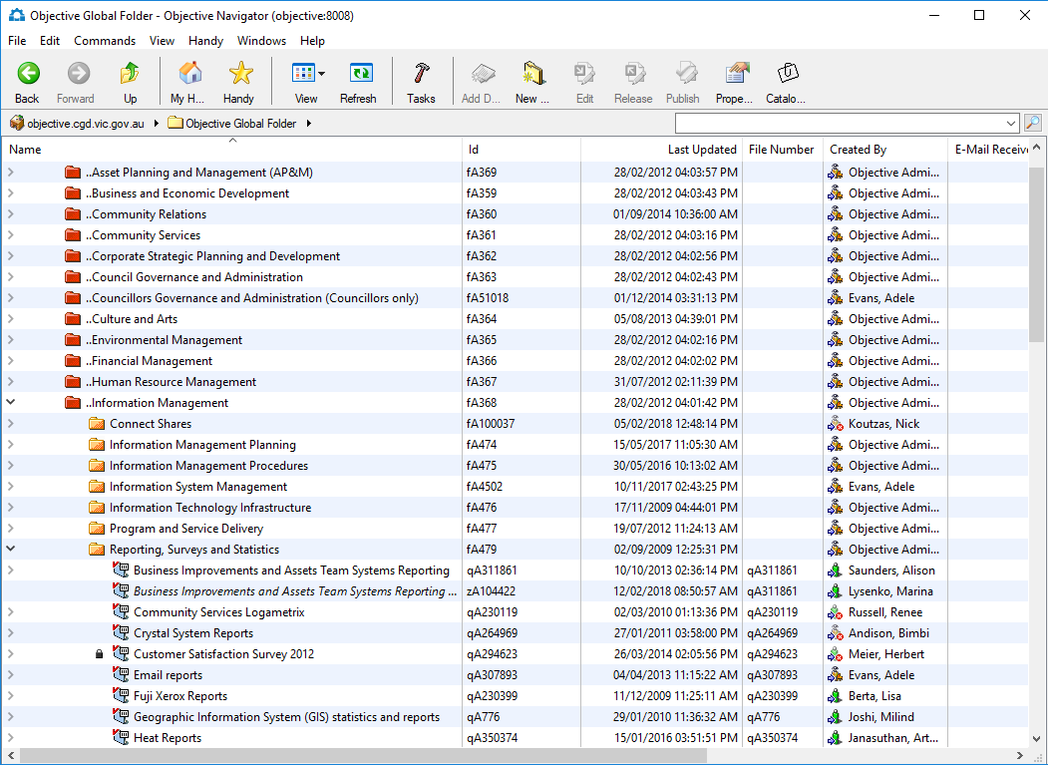
Sample of folder structure

EXERCISE Navigate the Folder Structure
Click a reveal triangle to expand and collapse the structure.
- Double-click a folder name to open that folder in a new window.
- Click a Breadcrumb button to navigate to that location within the current window.
- Hold down CTRL while clicking a Breadcrumb button to open the location in a new window.
- Click the double headed arrow to list hidden items. The double headed arrow indicates there are more items available on the breadcrumb trail.

Colour Coding

Red Folders are Function folders; Activity folders can be created within these folders.

Amber (yellow) Folders are Activity folders; only files can be created within these folders.

Green Folders are Global folders. Files can be created within these folders.

Files contain documents, spreadsheets, images etc. Documents can be created within or saved into files and file dividers.


File Dividers, allow for documents to be separated logically. File dividers contain documents, spreadsheets, images etc. Documents can be created within or saved into files and file dividers.
User Personal Folders are folders that can be created in a user’s home directory.

EXERCISE The Objective Menus
- Select the drop-down menus File, Edit, Commands, Handy and Windows to access menu options.
- Right-click on an object (folder, file or document) to open the Commands menu.
Note: Options on the right-click Commands menu will change depending on the context in which it is being used.
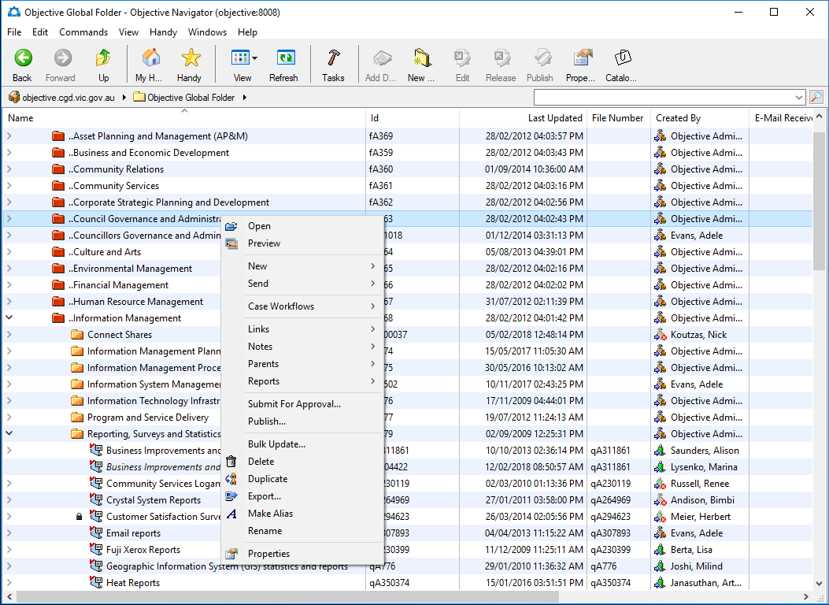
Commands Menu

EXERCISE Locate Your Home Folder
- Click on the Home tool bar button to view Your Name.
- Click a reveal triangle to expand and collapse the hierarchy. Within the Home Folder you will see the Special Folder which contains the following 2 Folders:
  - The Alert Folder is where you will store alerts that you may create.
  - The Handy Folder is where you will store frequently used templates or documents
Note: Your special folder will display your name.
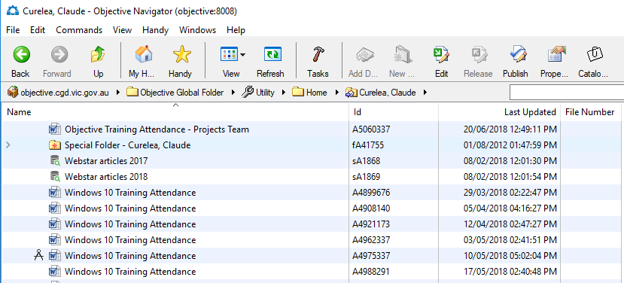
Home Folder Structure

Handy Features

Business Process:
You need to access the documents related to your event on a regular basis and want to save where you can get access to them quickly. You will save the search you have just created into your Handy.

Overview
Shortcuts or ‘pointers’ to frequently used documents, files or folders can be useful as more information is added to Objective and the folder structure grows. These ‘pointers’ are referred to as ‘aliases’. An alias can be created for any object you have the privileges to see.

Why use Aliases?
Creating a copy of a document, file or folder to provide easy access presents an issue when only one master copy should exist. Creating an alias to the object and placing the alias in a convenient location is a better solution for the following reasons:
An alias is a ‘pointer’ to the original object
- Multiple aliases can be created for an object
- Aliases provide easy access to objects within the folder structure
- The original object can be moved or renamed without affecting the alias
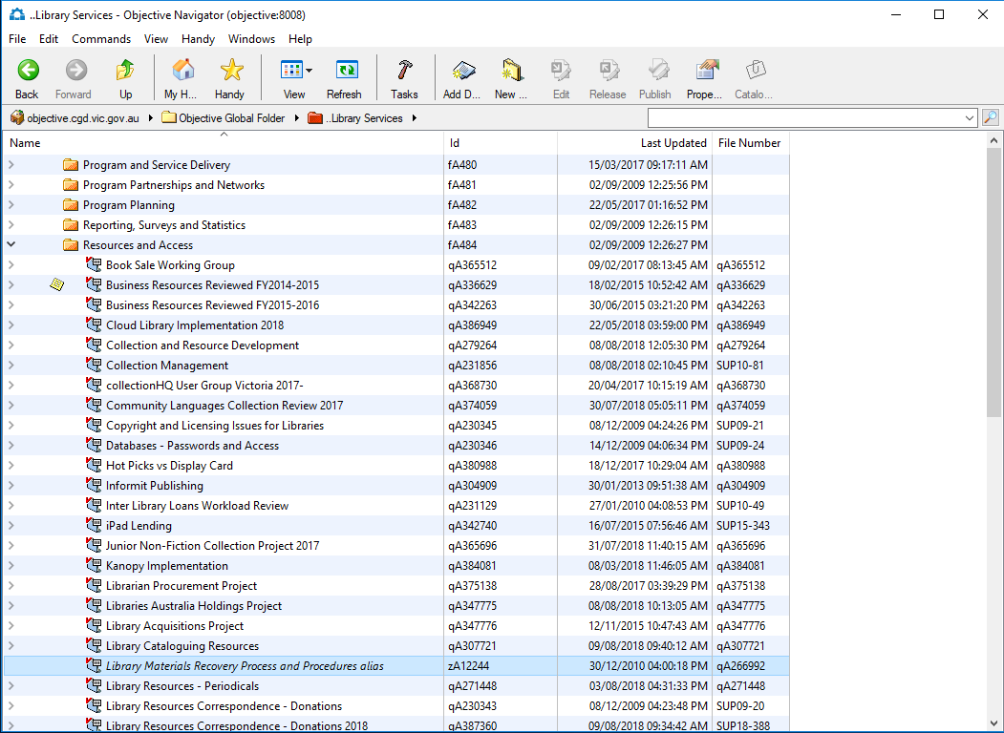
Alias in Global Folder
The alias in above screenshot points to the following file:
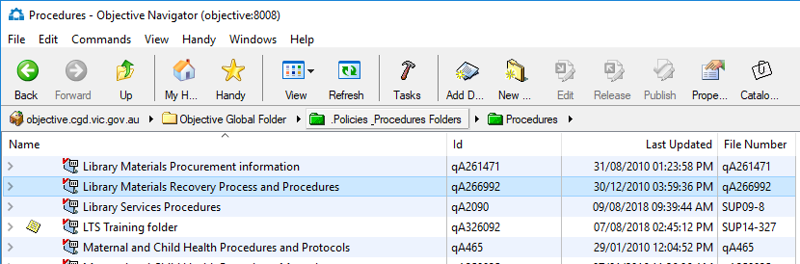
Original file in Global Folder

Note: You can double-click on the either the file or the alias to open the file.

Business Process:
Navigate to Community Relations > Event Management. Right click on the Agenda Train # Document, Select properties and Make Alias. Drag and Drop that Alias into your Handy. Right Click on the alias in your Handy and find Original

EXERCISE Create an Alias
  - Select an object
  - Right Mouse Click > Make Alias
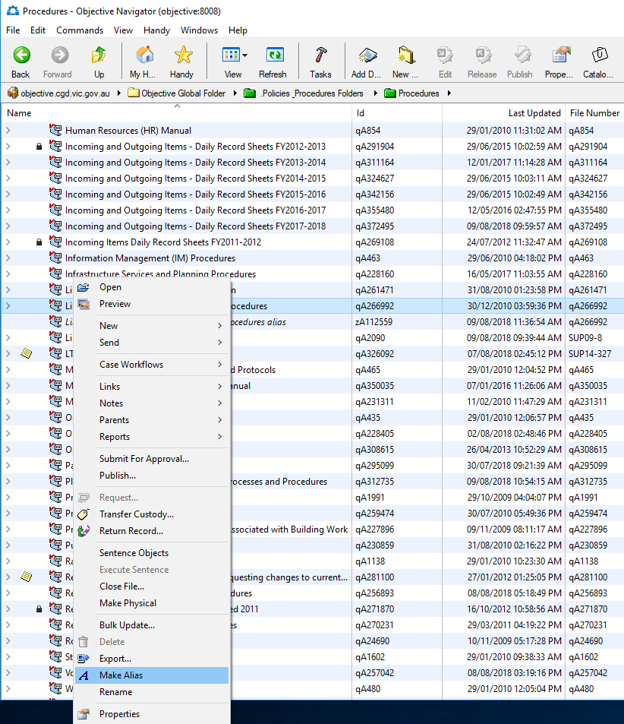
Create an Alias

Finding an Original Object from an Alias
To access the original object you can use the Find Original command

EXERCISE Find the Original Object
- Select an alias
- Select Right Mouse Click > Find Original
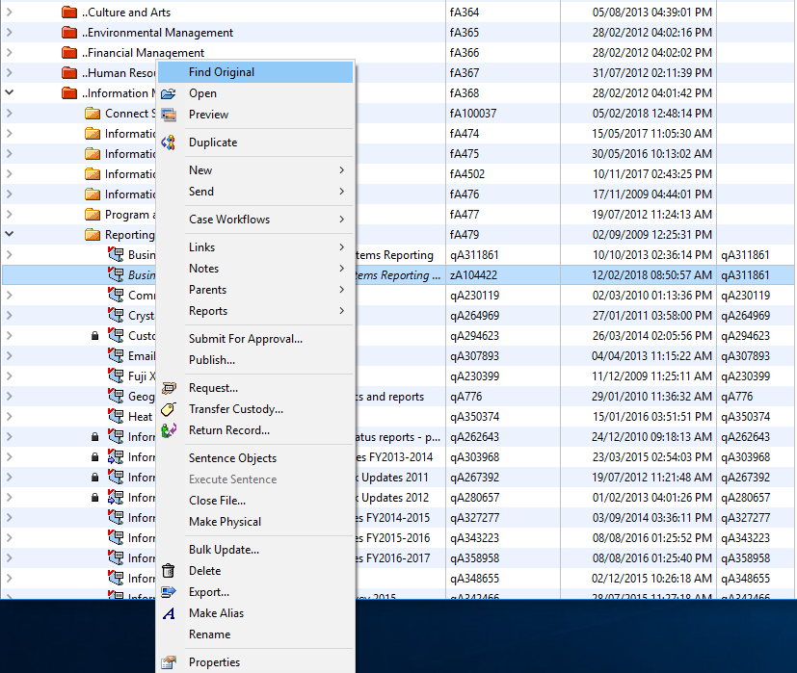
Find Original

Manage Objects using Aliases
Documents can be edited, released and published via their alias if appropriate privileges exist on the original object. An alias will show the same state as its original document object.
When an alias is deleted the original object remains intact. That is, the alias ‘pointer’ to the object is deleted rather than the object itself.
When the original object is marked for deletion (via the records management retention schedule) a warning displays advising that aliases exist. The alias icon changes to an  indicating the original object has been deleted and that the alias now points to a non-existent object.
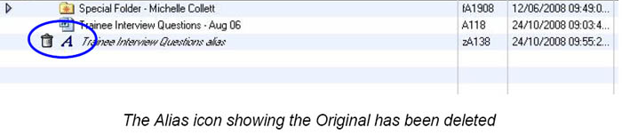

You can organise the aliases in your Handy by means of personal folders.

EXERCISE Creating Personal Folders in Handy
- Right-click on the Handy folder as seen below.
- Select New, New Folder from the right-click menu.
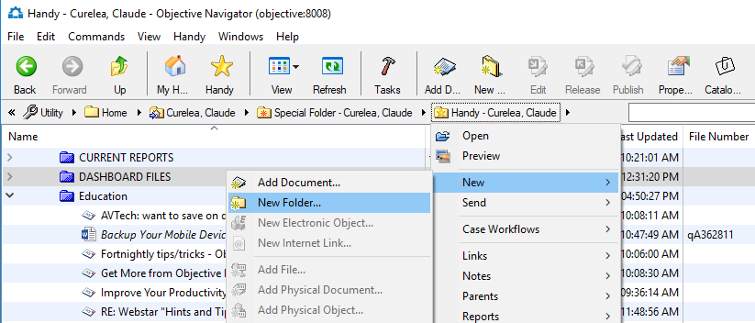
Right-click menu in Handy

- Provide a folder name in the dialog box below and click OK.
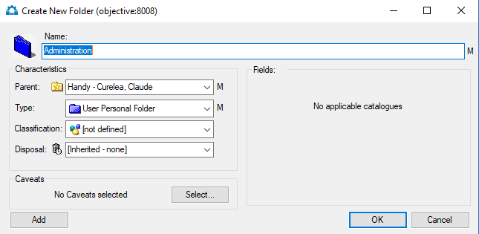

Add to Handy
An alias to an object can be created and moved to the Handy folder in one action. Objects in the Handy folder appear on the Handy menu as a convenient shortcut.

EXERCISE Add an Alias to Handy
- Select an object
- As seen below, Right Mouse Click > Send > Add to Handy to send an alias to your Handy Folder (menu)
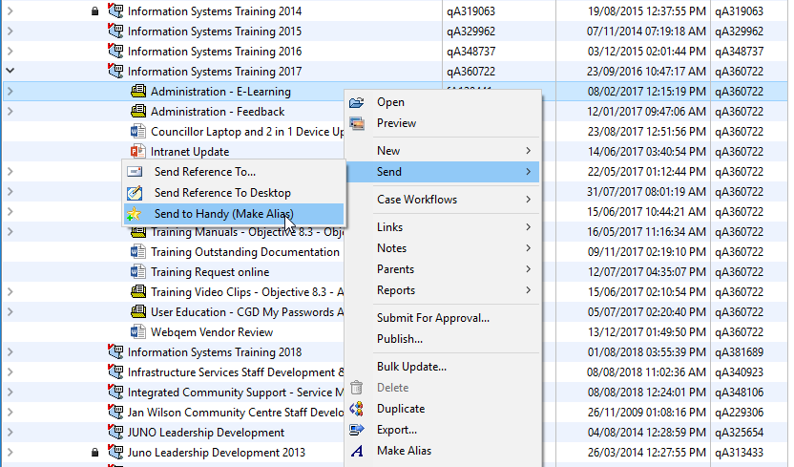
Tip: Select the Handy menu to view and access content added to it. Select Recent Documents to access document objects opened recently

The Handy Folder
Aliases added to Handy are stored within the Handy folder. The handy folder is a Special Folder in the Home folder.
The Templates sub-folder within the Handy Folder can be used to store aliases for templates in the hierarchy.
Place aliases in the Alerts sub-folder (within the Handy Folder) if you wish to be notified when an object is updated.

EXERCISE Access the Handy Folder
- Select the Handy button on the toolbar to open your handy folder
- Click on the reveal triangle to show the contents of the handy folder
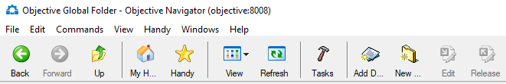
The Handy button
The Handy folder is located in the user Home location.
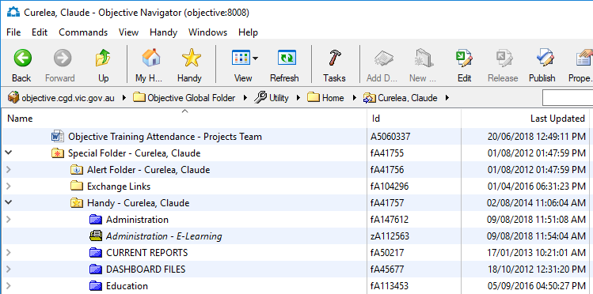
Home and Handy

Working with Columns

Display Additional Columns
Objective will display columns of information such as Name, Status and Last Updated. You can use the standard Windows features to resize and sort these columns. Columns can be added to display additional metadata. An effective place to apply additional columns is in the Find Objects windows.

EXERCISE Add and Reposition Columns
- Select View > Show Columns to open the Show Columns window
- Select a column to display from Available Fields
- Click Add to add the selected column to Fields Displayed
- Click Move Up or Move Down to position the column within the list
- Click OK to add the column to the display
Tip: Columns can be repositioned in a window by selecting the column header and dragging it to another position
Note: The field at the top of the Field Displayed list will be the first column in the Objective window.

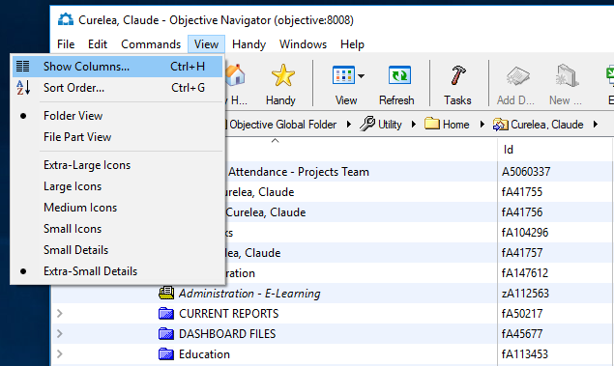
View Menu – Show Columns
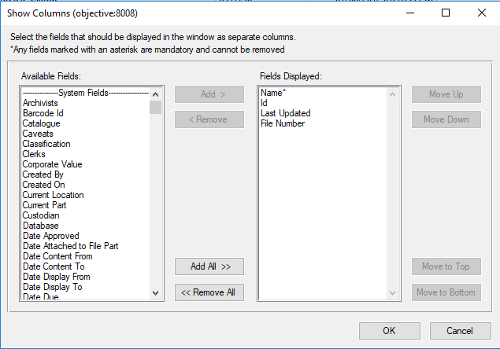
Show Columns Window

EXERCISE Managing Columns
- Click the column header to sort the hierarchy by that column value. For Example:
- Click Last Updated to sort objects by date
- Click Name to sort objects by name
- Select the column header to drag that column to another position
- Select the column header divider and drag to resize the column
Note: The symbol on a column header indicates the window’s current sort criteria. The symbol indicates the list is sorted in reverse order.
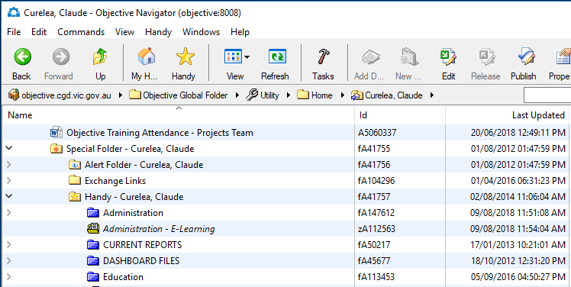
Columns Sorted by Name

Working with Objects

Overview
Objective stores all content in a central area for ease of access and security. Items stored within Objective are referred to as ‘objects’. Possible objects include documents, emails, drawings, spreadsheets or images. Objects have information recorded about them, such as date, time and size. This information is called ‘metadata’.

Object Types
Objective recognizes a variety of software applications. The application the object was created in will be activated (if it is one of the supported applications) when the object is opened. The application icon will be displayed next to the object. Supported (out of the box) applications for Objective 8.1 are Adobe, MS Outlook, MS Word, MS Excel, MS PowerPoint, as well as AutoCad and Microstation for drawings/plans.

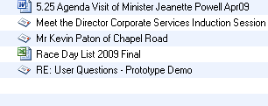
Sample Objects

Object Properties
Object properties differ based on the object type. For example, folder and document objects have different properties.

Metadata
Metadata is accessible via an object’s Properties window. Metadata exists in two forms: System and Corporate:
System metadata includes object information that is generated and maintained automatically by Objective or the operating system, such as creation date and time.
- Corporate metadata is added and maintained by users with the appropriate access to the object. This type of metadata acts as a label that further identifies an object. For example, a planning amendment number, resident’s name/address or an employee name.
Information and metadata for an object can be reviewed at any time by accessing an object’s properties.

Business Process:
Navigate to a folder in the Objective Global Folder Hierarchy.
Use the reveal triangles to show the files. Highlight any file and follow the instructions below from point 2.

EXERCISE Reviewing Object Properties
- Left-click to select an object (document, file, folder etc)
- Right Click > Properties to open the Properties window
- Select the General tab to review general information about the object
- Select the Catalogue tab to view object metadata
- Select the Audit tab to view an audit trail
- Select the Links tab to view any linked documents.

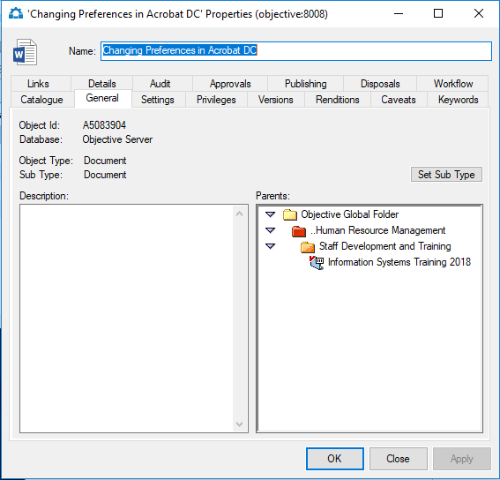
General Tab – General Information

Note: You must ensure you have right-clicked on the actual document object, not the alias, to see the above tabs. The alias will only display tabs relevant to the alias itself.
If you right-click on an alias and view the properties only the General, Privileges, Details and Audit tabs will be visible as seen in the below screenshot.
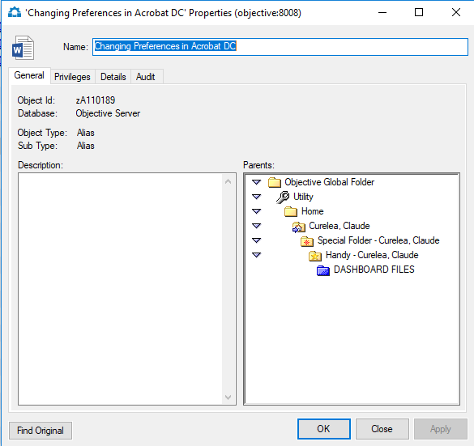
Tabs available for an Alias

Note: If you right-click on a file and display its properties you will be able to see how long the information is to be kept via the Disposals tab as seen below.
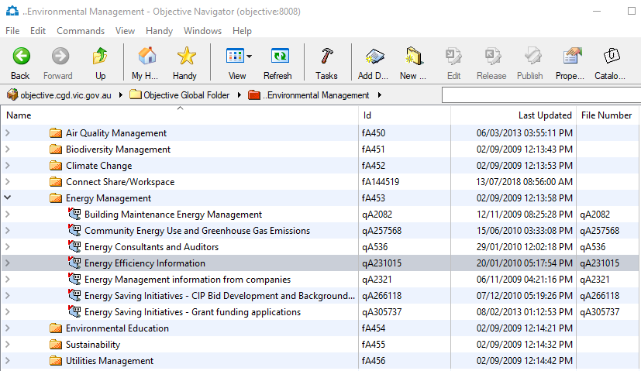

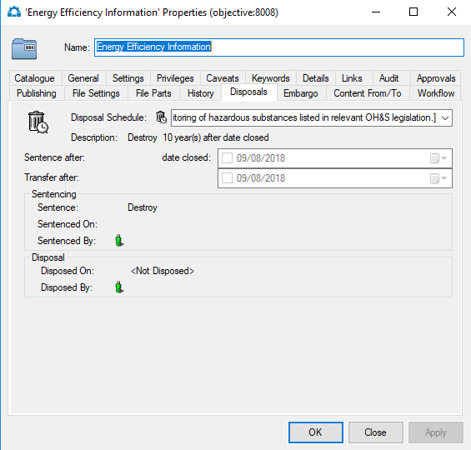
Disposals Tab

EXERCISE Creating a Rendition (PDF)

- Right Mouse Click on a document
- Select Properties to open the Object Properties window
- Select the Renditions tab
- Click on the Create button
- A dialog box will open listing the document versions
- Select the document version that you want to create a rendition of and then click on the OK button
- Tick the PDF file check box
- You can also specify if you would like to receive an email confirmation that the rendition has been created
- Click on the OK button when ready
- When the rendition has been created you will see it listed on the Renditions tab of the Properties dialog for the object
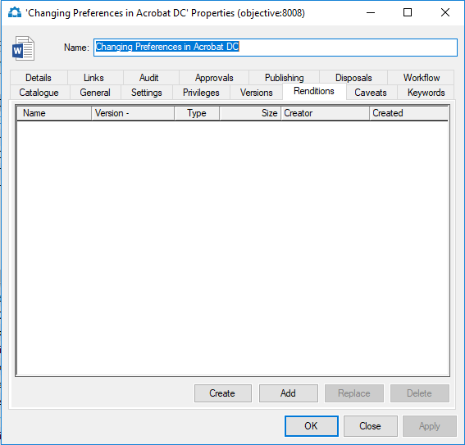
Renditions Tab
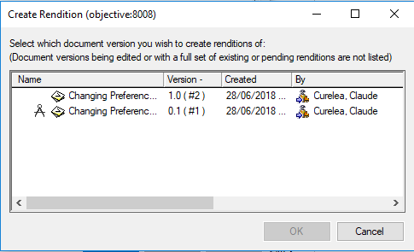
Create Rendition Dialog Box
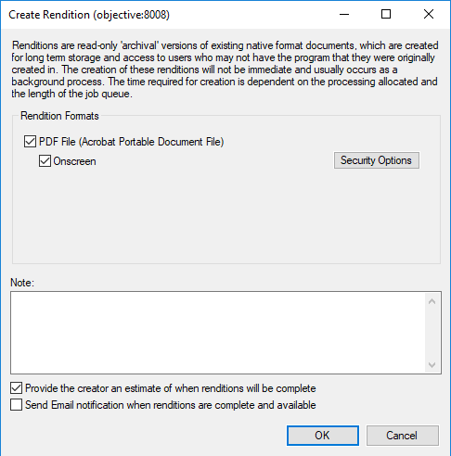
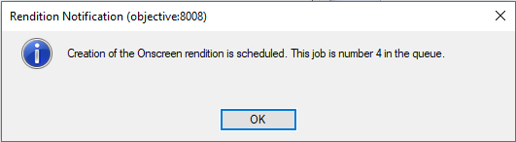
Rendition Notification

Email Notification
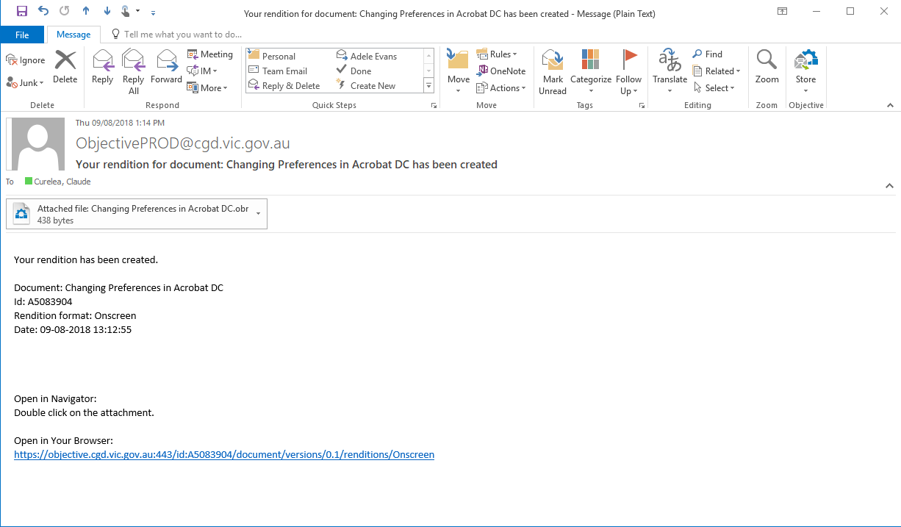
Rendition Email
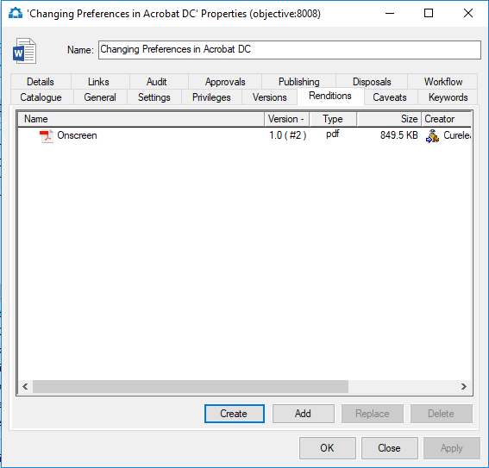
Renditions Tab showing created PDF
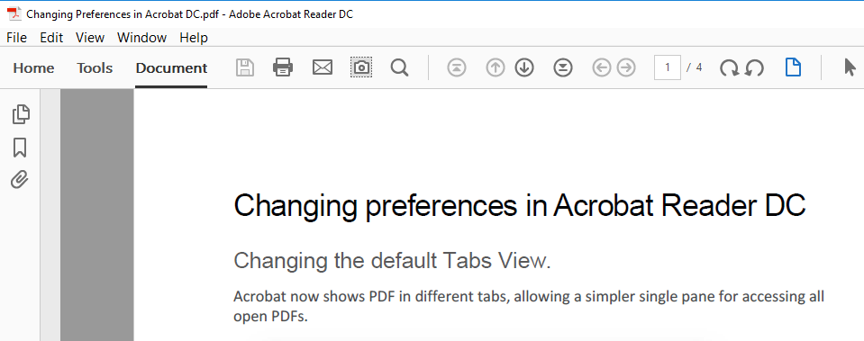
Use Email Icon in Adobe to attach to Email

Business Process:
Use the reveal triangle to view the contents of the file. Hold the Ctrl + Shift keys and hover your mouse over one of the documents in the file to view its metadata.

EXERCISE Display Object Information

Display System Metadata
Press CTRL + SHIFT while hovering your cursor on an object icon to display system metadata.
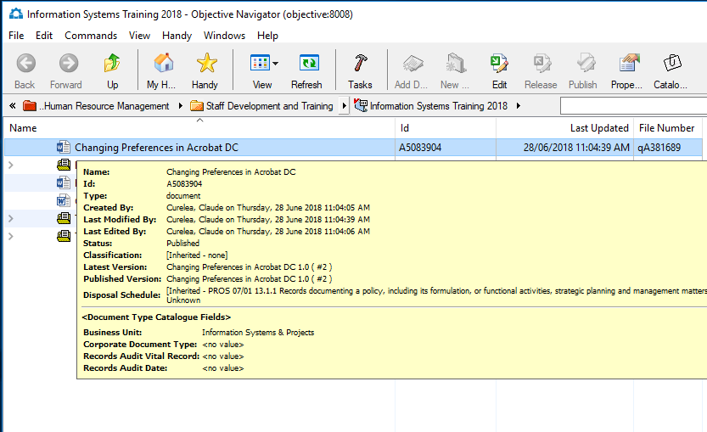
Display System Metadata

Working with Folders

Overview
Objective uses a logical structure to organise objects. Similar to the Microsoft Windows Explorer method of organising information into directories and sub-directories, Objective uses folders and sub-folders. By organising objects in this way, content can be grouped based on council functions and activities.
Folders are containers that store objects (documents, images, spreadsheets etc) within Objective hierarchy. The Business Classification Structure (BCS) is the name given to the specific way in which Greater Dandenong has decided to build the folder hierarchy.
Folders within the BCS will be created centrally by the Objective Administrator. If you believe a new folder is required, email your request to ITSERVICEDESK and your job will be logged by the IT Service Desk.
Note: It is unlikely that an additional Function folder will be created, activity folders will be considered on a case by case basis.

Privileges

Overview
Most information in Objective will be readable by all users. However the nature of some information means that it must be kept secure and only to be viewed by selected users. Such information may include personnel files, health records etc. When the BCS was established, a lot of work was done on determining what information would need to be secure.
In Objective, information is secured by applying access restrictions to a user or a group of users. The level of access a user or group has is referred to as ‘privileges’.

What are Privileges?
Privileges restrict who can access and edit objects by specifying what a user group is allowed to do within Objective. Privileges range from allowing an object to be seen to providing the ability to change existing privileges on an object.
Privileges on objects are assigned to a user or group through object properties. If privileges are not individually set on a object they are inherited from the file or folder that the object is created in.
Note: Privileges specifically set on individual objects will override those inherited from the file or folder it has been created in

Types of Privileges
There are seven levels of privileges with Objective:
- See – View the name of the object
- Open – View object contents and properties. Unable to make changes
- Create – Add new documents and create folders. When combined with Delete privilege can move an object
- Edit – Create new document versions and make changes to properties. For example, make a document into a template
- Delete – Delete an object from Objective. When combined with Create privileges can move an object
- Security – Assign other users privileges to an object and change privileges already assigned
- Administrator – All privileges listed above

Object Privileges
Privileges can be viewed in the object’s Properties window.

EXERCISE Review Object Privileges
- Select an object
- Right Mouse Click > Properties to open the Object Properties window
- Select the Privileges tab
- Select the Display Effective Privileges checkbox to display inherited privileges for this object
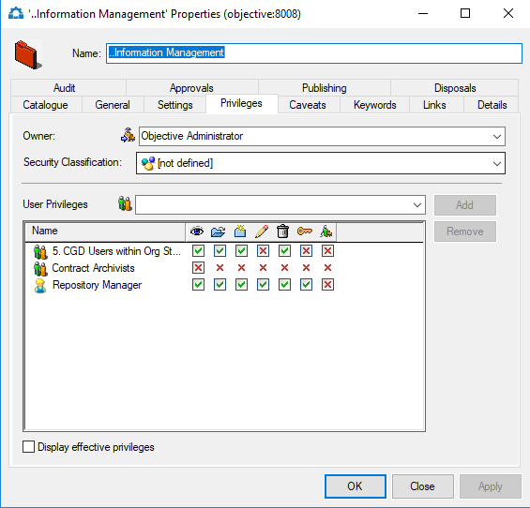
Privileges Tab

Working with Files

File Creation Requests

Overview
During everyday business, new files may need to be created. For example as new projects or transactions are undertaken, new files will be required to store related records.

New File Requests
A request for a new file can be created within Objective. All file requests are received and assessed by the file creation officer. The file creation officer will approved a file request (and create the new file), if the proposed file complies with the BCS structure and CGD’s File Naming Conventions. Where a file request does not comply, a member of the Records team will contact the requestor directly and discuss how it can be modified to conform.
Note: You can still work in your new File while your request is being processed.

File Naming Conventions
The title of a file should capture the purpose of the file and where possible the current year or year range of the objects stored in the file. Acronyms should not be used in the file name unless they are preceded by the full name represented in the acronym. Abbreviations may not be used under any circumstances. The file name might also include:
- a short phrase that defines the action, subject or topic of the document
- names (eg of an organisation, individual or project)
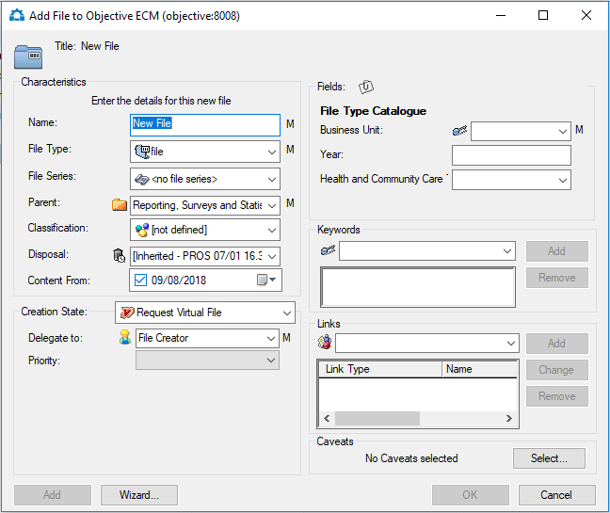

Business Process:
Your business unit is hosting a corporate event. You need to request a new file for this event. Navigate to Community Relations > Event Management in the folder hierarchy. Right click on Event Management and select New - Add File and follow instructions below.

EXERCISE Request Creation of a New File
- Right click the Activity (amber coloured) Folder that will contain the new file
- Select New> Add File to open the Add File to Objective window
- Provide a Name for the file (call the file Train # your computer number)
- Select appropriate File Type eg File, Council Report, etc
- Choose Request Virtual File from the Creation State drop-down list
- Delegate to File Creator – select from drop down list
- Complete remaining fields as required – M at the end of a field means Mandatory (this field must be filled in)
- Click OK to save the new file request
Note: You can request a file where fields are automatically populated with metadata from an existing file. Right click the existing file and then select New> New File Like This One.
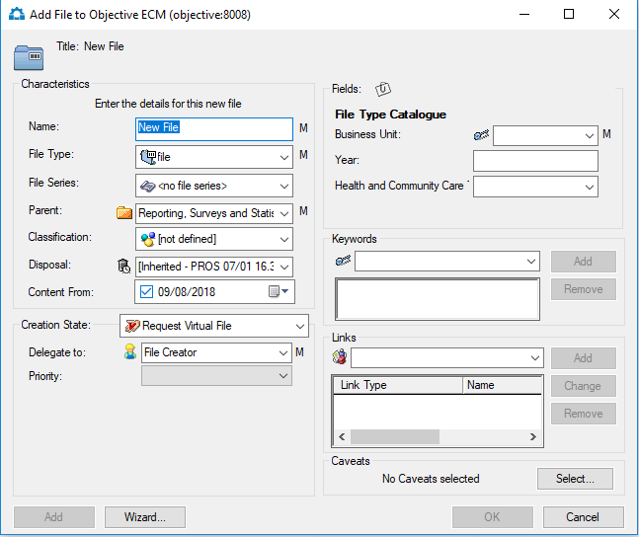
Note: If all mandatory fields are entered and OK button is greyed out, press TAB key.

Working with Documents

Overview
A typical process for creating and maintaining documents includes the opportunity to review and amend a document. Some drafts may be reviewed by a number of people before a document is eventually published.
Objective can help with collaboration by recording multiple drafts and eventual publication of documents. This is known as the ‘document lifecycle’ being the path or sequence documents pass through during their development. In this way, Objective ensures all changes are recorded and that no edits are lost during the document’s development.

Creating New Documents
Objective integrates directly with Windows applications. Saving to Objective from within an application will add the document as a new object. Users can create new documents using Word, Excel or PowerPoint and save them directly to Objective.

Business Process:
Open any Microsoft application and prepare a short document that relates to your event and follow the instruction below.

EXERCISE Add new documents from a Windows application
- Start the Windows application (eg Word)
- Create a new document
- Select Save to open the Save As window
- Select the Objective Icon 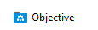 from left hand pane
(NOTE: in some Microsoft Office versions you may need to press Browse first).
- Navigate the Objective Hierarchy and select the destination file (Note: Office will remember where you last saved the document and present you with that file for saving)
- Click OK to add the new document to Objective and leave it open for further editing
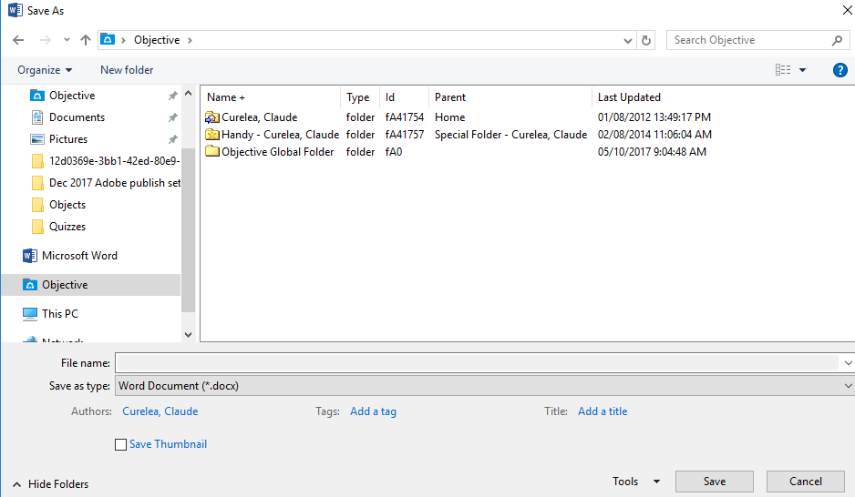
Objective: Navigate the Objective Hierarchy

Adding Documents

Business Process:
You have several documents that you are required to add to Objective. There are several ways to do this. On the network drive there is a folder with your train number and 4 documents. When completed you will have transferred these 4 documents into Objective.

Overview
Content can be added to Objective using a range of methods. You can chose from the methods listed below based on the type of content to be added or personal preference.
Existing documents in external directories (eg H & Q drive) can be transferred to Objective
- Documents can be created using templates stored in Objective
- Documents created using Windows Applications can be saved directly to Objective, for example, Microsoft office applications

Adding Documents
Existing documents can be added or moved to Objective using either File > Save or drag and drop. Either individual or multiple documents can be added. All documents and files currently stored on the H & Q drives will need to be added to Objective. A number of methods can be used to do this. These are detailed below.
Note: A file must be created or requested in Objective before a document can be added.

EXERCISE Add a Single Document
- Select the File destination in Objective – Community Relations (Red Folder) – Event Management (Amber Folder) Train # (file) (this is where you want to save your document)
- Right Click > New > Add Document to open the Import Document window
- Navigate to the directory containing the document
- Select one document
- Click Open button to display the Add Document to Objective window
- Change the document Name if required
- Click OK to add the document to Objective
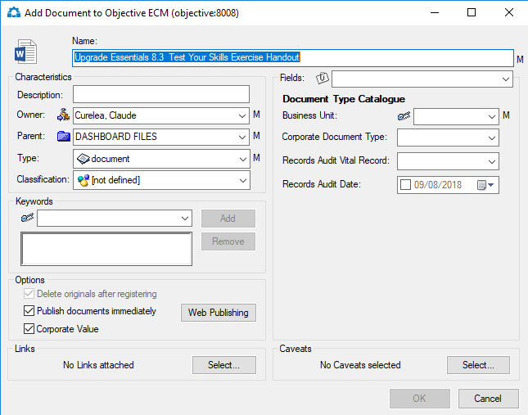
Add a Document to Objective

EXERCISE Use Drag and Drop
- Select the File destination in Objective
- Open Windows Explorer and located the required document(s)
- Minimize the window screen and also minimize the Object screen.
- Drag and drop the document from Window’s Explorer to the location in Objective
- Complete the required fields in the Add Document to Objective window
- Click OK to add the document to Objective

Tip: Use two Windows as seen below; one containing Objective folder structure and the other showing the document(s) to be added.

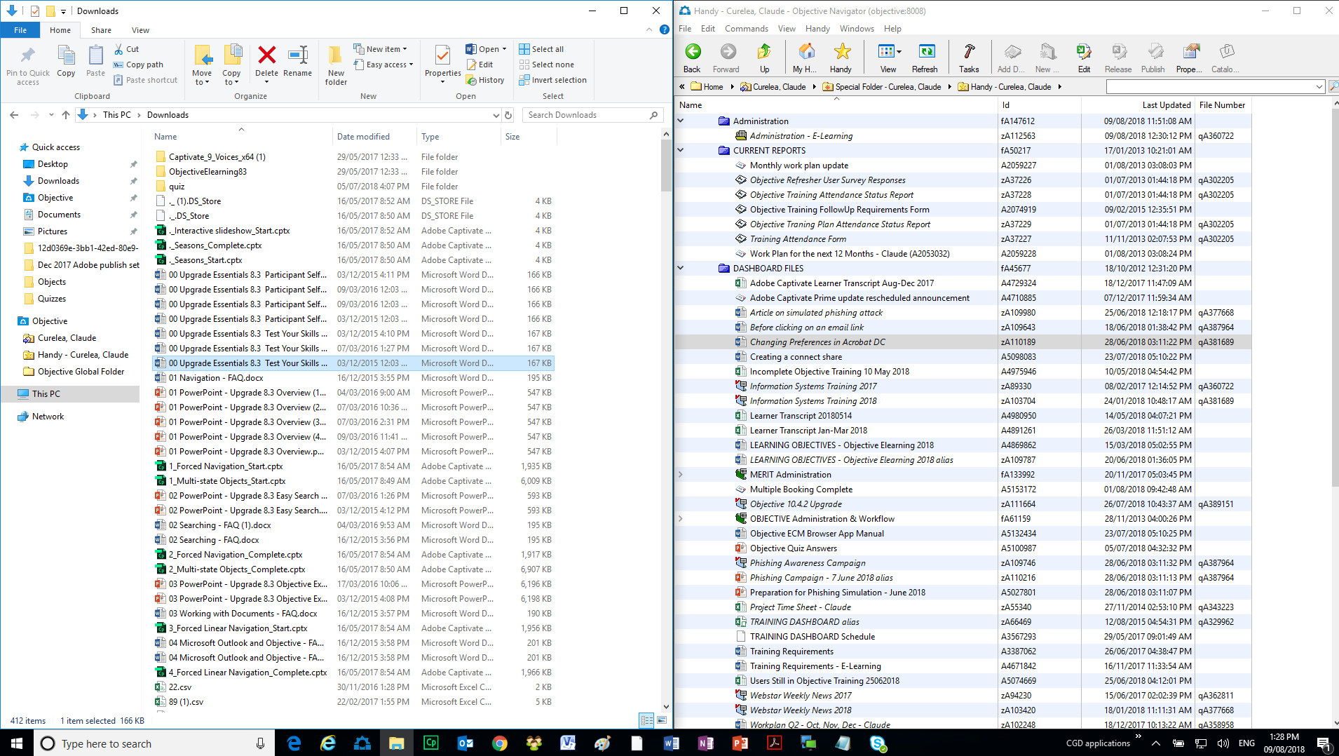
Note : Adding large volumes of information can affect system performance. System Administration personnel should be consulted when there is a need to add large volumes of information into Objective.
Note : Files can be exported from the Objective Navigator by right-clicking on them and selecting the Export option. Copies of documents will be extracted to the designated windows location.

EXERCISE Add Multiple Documents
- Select the File destination in Objective – Community Relations (Red Folder) – Event Management (Amber Folder) Train # (file) (this is where you want to save your document)
- Minimize the window screen and also minimize the Object screen.
- Right Mouse Click > New > Add Document to open the Import Document window
- Navigate to the directory containing the documents
- Select the documents to be added
- Click Open in the Windows Application to display the Add Multiple Objects window
- Click OK to display the Add Document to Objective window
- Click OK to add the documents to Objective

Tip: When selecting multiple documents, press SHIFT for a continuous selection or CTRL for a discontinuous selection.
Note: Uncheck Edit one set of metadata for all objects if each document requires a new Parent location or name change. The Add Document to Objective window will open for each document.
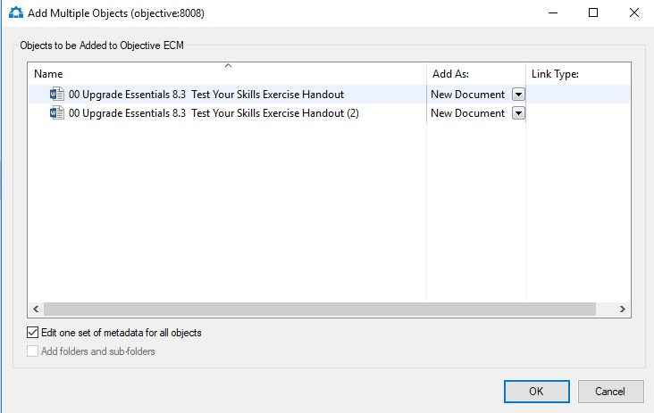
Add Multiple Objects Window

Document Status
Within Objective, document objects have a status reflecting their current stage of development. A document status can be either ‘draft’, ‘edit’ or ‘published’. The current status, along with standard security restrictions, determines what can or cannot be done to a document.
Whether you can open, view or edit a document will vary depending on its current status.
DRAFT
- Documents in draft state may have earlier published versions. Therefore, opening a draft document includes two possible options; open latest draft or last published version. Whichever version you choose will open in read-only mode
- Users with sufficient security privileges can create a new version and edit the document
- A document can have as many draft versions as required
Note: A user must have edit rights to open a draft document even in read only

EDIT
- The current author can open the document for editing in the originating application (if supported)
- The document is locked from being edited by other users
- Users with required security can open a read-only version of the last published (if available) or last draft version
- A new version cannot be created until the current edit is completed
- A new version of the document can be created for editing as many times as required
PUBLISHED – no special icon
- The last published document version will open in read-only mode
- A new version must be created to edit the document
- Users with required security can create a new version for editing
- A document can have as many published versions as required

Status | Icon | Description
Published | No special icon | Document is published and is available to other users
Draft |  | Document in the process of being created or finalized
Being edited by you |  | Currently being edited by you
Locked for editing |  | Currently being edited by another user

Open a Document
To view a document stored in Objective, double click on the name. This will open the document in a read only version. You can read, print or copy information from the document providing you have the necessary security privileges. In a read only version, you cannot make changes to the document. Several users can open the same document in a read only version but only one person can edit or change the document at a time.

Edit a Document
If you need to edit (change) a document, you will need to open a new version of the document. This new version will be locked to other users until you have completed editing. During editing, other users can still read and print the last published version of that document. When you have completed editing, you can publish or release the document.
A document can remain in edit state until all changes are finalized. When editing is complete the document may be released as a draft. Other users who have appropriate security privileges will be able to see the draft version. If they edit the document, it will be saved as a new version. A draft version of a document indicates that it is not yet finalized, may still be subject to change or may not be approved. In many instances, you may skip the draft stage and publish your completed document in one step.

Publish a Document
A document may be edited several times and have several draft versions before it is finalized and published. Once a document is published, other users will be able to see it. Publishing a document will indicate that is complete and it is the final version.

Adding Notes
A note can be added to any object to provide additional information. All users with appropriate security can read a note. Note contents are retained as metadata even after the note is deleted.

EXERCISE Add a Note to an Object
- Select an object by highlighting the document or file name
- Right Mouse Click > Notes > Add Note to open the Note for window
- Provide a comment about the object
- Click OK to add the note.
- To view the note, hover mouse over the icon.
Tip: Display note contents by placing the mouse on the note icon. You can edit or delete a note by Right Mouse Click > Notes > Edit Note or Delete Note
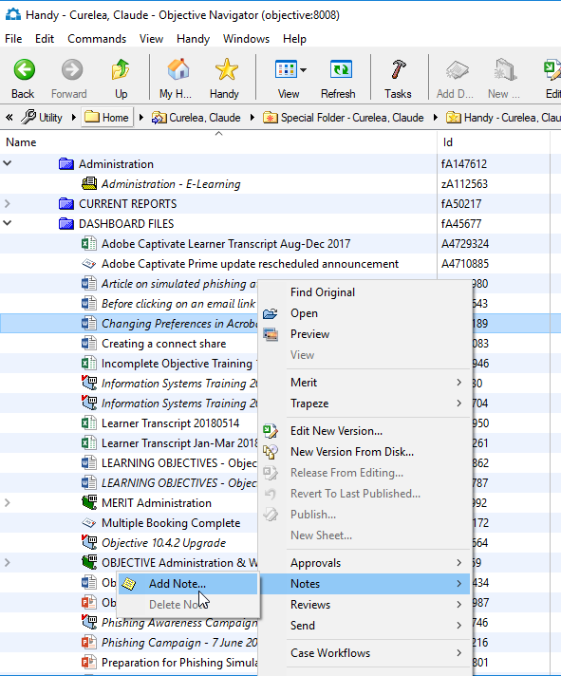
Add Note

Documents Being Edited, Documents Awaiting Approval, Recent Documents
You can see your recent document activity including recent documents, documents being edited and documents awaiting approval from your handy menu.
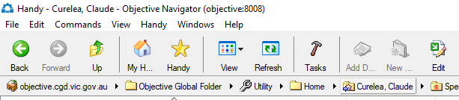
Click on the handy menu.
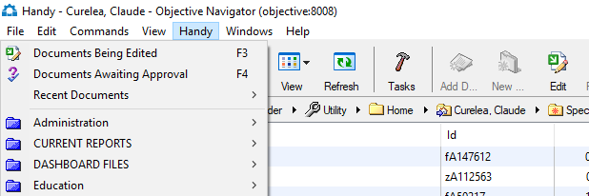
Click on recent documents to view – Display last 20 documents opened
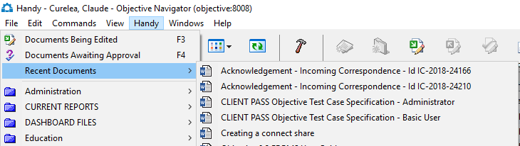
You are able to select and edit a document from this list – right click and edit new version.
To view more click on show all or press F6 on your keyboard – click on Recent Documents tab
Click on the handy menu.
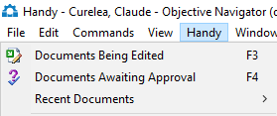
Click on Documents Being Edited or Documents Awaiting Approval pr press F3 or F4 on your keyboard
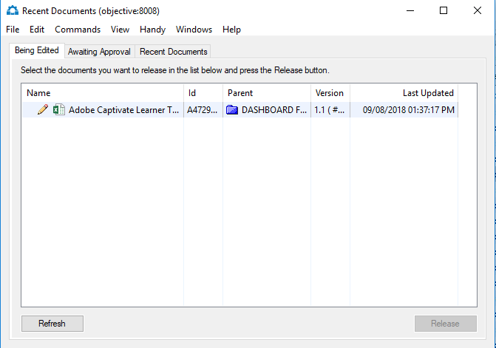

Editing Documents
Editing a document allows you to make changes to an existing document in Objective. You will only be able to edit a document if you have the appropriate security privileges.

Business Process:
Navigate to Community Relations > Enquiries, Feedback and Complaints > Train 1 to 12 in the folder hierarchy. Use the reveal triangles to show documents. Right click on the Enquiry document in your file and follow instructions below. When Editing the document add your name, reference number only.

EXERCISE Edit a Document
- Select a document using left-click.
- Right Mouse Click > Edit new Version to open the New Version window
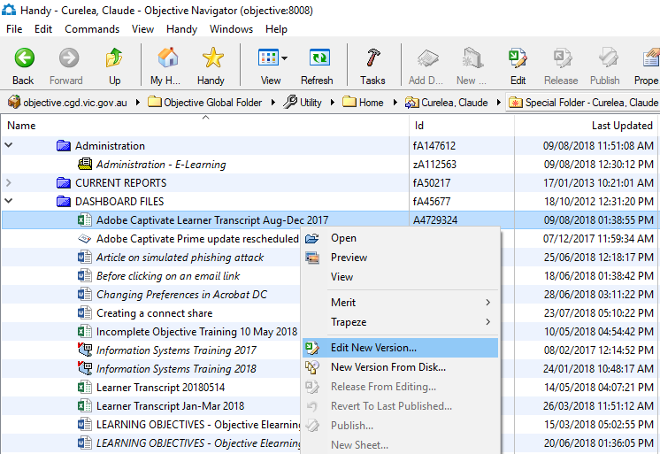
- Provide a Comment (optional – it may explain why you are making changes)
- Click Create to open the new version of the document
- Edit, save and close the document when you have finished making changes
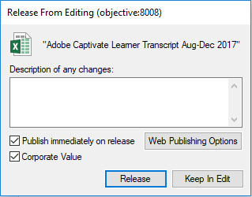
- At the “Release From Editing” screen above the two checkboxes are optional:
- Publish immediately on release will publish the document if you select it. If you leave it unchecked it will leave the document in draft sate.
- If you select Corporate Value for this document you will no longer be able to delete the document.
- The Release button must always be selected from the above screen.

Tip: You can also use the Edit 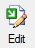 icon in the Objective Navigator toolbar to perform the same function specified in step 2 of the above instructions.

Note: If you have double-clicked on the document instead of using the above right-click method and you would like to save your changes:
- Save this Read Only document to the desktop.
- Drag-and-drop the saved document form the desktop and place it on top of the Objective document you would like to update (ie the original document you were trying to edit in Objective).
- At the “Edit New Version” screen select the same options as in step 6 of the above exercise and press the OK button to update your changes to the Objective document.

Release a Draft
A document can remain in edit state until changes are finalized. When editing is completed, the document may be released in a draft state.

EXERCISE Release as a Draft

Select a document currently in edit state
- Right Mouse Click > Release from Editing to open the Release from Editing window
- Provide a Comment (optional)
- Click Release to release the new draft version

Tip: Use F5 to refresh the Objective display

Release as Published
A document may go through several drafts and edit stages before it is published.

EXERCISE Release from Draft to Publish

Select a document in draft state
- Right Mouse Click > Publish to open the Publish Version window
- Provide a Comment (optional)
- Click Publish to create the published version
- Make sure that there is a tick in the Publish immediately on release and Corporate Value check box
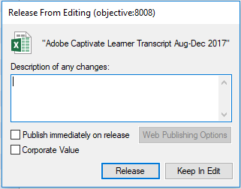
Tip: Double-clicking documents that are in Draft or Published status will open them as Read only

Version Management

Business Process:
Navigate to Community Relations > Enquiries, Feedback and Complaints > Train 1 to 12 in the folder hierarchy. Use the reveal triangles to show documents. Right click on the Enquiry document in your file and follow instructions below.

Overview
As documents are created, edited and published, Objective saves each version so that a history is always available. Previous documents versions can be accessed if required.

Document Properties
The Object Properties window provides access to metadata associated with any document saved in Objective. Detailed information about document activity is available on the Audit tab and document version history is provided on the Versions tab. Links to other documents are shown on the Links Tab.

Documents Audits
All documents activity is recorded in an audit trail. Audit trails provide a history of what has been done to a document. Audit information is displayed in the Object Properties window.

EXERCISE Review Document Audit Trail
- Select a document (select any document you have created today)
- Right Mouse Click > Properties to open the Object Properties window
- Select the Audit tab
- Review audit trail activity by scrolling through the list
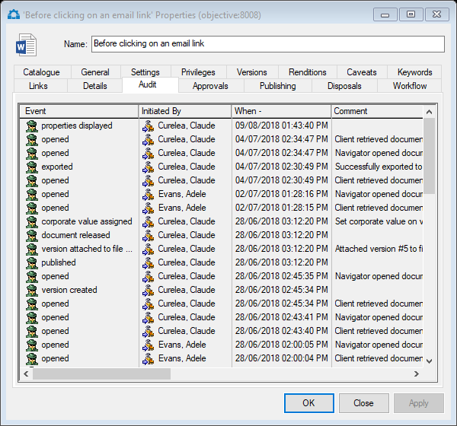
Object Properties Window – Audit Tab

Document Versions
Draft and published version are retained with the document, allowing access to previous information. Previous document versions can be viewed or printed.
A document in edit state can be reverted to the previous version. These activities will be recorded in a document’s audit trail.

EXERCISE Review Previous Versions
- Select a document
- Right click > Properties to open the Object Properties window
- Select the Versions tab
- Select Display Draft Versions to display all versions
- Double-click a version to open (Read only)
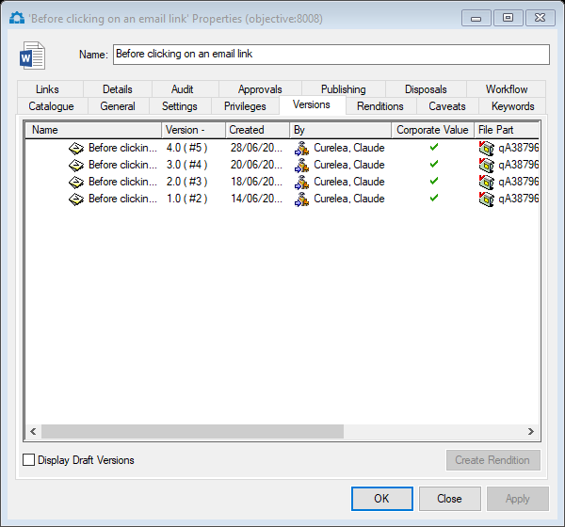
Object Properties Window – Version tab
Note: Only the three latest published versions (and any draft versions in between these) will be viewable when double-clicked).

Restore a Version
Any document version (draft or published) can be restored. Accessing the Version tab of the object’s properties allows a version to be selected and restored.
The following principles apply when restoring a document version:
- Only documents in a draft or published state can have a version restored
- When a document version is restored, it is opened in an edit state ready to make changes if required
- The most recent version (draft or published) is retained in the version history – changes are not lost

EXERCISE Restore a Document Version
- Right-Click on a document in a draft or published state
- Select Properties to open the Properties window
- Select the Versions tab
- Select the Display Draft Versions checkbox to display all versions
- Right-click on the required version and select Restore Version to open the Restore Version window
- Click Restore to confirm the action and open the document in an edit state
- The document opens in the native application (eg: Word, Excel etc) ready to be edited, published or released as a draft as required.
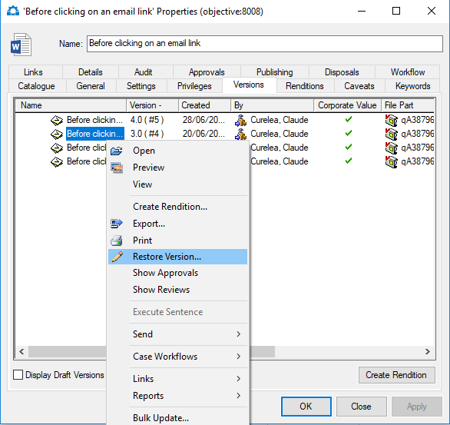

Using a Template
A template is a pre-defined document used as the basis for a new document. Templates can be used to maintain existing standard formats or content in frequently used document types. For example letterheads, facsimile cover pages or reports.

Business Process:
You have not been able to use your car to do a large amount of running around and need to fill in a travel expenses form. Navigate to the Corporate Document Template folder in Objective and follow the instructions.

EXERCISE Find a Template
- In the Objective Global Folder, open the Templates Folder using the reveal triangle
- Highlight Corporate Document Templates
- Right Mouse Click to display the Commands Menu
- Select Send and choose Add to Handy
- An alias (shortcut) to the Templates Folder will now exist in your Handy Folder
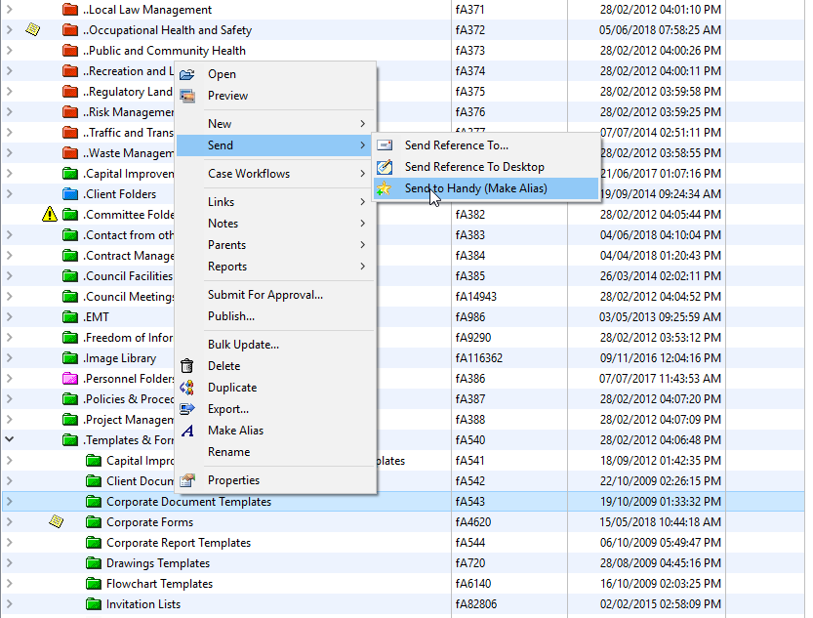
Add Corporate Document Templates Alias to Handy

EXERCISE Create a Template
- Right-click on a document that you would like to turn into a template.
- Select Properties from the right-click menu.
- In the Settings tab select the Document Template checkbox as seen below.
- Click OK.
- The document icon will change to a template icon ( ).

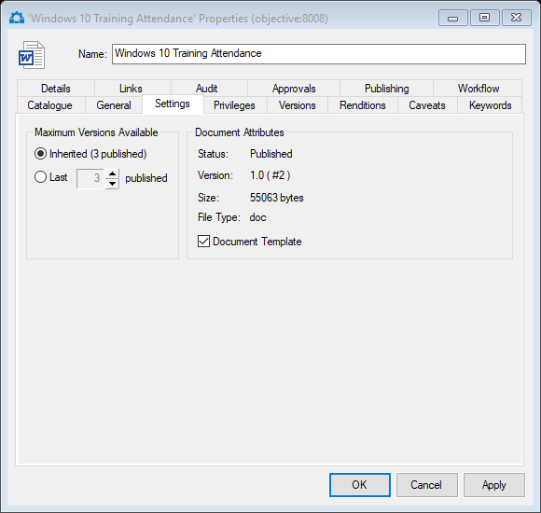

Note: Documents must be published and not in draft state before the Document Template checkbox can be seleccted.

Note: An alternative to Templates is to duplicate the existing document in Objective by right-clicking on it and selecting the “Duplicate” option. This creates anew document in Objective with its own unique Objective Id number and contains all the data as the document used to duplicate from.

EXERCISE Create a Document from a Template
- Double-click a template to open the Create Document from Template window
- Provide a Name for the new document
- Choose the destination folder from the Parent drop-down list (this will determine where the document is saved in Objective)
- Fill in all relevant metadata
- Click OK to create a new document and open it for editing
- Fill in details
- Close and save changes – the document will be in objective in edit state.
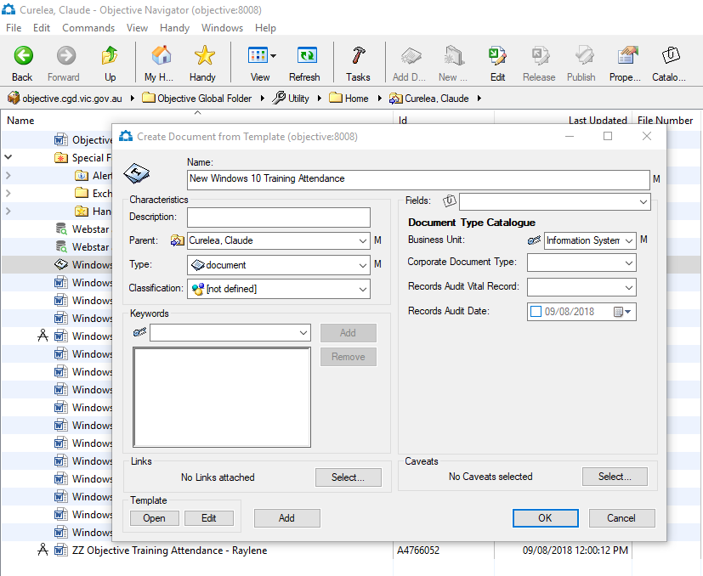
- Right click the in document in edit state and release from editing or simply save and close it as you would a document in Objective.

Note: When the Release from Editing window displays, select the check box Publish immediately on release and then select the Release button as depicted in next few screenshots.

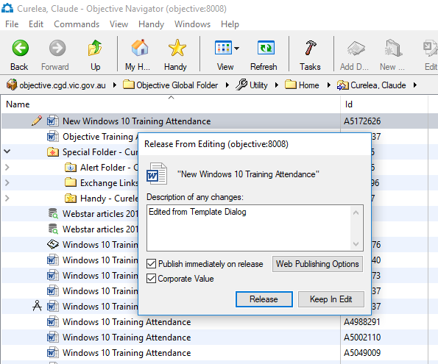
Release from Editing from the right-click menu

Searching Objective

Overview
Large volumes of information within Objective can make it challenging to locate specific objects. Objective search facility makes it easy to search for, display and work with object in one simple view.

Search Types
There are several search options available within Objective including Quick Searches and Searches and Queries from the Find Objects dialogue box.
When working in a Search window, the following features apply:
Search results are presented as a list of objects that meet the search criteria, no matter where in the hierarchy the objects are located;
- Listed objects are accessible according to your level of privileges;
- Search results can be printed; and
- Search specifications can be saved and used to re-run the search as required.

The Find Objects Window

EXERCISE Display Find Objects Window
- Click Find icon or press CTRL+F to display the Find Objects window.
- Click the Switch to Search or Switch to Query buttons to switch to either method (Search or Query).
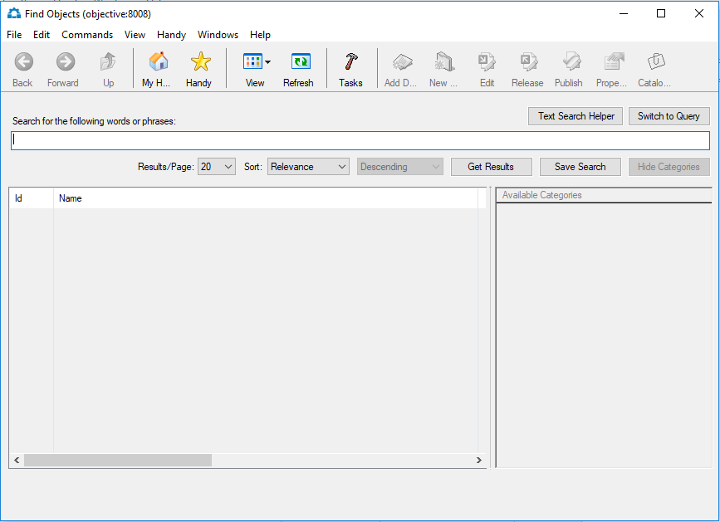
Find Objects Window
Note: In Objective ECM Search refers to what was previously known as Easy Search and Query to what was previously known as Advanced Search. Search focuses on ‘words and phrases’ types of searching while Query focuses on searching metadata.

EXERCISE Perform a Search
- Click Find icon or press CTRL and F to display the Find Objects window.
- Type the word or phrase to search and press the Get Results button – search results appear and are now paginated.
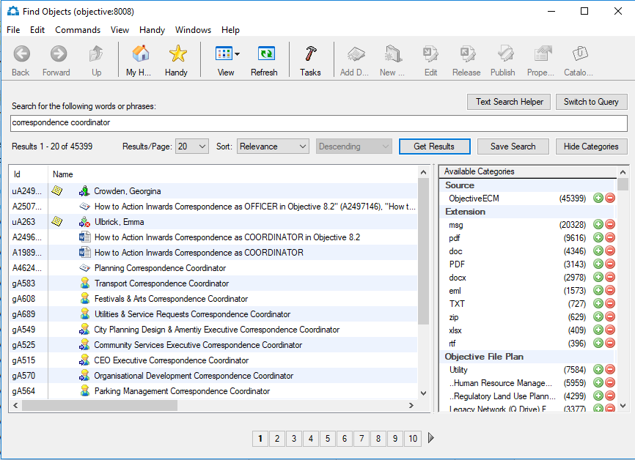
Paginated Search Results Screen
- Press the sign to remove a category from the results and refine your search or to include the search results from the selected category.
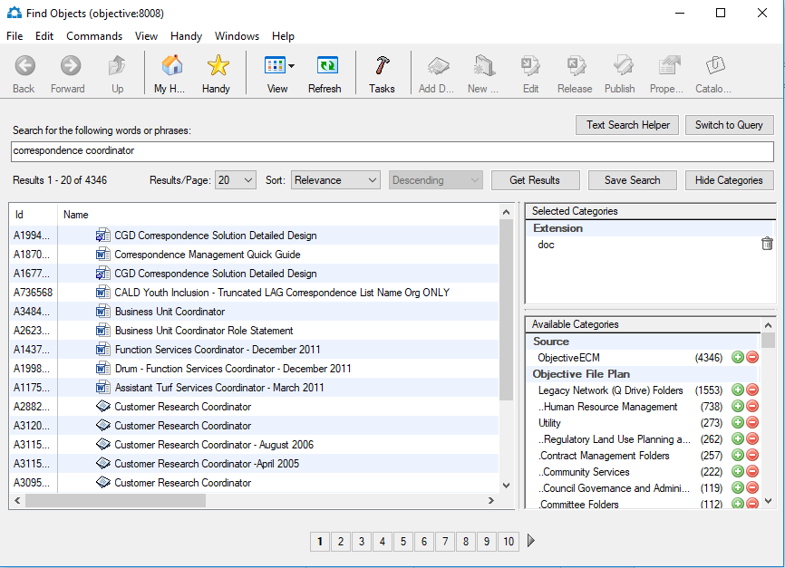
Selected Categories in Search Results

Note 1: Use the File, Print menu (and Print Preview) to print your search results.

Note 2: Right-click on a column in the search results window and click Show Columns… to insert additional columns in the search results window as depicted on page 20. The inserted columns will only be available for this search session.

Note 3: Right-click on an object listed in the search results, select Send, Send to Handy (Make Alias) to send the alias to your Handy.

EXERCISE Run a Query
- Select CTRL and F to display the Find Objects window
- Select Switch to Query button (if visible)
- Choose an object type from the Find drop-down list
- Select the Search object metadata….check box
- Choose a metadata field from the first criteria drop down list
- Choose a comparison type from the second criteria drop down list
- Choose or provide a value for the third criteria
- Click Search to execute the search
Tip: Click Edit to add additional objects types. Click the + icon to add additional criteria or the – icon to remove criteria
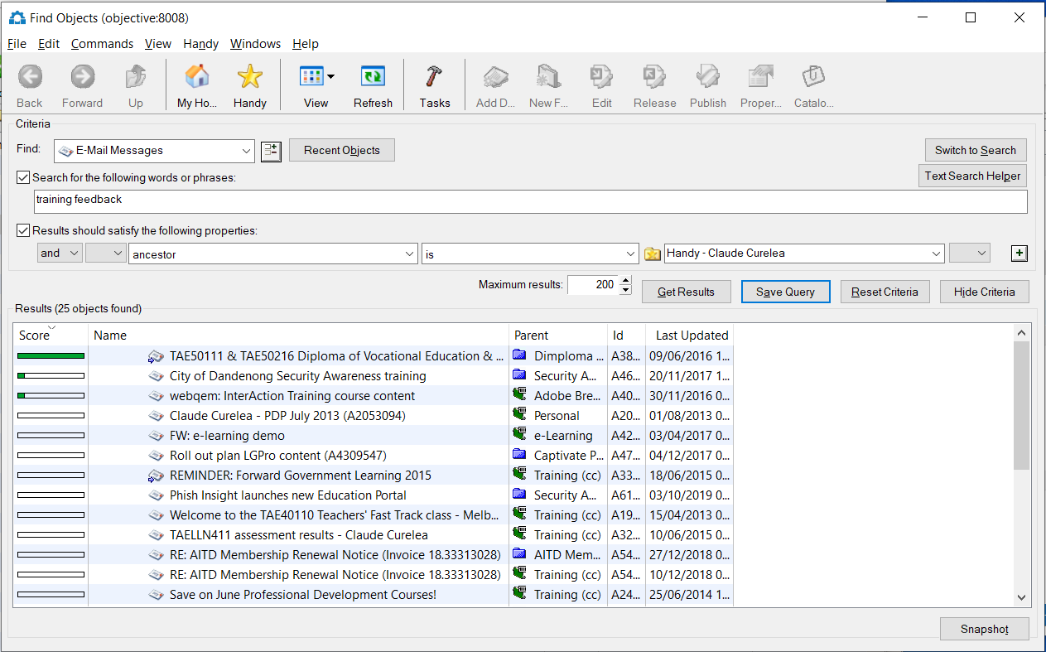
Find Objects Window (Search Results)
Note: The “ancestor” field can be used to search for objects in lower levels of the file structure. As in the screenshot above, it will search the entire Handy.

EXERCISE Add Object Types to Search
From the Find Objects window:
- Click the Edit button to open the Object Types window
- Select an object type from the drop down list
- Click Add to include the object in the list of object types to search
- Click OK to update the Find Objects type list and press the Get Results button.
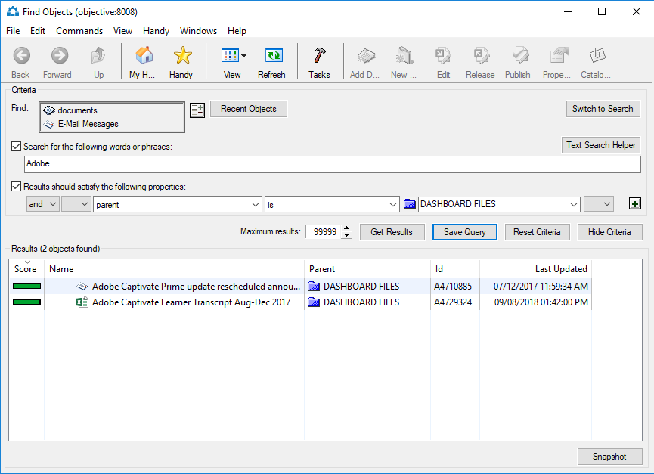
Edit Button

Search Results
The following information applies to the results of a search:
- Privileges will restrict objects returned in search results
- Some searches may take a longer than expected time to return results. A search can be interrupted by clicking the Stop button, which is displayed while a search is in progress
- The Find Objects window provides full functionality to objects listed in the Results area. All relevant details are displayed such as status icons and notes. Objects can be accessed by highlighting the name and then Right Mouse Click to display the Commands menu
- The search results can be printed: File>Print Window

Saving Search and Query Results
A search specification can be saved. Saved searches are another object type with properties, privileges and aliases. Searches can be created and shared amongst users to standardize common enquiries. Opening a saved search object does not automatically run the search.

EXERCISE Save a Search Specification
From the Find Objects window:
- Click Save Search (or Save Query for queries).
- In the Save Search window (or Save Query window) provide a name for the search/query.
- Drag the file/folder into the In Folder field to save your search/query in that location.
- Click OK to save.
- Saved Searches and Queries will by default be saved in your Home Folder.
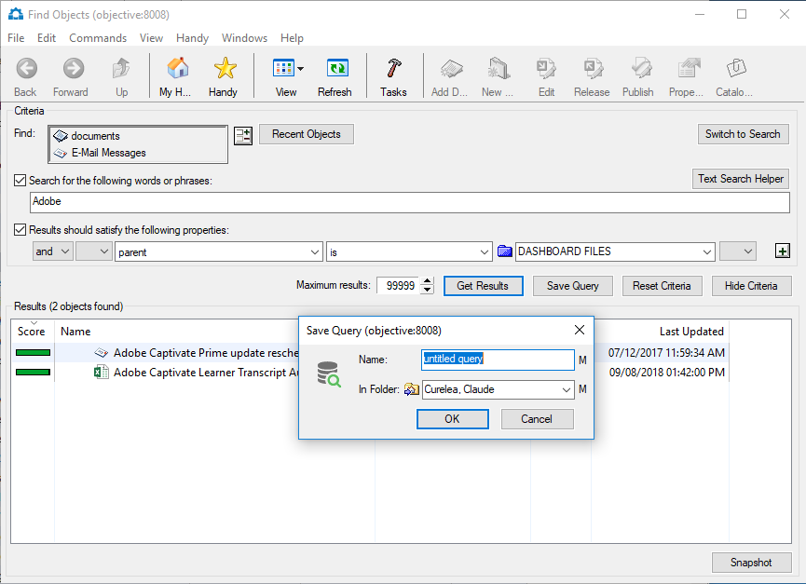
Save Query screen

Snapshot (only available in Query)
The Snapshot functionality is particularly useful when you want to capture evidence of object(s) and/or their metadata at a point in time. Capturing to PDF is ideal because the Adobe Acrobat PDF file can be secured from changes and is a universal cross platform file format.
A Snapshot button is available at the bottom of the Query Find Objects screen and is shown in a disabled state when the Find Objects screen is first presented to you.
The Snapshot button won’t become enabled until a search has been carried out and a search results set is shown in the Query Find Objects screen.

EXERCISE Create a Query Snapshot
From the Find Objects window:
- Click Snapshot to open the Snapshot Options window
- Select the most appropriate options and click OK
- Complete Add Document to Objective screen
- Click OK to create the Snapshot
- Snapshot will default to be saved in your Home Folder
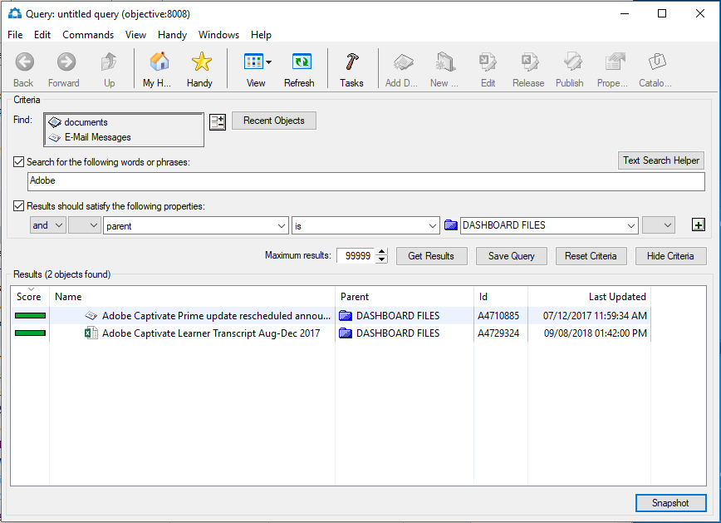
Snapshot Button
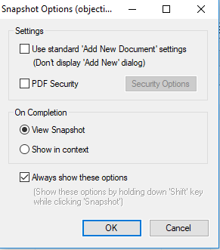
Snapshot Options

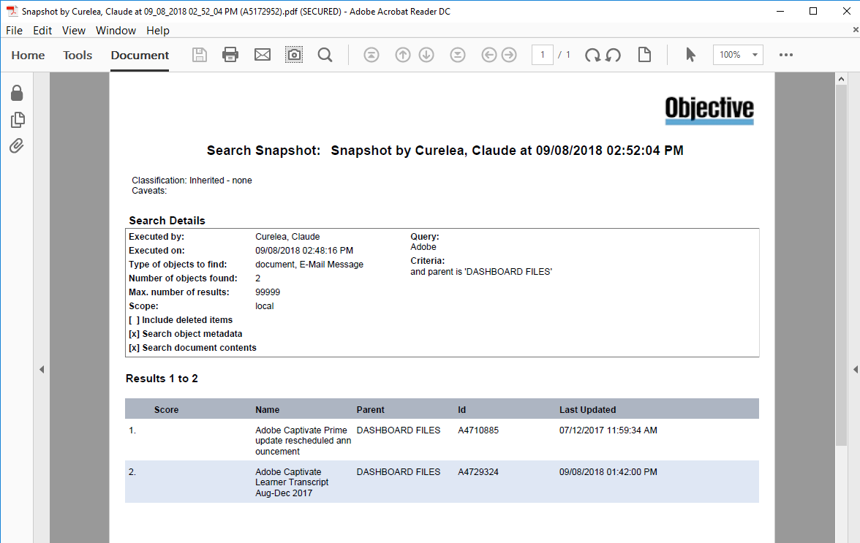
Snapshot Created
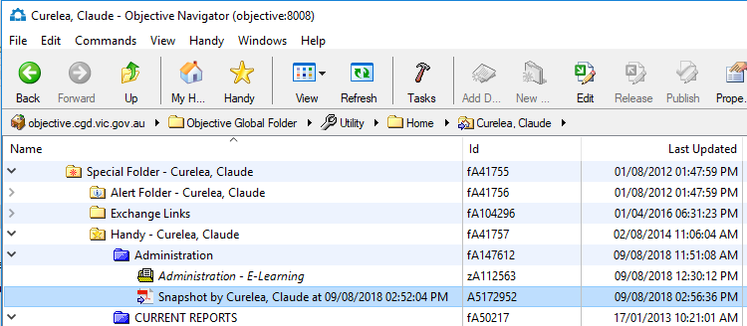
Snapshot is a PDF object

Creating Links
Links are a way of adding extra information to your documents and folders without having to add anything to the actual contents of those objects. A link is a way of establishing an implicit or explicit connection between two objects saved in Objective.
A Reference link is the most common type of link and is easy to use. A Reference tells the user that another document or file may be useful in relation to the object they are reading. For example, a report may contain a reference link to a file which stores further information on the subject of the report.

EXERCISE Create a Reference Link
- Both objects to be linked must be saved into Objective
- Open the first document and Right-Click > Properties > Links tab
- Drag-and-drop the document you would like to link here.
- The title of the linked document/file will appear in the window
- To confirm the link, click Apply
- Click OK to close the Link window and press the Refresh icon in the Objective Navigator to refresh your screen.
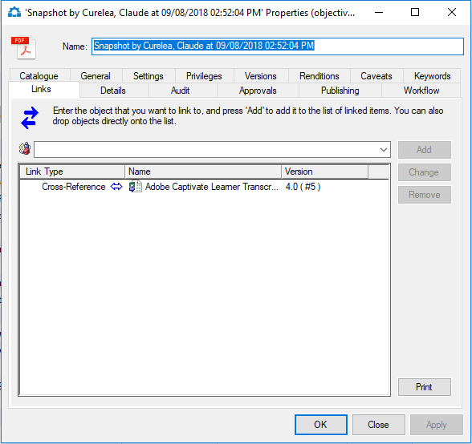
Add a Reference Link

EXERCISE View a Reference Link
- A document or file which has a link will display Link icon next to the name of the object
- Highlight the document or filename
- Right-Click > Links > Fetch Links
- Right Mouse Click > Links to view the name of the linked object
- Click on the linked object to open the document

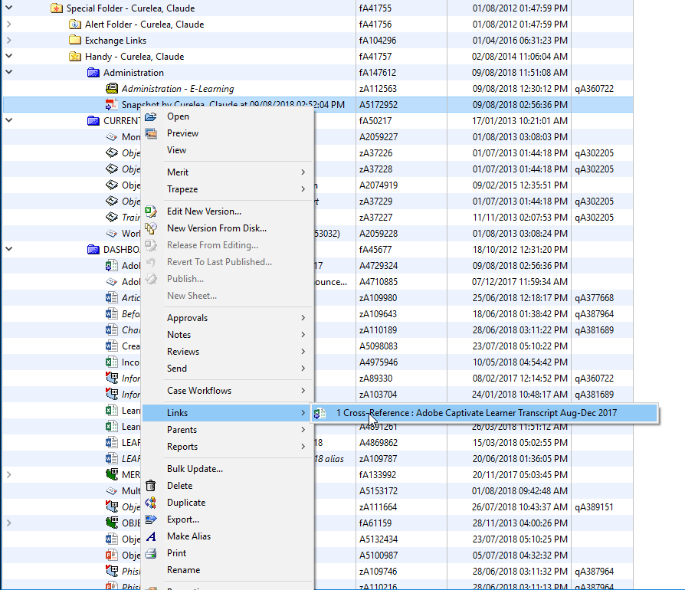
There are other types of links which can be created and these will be covered in the advanced training sessions. Further assistance can be obtained from Objective Training Team.

Microsoft Outlook and Objective

Overview
Objective integration with Microsoft Outlook allows users to send email with direct references (shortcuts) to objects saved within Objective. Other users with access to Objective can use these shortcuts to open the objects. Integration with Microsoft Office allows users to manage all documents via Objective. There is a subscribe option which allows users to add frequently used files.
Users outside of the organisation that do not have access to Objective can be sent copies of documents. Returned documents with changes can be added to Objective as a new version of the original document. This allows documents to be updated by external users while previous versions are retained as part of the audit trail.
Emails can be stored and managed with Objective to keep correspondence details and related information together. All users with appropriate privileges can access the stored email regardless of who received it.
Any functions available when accessing Objective content via Window’s Explorer are available when accessing the same content from within Outlook.
The email quota at CGD is 150 Megabytes (150,000 KB) and once this quota has been exceeded you will no longer be able to receive incoming email. To check your current mailbox size and see how close you are to exceeding your email quota you will need to:
- Open Microsoft Outlook.
- Ensure you are in Mail (ie not Calendar or Tasks)
- Select the File Tab, then press the Cleanup Tools button and select Mailbox Cleanup.
- Press the View Mailbox Size button (in both Outlook 20017 and 2010)
Note: Below mailbox size is 1.4 MB (size of Inbox, Calendar etc can be seen in listing).
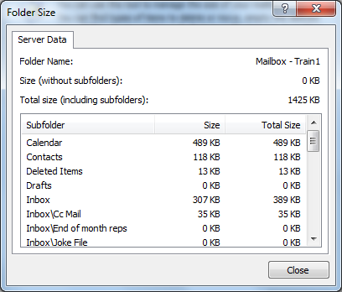

Accessing Objective from Outlook
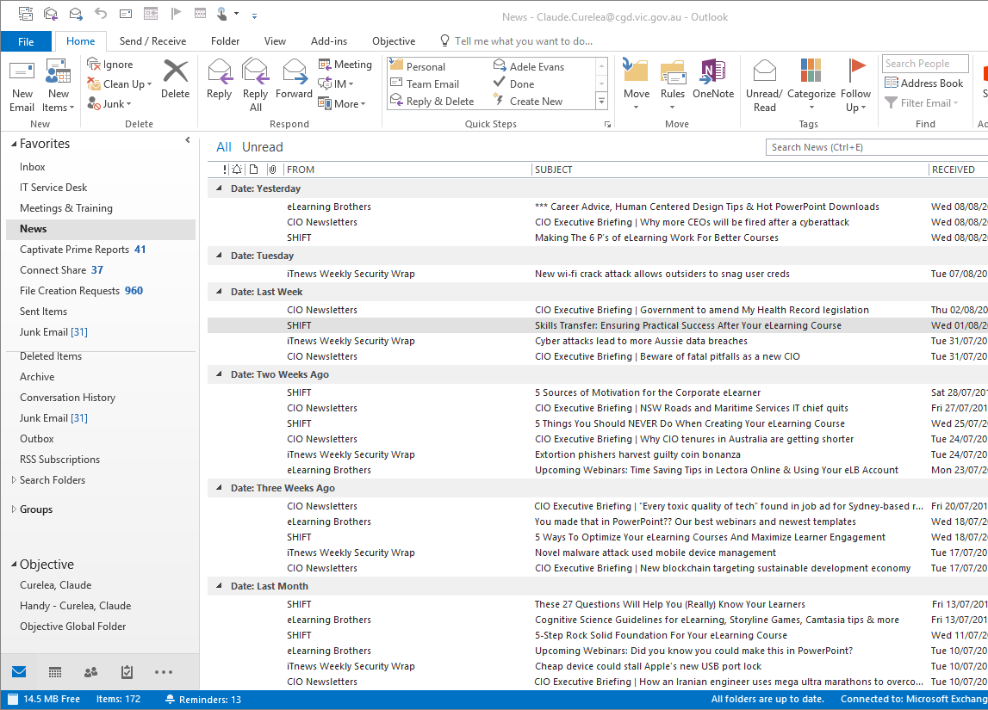
You can access documents stored in Objective Home, Handy and Global Folders from the Navigation Pane in Outlook. The Objective Outreach Add-in must be installed and enabled in Outlook for this integration to work.
Browsing the Objective files/folders from Outlook will display live data from Objective.

Adding an Email to Objective
Emails stored in Objective are managed the same way as other objects. Emails in Objective can be duplicated, moved, deleted and so on. There are options to add the email message only, both email and attachments or attachment only.

EXERCISE Add a Single/Multiple Email Object
- Select the email in Outlook
- Select the Store All button on the toolbar to open the Add Document to Objective window
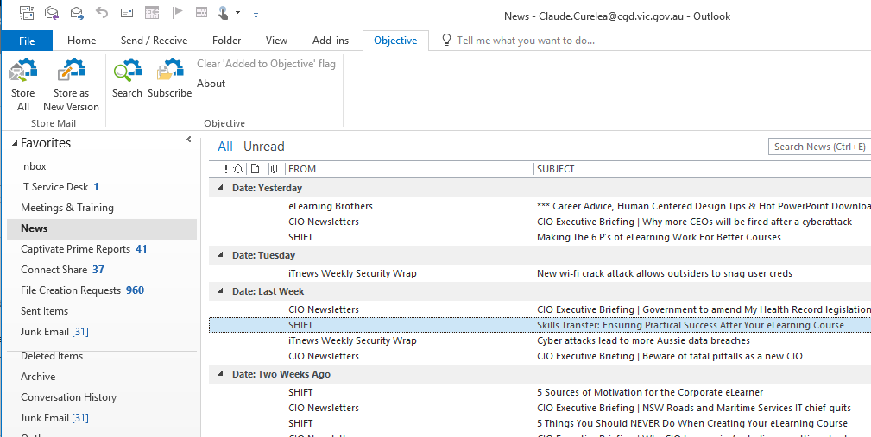
- Provide a Name for the email if required
- Choose a Parent location (destination) from the drop-down list (select your train # in Community Relations > Event Management)
- Click OK to add the email to the folder
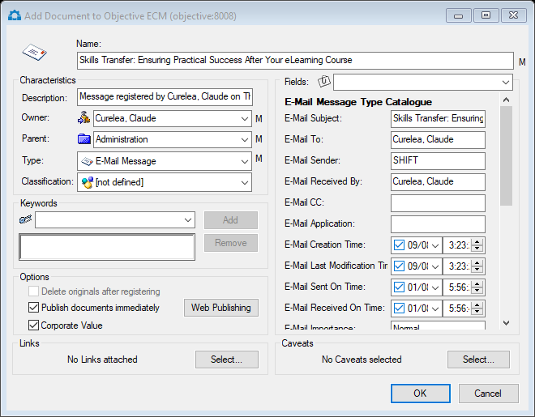

Adding Multiple Emails to Objective
Adding multiple emails to Objective regularly will save time and keep your email quota down.

EXERCISE Add Multiple Emails Using Drag & Drop
- Select multiple emails from your inbox (select the first one as usual and then hold the Ctrl key down as you select additional emails).
- Drag one of the selected emails from the Outlook into a file or folder in Objective.
- At the Add Multiple Objects window select New Document in the Add As field for an email or attachment to be inserted into Objective as a separate object. Selecting Enclose Attachments checkbox will keep the attachments inside the email that is stored in Objective.
Note: In the example below, the first email will be stored into Objective with the attachments inside the email. The second email will have the attachment inside the email as well as stored as a separate object, which sill also be cross-reference linked to the email.
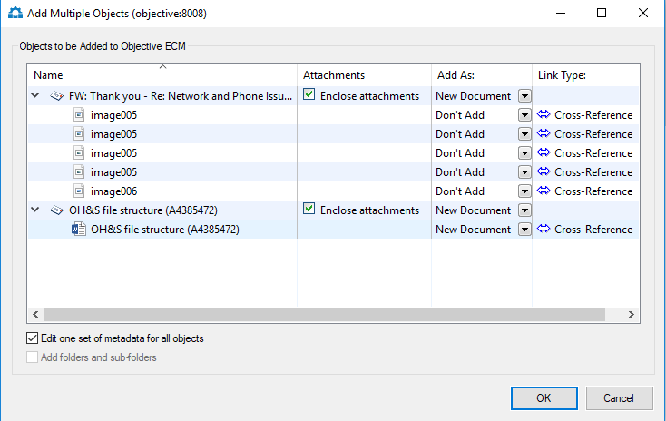
Add Multiple Email Objects Window

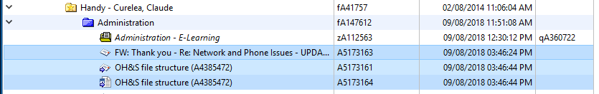
Emails and any attachments added as New Document are stored in Objective.

Opening Stored Email
Email stored in Objective is accessed and opened in the same way as other objects. When email stored in Objective is opening, it is viewed using Outlook.
Tip: Double-clicking a message will open the message using Microsoft Outlook. Normal Outlook functions such as reply and forward will then be available

Send Object via Email
Users who have access to Objective (internal users) can send object references (shortcuts) via email. External contacts can be sent document copies for review.
Note: Copies of folders cannot be sent – only copies of documents.

Email a Reference to an Object
When sending objects using an email reference, ensure the recipient has the required privileges to access the object within Objective hierarchy. When sending references to objects where the alias is in your Home or Handy use right-click, Find Original command to go to the object first, then send that object using the steps below.
Sending a reference to an object requires the recipient to have the edit privilege to view the object.

EXERCISE Email an Object Reference
- Right-click an object in Objective
- Select Send > Send Reference To open an Outlook email message window
- Complete the required email information and Send.
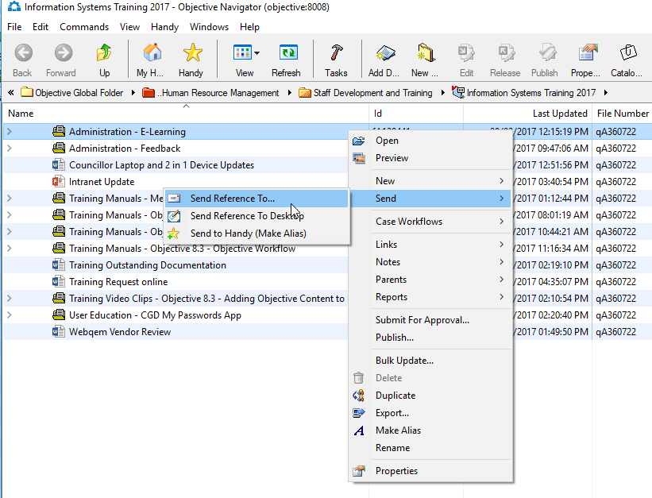
Sending a Reference

EXERCISE Email a Copy of an Object
- Right-click document in Objective
- Select Send > Send Copy To open the Send Options window
- Click OK.
- Outlook will generate a new email with the document attached.
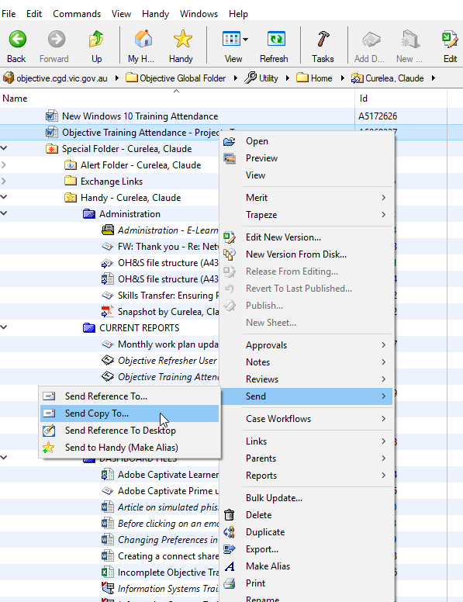
Tip: Drag-and-drop an object into the body of an email to send the reference to the object. Hold Ctrl + drag-and-drop to send the copy of the object via email.

Appendix A: Icons and Shortcuts

Objective Icons
Icon | Object | Description
 | Folder | A folder is used to group together like information. A folder can contain other folders or documents.
   | Document | An electronic document created by any application. If the application that created the document has an icon to represent it, this icon will be used by Objective.
 | Document Version | A representation of a document at a point in time. Documents can have one or more document versions.
 | Alias | An alias is used to access an object located elsewhere. An aliased object has the same icon as the source with the name displayed in italics.
 | Template | A template is a document that can be used to created new documents based on its contents.
 | Saved Search | Searches can be saved for re-use as needed.
 | Saved Query | Queries can be saved for re-use as needed.
 | User | Every person using Objective (The Safe) is a user.
 | User (Objective Administrator) | A special user who has control and access of all Objective (The Safe) contents.
 | Group | A group contains related users. For example, users with the same job role, such as ‘Sales Department.
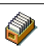 | Catalogue | Catalogues allow index or profile information to be assigned to objects for ease of retrieval.
 | Field | A field is a single index or piece of profile information, such as a document author.

Mouse Shortcuts
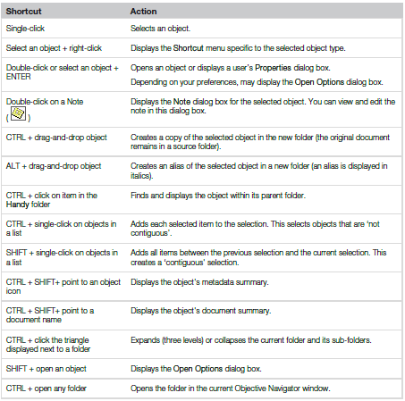

Keyboard Shortcuts
Where two commands are indicated, the first refers to the command that can be used no matter which window you are using, the second refers to the default command for a particular window.

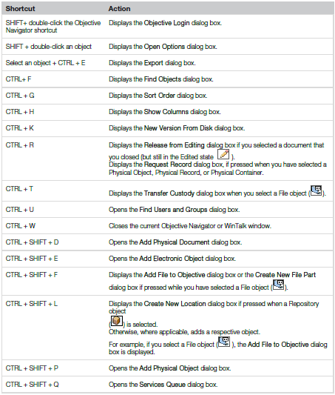

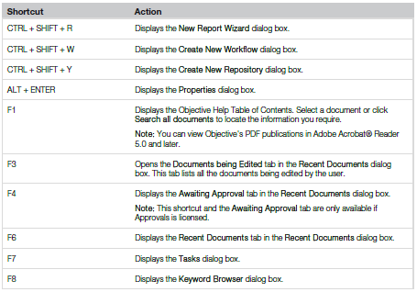

Action Shortcuts
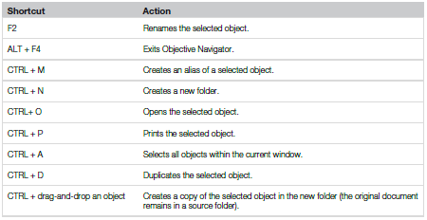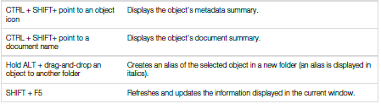

Folder shortcuts
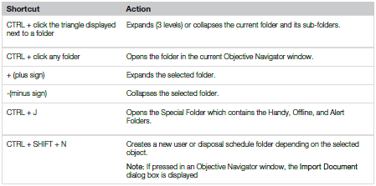

Appendix B: Automatically Adding Emails to Objective

The Automatic Email Capture (AEC) module enables automated storage of emails into Objective by means of Exchange Links. Use this procedure to setup each instance of automated email capture.
- Click on the Home 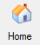 button in Objective to return to home and expand the Special Folder. Right-click on the Exchange Links folder and select New, New Electronic Object…
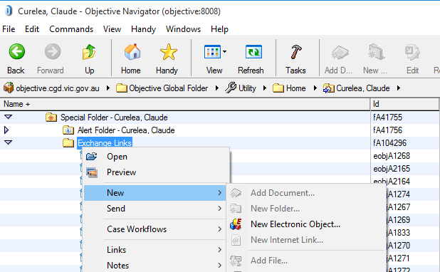
- Enter a brief description in the Name field. Drag-and-drop the Objective file or folder where emails will be stored into the Exchange Link Destination field. Press OK.
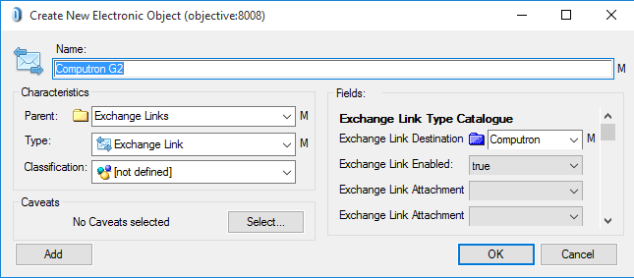
- The Exchange Link will now be visible in the Exchange Links folder.
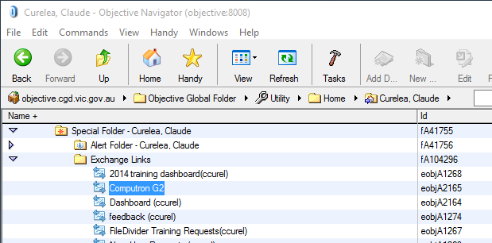
- A sub-folder is automatically created in the Outlook Inbox with the same name as the Objective file or folder (not the name of the Exchange Link).
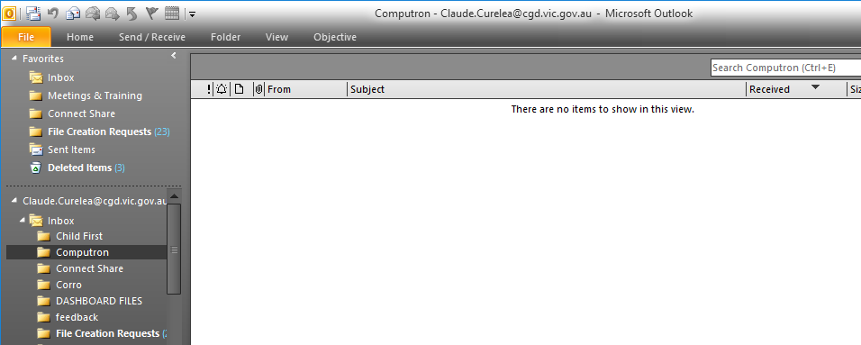
- Click on the newly created folder in Outlook to select it. Right-click on the Subject column and select Field Chooser.
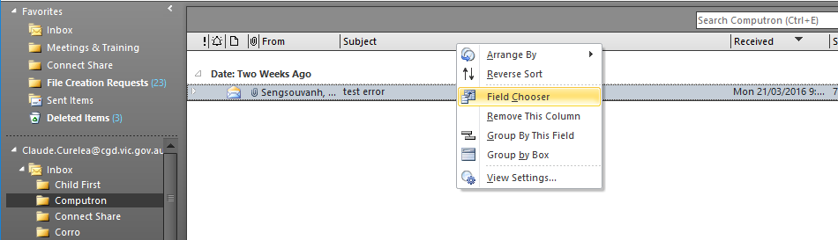
- Click the drop-down arrow change the selection to User-defined fields in folder.
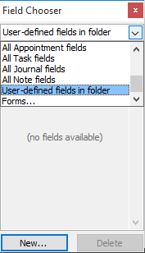
- Press the New… button and create a new column with “Objective” in the Name (must be capital O), select “Yes/No” in Type and “Icon” as the Format.
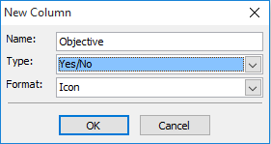
- Drag-and-drop the Objective field/column and position it next to the Subject column.
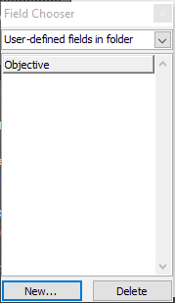

- Drag and email into the folder to automatically send it to Objective. A tick in the Objective column means that the email has been successfully stored in the Objective file or folder.
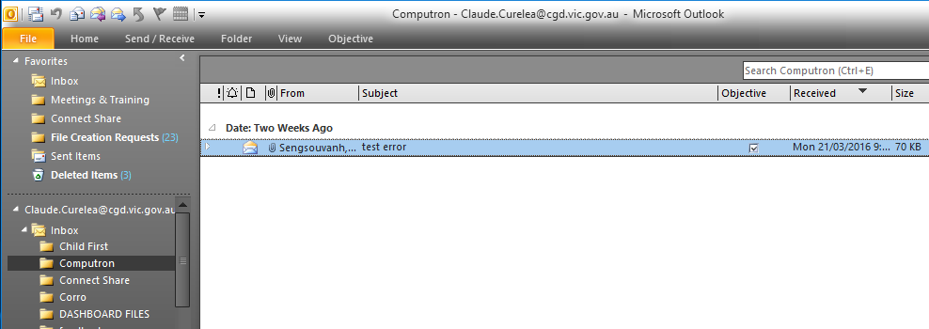
- Browse to the file or folder in the Objective Navigator and press the Refresh 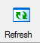 button. The email will now be stored in Objective and the email in Outlook can be deleted.
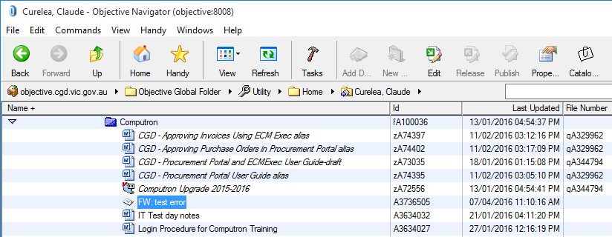

Please contact the IT Service Desk on 8571-5102 or email for assistance with this procedure.

