Instructions
1 | From Webstar landing page, select the Pulse Icon  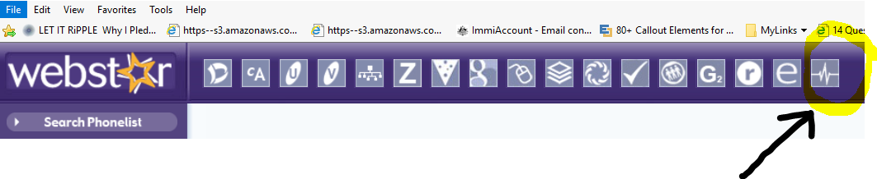
2 | From the Pulse Landing page, select People Management  
3 | Click the right arrow. Select Learning  

4 | Select My eLearning  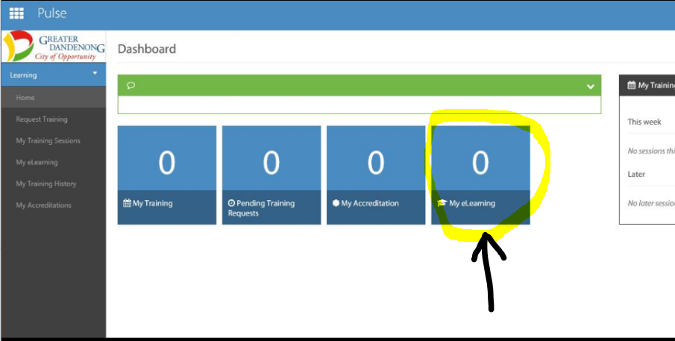
5 | Click on the green View more eLearning Courses box  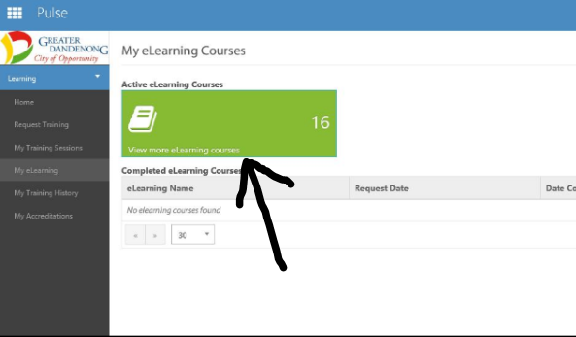

6 | From the eLearning Directory, click into a box to start or resume each of the eLearning courses you have been asked to do  