- To access
Open a browser on your PC or mobile device and type Intouch.cgd.vic.gov.au
There are 2 options for logging in-
- Login in using the CGD credentials (username and password)
- For workers who don’t have network logins, the login details are:
  - intouch (login)
  - withcgd (password)
Unless the person logs out at the end of the session, they won’t need to log in again.

_________________________________________________________________________________
- To add the Keep in Touch icon to an iPhone or iPad

Safari
Open Safari and type Intouch.cgd.vic.gov.au
Click 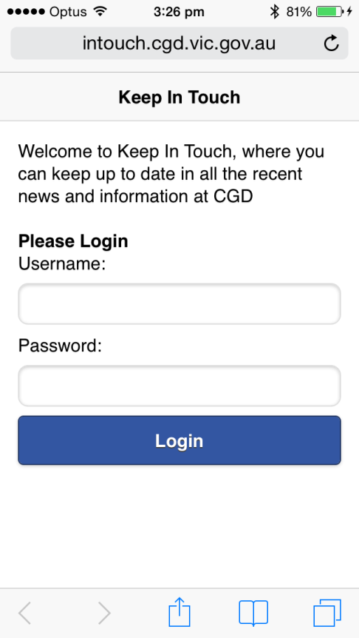 Then Click 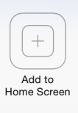
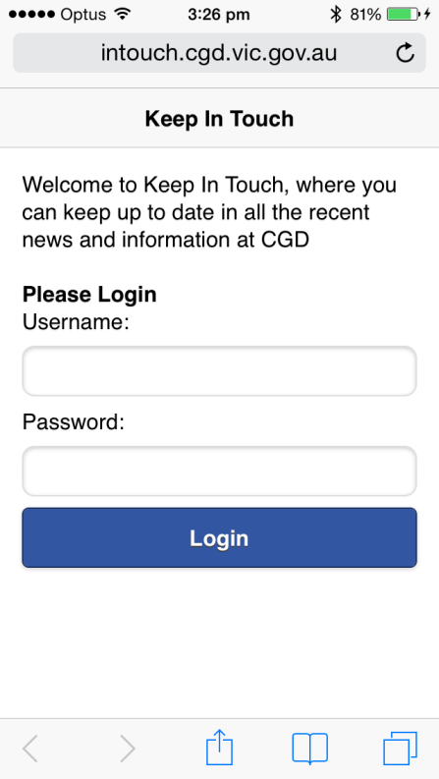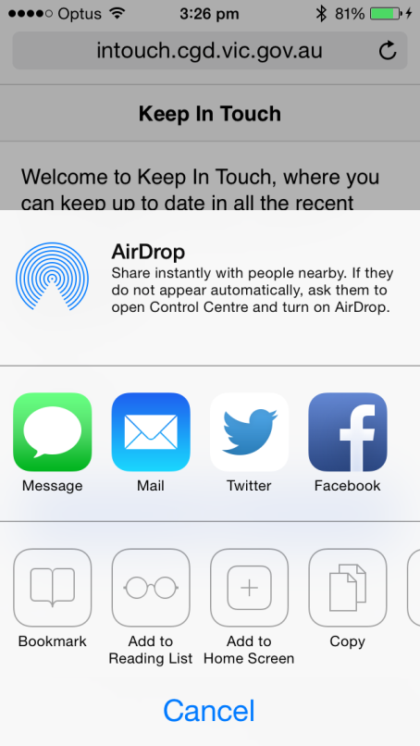

- To add the Keep in Touch icon to an Android device
Open the browser and type Intouch.cgd.vic.gov.au
Click 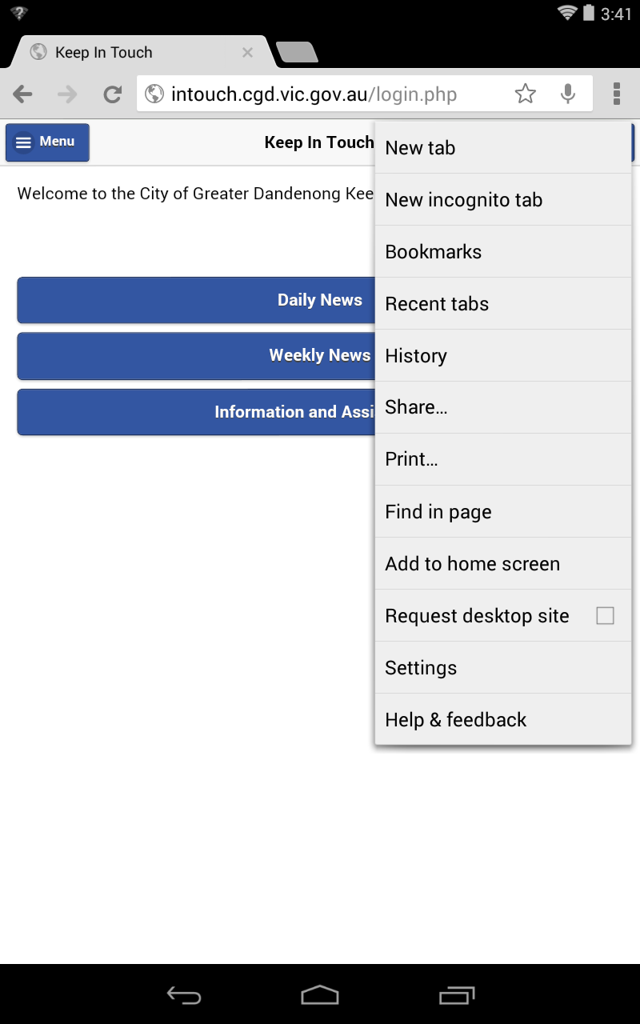
Then click on Add to home screen
