Getting to know Windows 10

The Start menu is back!

To display the Start menu:
Select the Start button on the far left of the taskbar.
—OR—
Press the Windows logo key on the keyboard.

To shut down, restart, or put your computer to sleep:
1.On the Startmenu, select Power button.
2.Select the option you want: Sleep,Shut down, or Restart.

The Start menu: More options added

In the left pane of the Start menu, you’ll find:

•Links to your most-used and recently added apps.
•Links to File Explorer and Settings.
•The Power button.

Right-click the app to:
• Pin to Start
• More
• Uninstall

To lock your computer, change your account settings, sign out, or switch account:
1. On the Start menu, select your user name button.
2. Choose the option you want: Change account settings, Lock, Sign out, or Switch account.
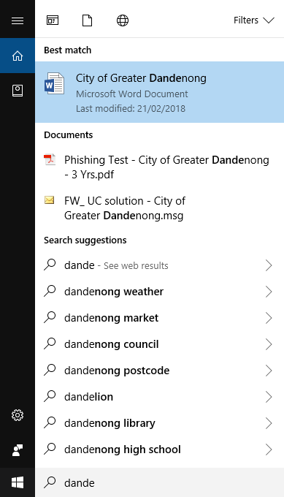
Searching with Cortana

When initial search results are displayed, you can:

•Select Apps to find results for apps.
•Select Documents to find your documents, pictures, music, and videos.
•Select Web to be taken to a full list of Bing search results.

From the Start menu, you can search for apps, settings, and files, and you can search across the web.

Click the circle to the right of the Start button , and start typing in Cortana to search the following locations:

• Apps on your PC.
• Documents—including your documents, pictures, music, and videos.
• The Web.
Using tiles

In the right pane of the Start menu, you’ll find tiles for some common apps.

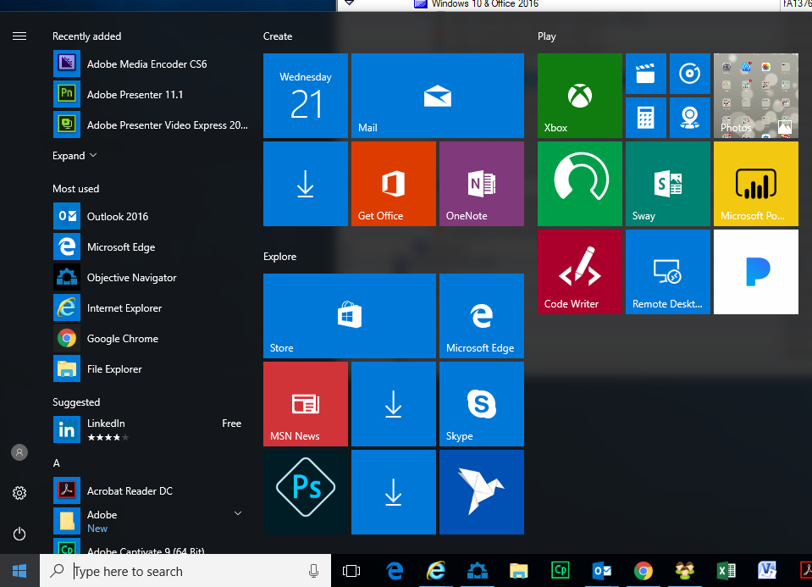
To move a tile, just drag it to another position. You can rearrange them within the pane. You can also drag apps between the tile view and the app list view.

Right-click a tile to display a menu for performing other actions with that tile, which may include:

•Unpin from Start
•Resize
•Uninstall
•More
•Open recent files with the app

Snap Assist

Windows 10 includes Snap Assist making it easy to work with multiple windows.

To snap two windows side by side:

1. Drag the title bar of one window to one side of the screen, until a half-screen outline of the window appears.
2. Release the mouse (or lift your finger) to snap the window into position.
3. Repeat steps 1 and 2 for the other window, using the other side of the screen.

File Explorer

Quick Access displays a list of useful locations and frequently visited and recently opened folders.

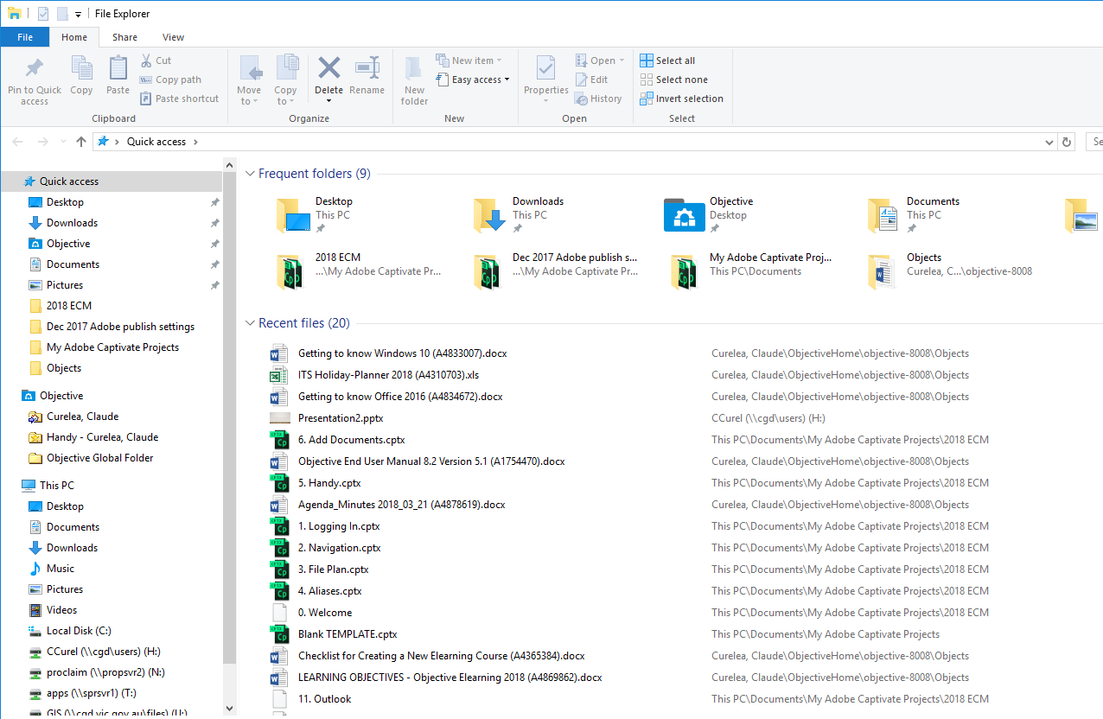
To open File Explorer:

1. Click the File Explorer  icon in the Start Menu or on the Taskbar.

