CONTENTS


Participant Notes

Merit Integration


CONTENTS 1
Overview 3
Background Information 3
Saving of documents 3
Attaching a document to a Merit CRM Request 3
Correspondence Documents 3
Attaching a document to a Merit CRM Request 4
Linking Correspondence to an existing Merit CRM Request 6
Viewing linked documents from Merit 9
Delinking documents linked to a Merit CRM Request 11
Navigating from Objective to a Merit CRM Request 12
Create a New Merit CRM Request from Objective 13

Overview

The Objective integration with Merit will allow users to attach correspondence, photos and other documents to a Merit Request. Users will be able to view all documents saved in Objective that are associated with the Merit request from Merit and vice versa.

Background Information

Saving of documents

For any new and existing Merit CRM Requests, users will be able to save corresponding documents, letter and/or photos to this request from within Merit or Objective.

Attaching a document to a Merit CRM Request

If the document is attached to a Merit CRM Request, the document will automatically be saved into the correct location depending on the Service, Request & Function in Objective.

Correspondence Documents

Any correspondence that is already in Objective will need to be linked back to the Merit CRM Request using the Merit Meta Data Fields. The correspondence document will also need to be moved manually into the correct location depending on the Service, Request & Function

Attaching a document to a Merit CRM Request

Although existing Merit functionality has not changed, users will now be able to attach a document(s) to a corresponding Merit CRM Request.

Business Process

Log into Merit, create a new Merit CRM Request and access the Request Summary screen.

- From the Request Summary Screen select “Objective Documents” as seen below.

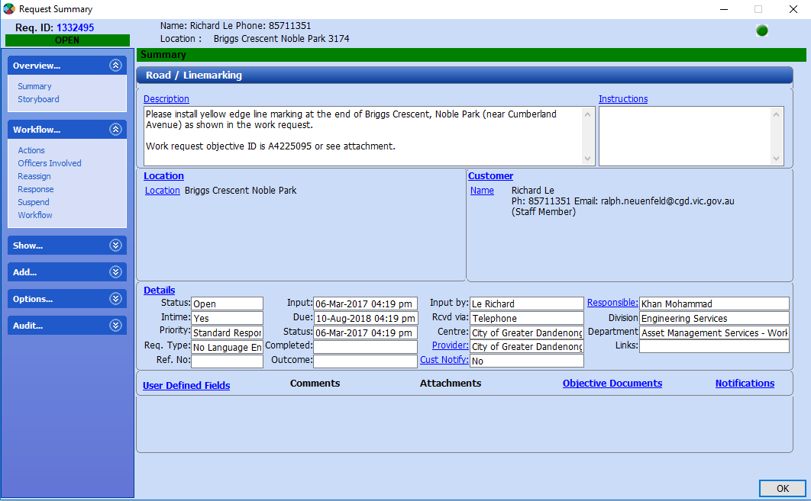

- Click on the “New” button. This will allow you to browse for a document that needs to be attached to the Merit CRM Request

- Select the file that needs to be attached and click on “Open”. When it has registered into Objective a successful document registration prompt will appear, as shown below.

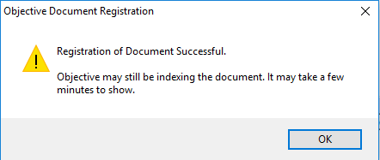

- Click on OK and the document will appear listed as in the screen below.

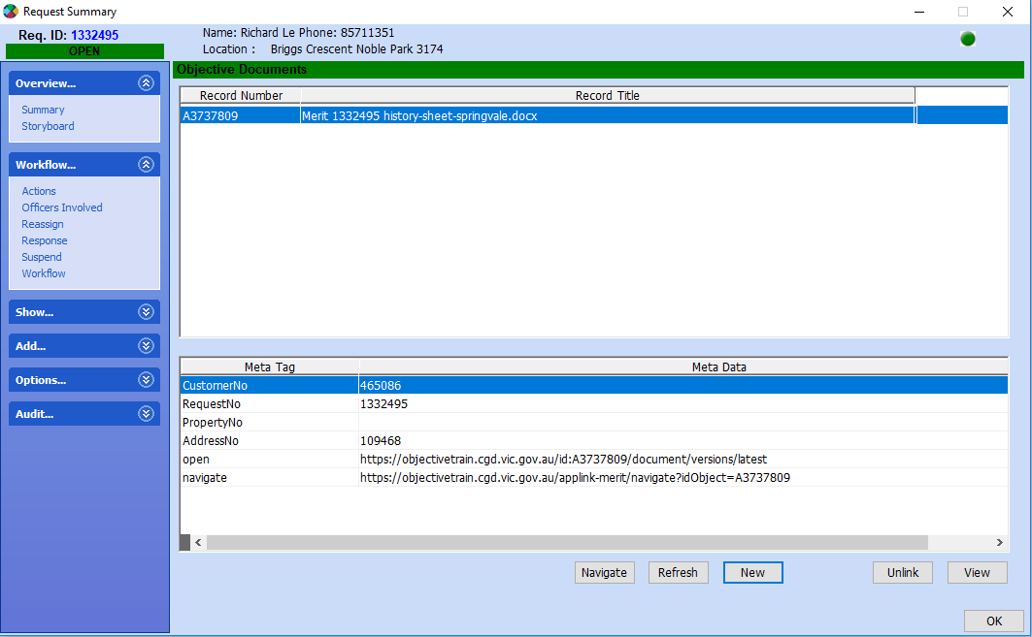

NOTE: The document has been successfully registered into Objective and saved in the correct location based on the Service, Request and Function. A reference will also be placed against the Merit CRM Request for users to access via Merit.

Linking Correspondence to an existing Merit CRM Request

Any documents received via the Records Management Unit will be scanned and saved into Objective. These documents can then be linked to a request in Merit.

Business Process

Locate the document in Objective that needs to be linked to an existing Merit CRM Request.

Business Process

Locate the document in Objective that needs to be linked to a Proclaim Record.

- Right Click on the document and select Properties. Ensure the Catalogue tab is selected.

- Select Merit Document Catalogue from the drop down list in the “Fields” section. This will then bring up all the Merit Meta Data fields.

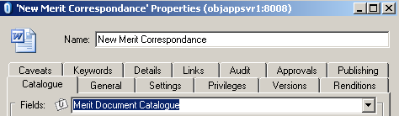

- There are 2 ways in which the document can be linked to a Merit CRM Request;
  - Typing in the Merit Request No.;
    - If you know the details of the Request you would like to link the document to, type in the details beside the Merit Request No Field.
    - Click on Apply to link the document.
OR
  - Performing a search using the lookup Icon beside the Merit Request No
Field
    - When you click on the Lookup Icon beside the Field, the Applink Manager Screen will appear as shown below;

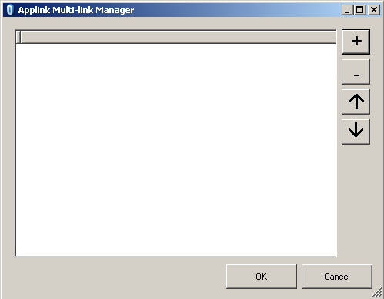
Add Request Button
Remove Request Button
Position Request Arrows
Add to Request Panel

ii Click on the “+” button to open the Merit External Search Request Mode screen. Here you can search on either the Names, Address, Facility or Request No. Fields.

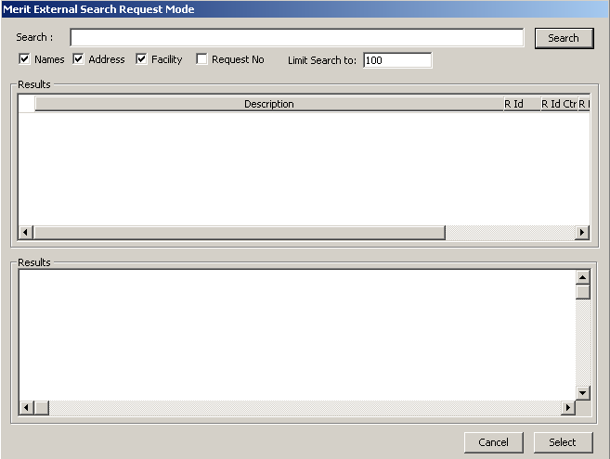

    - In order to search by Request No. Enter the Merit Request Number to search

    - Tick the “Request No.” check box.

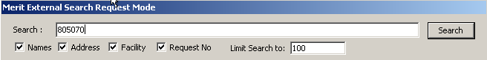

    - Then Click on Search

    - The results will be displayed within the Results Panel. Select the Request you wish to link the document to and click on Select. This will take you back to the Applink Multi-link Manager screen where the selected Request Number will appear.

Note: Users can link more than 1 Merit Request against the document by repeating steps 3ii to 3vi.

    - Click on OK for this to be placed against the Merit Request No. Meta Data field.

    - Click on Apply to link the document to the Merit CRM Request.

- Move the document into the correct location depending on the Service, Request & Function, if this has not already been done.

Viewing linked documents from Merit

If you are in Merit and you wish to view all the documents that have been saved against or linked to a specific Merit Request this can easily be done by following the steps below.

Business Process

Log into Merit and find the Merit Request you wish to view the documents for

- Select the “OBJECTIVE – Documents” option from the Menu Tree. This will open the documents window on the right hand side of the Merit Screen with a list of all documents linked to the request regardless of how these documents were attached to the Request.

- To view a particular document, select the document and click on view.

- Select Open when the File Download dialogue box appears. This will then open the document in a web browser which will be Read Only.

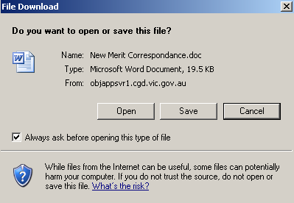

Delinking documents linked to a Merit CRM Request

If a document has been incorrectly linked to a Merit request this association can be removed easily by following the steps below;

Business Process

Log into Merit and find the Merit Request that the document is incorrectly linked to

- Select the “OBJECTIVE – Documents” option from the menu tree

- Select the document that is incorrectly associated to the request

- Click on “Unlink”. This will remove the document from the Documents list and in Objective; the document will no longer have a Merit Request Associated to it. You will need to ensure that the document is then linked to the correct Merit Request No.

Navigating from Objective to a Merit CRM Request

Users from within Objective can navigate to a Merit Request from the document.
Business Process

Locate a document in Objective which is linked to a Merit CRM Request.

- Right Mouse Click on the document and select one of the Display options shown below. Which one you select depends on what you would like more information on. To view the Merit Request click on View Merit CRM Request.

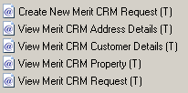

- This will then take you directly to that Merit CRM Request.

Note: If you chose any of the other options, this will take you into the details for that record i.e. Address Details, or Customer Details etc.

Create a New Merit CRM Request from Objective

Users now have the ability from Objective to create a new Merit CRM Request.
Business Process

Locate a document in Objective which is not linked to a Merit CRM Request.

- Right Mouse Click on the document and select the option to “Create New Merit CRM Request”.

This will log you into a session of Merit and open a “Request Workbench” screen.

- Follow the process to create a new Merit CRM Request and Save the record. The Merit Request Number will now be placed against the Merit Request No. Meta data field in Objective against the document that the Merit request was created by.

IMPORTANT Note: After you have saved the Merit CRM Record, ensure you close the Merit session.

